
Contract No. 004420

eu-DOMAIN - enabling users for
Distance-working & Organizational Mobility
using Ambient Intelligence Networks

D3.1+D4.1 Software Architecture Specification

Specific Targeted Research or Innovation Project

Project start date 1st June 2004 Duration 36 months

Published by the eu-DOMAIN Consortium March 2005 Version 22.0

Lead Contractor UAAR (WP3), CNET (WP4)

Project co-funded by the European Commission
within the Sixth Framework Programme (2002 -2006)

Dissemination Level: Confidential

Document file: input.doc

Work package: WP3 – Client-Side Architecture (UAAR)
WP4 – Server-Side Architecture (CNET)

Task: T3.1 – Software Architecture Analysis & Design (TID)
T4.1 – Software Architecture Analysis & Design (UAAR)

Deliverable Leader: D3.1: TID

Deliverable Leader: D4.1: UAAR

Document owner: Klaus Marius Hansen (University of Aarhus)

Document history:

Final version submitted to the European Commission.

Index:

1. Executive Summary 6
1.1 The purpose of this document 6
1.2 Contents of this deliverable 6
1.3 Reader prerequisites 6
2. Overview 7
2.1 Key Principles 7
2.1.1 An adaptive, meta-model-based architecture 7
2.1.2 Open web services 7
2.1.3 A multi-tier platform 7
2.1.4 Intelligence 8
2.2 Overview of Tiers 8
2.3 Status 11
3. Requirements 12
3.1 Functional Requirements 12
3.2 Quality Requirements 14
4. Domain Model 17
4.1 Security 18
4.1.1 Implementation 18
4.2 Elements of the Service-Oriented Architecture (SOA) Domain Model 19
4.2.1 Definition The Domain Model Meta-Information 19
4.2.2 The SOA modeller 20
4.2.3 The UDDI server 20
4.2.4 The Web Service Server and the Gateway server 20
4.2.5 The eu-DOMAIN Server-Side Functions 20
4.2.6 The Content Providers 21
4.2.7 The Domain Model Interpreter 21
4.2.8 The Configuration Functions 21
4.2.9 The Event Manager 21
4.2.10 The Domain Model Client 22
4.3 Dynamics 22
5. Server-Side Components 23
5.1 Managers 23
5.1.1 Notification Manager 23
5.1.2 Location Manager 26
5.1.3 Task Manager Description 28
5.1.4 Mobile Content Compiler 30
5.1.5 Resource Manager 31
5.1.6 Log Manager 31
5.1.7 Security Manager 32
5.2 Servers 32
5.2.1 Web Service Server 32
5.2.2 Data Server 34
5.2.3 Gateway Server 38
5.2.4 Interaction Server 40
5.3 Interpreters 43
5.3.1 Domain Model Interpreter 43
5.3.2 Application Intelligence 43
6. Client-Side Components 47
6.1 Devices 47
6.2 Terminals 48
6.2.1 Connectivity 48
6.2.2 Context Awareness 48
6.3 Gateways 49
6.3.1 Gateway Client Service 50
6.3.2 Domain Model 50
6.3.3 Device Access Services 51
6.3.4 Platform Services 51
6.4 Client-Side Scenarios 51
6.4.1 Monitor Pump Performance 51
6.4.2 Remote Software Update 52
6.4.3 User Authentication at Location 52
7. Discussion 54
7.1 Functional Requirements 54
7.1.1 ESN.1.1: Monitor 24 hours a day the effectiveness and the performance of a technical installation in a commercial building 54
7.1.2 ESN.2.2: Create all the necessary profiles for service people, tools and vans 54
7.1.3 ESN.3.2: Access the commercial building, obtaining identification and authorization 54
7.1.4 ESN.3.3: Receive the information relevant to […] profile and task 54
7.1.5 ESN.3.4: To receive […] all data history and service records for the installed equipments 54
7.1.6 ESN.3.5: To download from Grundfos product database all the product information and tutorials 55
7.1.7 ESN.3.6: Negotiate technical support directly from Grundfos 55
7.1.8 ESN.3.9: Make an update of the activities accomplished, sending this information both to Servizio Provinzia database and to that of Grundfos 55
7.1.9 ESN.3.10: Receive alerts over the coming days in case of similar malfunctions 55
7.1.10 ESN.4.1: Remotely access every single product enabled with the eu-DOMAIN service 55
7.1.11 ESN.4.2: Remotely update the software in the installed equipments 55
7.1.12 HC.1.3: To have its blood pressure remotely monitored 24 hours a day 55
7.1.13 HC.1.4: The patient has to buy a blood pressure device which has to automatically configure itself using the patient’s digital signature and data from the PEHSCR 56
7.1.14 HC.1.7: To see graphical information about essential parts of its self-manage program 56
7.1.15 HC.3.1: the PALS coordinator has to pass the EPR details to the MHDSS 56
7.1.16 HC.3.4: The GP has to give permission (using his certificate) to upload automatically the readings of the patient’s blood pressure in the patient’s PEHSCR 56
7.1.17 HC.3.7: The GP has to enable the nurse practitioner on the eu-DOMAIN network 56
7.2 Quality Requirements 56
7.2.1 Availability 56
7.2.2 Modifiability 57
7.2.3 Interoperability 58
7.2.4 Performance 58
7.2.5 Scalability 59
7.3 Security Requirements 60
8. Conclusion 61
9. Appendices 62
9.1 Quality Attribute Scenarios 62
9.1.1 Refined Scenarios for ESN 62
9.1.2 Refined Scenarios for Healthcare 66
9.2 Main requirements of the eu-DOMAIN Domain Model 70
9.2.1 The need of having meta-information at runtime 71
9.2.2 The complexity of integration with Content Providers 73
9.2.3 Taking advantage of local calls when possible 75
9.2.4 Mapping to actual implementations 75
9.3 Some choices for implementing the Domain Model 75
9.3.1 Using Semantic technologies to represent the metamodel 76
9.3.2 Using Service Oriented Architecture standards to represent the metamodel 80
9.3.3 Conclusions and choice of a solution 81
9.4 Dynamics of the Domain Model SOA solution 83
9.4.1 A Billing scenario 83
9.4.2 Monitoring scenario 95
9.5 More details about some of the components of the architecture 104
9.5.1 The Event Manager 104
9.5.2 The Domain Model Client 105
9.5.3 The Semantic Integrator 108
9.5.4 Elements of the SOA solution 110
9.5.5 Some advance on detailed design 115
9.6 Security 121
9.6.1 Responsibilities 121
9.6.2 Choice of technology 121
9.6.3 Device categories 121
9.6.4 Other issues regarding the security architecture 122
9.6.5 Performance considerations 123
10. References 124

Executive Summary

The purpose of this document
This document describes the results of the work performed to establish an initial, complete description of the software architecture of the eu-DOMAIN platform. The purpose of the work has been to establish the overall structure and constraints of the platform in order to have a solid grounding for implementation work.
As such it combines deliverables D3.1 and D4.1 in order to provide a complete overview of the software architecture of eu-DOMAIN. There client-side and server-side of eu-DOMAIN are interrelated (among other through the Domain Model, see Section 4) and thus it is convenient to collect the description of these in one document.

Contents of this deliverable
The deliverable contains a description of the eu-DOMAIN architecture at a level of detail that enables further design and implementation of the platform. The architecture design is based on the work in WP2 – User Requirements.
The rest of this deliverable is structured as follows: First, we give an overview of the eu-DOMAIN architecture and its key concepts in Section 2. Following that, we detail architectural and relevant functional requirements for the platform in Section 3. Next, we describe the central Domain Model component of the eu-DOMAIN architecture (Section 4), elements of the server-side (Section 4), and the client-side (Section 6) architecture design from a logical, process, and physical viewpoint. Following that, Section 7 discusses how the proposed architecture meets the requirements outlined in Section 3. Finally, Section 8 concludes.

Reader prerequisites
The reader is assumed to be familiar with the referenced deliverables of eu-DOMAIN. Furthermore, knowledge of the Unified Modeling Language (UML; [OMG, 2003]) as well as of web service-related standards is assumed.

Overview
This deliverable specifies the software architecture of the eu-DOMAIN platform. This software architecture should make it possible to implement the visions of eu-DOMAIN, including to:
- Build a wide-area, ambient intelligence service platform for automatic, context sensitive offering and contracting of web services across heterogeneous networks.
- Build demonstrators following the architecture, demonstrating mobility among users and workers and new ways of working in collaborative environments. These demonstrators will validate eu-DOMAIN in two sectors: building facility management and eHealth services.
To do this the architecture should support implementation of the functional and security requirements as outlined in D2.1 (“User validation framework plan”), D2.3 (“Functional user requirements”), and D2.4 (“Trust and security user requirements”) of the eu-DOMAIN project. It is assumed that the readers of this document are familiar with these deliverables.
From an architectural point of view, the following architectural qualities [Bass et al., 2003] are driving qualities of the eu-DOMAIN platform:
- Interoperability
  - Applications running on the eu-DOMAIN platform should be able to interchange data with an open set of systems including external services and devices
- Modifiability
  - The eu-DOMAIN platform should support a variety of applications through change at deployment and runtime
- Performance
  - eu-DOMAIN should support interactive performance when used by mobile users
- Scalability
  - The eu-DOMAIN architecture should support a large number of concurrent users and applications
The deliverable then describes the first version of an architecture aiming at satisfying these requirements.

Key Principles
The following are the key principles on which the eu-DOMAIN architecture is based:

An adaptive, meta-model-based architecture
To support modifiability, the core of the eu-DOMAIN platform is a domain model which initially models basic concepts of eu-DOMAIN-based application. This domain model may be adapted – by extending a corresponding meta-model – to add new concepts supporting specific application domains. The domain model defines all application domain-related features, like data and operations, so that every part of the system is able to access them.

Open web services
When possible, functionality and data is accessible as web services. Externally, this supports interoperability and modifiability by easing integration with external content providers. Internally, this enables interoperability between implementation platforms such as Microsoft .NET and Java.

A multi-tier platform
To support heterogeneous devices, terminals, and content providers, the eu-DOMAIN is divided into four tiers containing devices, terminals and gateways, servers, and external services respectively.

Intelligence
“Intelligence”, in the sense of able to make decisions based on previous activities, data reported from different sensors, and the location of objects and people, is central to eu-DOMAIN and the eu-DOMAIN architecture. Intelligence is coupled to objects, people, and locations.

Overview of Tiers
This section provides an overview of the eu-DOMAIN architecture solution from a physical viewpoint. The notation used is UML deployment diagrams. Figure 1 shows the most high-level overview of the eu-DOMAIN platform.

Figure 1. eu-DOMAIN Platform Overview

Briefly, the tiers have the following responsibilities:
- The Device Tier contains devices which are sensors, actuators, and processors installed at a location. An example of a Device is a blood pressure monitoring device which is accessible via a serial line over Bluetooth. Devices communicate with the eu-DOMAIN platform solely through their connection to a Gateway. Eu-DOMAIN does not assume any specific protocols on behalf of devices.
- The Client Tier contains terminals and service gateways. Terminals provide the user interface to the eu-DOMAIN platform through web browsers. An example of a terminal is a PDA. Gateways are dedicated hardware boxes installed at a location. They are the mediator between devices and the Server Tier through physical connections to devices and through a network connection to the Server Tier, and are responsible for integrating devices into the platform.
- The Server Tier contains servers implementing the eu-DOMAIN platform functionality per se. Multiple eu-DOMAIN applications (such as facility management from different service providers or facility management and eHealth services) may run on the same eu-DOMAIN server deployment.
- The Service Tier contains services external to eu-DOMAIN which are accessible through web services. An example of a service would be a web service-based interface to the producers of equipment for a facility management application. Again, the eu-DOMAIN platform does not make any assumptions on the type of web service interface that external services provide.
The eu-DOMAIN platform may be deployed on a mixture of execution platforms. Figure 1 shows an interoperable deployment on nodes running a Java VM and on nodes running Microsoft .NET.
Figure 2, next, shows an overview of the eu-DOMAIN Server Tier. The main components of the Server Tier are:
- The Domain Model provides an interface for all concepts in specific application domains (such as Patient, Bill, Location) through which components may access domain data and functionality.
- Interpreters contain rule-based parameterizations of functionality for eu-DOMAIN such as alarm handling and device management.
- Managers contain specific implementations of functionality for eu-DOMAIN such as billing or log handling.
- Servers are the primary access point to and from other tiers in the eu-DOMAIN architecture.
All components are in principle accessed through a web service interface for interoperability and scalability reasons. If two components are running on the virtual machine and an invocation between them is made, the invocation is optimized as a local call and not a web service invocation.

Figure 2. Overview of the Eu-DOMAIN Server Tier

Figure 3 shows an overview of the eu-DOMAIN client tier. The main components of the client tier are:
- An Open Service Gateway initiative (OSGI) implementation that provides for managed deployment and execution of lightweight Java components in the form of bundles.
- Device Access Services which handle interaction with Devices through the protocol of the device including driver issues.
- Platform Services which implements functionality needed across eu-DOMAIN applications and that includes OSGi common services such as a Http service and log service.
- Domain Model which packages a client-side domain model
- A Web Browser on terminals provides end user interaction capabilities with the eu-DOMAIN platform.
Devices and services on the gateway are accessible also through a web service interface which is dispatched by the OSGi implementation on the gateway.

Figure 3. Overview of Eu-DOMAIN Client Tier

Status
The architecture design has been a collaborative, iterative, and incremental process. Different partners have provided suggestions and input based on which new versions of the architecture have been drafted.
A number of concrete experiments with central components of the architecture have been performed including:
- Experimental device integration of a Grundfos pump based on OSGi on the client-side
- Experiments with service-oriented architectures and semantic web services for integration with external content providers on the server-side [OWL-S]
- Experiments with domain model creation based on web services standards
The present deliverable represents the current status of the architecture based on which implementation work will be commenced. As such, it is expected that the future process will be experimental, collaborative, iterative, and incremental as well. It is thus to be expected that the architecture will change further during the course of the project.

Requirements
Figure 4 shows the overall process of architecture design in eu-DOMAIN in simplified form. In reality this process is iterative, incremental, and artefacts are worked on in parallel. Functional requirements have been described in D2.1 (“User Validation Framework Plan”) as scenarios and in D2.3 (“Functional User Requirements”) as use cases. Quality requirements are documented as quality attribute scenarios and utility trees [Bass et al., 2003]. Furthermore, the “Trust and Security Requirements” (D2.4) contribute to requirements for the security quality attribute.
Figure 4. Simplified flow of architectural design process.
Arrows indicate main flow of activities

Together the architecturally significant functional and quality requirements form the architectural requirements for eu-DOMAIN upon which the software architecture has been designed. These are described in Section 3.1 and Section 3.2 respectively.

Functional Requirements
Of the eu-DOMAIN scenarios, two have been chosen as central to the implementation of the eu-DOMAIN platform. These are the European Service Network scenario “Serving your every needs!” (D2.1, pp. 29-30: henceforth the “ESN” scenario):

In a world where customers are the primary driving force in shaping product characteristics, features and use of pumps, combined with the existence of a sophisticated communication infrastructure, i.e. the eu-DOMAIN, the basic product function of a pump will shift from simply moving water (or fluids) to be an integral, maybe even a crucial part, of the customers solution. The value created by the “ambient intelligence” functionality of the pump becomes a major part of the customers overall value creation. The pumps are “serving you – wherever you are – whatever you do – whenever you want it”.
We call this scenario: “Serving your every need!”
Serving
your
every
need!

and the Healthcare for Tomorrow scenario “Patients as customers!” (D2.1, pp. 48-49; henceforth the “healthcare” scenario):


The healthcare system is multi-faceted. A large amount of new methods, devices and medication are available from various service providers, each of them offering their services to an informed patient - sometimes in competition; sometimes in cooperation. The patient chooses the providers that are most suited to her/his needs. We call this scenario: “Patients as customers!”
Patients as customers!

From these, use cases have been derived. The subset of these use cases shown in Table 1 may be termed architecturally significant in the sense that they have implications for the overall structure of the eu-DOMAIN platform. Table 1 also contains a short comment on which aspect of the architecture they are significant for; in Section 7.1, p 58 ff it is discussed whether the architecture enables implementation of the use cases.
Use Case | Name | Actors | Implications
ESN.1.1 | Monitor 24 hours a day the effectiveness and the performance of a technical installation in a commercial building | Maintenance company responsible, Servizio Provinzia operator, Technician, Grundfos | Remote monitoring and data storage and analysis capabilities
ESN.2.2 | Create all the necessary profiles for service people, tools and vans | Servizio Provinzia operator | Need domain data for various objects
ESN.2.6 | Establish connection with the domain service provider (Grundfos) to ask for explanation on issues related to the technical equipment functionalities | Servizio Provinzia operator, Grundfos | Outside eu-DOMAIN for current platform
ESN.3.2 | Access the commercial building, obtaining identification and authorization | Technician | Location-based log-in, mobility of persons
ESN.3.3 | Receive the information relevant to […] profile and task | Technician | Awareness of context in form of task
ESN.3.4 | To receive […] all data history and service records for the installed equipments | Technician | Data retrieval and presentation to end users
ESN.3.5 | To download from Grundfos product database all the product information and tutorials | Technician | Interoperability with external database controlled by application provider
ESN.3.6 | Negotiate technical support directly from Grundfos | Technician, Grundfos | Support for remote diagnostics, billing
ESN.3.7 | To establish a virtual workgroup with Grundfos | Technician, Grundfos | Outside eu-DOMAIN for current platform
ESN.3.9 | Make an update of the activities accomplished, sending this information both to Servizio Provinzia database and to that of Grundfos | Technician, Servizio Provinzia, Grundfos | Activity/workflow support
ESN.3.10 | Receive alerts over the coming days in case of similar malfunctions | Technician, Servizio Provinzia | Setting up (monitoring) schemes by end user
ESN.4.1 | Remotely access every single product enabled with the eu-DOMAIN service | Grundfos | Security implications
ESN.4.2 | Remotely update the software in the installed equipments | Grundfos | Modifiability of devices/device control
ESN.4.4 | Establish a virtual workgroup with the technician | Grundfos, technician | Outside eu-DOMAIN for current platform
HC.1.3 | To have its blood pressure remotely monitored 24 hours a day | Patient, medical devices, formal carers | Mobility of devices
HC.1.4 | The patient has to buy a blood pressure device which has to automatically configure itself using the patient’s digital signature and data from the PEHSCR | Patient, blood pressure device, Ambient Intelligence Environment | Automatic configuration support
HC.1.7 | To see graphical information about essential parts of its self-manage program | Patient | Personalized, interactive presentations
HC.3.1 | the PALS coordinator has to pass the EPR details to the MHDSS | PALS coordinator, MHDSS | Interoperability with external system outside eu-DOMAIN control
HC.3.4 | The GP has to give permission (using his certificate) to upload automatically the readings of the patient’s blood pressure in the patient’s PEHSCR | GP | Security implications
HC.3.7 | The GP has to enable the nurse practitioner on the eu-DOMAIN network | GP, nurse practitioner (other formal carers) | Security implications
Table 1. Architecturally significant eu-DOMAIN use cases

Quality Requirements
The architectural quality requirements in eu-DOMAIN have been uncovered mainly through a Quality Attribute Workshop (QAW; [Barbacci et al., 2003]) conducted among the technical and user partners of the project. The detailed quality attribute scenarios are listed in Appendix 9.1, p 67 ff. A corresponding utility tree [Bass et al., 2003] is shown in Figure 5. The utility tree basically summarizes each quality attribute scenario by grouping related scenarios under the quality attribute that it is most related to.
In Section 7, the utility tree will be used as a basis for an analysis of the potential quality attributes of the eu-DOMAIN platform as described in this architecture specification. It should be noted that at this point of the eu-DOMAIN development, the utility tree expresses desired qualities and that it cannot be guaranteed but only tentatively argued that systems implemented according to the software architecture outlined in this document may exhibit the desired qualities.
In summary, the following system qualities are desired:
- Interoperability
  - Applications running on the eu-DOMAIN platform should be able to interchange data with an open set of systems including external services and devices
- Modifiability
  - The eu-DOMAIN platform should support a variety of applications through change at deployment and runtime
- Performance
  - Eu-DOMAIN should support interactive performance when used by mobile users
- Scalability
  - The eu-DOMAIN architecture should support a large number of concurrent users and applications
Furthermore, and more generally, the architecture should exhibit the following qualities:
- Conceptual integrity
  - There should be an underlying theme and vision unifying all levels of design of the eu-DOMAIN platform. Similar things should be done in similar ways
- Correctness and completeness
  - The architecture should support the design and implementation of the eu-DOMAIN platform as outlined in functional and security requirements
- Buildability
  - The architecture should support that versions of the eu-DOMAIN platform can be built with the available resources of the project

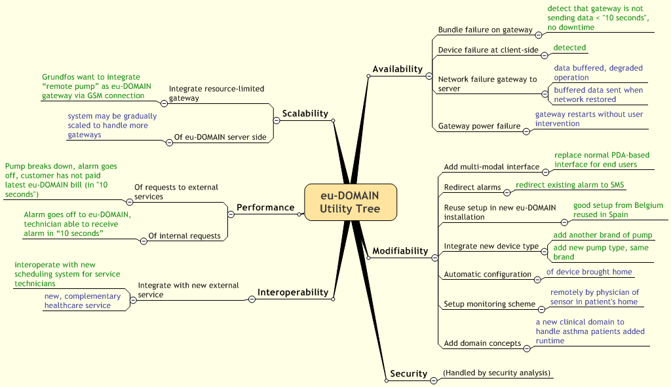

Figure 5. eu-DOMAIN Utility Tree

Domain Model
From a logical point of view, the eu-DOMAIN architecture contains concepts supporting the integration of people, tasks, services, and devices realized as objects in a domain model. The domain model reflects the key concepts of eu-DOMAIN. At runtime the domain model contains all data and operation that must be implemented in order for higher level functions (e.g. user interface) to work. It is what in many information systems is called “Business Logic”.
There is a common model covering domain concepts common to all eu-DOMAIN applications (containing concepts such as Location and Person) as well as application-specific domain models specific to application domains such as facility management and healthcare (containing concepts such as Patient and Patient Record). Application-specific domain models assume the existence of the concepts in the common domain model. This approach is illustrated in Figure 6.

Figure 6. Conceptual Layering of Domain Models
An example domain model is shown in Figure 7 in UML. The model contains concepts (as classes), relationships among them, data of each one of them and operations on them.

Figure 7. An Example ESN Domain Model
Most IT systems have such a model that is often implemented by a mixture of software code and database schemas. Here, this distinction between the model and its implementation is important: the model can be seen as the meta-information about the implementation.
The above characteristics determine the requirements the Domain Model must fulfil, which can be summarized as:
- Have meta-information about the system features (data, operations) at runtime
- Allow Content Providers to plug-in to eu-DOMAIN using its own interface, instead of forcing them to implement a given one
- The main role of the Domain Model is to describe the features of a given eu-DOMAIN installation, but not to implement them. The Domain Model solution described here makes no assumptions about how these features are to be implemented, focusing only in how to allow all these features to be used by every other part of the system.
Still, the Domain Model design should respect the quality requirements (cf. Section 3.2) such as performance even though this is often lost in standards and meta-information.
The requirements are described in further detail in Appendix 9.2. Next, the solution chosen for creating the Domain Model in eu-DOMAIN is outlined. Obviously, this is not the only solution available; other alternatives and a discussion of why they were not chosen is outlined in Appendix 9.3.

Security
Access control in eu-DOMAIN boils down to controlling the type of access one object in the domain model has to other objects in the domain model. This is seen from an object-oriented viewpoint where a subject invokes methods on an object and the object is responsible for checking whether to allow the operation or not.
In order to support this form of security, each object in the domain model must have some information about what it is allowed to access, and who can access it. Therefore the following three security attributes exist for each object in the domain model:
- Credentials
Credentials is data stating that the owner of the credentials belong to a specific group or has a specific identifier. A driver’s license is, e.g., a credential stating that you are a member of the group of people allowed to drive a car, but it is also a credential showing your identity.
- Access Control Lists (ACLs)
An access control list is a list of identities that are allowed to perform a specific operation.
- Key material
Contains public keys for verifying credentials and encrypting messages, private keys for signing and encrypting messages as well as any other key material needed.
When each object described by the Domain Model have these attributes, security checks using this information can then be performed whenever one object tries to access another object. It is worth noting that classes outside the Domain Model will not have these security-related attributes. The only exception being that some key material will be needed outside the Domain Model.

Implementation
On the server side, access control is used to restrict which objects can access which other objects. External to the server, the issue is rather which entities (users, devices, terminals, and gateways) can access which other entities. Clearly the security requirements are different since the server is a trusted environment whereas users, devices, terminals, and gateways are in a potentially hostile environment. Still, a mapping is needed between these two environments since some Domain Model objects may be represented both places.
This means that there will be two different ways to implement the security attributes:
- Only on the server side. If the object (e.g., a rule) only lives on the server-side, no key material is needed and the credentials can be issued temporarily by a trusted authority. The access control lists are still needed to represent who can access the object, but can be stored a central place.
- Both on the server and externally. If the object is both used on the server and external to the server there are different ways to represent the information. On the server, the information is represented as above, but outside the server the credentials are more advanced. For example a device must be able to prove possession of a credential in a secure way and key material also contains private keys. When an external object communicates with the server, all requests go through the gateway server, which will verify and translate the more advanced credential system used externally, to the simple identifiers used internally on the server side.

Elements of the Service-Oriented Architecture (SOA) Domain Model
For eu-DOMAIN, a Domain Model based on a Service-Oriented Architecture and web services has been designed. The elements making this solution possible are shown in Figure 8. In the following sections, each of these elements is described.

Figure 8. Elements of the SOA Domain Model

Definition The Domain Model Meta-Information
The Domain Model will be defined mainly using the following technologies:
- Data structures (e.g., associations, aggregations, inheritance) will be defined using XML Schema (see [XML Schema] and [XML Schema 1.0 primer])
- The operations will be operations in web services, described by its WSDL documents (see [WSDL 1.1] and [WS-I Basic Profile 1.1])
- One or more UDDI taxonomies will be used to catalogue and find the services (see [UDDI]). For example, there can be a taxonomy to catalogue the eu-DOMAIN domain model, and other for each one of the Content Providers. Or also different taxonomies for different eu-DOMAIN applications can be devised.
But other meta-information is also needed:
- How associations between information structures are implemented (e.g., by a Web Service)
- Mapping between data elements used in operations (e.g., input parameters) and data items
- Security attributes of each model element (cf. Section 4.1)
- Cache policies of data elements (see Section 4.2.10 on the Domain Model Client )
- Additional meta-information like WS-Policy documents and others
This additional meta-information will be defined in more detailed design documents, as the metamodel design gets more complete. If a suitable existing standard for defining it is found, it will be used; otherwise, ad-hoc techniques will be applied.

The SOA modeller
The SOA modeller will allow to create, maintain, and manage all of the Domain Model meta-information. It will be used by eu-DOMAIN administrators, with also controlled usage by Content Provider administrators to enable them to update the information in eu-DOMAIN on the SOAP layers of the Content Provider.
Since most of the information handled by the SOA modeller are standard (e.g., XML Schema and WSDL) there exist many existing tools and libraries allowing to manage them, and whenever possible, we will take advantage on that, using mechanisms like WebDAV to integrate them.

The UDDI server
It is the central piece of the Domain Model run time, acting as a dispatcher towards the implementation of the Domain Model operations (note that it does not directly provide access to the Domain Model data, only to the operations). Once all operations needed in eu-DOMAIN are defined as a Web Service in the Domain Model, component of the system must first look up the WSDL of operations (which tells who implements it) in the UDDI server before invoking them
Frequent calls to the UDDI server would cause very bad performance, so caches will be used (see also Section 4.2.10 on the Domain Model Client)
The Content Providers can also have its own UDDI servers, that will be integrated in the eu-DOMAIN one through UDDI v3.

The Web Service Server and the Gateway server
These components are the same ones described in other parts of the architecture.

The eu-DOMAIN Server-Side Functions
They are the implementation of the tasks to be performed inside eu-DOMAIN, either common to every application domain or specific of a given one. They can be things needed to perform domain services (e.g. handling of ESN work orders), value-added services (e.g. searching for a suitable physician across several Content Providers) or internal bookkeeping (e.g. billing to end users and Content Providers.)
Note that they do not include the actual end-user functions, but they support them – the end-user functions, in order to work, will constantly invoke the server-side functions through the Domain Model. All Manager components of eu-DOMAIN will fall in this category.
In the SOA solution, every feature offered by these server-side functions must be available as a web service, and must be defined in the Domain Model. Although this in principle would mean that in order to invoke the service a SOAP/HTTP call must be done, in many cases this will not be desirable because the service can be called locally (e.g. as a Java method.) The Domain Model Client (Section 4.2.10) can help on this.
The SOA solution does not enforce or preclude any kind of implementation for these functions, as long as they are standard web services properly defined in the Domain Model meta-information.

The Semantic Integrator, Meta-Information and Modeller
These are a way of implementing the server-side functions described above. They are included here, however, to stress the fact that the SOA solution does not preclude semantic solutions to be used e.g. for automatic integration of Content Providers.
For more information about these components, see Appendices 9.3.1 and 9.5.3 .

The Content Providers
The Content Providers expose a layer of SOAP web services that eu-DOMAIN will call in order to perform its duties. These web services will also contact eu-DOMAIN through SOAP to notify eu-DOMAIN about relevant events, perform internal housekeeping, or perform other operations defined as needed in the Domain Model. They will thus implement part of the functions of the system, and thus its web services and associated model will be defined in the Domain Model.
Different content providers could implement the same Domain Model operation (e.g. “GetTechnicianPersonalData”;) however, they would do so for different organizations, which is a built-in concept in UDDI. So when querying the UDDI server for some operation, it will return every implementation of it. along with the organization it belongs to, or if queried for the operation of a given organization it would return just the one for the given organization. This suits very much the multi-organization structure of eu-DOMAIN, but it requires that the web service clients would be aware and properly identify the organization in which they want to invoke the operation.
In the SOA solution, when any of the eu-DOMAIN server-side components needs to invoke some functionality of some Content Provider, it will invoke some web service through SOAP after finding its WSDL in the UDDI server. However, this direct invocation will be possible only if the Content Provider operation is completely compatible with the definition of the operation in the Domain Model (i.e. it has a compatible WSDL.) Incompatibilities of operations could happen for many possible reasons, ranging from different encodings to not existing such a similar operation altogether. If incompatibilities exist, adaptation will be needed.
This adaptation would be a new server-side function just as any other, defined in the Domain Model as performing the operation in behalf of the Content Provider being adapted. The same is true for the opposite interaction, i.e. when a Content Provider contacts eu-DOMAIN: if it needs some adaptation, a new server-side function would be created and defined in the Domain Model.

The Domain Model Interpreter
This component is described in Section 5.3.1, p 47.

The Configuration Functions
The Configuration Functions are interactive functions allowing the end-user to configure the access that some components will have to the Domain Model at run time. Examples of such components are the Application Intelligence or the Notification Manager. These functions will make heavy usage of the Domain Model meta-information in order to assist the users in selecting the right Domain Model elements to make the system perform the function they want. For more information about this, see Appendix 9.2.1.

The Event Manager
The Event Manager provides publish/subscribe and store-and-forward mechanisms to queue and distribute messages and events in an asynchronous way between eu-DOMAIN components, which is very important for scalability, temporal, and functional decoupling between components. The Event Manager may be viewed as performing at least part of the roles of the “Enterprise Service Bus” (ESB) of many Service Oriented Architectures.
For further information about this component, see Appendix 9.5.1.

The Domain Model Client
This element is not shown in the above diagram, because it would make the picture too complex. It is a component that every server-side component should (not must) utilize to access both the Domain Model meta-information and the Domain Model implementations, i.e., to query the UDDI server and invoke other components. In this way, it may be used to handle, e.g., a UDDI cache, a Domain Data cache, and local (i.e., not SOAP) calls when possible. Thus, it is a critical component for performance of the SOA of the server-side of eu-DOMAIN.
For further information about this element, see Appendix 9.5.2.2.

Dynamics
Figure 9 illustrates the use of the Domain Model in the ESN Scenario. For a thorough description of dynamics of the Domain Model, see Section 9.4.

Figure 9. Part of Billing Process of the ESN Scenario

Server-Side Components

Managers
Each Manager has knowledge about a specific part of the Domain Model and encapsulates functionality to provide a high-level interface for other modules to access the Domain Model.
A Manager is a stand-alone component with a well-defined interface. It might use its own data stores to manage its internal data and states. These data stores are eventually handled by the Data Server, however (cf. Section 5.2.2, p 37 ff).
Managers may be application-specific or common to all Domain Models. If they are common managers, they are implemented only with knowledge of the meta-information described by the Common Model of the Domain Model layers. The Common Model is an area for future design, thus it is not explicated which of the managers in this section that are common vs. application-specific.
The distinction between the Domain Model and the Managers is a distinction between policy and mechanisms: the Domain Model knows about which services exist and which methods to call to perform an action (i.e., policy), while the Managers are the components that actually performs the actions by calling the correct services and methods (i.e., mechanism).
The following sections describe the currently defined Managers of eu-DOMAIN. For each Manager, its responsibilities, an overview, and possibly a scenario illustrating its dynamics are presented.

Notification Manager
The Notification Manager is basically in charge of sending events to a user. Its main function is to build the message and to send it to the proper direction.
This involves among others:
- Handling the event channel. The channel to send those events could be basically SMS for mobile phones or email. Web notification using the Interaction Server is also a possibility (see Section Interaction Server)
- Use of rules and templates, which will be allocated locally. The templates could be changed through the Interaction Server.

Overview

Figure 10. Notification Manager Process Overview
This figure shows the functional blocks of the Notification Manager to be built. Interpreters and Managers, who will find the Notification Service (querying the Domain Model or asking the UDDI registry directly), contact the Notification Manager through the Notification Web Service Interface.
The Message Engine is the element that controls the whole functioning of the Notification Manager. It decides what to do using the Message Rules and asks the Message Composer to build a message with adequate data. It also asks the Domain Model Interpreter to find the contact info of the entity to be alerted or warned. Once the Message Composer has built the message, using the available Message Templates, the Message Sender is in charge of control the queued messages. It chooses the proper Sender Gateway (e.g., SMS or email) and asks it to perform the physical sending of the message. Once the operation is being done, the Message Engine returns the status of the operation to the Interpreter or Manager that had asked the Notification Manager for operation.

Dynamics
The following sequence diagram shows the typical operations that are performed in order to send a message to a user.
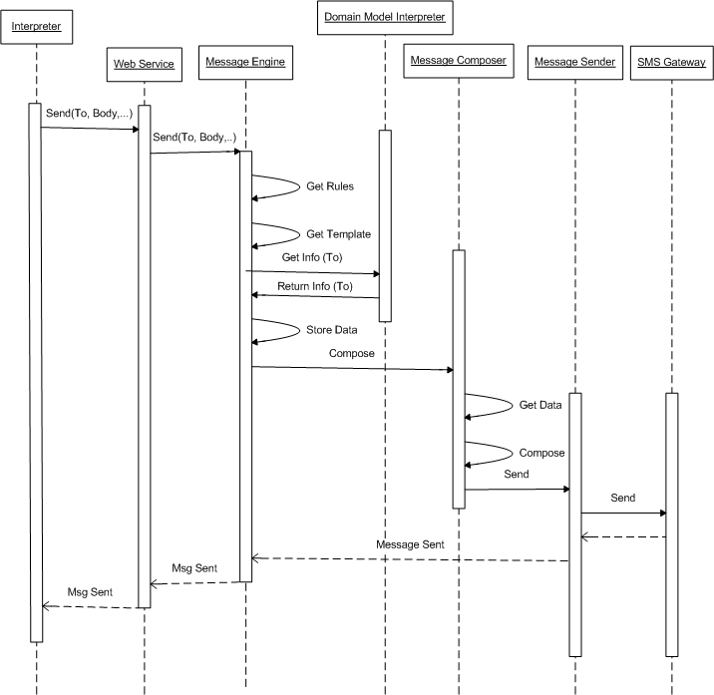

Figure 11. Send Message Sequence Diagram

In here, both Interpreter and the Domain Model Interpreter are external to the Notification Manager.
The following sequence diagram shows the typical operation of managing the templates using the web service through the Interaction Server (out of the Notification Manager).

Figure 12. Update Template Sequence Diagram

Location Manager
The Location Manager knows about different locations and their geographical positions. It is dedicated to answer questions such as the distance between two points, how to get between point A and B, and if traffic jams can be expected.
Further characteristics of the Location Manager are that
- It has two types of internal databases:
  - One with static geographical data (such as coordinates/maps etc)
  - Another with dynamic data (such as experiences from traffic situations during different hours)
- It provides an interface to services providing live traffic/weather data.
- It provides maps and drawings.
- It provides route planning.
Some of the functionality of the Location Manager is expected to be implemented using external web services.

Overview

Figure 13. Location Manager Process Overview

This figure shows the functional blocks of the Location Manager to be built. The Location Manager will be invoked by different managers, domain model interpreters and all other modules that need to take location into account through, e.g., routing, distance, and time and points-of-interest. A request for a route and points-of-interest between point A and B is received by the Interface which calls the Packager. The Packager resolves the request into two calls to the POI and the Route Planner. If a time interval is attached to the request (i.e. someone wants to travel between A and B at a certain time of the day) the Route Planner consults the Knowledge DB to check if it has any knowledge about frequent traffic jams or other relevant information.

Task Manager Description
The Task Manager is dedicated to the tasks that need to be carried out by mobile workers, like nurses and service technicians, involved in eu-DOMAIN services. The Task Manager decides which tasks need to carried out, given a certain situation (such as an alarm in a building), and which resources to be used.
To do this, the Task Manager
- receives task descriptions and checks if a task should be carried out under the offered eu-DOMAIN service,
- has the overall responsibility for find out what is needed in terms of resources, tools, information to carry out the task,
- decides when the task should be carried and by whom, and
- keeps a schedule of task and dispatches them at the right time.

Overview

Figure 14. Task Manager Process Overview

This figure shows the functional blocks of the Task Manager to be built. The Task Manager will be invoked through the Domain Model and Application Intelligence. The input to the Task Manager will be a high-level task description, i.e., what needs to be done and at what location and any possible time constraints. The request is received by the Interface which passes it on to the Task Engine. The Task Engine checks with the Task Validator if it is a valid task.
The Task Validator either checks an internal database or communicates with an underlying external Content Provider service to get information if the task is to valid. Typical rules to check if a task is valid are “Is it a paying customer?” or “Do we have contract that requires us to do the task?”. If the task is valid the Task Engine then asks the Task Resolver to populate the task with resources and the necessary information needed to carry out the task (e.g., manuals, service instructions, or maps to get to the location). The Task Assigner then allocates a specific resource, like a service technician and decides based on know schedules when this task is to be carried out. The Task Dispatcher keeps track of all assigned tasks and activates them at the appropriate time.

Mobile Content Compiler
The Mobile Content Compiler is responsible for information management at an individual task level. Its role is to provide an optimal information package to support an individual worker carrying out a specific task. It tries to predict in advance what information the individual worker will need or request when carrying out the task.
To achieve these goals, the Mobile Content Compiler
- is responsible for retrieving and package information to support a mobile worker (like a service technician or a nurse) in a certain task,
- produces a tailored, individualised information package which is optimised for a task, and
- uses a task description but also knowledge about previous execution of similar tasks.

Overview

Figure 15. Mobile Content Compiler Process Overview

This figure shows the functional blocks of the Mobile Content Compiler to be built. The Mobile Content Compiler will be invoked by managers like the Task Manager and by Domain Model Interpreter. Typical input to the Mobile Content Compiler will be a task description (which includes information about a task, the person to perform it and the location where it is to be carried out). The request is received by the Interface which passes it on to the Compiler. The Compiler resolves the request and transforms it into a set of retrieval requests which are sent to the Content Retriever. The Compiler does so based on knowledge about similar tasks that have previously been carried out.
The Predicition Engine subscribes to requests and tries to predict the next request intelligently (like someone is asking about A and, based on knowledge about previous tasks, therefore is likely to ask about B).

Resource Manager
The Resource Manager is responsible for managing and delivering information about available resources such as workers, vehicles, tools, and medical equipment needed to provide the eu-DOMAIN service to end-users.
The purpose of the Resource Manager is to provide an efficient use of available resources. To achieve this, it provides functionality for:
- Given a profile it retrieves a list of available resources that matches the profile.
- It presents a ranked list of resources that matches the requested profile.

Overview

Figure 16. Resource Manager Process Overview

This figure shows the functional blocks of the Resource Manager to be built. The Resource Manager will be invoked mainly by the Task Manager. The input to the Resource Manager is a task description. The Task Description contains requirements on needed resources. The Resource Compiler checks with the Agreement Retriever if we have any agreements/contracts with such resources. At the same time the Resource Compiler ask the Profile Matcher to find resources that matches the request. The Resource Compiler then matches the two lists into a set of resources that can be used to carry out the task. The Resource Prioritiser organises the list into a ranked list over how well each resource matches the requirements.

Log Manager
The Log Manager is a back-end module that is used internally for all tasks of logging and saving event information permanently.
Furthermore, the Log Manager provides runtime access to the Log so that other components can use the information in the Log to make informed decisions. It also provides to the Log Database, e.g., for billing purposes or to provide different analyses of the logged information.

Overview

Figure 17. Log Manager Process Overview

This figure shows the functional blocks of the Log Manager to be built. The Log Manager will be invoked by all components that need to log information or analyse logged information. The input to the Log Manager will be a request to log something or a request to retrieve data from the log. The request is received by the Interface which passes it on to the Resolver. Depending on the request the Resolver sends it to the Filter, the Log Reader or the Log Analyser.
The Filter checks if this is a request that actually should be logged, if so it sends the log request to the Log Writer who stores the log information. It will be possible to configure the Filter depending on the application needs. The Log Reader is used to read out information from a detailed level. It is typically used by components that need access to information about what has previously happened in a task. The Log Analyser provides functions for, e.g. back-end analysis or report generation from the Log DB.

Security Manager
The Security Manager is responsible for managing credentials and cryptographic keys, as well as fetching other security-related attributes such as access control lists and querying objects about their security. It will also have access to a key store where private keys needed for the server-side are kept.

Servers

Web Service Server
The Web Service Server is in charge of communication and data interchange with services of external Content Providers. Its main function is to translate requests for external data, expressed in terms of the Domain Model, into a set of web service calls.
As described in Section 4, the protocols/languages to be used for communication and interchange with external services are SOAP (Simple Object Access Protocol) and WSDL (Web Service Description Language).
To implement the desired communication, the Web Service Server
- constructs an evaluation plan to make the web service calls correctly and efficiently,
- composes and translates the data into calls to the Domain Model once the requested information arrives,
- tries to optimise the evaluation of multiple requests, with respect to possible parallel solutions and data dependencies, and
- has knowledge and meta-information about external Content Provider Services which it uses to construct its evaluation plan.

Overview

Figure 18. Web Service Server Process Overview

This figure shows the functional blocks of the Web Service Server to be built. The Web Service Server will be invoked by different mangers such as the Mobile Content Manager, Location Manager, or Resource Manager. The Web Service Server receives a request through its Interface, for instance GetPatientData(…). That request is passed onto the Execution Engine which is responsible for the control flow of the request. The Execution Engine invokes the Planner which consults the Domain Model to get information about how this request maps to available Content Provider Services. The Planner creates a plan taking into account what it knows about the external services (such as response times) and other on-going requests. The Planner tries to optimise the retrieval by translating the plan into a set of Web Service requests, possibly in parallel if the plan allows that. The Planner gives its plan to the Execution Engine. The requests are carried out by the Web Service Call Handler.
When the external Content Provider Service return an answer, the answer is received by the Web Service Call Handler, which passes it on to the Execution Engine which populates the plan with the retrieved data. The populated plan is passed on to the Model Mapper. The Model Mapper translates the data into Domain Model data which is then returned to the calling module.

Dynamics
The following sequence diagram shows the typical operations that are performed in order to retrieve data about a patient:

Figure 19. Get Patient Data Sequence Diagram

Data Server
The Data Server is the element of the server-side eu-DOMAIN architecture that will provide all of the data storage and management capabilities to the rest of the server-side elements.
The main characteristic determining the design and implementation of the Data Server is obviously characteristics of the stored data, including its type and volume. We will distinguish among the three types of data shown in Figure 20
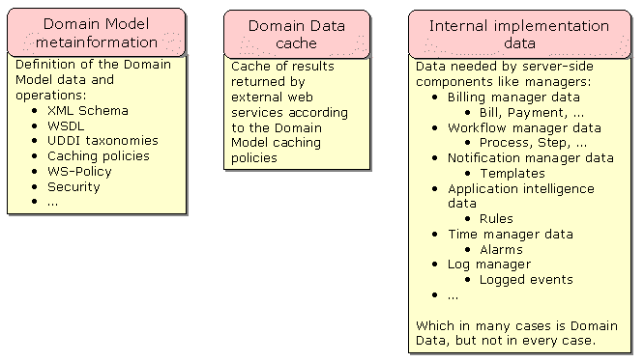
Figure 20. Types of Data to Store in eu-DOMAIN
Although a large part of the eu-DOMAIN data will be stored outside eu-DOMAIN, the Data Server will still have to be capable of handling a large amount of data, supporting heavy usage patterns.
The fact that the Domain Model is implemented using a SOA solution, with strong reliance in XML standards, can make it advisable to store a large part of the data as XML, if not all of it. However, some other data will not be defined in the Domain Model and thus it has not such a characteristic.
The following sections detail this argument.

Domain Model Meta-Information
The Domain Model meta-information will include (cf. 4):
  - XML Schema definitions of the data handled inside eu-DOMAIN
  - WSDL definitions of the web services implementing the operations inside eu-DOMAIN
  - Other documents needed for the operation of the eu-DOMAIN UDDI server, like taxonomy definitions and directory entries, as defined by the XML Schemas in the UDDI specification
  - Security information like ACLs attached to data and operations of the Domain Model
Other meta-information yet to be defined about the web services of eu-DOMAIN, like WS-Policy documents and/or caching policies may also need to be stored.
All of this information is defined originally as XML, so it would make much sense to store and handle it during runtime as XML, if possible.
The volume of this information will not be very large, and it will be much more read than written, although there will be maintenance procedures for it. The main users of it will be:
  - The UDDI server, which will do heavy usage of it
  - The Domain Model Interpreter
  - The interactive tools allowing to define the Domain Model meta-information

Domain Data Cache
There will be a persistent, system-wide cache of Domain Data returned by web services, as defined in the caching policies (cf. Section 4.2.10, p 24 on the Domain Model Client). The data stored in it will be SOAP documents (or at least SOAP bodies) organized by web service invocation (i.e., by the web service being called and its invocation parameters). Again, all of it is XML data, and it would make sense to be stored in this way.
The volume of this information will depend on the caching policies being established in the particular eu-DOMAIN instance, but given that a large part of the eu-DOMAIN data model can be stored outside the eu-DOMAIN server, it can be very large.
Also, this cache will have to support heavy usage, both for reading and for writing, by the server-side components of eu-DOMAIN.

Internal Implementation Data
Inside the eu-DOMAIN server side there will be a large number of Managers performing all kind of tasks, in fact implementing a large part of the Domain Model features. Each one of these managers will deal with different tasks ranging from generating alarms to controlling workflows.
This definition of manager encompasses most (if not all) of the features to be implemented inside the eu-DOMAIN server side, so that every other data storage need should fall in this category. Thus, this category should cover the data for every feature developed inside eu-DOMAIN, either domain-specific or common across several application domains. This is, this data will account for a large share of all the information to be handled by the data server.
Each manager will have its own unique requirements and thus its own unique data model and usage policies. However, since all of them will implement features from the Domain Model, its public data model will have to be modelled as XML Schema, since all of the Domain Model will be so. Thus, although nothing prevents a manager from choosing a non-XML (e.g. relational) implementation of its data, using a XML data storage would ease maintenance of the mapping between the Domain Model data and its implementation.
However, many managers will have internal data that will not be public (i.e., not known by its users) and so it will not be defined in the eu-DOMAIN Domain Model, such as the rules used by the Application Intelligence rule engine. For this kind of data there is actually no predisposition to being stored as XML more than by using any other formalism.

Design Overview
The Data Server may be implemented using the Software AG Tamino native XML database, which offers all data management features of any mature DBMS. Tamino models its structures as XML Schemas, so defining the required part of the Domain Model in Tamino should be straightforward. There could be even no need of storing duplicate definitions of the Domain Model data and of the database schemas, but for both of them the Tamino schema definitions could be used; although this still has to be further analysed.
Including a relational DBMS (RDBMS) besides Tamino could suit the storage needs some Managers will have regarding to its non-public data, i.e., data that may not defined in the Domain Model (e.g., the rules of the rule engine). Moreover, some of the modules needed by these managers may be not developed inside eu-DOMAIN and may require to use a RDBMS (e.g., a rule engine). We here choose to use an XML database, Tamino, for reasons of coherence, but if later it turns out that a RDBMS is required or is convenient, it can be equally used.
The Tamino database can be installed both in Windows and in Linux platforms, with options ranging from using a single server both for applications and data, to using several independent data servers to provide high availability (see later.) There is no option to run a parallel database server, however. Tamino offers, among others, both Java and .NET APIs; here we propose a persistence layer to be used here on top of these APIs.

Physical View of the Data Server
Tamino can support several physical architectures, depending on the requirements and resources of a given eu-DOMAIN instance. Configurations include:
Figure 21. Tamino on Linux server Figure 22. Tamino on Windows server

Figure 23. Tamino on separate server

Figure 24. Tamino with High Availability

Data Access Patterns
The recommended way of layering the software regarding data access inside the eu-DOMAIN server would be following the Model-View-Controller and Data Access Layer patterns, i.e.:
Figure 25. Data Access

I.e. the Data Server would be accessed only by the Domain Model implementations (e.g., managers,) never by the end-user functions. And inside the Domain Model implementations, the actual access to the Data Server would be performed by a specific Data Access Layer that would abstract the rest of the Domain Model implementation out from the actual data implementation, making it irrelevant whether it is Tamino, some other XML database, or a RDBMS.
On the top of the Java and .NET APIs, a (Tamino-independent) interface to object-oriented persistence management facility will be provided. Using a tool, a data access layer will be generated that has a representation of every required data entity (class, document type, etc) of the Domain Model as a Java/.NET class, including the data elements and relationships defined in the Domain Model and supporting both reading and updating of the data.
For generating this layer, the best option would be for the developer to use some interactive tool that, out of the Domain Model meta-information and the developer directions would generate the actual classes for the developer to add required logic. Preferably, this tool would be accessible from a development environment, e.g., as an Eclipse plug-in for Java developers or as a Visual Studio.Net plug-in for .NET developers. Such a tool would need to be developed inside the eu-DOMAIN project.

Gateway Server
The Gateway Server is the entrance point for client-side gateways to the server-side of eu-DOMAIN. Its main function is to direct traffic to and from such gateways. Thus, it handles connectivity with all the client Gateways within eu-DOMAIN. The communication between gateway and server is based on web services. The responsibilities of the Gateway Server include:
- knowing whether requests come from proper Gateway Clients or not,
- managing priorities of messages before passing them to other elements in the server,
- request handling,
- determining to which Gateway to direct replies,
- implementing firewall policies,
- employing queuing techniques and algorithms, among others, to handle prioritized requests
Communication between the Gateway Server and gateways is handled using web service protocols.

Overview
Figure 26. Process Overview of the Gateway Server

Figure 26 shows the functional blocks of the Gateway Server. Clients talk with the Gateway Server using Web Services Technologies. Once the request has passed the Firewall filter, goes to the Request Manager or the Sign-Up Manager. The former is used to handle function requests from clients, the latter to manage clients plugged to eu-DOMAIN Server Park.
When a Client wants to join eu-DOMAIN has to talk with the Sign-up Manager. This element is in charge of managing a Client Gateway database, where clients that are allowed to connect to the Server Park are stored.
On the other hand, when a Client wants to perform a request to eu-DOMAIN Server Park, it talks to the Request Manager. The first step in here is to confirm that the Client is allowed to talk with eu-DOMAIN. This task is done by the Client Gateway Manager. Once this element gives the OK, the request passes to the Priority Manager, which is in charge of Priority Stacks, where requests are ordered by importance. The Priority Manager decides which request has to be answered next. The following step is to answer the request. This is done by the Request Dispatcher. It asks the UDDI Server about who has to manage the request and the Request Dispatcher send it to the proper eu-DOMAIN server-side entity to be managed in there.
The Client Gateway Manager also handles heartbeat messages from gateways.

Dynamics
The sequence diagram in Figure 27 shows the typical operations that take place when a client gateway asks for a bundle. Figure 36, p 57 shows part of the client-side dynamics of the same scenario.
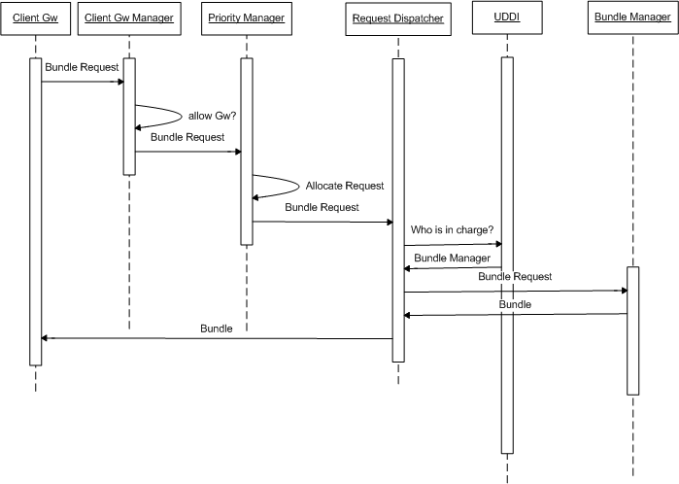
Figure 27. Bundle Request Sequence Diagram

A Gateway Client contacts the Client Gateway Manager (once the request passes the firewall protection), in order to talk with eu-DOMAIN Server Park. The Client Gateway decides whether the request comes from a known Gateway Server and redirects the request to the Priority Manager. It allocates the requests taking into account its priority, and when its turn comes, the Priority Manager passes it to the Request Dispatcher, which asks the UDDI Server so as to know which manager is in charge of handling the request. It passes the request to the properly manager, and the request is answered.
In the next sequence diagram, a Client Gateway wants to be added to eu-DOMAIN platform. In order to do that, it has to talk with the Sign-Up Manager in the Gateway Server.
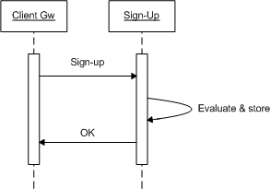

Figure 28: Client Gateway Sign-up Sequence Diagram

Interaction Server
The Interaction Server is the entrance point for end-user terminals to the functionality of the server-side of eu-DOMAIN. The Interaction Server is accessible from multimodal terminals (e.g., laptops, PDA, mobile phones) from which requests are created that are passed through the Interaction Server to other elements on the server-side. The resulting reply is rendered and shown to end-user again using the Interaction Server.
Definitive services are still to be defined, so that it is not clear yet which functionality will be offered to users through the Interaction Server. Examples of potential functionality include:
- User administration
- Programming of Local Intelligence.
- Programming of Application Intelligence.
- Alarm setup & handling.
- Access to stored data.
- SOA Modeller.
- Semantic Modeller.
- UDDI Server Manager.
For all of these, terminal capabilities have to be taken into account in order to perform a suitable layout.
The Interaction Server is to be built in the shape of a Web Server, with an Application Server to host the different applications. A Presentation layer, used to perform communication with User Terminals is needed. In order to perform communication with the rest of the elements in the Server Park, an Application Layer will be also built.

Overview
Figure 29. Interaction Server Physical Overview (Here with CMS – Nukes on JBoss. Configuration without CMS also possible)

The figure above show the functional blocks of the Interaction Server, which is the entrance point for users and administrators to eu-DOMAIN functionality. The Interaction Server will be a Web Server, where a Presentation Layer and an Application Layer divide interfaces from functionality. Clients’ terminals are to have web browsers incorporated in them.
The Interaction Server has to deal with different problems, among which we highlight:
- Development Platform
  - Java
- Presentation and Content Management System (CMS) platform: we propose two different proposals (Figure 29)
  - In the first one, a CMS is to be used (Nukes on JBoss). This open source solution is a Java CMS (as PHPNuke or PostNuke for PHP). It allows security and management of users with a homogeneous layout (based on themes). Each application is a module built on Java and presentation is built with HTML tags. This CMS, as the name reflects, works over the JBoss Application Server.
  - In the second proposal, JBoss (or other Application Server) is used (using Tomcat as Web Server). JSPs or Struts are used for the Presentation Framework and EJBs or JavaBeans for the Application itself.
- Multichannel applications: Different applications have to be built for mobile devices (not full functionality) and for laptops depending on terminal capabilities.
For each configurable and/or accessible service, a new Configuration Function and/or User Service block need to be developed (approving Billings, configuring alert’s templates, etc.). These blocks allow the user or the administrator access and manage the whole functionality within eu-Domain. Configurations Functions are also used by administrators to maintain UDDI server.
Moreover, a SOA Modeller is used to maintain the Domain Model meta-information. This information is thought to be managed by administrators.
Finally, a Semantic Modeller may be used to manage Semantic Meta Information (again by administrators).

Dynamics
The following sequence diagram shows the typical operations that are performed so as make use of one of the User Services within eu-Domain (Billing Manager in this case).
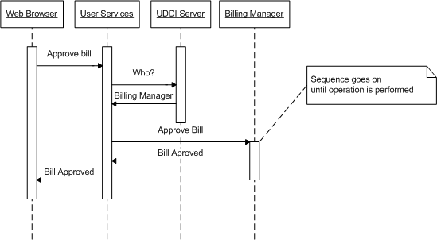

Figure 30. Approve Bill Sequence Diagram

A client, using its web browser wants to approve a bill. The corresponding User Service Block asks the UDDI Server about who is in charge of performing this task. Once the User Service block knows that is the Billing Manager the one in charge of the task it asks the Billing Manager to approve the bill (the sequence of operations started by the Billing Manager is not shown in here). Finally, the user is informed about the result of the operation.
The next sequence diagram shows how an administrator makes use of the SOA Modeller from its terminal in order to manage the Domain Model Meta Information.
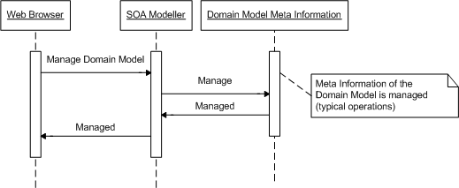

Figure 31. SOA Modeller Sequence Diagram

Interpreters

Domain Model Interpreter
This component will allow dynamic access to the Domain Model, i.e., accesses that are not known and hard-coded in advance by a developer. This capability will be used by components like the Application Intelligence (Section 5.3.2) and the Notification Manager (Section 5.1.1).
Abstractly, this component will take a list of Domain Model operations to be performed, comparable to a simple script, and it will just execute it by interpreting the list and invoking the UDDI server as appropriate.
However, the Domain Model will define operations with finer granularity than the typical one of a SOAP web service, e.g. retrieval of simple data. For example, the Notification Manager will typically need to retrieve single data items like the name of a person, some address or some date, because they are referenced in a message template and it must include them in the text of a notification.
The Domain Model Interpreter will take care of this by analyzing the Domain Model meta-information to find out which is the best way to solve this finer-grained operation that does not directly match any existing web service, in terms of the available web services. For this concrete task, complex technologies like Semantic Web Services are not expected to be needed, rather simpler technologies seem appropriate.
The Domain Model Interpreter will have a networked SOAP interface. However, in order to take full advantage of the possibility of invoking services locally, the interface of the Domain Model Interpreter is be also local, which means that there will be both Java and .Net versions of it.

Application Intelligence
The application intelligence is responsible for managing the interpretation of input to the Eu-DOMAIN system and evaluating actions for these inputs. The main functional requirements of this component can be summarised as follows:
- Multiple applications should be able to run in parallel without posing any integration restrictions, i.e. the applications should be able to be fully independent of each other.
- Events should be able to “remember” previous states, i.e., we need some kind of sessions.
- Application intelligence should be easily extendable and provide a rich set of functions for managing the different inputs.
- It should be possible to express the application intelligence using rule based programming.
- Since the application intelligence should be tailored for each application it should use well known languages for expressing the rules.
- The rule engine should provide more than basic rule execution functionality, i.e., it should provide functionality for, e.g., prioritising rules and pruning
- It should be easily possible to extend the language with Eu-DOMAIN-specific constructs.
The basic idea behind the Application Intelligence module is to define an XML structure that represents a Session. This Session object keeps all the Events that happens during the Session.
When looking at different languages and rule based systems that could supply this functionality to eu-DOMAIN there are a number of candidates that could fulfil these requirements:
- Prolog (and other inference based programming languages)
- Functional programming languages such as F#, Lisp et c.
- XML-based languages, e.g., XSLT with XPath.
- Code generating systems, i.e., rule compilers
- Ordinary script based languages, such as JavaScript
Table 2 summarizes the properties of these solutions.
Property | Inference based | Functional | XSLT/XPath | Rule compilers | Script
Rules | Yes | No (Can be implemented) | Yes to a certain extent | Yes | No (Can be implemented)
Developer community | Small | Small | Fairly large | Small | Large
Extensibility | Yes (language dependent) | Yes (language dependent) | Yes, standardised to some extent | Non standardised | Non standardised
Platform support | Uses normally its own environment | Uses normally its own environment | Platform independent | Platform dependent | Needs to be tailored to each platform
Implementations | Proprietary | Proprietary | Widely available | Proprietary | Proprietary
Tools/Editors | Proprietary | Proprietary | Widely available | Proprietary | Widely available
Industry acceptance | Low | Low | High | Low | High
XML Support | No | No | Yes | No | Some
Table 2. Properties of rule-based systems

Looking at the table, the present conclusion is that XSLT seems to be a good candidate to use as basis for defining/programming the application intelligence. The only main drawback, compared to inference based and rule compilers, is that it does not have advanced rule handling in the same extent.
The fact that XSLT processing has the advantage that it is well known for a larger community of developers, that there are a number of industrial strength implementations on a wide range of platforms, and that it is extensible compensates some for this drawback.
Since XSLT is XML-based it also easy to create high level languages for the application developers if XSLT would not suffice itself, which then could be transformed into XSLT.
An XSL-T document representing a rule engine is applied to the Session Object and depending on the different matching rules (expressed in XPath) in the XSL-T template different rules are fired. The XPath constructs will be used to represent rules.
The constructs of the XPath language gives us conditional, comparison and logical constructs like “equals, greater than, not equal, AND, OR), but also extremely powerful pattern matching capabilities. This allows us to express simple rules based on the nature of a single event (if alarm of type B then do X), the nature of a complex event with subtypes (if alarm of type B, sub-alarm of type C, with error code D then do Y) but also on a sequence of events (if A, B, C has occurred but not D, then do Y).

Overview
The main parts of the architecture of the Application intelligence are from a process viewpoint:
- Interpreter
- Application rules/logic
- Session, to keep information
- Evaluator
- Cache
Figure 32. Application Intelligence Process Overview

The event dispatcher will analyse input events and determine to which application it belongs to. Then it passes the event to the appropriate Application interpreter.
Each application running in eu-DOMAIN will have its own instance of interpreters, session state and logic/rules. This makes it possible to have two completely different applications running independently.
The application interpreter will run the applicable rules for the event and these will result in a number of calls to eu-DOMAIN servers and managers. In fact an event can be a non-event triggering no calls at all. The interpreter will not make the actual calls instead it will pass all calls collected by the event and pass them on to the evaluator.
The evaluator makes the actual calls to the different servers and services.

Client-Side Components
The client-side components of eu-DOMAIN are divided into devices, terminals, and gateways. Devices are what enable the ambient intelligence environment that the eu-DOMAIN platform works in; terminals are means for user interaction; and gateways connect devices and the eu-DOMAIN server-side. The logical relationship among servers, gateways, devices and terminals is shown in Figure 33.

Figure 33. Logical view of relationship among client-side components

Consequently, gateways impose a hierarchical structure on device in that all communication from devices to the server-side must go through the gateway. Aside from functional concerns such as range of communication means of devices, this is mainly done for scalability and performance reasons: Gateways are able to decide the policy for how to handle the multitude of devices for a location and thus introduce, e.g., caching or transformations of information from devices. On the other hand, this introduces a point-of-failure at a location, possibly hampering availability. Some of this may be alleviated by using multiple gateways at a location.
The rest of this section describes the client-side components in turn.

Devices
Devices are actuators, sensors, or processors that are installed and operated in an eu-DOMAIN location. At any point in time, devices are connected to one gateway, but devices may move between gateways as a consequence of user mobility.
We may distinguish between different types of devices according to their capabilities towards the eu-DOMAIN platform:
- Readable devices, which may deliver data to the eu-DOMAIN platform. A temperature sensor that only has a serial interface for polling temperature readings only is an example of a device in this category.
- Writable devices, which accept data from the eu-DOMAIN platform. A Grundfos pump on which parameters for, e.g., effect may be set is an example of such a device.
- Discoverable devices, which are able to be programmatically discovered by the eu-DOMAIN platform. A Bluetooth-enabled pulse oximeter is an example of a device in this category.
- Updatable devices, which accept code from the eu-DOMAIN platform. A (hypothetical) Grundfos pump with capabilities to be discovered by and directly communicate with a gateway might be an example of a product in this category .
The eu-DOMAIN client-side is able to work with devices of all capabilities. This interoperability is essential since it cannot be assumed, neither short-term nor long-term, that devices are adapted directly to the eu-DOMAIN platform. It is expected that most devices will be of type 1. or 2.

Terminals
Terminals are the means for end user interaction with the eu-DOMAIN platform. Examples of terminals may be a PDA or a wearable computer with heads up display. In eu-DOMAIN, terminals are associated with a person so that the terminal may be used as a token for the person.
Web-based interaction provides a means for presenting user interfaces that support the eu-DOMAIN quality goals of modifiability and scalability. In particular, the system is flexible in relation to different content providers and applications because there is no need to develop a customized local software for every user type. Interaction with eu-DOMAIN is thus browser-based.
In particular there are two main advantages that a software installed locally on the Terminals is able to provide:
- Automation: this means providing some intelligence to accomplish a number of tasks automatically, some customised software can help the user and speed operations making them transparent;
- Data retrieval: an hypothetic local application could also contemplate the creation of a local Database or a local Cache to store some information which doesn’t change frequently during the time.
Another possible need for the creation of some local application is the use of some additional component plugged into or connected to the terminal, as a GPS, that could need a specific interface to communicate data to the server-side component such as a Location Manager.
The decision to use browser-based interaction puts particular stress on two central issues in end user interaction in eu-DOMAIN is connectivity and context awareness. These are discussed next.

Connectivity
Network connectivity is crucial for the web-browser based terminal solution. This means that there is an underlying assumption that network connectivity is pervasive in the eu-DOMAIN scenarios.
Outside locations this may be achieved by using WANs such as GPRS; inside locations, mobile terminals may more conveniently access an existing wireless network. In this case, the terminal will authenticate with the existing wireless network infrastructure in some way depending on the security of the network. This could be based on MAC address filtering, WEP/WPA shared key, or WPA-RADIUS authentication.
If no existing wireless infrastructure exists outside eu-DOMAIN, the eu-DOMAIN gateways at a location can be used as wireless access points and routers providing access to the Interaction Server.

Context Awareness
Tailoring services to the context of entities, i.e., any information which may be used to characterize the situation of an entity (person, place, or object) of entities is essential to ambient intelligence [Dey, 2001]. In particular, knowing the location of persons/end users in eu-DOMAIN is essential to providing context-aware services. Since a terminal is used as a token for a person, locating a person is equivalent to locating a terminal. Currently, we will focus on location awareness.
Given a terminal, there are two basic possibilities for enabling location awareness:
- The environment senses the terminal. In the eu-DOMAIN architecture this means that eventually a gateway will sense the terminal, essentially turning the terminal into a device.
- The terminal senses the environment. Since eu-DOMAIN terminals are browser-only this requires the physical terminal also to be a gateway; something which is possible if the terminal is, e.g., a PDA.
For location information, we may rely on GPS outside. This implies that possibility 2. needs to be employed. For inside location the problem is more difficult.
How it should be solved depends on how fine grained we need to pinpoint a user’s location. The most coarse-grained methods use a building’s wireless network to get the location of the user, where the most fine-grained methods use for example smartcards, BlueTAGS, or RFID tags.
When using a wireless network in a location (either an existing network or a network with an eu-DOMAIN gateway as router) from a terminal, it is essentially possible to couple the terminal with the location given that the terminal in some way contacts the gateway. This may be done through contacting the Http Service of the gateway (see Section 6.3.4, p 55).

Digital Signatures
One requirement of the terminal is that a user is able to put his digital signature on some document using the terminal, for example when approving a bill. In order to provide non-repudiation, the user’s private key should be stored only on the terminal, but this poses a problem since the only software we have available on the terminal is web browser, and using a web browser alone there is no way to sign a document using a secret key stored on the terminal.
One reasonable assumption is that the secret key is placed on the terminal prior to it’s deployment, and hence does not have to depend on a web browser. Then a Java applet or ActiveX control could be granted the right to read the private key and sign documents though the web browser.
Another solution is that the private key is placed outside the terminal (for example at the eu-DOMAIN server), and some authentication from the terminal and/or some other protocol (such as an SMS) is needed to release the private key for signing. There are commercial solutions that handle this issue.
Finally we can use the private key only to secure a connection to the eu-DOMAIN server where the user approves the bill using a web interface. The problem is that we don’t really have non-repudiation in this case, since the eu-DOMAIN administrators can claim that a user made a signature that he in fact didn’t. Still, if we trust the eu-DOMAIN administrators and the overall security of the eu-DOMAIN server, this is a valid solution.

Gateways
Gateways act as mediators among devices and the eu-DOMAIN server-side. At any given time, they physically belong to a location. Gateways run an OSGi service platform, i.e., a Java VM, an OSGi Framework, and a set of bundles. It is assumed that at least OSGi R3 [OSGi, 2003] is present on gateways. The reasons for using OSGi as a gateway platform has been discussed in D2.2 (“State-of-the-Art Analysis”, Section 5, p 17 ff).
Figure 34 shows a process view of the components on the eu-DOMAIN gateway.

Figure 34. Process View of Client-Side Components on Gateways

Gateway Client Service
The Gateway Client service is the entrance point of a eu-DOMAIN gateway. The Gateway Client interacts with the Gateway Server of the eu-DOMAIN server-side. It is responsible for
- Providing a web service entrance point to and from functionality on the gateway
- Caching and queuing events, requests, and replies
- Handling intermittent communication failures on the gateway including loss of connectivity and emitting heartbeats to the Gateway Server
- Perform firewall functionality similar to what is found on the gateway server
- Check if requests are actually allowed to enter the gateway

Domain Model
The Domain Model of the client-side contains a location-specific version of the Domain Model. Different versions of the Domain Model are possible:
- A dispatching version in which all request are dispatched directly to the server-side of eu-DOMAIN (subject to caching at the Gateway Client service)
- A replicated version in which data is stored at the gateway and synchronized with the server-side
A mix between 1. and 2. is also possible and indeed aspects of 2. may be necessary to support, e.g., loss of connectivity in critical situations such as alarm handling.
The client-side Domain Model per default provides a Java-based interface rather than a web service-based interface.
Security-wise the domain model on the gateway is the same as on the server-side of eu-DOMAIN. However, since web services are not used on the client side, some custom protocol is needed.

Device Access Services
Managing devices is essential to eu-DOMAIN; handling device attachment and managing device drivers are aspects of this. The Device Access Services in eu-DOMAIN builds naturally builds upon the Device Access Specification of OSGi. The following entities are relevant and refined in eu-DOMAIN ([OSGi, 2003], p 224):
- The Device Manager controls the initiation and attachment process of devices. It encapsulates an algorithm for device attachment which will be refined for eu-DOMAIN purposes
- A Device represents a physical devices and other entities such as networks which may be attached to a gateway
- Drivers decouples Devices from specific ways of interfacing to entities external to the gateway
- DriverLocator and DriverSelector provides mechanisms and policies respectively for locating and selecting appropriate Driver services
Bundles for Device services and Device Driver services may be located and distributed by the eu-DOMAIN server side through among others (semantic) search. This is an area for further research.

Platform Services
The Platform Services correspond to the Interpreters and Managers on the server-side of eu-DOMAIN. The Domain Model may dispatch requests to these and may be called by Platform Services.
Figure 34 shows examples of such services:
- The Log Service is an example of a standard OSGi service for logging. Other relevant built-in OSGi services are the Package Admin Service, Start Level Service, Permission Admin Service, Configuration Admin Service, User Admin Service, Http Service, Preferences Service, and the Service Tracker Service [OSGi, 2003].
- The Management Agent Service is an example of service from the non-normative part of the OSGi specification. This service handles the client-side of remote management of OSGi frameworks.
- The Interpreter Service is a eu-DOMAIN-specific, client-side bundle for handling rule-based interpretations of operations and data in the Domain Model. Another example would be a Location Service based on, among others, the Http Service.

Client-Side Scenarios
The following scenarios show characteristic interaction of the components of the client-side of eu-DOMAIN.

Monitor Pump Performance
This scenario refers to the situation in which a remote monitoring of a location has been set up. Pump optimization is attempted if the temperature at the location is below or above a certain threshold. If this does not effective, a notification is sent through the eu-DOMAIN server-side (ESN scenario and ESN.1.1 use case).
Figure 35 shows how the client-side component interactions work at an architectural level. The monitoring operation is installed as rules in the Interpreter Service. Based on the rules, the Interpreter Service periodically checks the thermometer at the location at adjusts the pump as appropriate. If the desired operating conditions cannot be met, a notification message is sent through the Gateway Client to the Gateway Server.

Figure 35. Monitor Pump Performance scenario of the eu-DOMAIN client-side

Remote Software Update
This scenario is concerned with updating a the software used to access a devices from a gateway in a location (ESN scenario, ESN.4.2 use case). The mechanisms for doing this is a variation of the mechanisms in the Remote Management Architecture of OSGi R3 ([OSGi, 2003], p 43 ff). This is shown in Figure 36.

Figure 36. Remote Software Update scenario of the eu-DOMAIN client-side

User Authentication at Location
This scenario involves authenticating and locating a user through the terminal of the user. The mechanisms for doing this using a WiFi network is outlined in Section 6.2.2 on page 53 (ESN scenario, use case ESN.3.2). Figure 37 maps this to interactions among client-side components.

Figure 37. User Authentication at Location scenario of the eu-DOMAIN client-side

Discussion
This section discusses to which extent the software architecture fulfils its requirements. Obviously, we cannot at this stage claim conclusively that functional and quality requirements will be met in the implementation of the eu-DOMAIN platform. The discussion is primarily qualitative; quantitative, and decisive, evaluations will be made as the project iteratively and incrementally develops the eu-DOMAIN platform.
This section is divided into three parts: the first part (Section 7.1) discusses the architecture in relation to the functional requirements of eu-DOMAIN as expressed in use cases. The second part (Section 7.2) discusses the architecture in relation to the quality requirements of eu-DOMAIN as expressed in a utility tree. The third part (Section 7.3) specifically discusses trust and security quality requirements of eu-DOMAIN.

Functional Requirements
We here outline how an implementation based on the presented architecture may handle the architecturally significant use cases in the scope of eu-DOMAIN.

ESN.1.1: Monitor 24 hours a day the effectiveness and the performance of a technical installation in a commercial building
Heterogeneous technical installations may be connected to an eu-DOMAIN-enabled service gateway and connected to an eu-DOMAIN server-side installation. If the equipment of the technical installation supports reading the relevant data, this data may be either processed locally on the gateway or transmitted to the eu-DOMAIN server-side for processing.
Processing may be handled programmatically or by parameterisations through the Interpreter components of the architecture. Historical analyses are supported by the Data Server components.

ESN.2.2: Create all the necessary profiles for service people, tools and vans
The Domain Model supports modelling domain data both for objects common to multiple application domains (such as service people and billing) and for objects specific to an application (such as pumps or health readings). Moreover, the Domain Model supports that this information to some extent may be dynamically extended.
For configuring objects, the Interaction Server provides capabilities for hosting end-user functions that may provide the necessary functionality.

ESN.3.2: Access the commercial building, obtaining identification and authorization
The platform supports mobility of persons through among others mobility of terminals. Location-based log-in support is discussed in Section 6.2, p 52 on Terminals.

ESN.3.3: Receive the information relevant to […] profile and task
Tailoring user interfaces and available resources to a person at a location is handled by the Task Manager, Mobile Content Compiler, and Resource Manager.
A requisite for supporting fluent use of profile- and task-relevant information is context-awareness in the form of automatic location of users. This is discussed in Section 6.2.2, p 53.

ESN.3.4: To receive […] all data history and service records for the installed equipments
Given a user interface tailored to a location, history and service records may be accessed through the Interaction Server, which forwards data from the Data Server components.

ESN.3.5: To download from Grundfos product database all the product information and tutorials
Here Grundfos is regarded as Content Provider which has a service (providing access to a product database) that the eu-DOMAIN platform should be able to access. If the service is web service-enabled, the platform provides support through an integration of external services in the Domain Model and through the Web Service Server. This components involved in this integration are outlined in Section 4.
To access the correct product information, the product needs to be identified at the client-side of eu-DOMAIN. How to do this, and how automatic is possible to do it, is device-specific.

ESN.3.6: Negotiate technical support directly from Grundfos
Devices including operating conditions and history are accessible through the eu-DOMAIN server-side. The server-side supports this through the Domain Model, capabilities for interoperation with external services, and by adequate security mechanisms.
Terminals may run web-based applications for real-time collaboration as necessary.

ESN.3.9: Make an update of the activities accomplished, sending this information both to Servizio Provinzia database and to that of Grundfos
Through the Task Manager activity support may be implemented for end users. Communication with external Content Providers is inherent in the architecture.

ESN.3.10: Receive alerts over the coming days in case of similar malfunctions
The main issue here is setting up end-user monitoring schemes and being notified if this monitoring scheme causes an alarm. The Notification Manager supports configuration of alerting and the Application Intelligence component supports configuring monitoring schemes.
It should be noted that even though it is architecturally very feasible to support these kinds of alerts, it is still a major usability challenge to provide proper end-user support.

ESN.4.1: Remotely access every single product enabled with the eu-DOMAIN service
The information and communication capabilities of eu-DOMAIN allows for remote access of devices. The security architecture (e.g., credentials and ACLs) supports that a system may be configured so that Grundfos (or other Service Providers) may access only the Domain Model-related information that they should be allowed to.

ESN.4.2: Remotely update the software in the installed equipments
Remote software update is supported by the Gateway Server on the server-side and by the Management Agent Service on the client-side. Updating software in the installed equipment (as opposed to on gateways) only applies to the types of devices that support updates (cf. Section 6.1, p 51).

HC.1.3: To have its blood pressure remotely monitored 24 hours a day
In addition to the need for remote monitoring (cf. ESN.1.1) and the need for extra security because of medical data, an issue here may be mobility of devices: a device that continuously monitors blood pressure may need to move with its user implying that supporting mobile devices should be possible.
In many ways, mobile or roaming devices are a special case of automatic configuration of discovered devices which is in principle supported by the OSGi-based gateways (cf. Section 6.3, p 54). A particular issue is security when roaming devices. Depending on the device category (cf. Section 9.6.3, p 133), this may be a security problem for devices as well as gateways, thus mobility may need to be disallowed for certain types of devices.

HC.1.4: The patient has to buy a blood pressure device which has to automatically configure itself using the patient’s digital signature and data from the PEHSCR
In addition to the issues outlined in HC.1.3, there needs to be a description of the relationship between the blood pressure device and the patient in PEHSCR and this relationships potentially needs to be updatable from outside eu-DOMAIN. This is clearly supported.

HC.1.7: To see graphical information about essential parts of its self-manage program
The choice here has been to base the user interface (through the Interaction Server) on web browser technology. If there is to be much dynamic data or data that must be frequently updated or static data such as digital maps that do not change so frequently such data could preferably be stored locally. From what we know so far, anyway, a browser-based interface properly meets the requirements.
Patient Personalized, interactive presentations
There is trade-off between system and end user efficiency and flexibility/openness. Here it has been decided that a browser-based approach is the best choice taking into account that many tasks related to remote interaction and communication already require an always available connection and that the eu-DOMAIN platform requires flexible and easily updatable user interfaces.

HC.3.1: the PALS coordinator has to pass the EPR details to the MHDSS
This requirement is a matter of interoperability with external systems (or Content Providers) outside eu-DOMAIN control. As outlined in Appendix 9.2.2, p 79, we consider different forms of interoperability all based on web services. In the first option, the Content Provider adapts its services to the eu-DOMAIN interface as defined by the Domain Model. The second option is to provide adapters to map the Domain Model to a differing service interface at a Content Provider. These adapters may be implemented manually or provided semi-automatically, e.g., by semantic technologies.
The current strategy is to provide facilities primarily for manual adapters, leaving room for possible semantic adaptation.

HC.3.4: The GP has to give permission (using his certificate) to upload automatically the readings of the patient’s blood pressure in the patient’s PEHSCR
Internal to eu-DOMAIN, this is enabled or disabled by adding or removing the domain object that represents blood pressure reading from the ACL of the object representing the relevant part of the patient’s PEHSCR. External to eu-DOMAIN, the proper security protocols need to be observed.

HC.3.7: The GP has to enable the nurse practitioner on the eu-DOMAIN network
This pertains to have end-users (or administrators) configure security attributes for other users. This should be supported by the Security Manager through the Interaction Server.

Quality Requirements
This section discusses to which extent the architecture presented may exhibit the quality attributes as expressed in the eu-DOMAIN quality requirements.

Availability
Availability is concerned with the probability that the system will be operational when needed. Tactics for handling availability are typically concerned with fault detection, fault recovery, and fault prevention (Bass et al., 2003).
Availability on the server-side has currently primarily been considered for the Data Server for which traditional fault prevention and detection tactics such as redundancy and transactions can be used (cf. 5.2.2.4.1, p 40).
Critical for the availability of the eu-DOMAIN platform are the availability properties of the gateway.
One aspect of this is bundle failure on gateway. In general, it is not possible to make availability guarantees for the OSGi platform since it is open and is deployed on a single Java VM. A tactic employed in eu-DOMAIN is heartbeat in which each gateway periodically contacts the Gateway Server to announce that it is alive. If periodic arrival of specific data is important, rules for detecting this may be set up via the Application Intelligence.
For handling device failure at client-side internal monitoring on the gateway for devices is needed. The facilities for this are driver-dependent and are configurable via the Interpreter Service.
Handling network failures, gateway server in which the gateway and server are unable to contact each other have more profound architectural consequences. First, it is detectable via failure detection on both gateway and server. Second, operating during network failures, which is important in particular for alarm and critical monitoring, requires caching of requests on both gateway and server. This is provided. Moreover, there needs to be facilities for having logic and data on the gateway. This is also provided.
For both client-side and server-side it should be considered whether fault detection should be built deeper into the platform, attempting to detect failures for all bundles and devices, at the cost of performance. The best trade-off should become evident as implementation progresses.
Lastly, availability through gateway power failure is really a hardware problem and is to be handled as such (e.g., through use of Uninterruptible Power Supply (UPS) technology). An aspect of this is, however, what happens if the gateway shuts down and then is restarted later. There are currently no facilities for handling problems such as data corruption in the eu-DOMAIN platform; this is the responsibility of the operating systems on the gateways. Saving configurations on the server-side may, however, be considered. On the other hand, connection to the server and possible reconfiguration is supported among others through support for the OSGi remote management architecture.

Modifiability
Modifiability is concerned with the ease with which a system supports change. A general principle in eu-DOMAIN is to try to defer when changes need to be made to deployment time or runtime instead of, e.g., development time or compilation time. A goal is that the same set of executables should be usable for different applications, e.g., within the facility management domain, of the eu-DOMAIN platform.
The modifiability of the Domain Model is key to supporting modifiability in eu-DOMAIN because of its central position in the platform. The Domain Model is modifiable in two main ways in that it has facilities to
- modify mappings of meta-information to actual implementations at runtime and
- facilities to add domain concepts to the meta-information at runtime.
The modifiability is mainly a result of using XML technologies for representing the meta-information at runtime.
Moreover, the use of a Domain Model as a central component promotes semantic coherence, information hiding, and restricts communication paths to a certain extent. All of this helps in potentially restricting modifications to a smaller set of components. The eu-DOMAIN architecture has not been analyzed fully with respect to the effect of possible modification scenarios. Here, however, our main concern is runtime modifiability.
In general, the Interpreters are the components supporting runtime modifiability. Specific aspects of runtime modifiability are the ability to redirect alarms and the ability to setup monitoring scheme through the Configuration Functions of the Interaction Server. Both types of modification make use of the Application Intelligence to specify rules on Domain Data and redirecting alarms is done via the Notification Manager. Automatic configuration of devices in relation to a eu-DOMAIN gateway has been discussed in Section 7.1 and automatic configuration of PESHCR from EHR data.
Modifiability at deployment time should be supported through, e.g., reuse [a] setup in new eu-DOMAIN installation. The Data Server handles all data on the eu-DOMAIN server-side and can thus have global knowledge of all server-side data. Still special care has to be taken in designing the data layer to support reuse of configuration data. With respect to the client-side, much configuration data is to be saved at the server-side through the Domain Model, but saving complete configurations may be considered, cf. Section 7.2.1.
An example of modifiability at development time is to be able to add a multi-modal interface. The architecture does not directly support this since there is an underlying assumption of using browser technology which may conflict with support for multi-modality. On the other hand, it is a design principle that the user interface-related responsibilities of eu-DOMAIN should be implemented in components of the Interaction Server, effectively localizing the effect of, e.g., adding a multi-modal interface.
The last scenario of modifiability, viz., integrate new device type such as another brand of pump or a new pump type of same brand, pertains to runtime as well as development time. At runtime it is a matter of deploying new components for the device including bundles and end-user functions for it. This is supported. At development time, the level of support for modifiability is a matter of the effort needed to develop support in eu-DOMAIN for the new device. If a driver for the device has been developed, integrating its functionality into eu-DOMAIN is a matter of wrapping it to run on the OSGi platform and creating meta-information for the functionality of the device for the Domain Model.
Introducing another brand of pump, e.g., may require extensive development of new user interface if support for specific user interfaces for the pump and in particular branding is wanted. On the other hand, if a generic user interface for the pump based on the Domain Model is all that is needed, automatic generation of a user interface based on reflection/meta-information is possible. Further design in this area is definitely needed, but approaches such as Naked Objects [Pawson and Matthews, 2002] show that it is a practical approach.

Interoperability
Interoperability is concerned with the ability of systems to operate in conjunction with each other. In eu-DOMAIN this is mainly a matter of web service interoperability. As discussed previously, the current architecture supports integration with new external services through adaptation of external web services mainly through adaptations in the Service-Oriented Architecture. From the point of view of eu-DOMAIN, however, interoperability is eased by having the Domain Model as an intermediary that eu-DOMAIN has control over and that is the main interface of components to external services.
Nothing in the architecture precludes us from using semantic technologies for integration through, e.g., automatic discovery and mapping of operations to Domain Model operations, but the current design and development focuses on providing ambient intelligence support. It may, however, be relevant to continue to investigate, e.g., OWL-S as a means for integration. The experience from previous experiments has been that semantic technologies may ease interoperability efforts, but that they may not replace the need for manual adaptation.
Another aspect of interoperability in this context is the deliberate use of .NET and Java to demonstrate inter-platform interoperability through web service technology.

Performance
Performance is considered with how long it takes the system to respond following the occurrence of an event to which it should respond. There are no inherent real-time requirements for the eu-DOMAIN platforms, but in the case the functionality can be confined to gateway-device communication, the flexibility of the OSGi platform supports various performance tactics.
Considering performance characteristics, the following two types of event responses are of interest:
- Requests internal to eu-DOMAIN. In the ESN scenario, if an alarm is sent to eu-DOMAIN, the relevant service technician should be able to receive the alarm within seconds.
- Requests to external services. In the Healthcare scenario, a blood pressure reading should be able to be transferred to an external healthcare system in seconds.
In the first case, we may optimize for performance by, e.g., avoiding web services for calls between components running in the same process, but still using WSDL for mapping to calls, in this case local. In the second case, we need to use web services and may optimize for performance based on, e.g., caching. Also, as a general principle, the eu-DOMAIN Servers should use asynchronous calls to external entities as much as possible. The most novel part of the web service usage in eu-DOMAIN is as a pervasive internal communication mechanism. It is thus here the potentially biggest performance problems may be.
In the eu-DOMAIN scenarios, there is a difference as to how performance-critical certain event responses are. In the case of alarm handling, the Gateway Server has provisions for prioritizations which help in the performance of critical event responses.
It is generally hard to estimate performance at this stage without having good expectations of typical load on the individual components and communication links in the architecture. Consequently, as mock-ups and prototypes of typical use scenarios are developed, further experiments with and simulations of performance are needed.
Should the current architecture fail to meet performance requirements; there are a number of tactics that may be used to repair this. These range from increasing resources and caching to actually not using web service technologies as inter-component communication mechanism in eu-DOMAIN. This will, however, hamper interoperability (between .NET and Java), modifiability, and potentially scalability.

Scalability
Scalability is concerned with supporting a varying use of resources, e.g., the number of requests for a resource or the size of a resource. The eu-DOMAIN platform needs to scale “vertically” on the client-side to integrate resource-limited gateways and to scale “horizontally” on the server-side to handle more clients.
Vertically, for integrating a resource-limited gateway, there are a number of options. The first is to try to make the client-side architecture scale to fit the resource-limited gateway.
OSGi requires Java to run which set a high lower limit on the resources needed to run the client-side. But given this, a number of services on the gateway may be considered optional such as the Interpreter Service and part of the Domain Model service. In particular, if caching is not possible or desired on the gateway and all communication goes directly to and from the server much of the Domain Model service and the Gateway Client service is not needed. Still, if resource-weak gateways should be supported properly, the client-side architecture should be refined with this in mind.
If the gateway does not have enough resources to run Java and OSGi, the fact that all communication to the gateway from the server-side is through web services through the Gateway Client service may be taken advantage of. In fact, the Gateway Client web service may run on the eu-DOMAIN service, implementing a gateway-specific protocol, e.g., via SMS, for communication with the gateway that is to be integrated.
Horizontally, for increasing the number of clients that can be serviced by the eu-DOMAIN server-side in a period of time there are a number of options. One option is to try to scale by adding extra servers at the server-side. Here one bottleneck would be the data of the Domain Model as stored and updated by the Data Server since some data may be frequently updated and thus need frequent replication. Here, however, techniques for database scalability as implemented by the database vendor may be used.
Other potential bottlenecks in the one-server case are at the Server components that handle interaction with entities outside eu-DOMAIN. Each of these can be replicated as a load-balancing measure since they are designed to be stateless, i.e., not storing client context between calls.

Security Requirements
Most of the security objectives deal with confidentiality and integrity of messages. This can be solved using encryption using the keys available in the key store of each object using standard techniques such as digital signatures and public key encryption. Using the same techniques, this can also be used to provide non-repudiation. Other objectives related to this are:
- Keeping data secure when stored on a device or gateway is an issue of when to encrypt data, and who can decrypt it.
- Preventing replay attacks is an issue of implementing integrity correctly.
- Revoking access. Since it’s generally not possible to physically remove a credential from an entity or remove that entity from all access control lists in the system, there should be some way to check if a credential is still valid. This is an issue of implementing some form of revocation of credentials, and related to the credential system used.
Issues that are related to identification of entities and ensuring that only legitimate parties have access can be solved using the credentials and access control lists. This can also be used to establish role-based access control.
It should be noted that the security architecture does not actually solve any of the identified security issues, but instead provides the means to do so by correct use of the keys, credentials and access control lists.
Still, there are issues not solved by the above. While they are still related to the security architecture, they are treated later because even with the basic security architecture fixed as above, there are still a lot of different ways to solve these issues and several different solutions can be used at the same time or replaced as they are found to be inadequate. These issues include
- Bootstrapping of entities. There need to be a secure way to distribute keys to and register new entities in the system.
- Physical access control. This consists of two things
  - Identifying users. There must be a way to tie the physical identity of a user to his virtual identity.
  - Tamper resistance. Some devices might need some level of tamper resistance to make it harder or less profitable to misuse them.
- Malicious code. Preventing malicious code, or at least reducing the effect of malicious code.
- User education is not really part of the security architecture, but still users need to know where the architecture is vulnerable to human error.
These issues will be further discussed in Appendix 9.6

Conclusion
This deliverable has presented the first complete design of the eu-DOMAIN software architecture. Even though the architecture may be expected to evolve considerably throughout the project as more detailed design and demonstrators are iteratively and incrementally developed, the architecture in the form of:
- Devices
- Gateways
- Terminals
- Servers
- Services
provides a good basis for the research and development effort in the eu-DOMAIN project.
We have argued that an implementation of the architecture may be expected to support most of the functional and quality requirements of eu-DOMAIN. Still, further experiments and research is needed as the project progresses in areas such as semantic technologies, remote management, and performance and scalability.

Appendices

Quality Attribute Scenarios

Refined Scenarios for ESN
The top scenarios were refined during the process. The following reports from this refinement but also provides refinement for a number of other scenarios.
Scenario Refinement for Scenario ESN.1
Scenario(s): |  | Faulty software bundle uploaded to gateway (connected to a pump)  (A pump fails)  (Sensor on pump breaks)  (Correct bundle is uploaded to gateway, installed without downtime)  (Virus/worm attacks bundle code, patch remotely)
Relevant Quality Attributes: |  | Availability, security
Scenario Components | Stimulus: | Server tier
Scenario Components | Stimulus Source: | A software bundle is uploaded to gateway. The bundle contains a fault which causes the gateway to stop sending measurements to the server
Scenario Components | Environment: | Normal operation
Scenario Components | Artefact (If Known): | OSGi system on gateway
Scenario Components | Response: | It is detected that the gateway is no longer sending measurements to the server. Faulty bundle is replaced
Scenario Components | Response Measure: | Detection is made in “less than 10 seconds”  No downtime of total system
Questions: |  | How do we ensure that bundles are as fault-free as possible? (Do we need some kind of special test facilities before deployment)  Do we need special facilities for availability management (leases, ping/echo, heartbeats?)
Issues: |  | Should service providers be able to provide bundles for gateways?  Bundles will contain faults, in particular in an open environment  In general it is not possible to determine whether a bundle has failed

Scenario Refinement for Scenario ESN.2
Scenario(s): |  | Multimodal (voice, gestures) interface instead of “normal” PDA interface is required for the service technician  (“Look & feel” of eu-DOMAIN is changed without stopping the system)
Relevant Quality Attributes: |  | Modifiability, interoperability, usability
Scenario Components | Stimulus: | Wants to add a voice-based interface to ESN application. The platform for the voice-based interface is existing and needs to be integrated into the eu-DOMAIN platform
Scenario Components | Stimulus Source: | Developer
Scenario Components | Environment: | At design time, at runtime
Scenario Components | Artefact (If Known): | External tier and server tier
Scenario Components | Response: | Multimodal interface is added and deployed
Scenario Components | Response Measure: | Integration done in less than one week by developer  Deployment made with no downtime or side effects
Questions: |  | Which type of modifications to the user interface/device part do we want to make at runtime?  Are the components of the system which needs to change minimized by the architectural design?
Issues:

Scenario Refinement for Scenario ESN.3
Scenario(s): |  | Customer wants another brand of pump (from competitor) also  (Customer has eu-DOMAIN from both Falck and Grundfos)
Relevant Quality Attributes: |  | Modifiability, usability
Scenario Components | Stimulus: | Wants to add pump from Vortex to Grundfos-based eu-DOMAIN installation
Scenario Components | Stimulus Source: | Customer
Scenario Components | Environment: | Normal operation
Scenario Components | Artefact (If Known): | eu-DOMAIN installation
Scenario Components | Response: | Pump and monitoring of pump is added by customer
Scenario Components | Response Measure: | Customer is able to add pump to installation with eu-DOMAIN data from Vortex  No downtime
Questions: |  | Can device descriptions be sufficiently standardized for such modifiability to be possible?  How can Vortex tailor pump (description) to current installation?
Issues: |  | Openness to and interoperability with competitors needed

Scenario Refinement for Scenario ESN.4
Scenario(s): |  | An eu-DOMAIN installation should interoperate with new scheduling system for technicians  (Pump breaks down at A (high priority) when technician is scheduled to go to B)
Relevant Quality Attributes: |  | Interoperability, modifiability, security
Scenario Components | Stimulus: | An eu-DOMAIN installation should interoperate with new scheduling system for technicians
Scenario Components | Stimulus Source: | Developer
Scenario Components | Environment: | Development time, deployment time. Scheduling system has web service interface
Scenario Components | Artefact (If Known): | External tier, server tier
Scenario Components | Response: | Proper two way integration and interoperation with scheduling system is made
Scenario Components | Response Measure: | Binding eu-DOMAIN interfaces to scheduling system interfaces requires less than one man-week of development  Application intelligence related to scheduling system can be created without any programming needed
Questions:
Issues: |  | This scenario may be too broad; it is unclear what the impact of the scheduling system really is

Scenario Refinement for Scenario ESN.5
Scenario(s): |  | A new pump type is introduced, integrated into existing application  (Integrate more than pumps (thermometer, weather station))  (New functionality in existing pump (e.g., integer -> float for parameters))  (New functionality combined with already installed pump (e.g., thermometer, hygrometer) (K))
Relevant Quality Attributes: |  | Modifiability
Scenario Components | Stimulus: | A new pump type is introduced, purchased by customer of eu-DOMAIN installation
Scenario Components | Stimulus Source: | Service provider, customer
Scenario Components | Environment: | Normal operation
Scenario Components | Artefact (If Known): | External tier (device), client tier (gateway), server tier
Scenario Components | Response: | New pump (and type) is integrated into existing application
Scenario Components | Response Measure: | Integration is done by service provider and customer without need of programming  No downtime
Questions:
Issues:

Scenario Refinement for Scenario ESN.6
Scenario(s): |  | Customer redirects existing alarm to send SMS to mobile phone when the alarm triggers
Relevant Quality Attributes: |  | Modifiability, usability
Scenario Components | Stimulus: | Customer wants to redirect alarm to mobile phone
Scenario Components | Stimulus Source: | Customer
Scenario Components | Environment: | Normal operation, alarm defined in system
Scenario Components | Artefact (If Known): | Server tier
Scenario Components | Response: | Alarm notifications are redirected
Scenario Components | Response Measure: | Customer is able to do redirection in less than one minute
Questions:
Issues:

Scenario Refinement for Scenario ESN.7
Scenario(s): |  | Pump breaks down, alarm goes off, customer has not paid latest eu-DOMAIN bill  (Pump owner (not an eu-DOMAIN customer) calls ESN  - ESN remotely accesses pump  - ESN sends appropriate service technician)
Relevant Quality Attributes: |  | Performance, interoperability
Scenario Components | Stimulus: | Pump breaks down
Scenario Components | Stimulus Source: | Pump
Scenario Components | Environment: | Normal operation, customer/pump owner has not paid latest eu-DOMAIN bill
Scenario Components | Artefact (If Known): | Server tier
Scenario Components | Response: | Customer receives alarm and notification about not having paid
Scenario Components | Response Measure: | Alarm is received within “10 seconds”
Questions: |  | Is it at all feasible (or desirable) to intermix alarm handling and billing?  Should it just be an option to involve other functionality (e.g., billing) in alarm handling?
Issues:

Scenario Refinement for Scenario ESN.8
Scenario(s): |  | Customer has a good eu-DOMAIN setup in Belgium of among others application intelligence; the setup is reused in new installation in Spain
Relevant Quality Attributes: |  | Modifiability
Scenario Components | Stimulus: | Service provider wants to take customer setup from Belgium and reuse as much as possible for new customer setup in Spain
Scenario Components | Stimulus Source: | Service provider
Scenario Components | Environment: | Normal operation Belgium, installation time in Spain; both installations run on the same eu-DOMAIN installation
Scenario Components | Artefact (If Known): | Application in Belgium, application in Spain
Scenario Components | Response: | Setup is reused
Scenario Components | Response Measure: | Setup can be extracted and subsets reused in days  No downtime for Belgian part
Questions:
Issues: |  | “Setup” needs to be further refined

Scenario Refinement for Scenario ESN.9
Scenario(s): |  | Grundfos want to integrate “remote pump” as eu-DOMAIN gateway via GSM connection (K, J, I, P, K)  - Pump: 32 bit, 16 MIPS processor, modem: 32 bit, 16 MIPS, 1 MB RAM, J2ME
Relevant Quality Attributes: |  | Scalability, modifiability
Scenario Components | Stimulus: | Wants to integrate GSM-based remote pump as eu-DOMAIN gateway
Scenario Components | Stimulus Source: | Grundfos (service provider)
Scenario Components | Environment: | Design time
Scenario Components | Artefact (If Known): | External tier
Scenario Components | Response: | Remote pump is integrated
Scenario Components | Response Measure: | Integration is done without implementation changes to eu-DOMAIN platform  Grundfos is able to make the remote pump a gateway based on open interfaces and scalability of the platform  The server tier scales to handle GSM-only Internet connection
Questions: |  | Can we scale an OSGi platform to fit in the system requirements?
Issues:

Scenario Refinement for Scenario ESN.10
Scenario(s): |  | Alarm goes off to eu-DOMAIN, technician able to receive alarm in “10 seconds”
Relevant Quality Attributes: |  | Performance, availability, security
Scenario Components | Stimulus: | Alarm goes off
Scenario Components | Stimulus Source: | Device with condition that triggers alarm
Scenario Components | Environment: | Normal operation
Scenario Components | Artefact (If Known): | System
Scenario Components | Response: | Technician receives alarm
Scenario Components | Response Measure: | Within “10 seconds”
Questions:
Issues: |  | Alarms in the ESN scenario needs to be handled in 10s of seconds (not in minutes and not in a few seconds)

Refined Scenarios for Healthcare
The top scenarios were refined during the workshop. The following reports from this refinement but also provides refinement for a number of other scenarios.
Scenario Refinement for Scenario PaC.1
Scenario(s): |  | The PESCHR is created by the MHDS and some information is pulled automatically from the EHR with permission from the patient
Relevant Quality Attributes: |  | Usability, security, modifiability
Scenario Components | Stimulus: | A user at the MHDS wants to create a PESCHR for a new patient.
Scenario Components | Stimulus Source: | PESCHR administrator
Scenario Components | Environment: | Normal operation
Scenario Components | Artefact (If Known): | Eu-DOMAIN installation
Scenario Components | Response: | The PESCHR is created and relevant data is downloaded from the EPR and stored in the PESCHR.
Scenario Components | Response Measure: | The user is notified on screen when the data have been downloaded  The PESCHR for that patient is ready for use
Questions: |  | How is the permission from the patient represented?  Do we have any requirements on response time for this?
Issues:

Scenario Refinement for Scenario PaC.2
Scenario(s): |  | The device is brought home and automatically configures itself without interfering with the rest of the system
Relevant Quality Attributes: |  | Usability, security, modifiability
Scenario Components | Stimulus: | An end-user brings home a new device
Scenario Components | Stimulus Source: | End-user
Scenario Components | Environment: | Normal operation
Scenario Components | Artefact (If Known): | Gateway, eu-DOMAIN installation
Scenario Components | Response: | The device is associated with the gateway and is registered as a device in the eu-DOMAIN
Scenario Components | Response Measure: | The physician is notified when the device is ready  The physician can set up a monitoring scheme based on the device
Questions:
Issues:

Scenario Refinement for Scenario PaC.3
Scenario(s): |  | The physician sets up a monitoring scheme
Relevant Quality Attributes: |  | Modifiability
Scenario Components | Stimulus: | The physician decides to monitor some data collected by a device at the patients home
Scenario Components | Stimulus Source: | Physician
Scenario Components | Environment: | Normal operation
Scenario Components | Artefact (If Known): | Eu-DOMAIN installation
Scenario Components | Response: | The monitoring scheme is set up in the eu-DOMAIN system
Scenario Components | Response Measure: | The monitoring scheme takes effect within seconds after it has been created  The physician receives a notification if some threshold he set up is exceeded
Questions:
Issues: |  | The physician should be able to test the monitoring scheme to assure that it is working as intended

Scenario Refinement for Scenario PaC.4
Scenario(s): |  | The blood pressure device is remotely changed into a different mode of operation by the physician
Relevant Quality Attributes: |  | Usability, security
Scenario Components | Stimulus: | The physician wants to change the mode of operation of the blood pressure device remotely
Scenario Components | Stimulus Source: | Physician
Scenario Components | Environment: | Normal operation
Scenario Components | Artefact (If Known): | Eu-DOMAIN installation
Scenario Components | Response: | The device’s mode of operation is changed
Scenario Components | Response Measure: | The device immediately starts operating in the new mode without downtime
Questions: |  | How is the patient notified about the change?
Issues:

Scenario Refinement for Scenario PaC.5
Scenario(s): |  | A new health organization provides services
Relevant Quality Attributes: |  | Interoperability
Scenario Components | Stimulus: | A new health organisation wants to provide services though eu-DOMAIN
Scenario Components | Stimulus Source: | eu-DOMAIN administrator
Scenario Components | Environment: | Normal operation
Scenario Components | Artefact (If Known): | Eu-DOMAIN installation
Scenario Components | Response: | A new health organisation is added to eu-DOMAIN
Scenario Components | Response Measure: | Customers can now choose the same service from different organisations  Does not disrupt the operation of the existing health organisations
Questions: |  | If the user wants to switch from one organisation to the other, what happens to the devices that are associated with the old health organisation?
Issues: |  | Do we really want this to happen at runtime?

Scenario Refinement for Scenario PaC.6
Scenario(s): |  | A new clinical domain is added
Relevant Quality Attributes: |  | Modifiability
Scenario Components | Stimulus: | Some health organisation wants to add a new clinical domain for example to treat asthma patients
Scenario Components | Stimulus Source: | Eu-DOMAIN administrator
Scenario Components | Environment: | Normal operation
Scenario Components | Artefact (If Known): | Eu-DOMAIN installation
Scenario Components | Response: | The new clinical domain is added
Scenario Components | Response Measure: | Eu-DOMAIN administrators add the new clinical domain within a week in corporation with the health organisation.
Questions: |  | Should the health organisation itself be able to add a new clinical domain without involving the eu-DOMAIN administrators?
Issues: |  | Runtime?

Scenario Refinement for Scenario PaC.7
Scenario(s): |  | The communication link between the gateway and the gateway server breaks down
Relevant Quality Attributes: |  | Availability
Scenario Components | Stimulus: | Workers outside accidentally cuts the phone cable going to the house
Scenario Components | Stimulus Source: | Human actor outside eu-DOMAIN
Scenario Components | Environment: | Normal operation
Scenario Components | Artefact (If Known): | Client tier
Scenario Components | Response: | No access to the gateway server from the gateway
Scenario Components | Response Measure: | The gateway buffers data so devices can continue to operate normally. Gateway operates in degraded mode  When the connection is restored, the gateway sends only relevant data to the gateway server
Questions: |  | How do we prevent the gateway server from being flooded with messages?  Are all data even relevant to buffer?
Issues:

Scenario Refinement for Scenario PaC.8
Scenario(s): |  | Power to the house is cut. The system keeps operating with reduced capabilities  (when power is restored, the system resumes normal operation)
Relevant Quality Attributes: |  | Availability
Scenario Components | Stimulus: | A blown fuse causes a loss of power to the gateway
Scenario Components | Stimulus Source: | Power failure
Scenario Components | Environment: | Normal operation
Scenario Components | Artefact (If Known): | Gateway
Scenario Components | Response: | Devices can’t connect to the gateway and no measurements can be sent
Scenario Components | Response Measure: | When power is restored the gateway starts up and resumes normal operation without user involvement
Questions:
Issues: |  | No user involvement should be required to make authorised devices interact with the gateway after the gateway is turned on  If devices are actively aware of eu-DOMAIN they may try to contact the gateway periodically

Scenario Refinement for Scenario PaC.9
Scenario(s): |  | The number of patients increase beyond what was expected
Relevant Quality Attributes: |  | Performance
Scenario Components | Stimulus: | More patients added to the system than what the system was designed to handle
Scenario Components | Stimulus Source: | Success of the system and the addition of new clinical domains
Scenario Components | Environment: | System overloaded
Scenario Components | Artefact (If Known): | Eu-DOMAIN installation
Scenario Components | Response: | The system becomes slow  Notifications are delayed
Scenario Components | Response Measure: | New servers can be added to eu-DOMAIN to improve performance
Questions:
Issues: |  | The system should be scalable so it is possible to increase performance by adding more hardware

Main requirements of the eu-DOMAIN Domain Model
While Domain Models are common to every Information System, the eu-DOMAIN one has some special characteristics:
- It can not be designed in advance, since eu-DOMAIN must be able to work in many Domains like ESN, PaC, building management, security, ...
- It is sort of a federated model, since while parts of it will be implemented by internal eu-DOMAIN modules; a large part of it must be implemented in by external web services offered by Content Providers. This is, there is a strong need for integration with many different external systems.
E.g. a large part of the data handled by eu-DOMAIN will actually be owned by the external Content Provider systems. It is not feasible to assume that eu-DOMAIN will just copy every information from the organizations working with it, but it will instead have to access it. This can be the case for example of the personal information about technicians in the ESN scenario, or the health record of the patients in the PaC scenario.
- It is more dynamic than in other systems. It can change over time at a faster pace than in other IT systems, adding new information and operations.
For example, a new Content Provider being plugged to eu-DOMAIN may bring new devices to be installed in the gateways, and these devices may offer new information and operations that must have to be used e.g. by the Application Intelligence rules (e.g. “If the NewMeasure of the pump goes below X, then do NewOperation on the pump”), and thus the tools used by the user to enter these rules must be aware of the availability of these new elements in the model.
Here it is mainly assumed that these changes are mainly additions, i.e. it will not be usual to have changes and removals of data and operations in the Domain Model. This is of course important to keep interoperability between external and internal components.

The need of having meta-information at runtime
The Domain Model is the meta-information about the features of a eu-DOMAIN installation. It defines how the information and other features, like operations, will be stored and handled by eu-DOMAIN. It talks about Customers, Customer names, Invoices of a customer, Deletion of a customer and so on.
But the Domain Model is not something absolute by itself, but it is in its turn defined in terms of other elements, like Entities, Properties, Operations or Relationships. These elements that define the Domain Model compose what is called the metamodel.
If the data (and other features) handled in a given instance of eu-DOMAIN is information, then the Domain Model is meta-information that defines the structure and other things about this information. In turn, the metamodel is what defines this meta-information; i.e. it is the model of the meta-information that is the Domain Model.
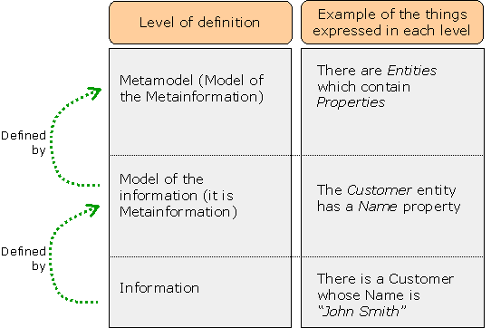

Figure 38. Metamodel, Model and Information levels

The same as every IT system has a Domain Model, even if it is not explicitly defined, also every Domain Model has an associated Metamodel, although it again may not be explicitly stated. Usually Domain Models are defined in terms of things like Entities, Relationships, Attributes, Methods, Cardinality, Tables, Primary Keys, Indexes, and so on, but these concepts are just known and accepted by the participants in the project, or imposed by development tools (e.g. CASE tools) and runtime systems (e.g. databases or programming languages).
Most IT systems do not need to explicitly define this metamodel because they usually just use the information of the system, but not its meta-information, and thus they do not need to strictly model it. However, as explained later, because of its multi-domain and dynamism, eu-DOMAIN needs to process this meta-information at runtime, and not only the information. This meta-information could be used to:
- Find out who implements a given operation of the model
E.g. when a new Content Provider is plugged in, it will start implementing existing operations of the model, and also providing new ones. By querying the meta-information, these new implementations can be found without modifying the code.
- Support the operation of dynamically configured components
While most of the components to be developed for a given domain will be developed by hand (e.g. to handle billing), some of them will have to be flexibily configured by users. For example:
- Rules for Application Intelligence, Workflows and Notification
- Notification templates used by the Notification Manager
And many others not yet implemented. These components, as the rest of them, will access the Domain Model; but they will refer to operations and data that have been specified dynamically by end users, instead of programmatically by developers. E.g. the Notification templates will include dynamic references to data that is defined in the Domain Model, and the consequences of Application Intelligence rules will perform operations defined in the Domain Model. And these references will be configured, not programmed, and thus they must be solved dynamically in some point of time.
- Support the operation of interactive tools to be used by end-users to configure the system
The above-described dynamic components will be configured by end users, which will use for that friendly interactive tools (e.g. “Setup monitoring plan”, “Define approval workflow” or “Edit Notification Template”). In order for these tools to help users to select the Domain Model data and operations to use, and to validate that what the user enters is correct, they will have to analyze the live Domain Model meta-information at runtime.
- Allow to create components, in particular components interfacing with the end-user, that are not limited to a given eu-DOMAIN installation but that can be used in several similar eu-DOMAIN installations
For example, in a typical healthcare IT system the structure and other features of the patient records would be fixed at development time. If some of these features change (e.g. a new data item or a new operation are added to the system), the software must be changed manually.
But by having the Domain Model meta-information at runtime and exploiting it, for example a eu-DOMAIN Patient Record view could adapt itself to many changes in the structure of the Patient Record and still be able to handle it, and it could be used in most healthcare installations of eu-DOMAIN.
- Support automatic generation of code
Of course, this idea of handling meta-information at runtime to improve flexibility is not new. It is not new either the fact that it usually leads to systems that are slower and take up more system resources in general, than the ones that are prefixed in development time.
An option to try to avoid this is to allow for automatic generation of software. The meta-information could be used to automatically generate software code that contains predefined answers to meta-information queries (e.g., who implements some operation or which data items has the Patient Record), thus enhancing performance and easing development, without losing flexibility because when the answers change the code can be regenerated.
In short, the purpose of having all this meta-information at runtime this is to provide the flexibility that eu-DOMAIN needs to allow it to properly adapt both to multiple Domains, and to changes to a given Domain Model.

The complexity of integration with Content Providers
As described previously, eu-DOMAIN will have to interact much with the IT systems of Content Providers, because they will implement a part of the Domain Model operations and will give access to many of its data.
One good thing to have in eu-DOMAIN would be to make it the easiest possible to Content Providers to plug in into the system. This is not only a technical requirement, but also a business one, since the easier it is to interact with eu-DOMAIN, the more Content Providers will do.
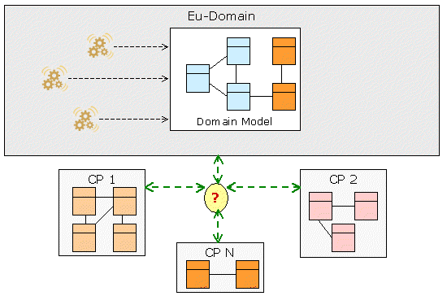

Figure 39. The problem of integrating with CPs

It has been already decided that this interaction will take place using SOAP Web Services (which actually is the only viable option), but beyond this there are still several options for the design the interface.

Using a Domain-based interface or a Metamodel-based one
The first question is whether the SOAP interface used for a given Application Domain will be expressed in terms of the Domain Model (“Model-based Interface”) or in terms of the Metamodel (“Metamodel-based interface”). A Model-based interface would offer many fixed SOAP operations like “GetEmployeeData”, “ListCustomers”, “GetPatientRecord” or “FindPhysician” and handle relatively simple data like “Employee”, “Customer”, “Patient” or “Physician”; i.e. data and operations defined in the Domain Model.
A Metamodel-based SOAP interface would instead offer very few operations, like “RetrieveData” or “UpdateData”, which would handle complex parameters being metamodel expressions, like “Find an object from the schema ‘Employee’ whose ‘Employee.id’ is equal to ‘something’ and retrieve all of its data”. I.e. something like SQL (whose metamodel is the relational model) or XQuery (whose metamodel is XML Schema), but compatible with the actual metamodel used to define the model.
Of course the Model-based interface is much more easier to implement and more similar to the usual SOAP interfaces used in IT systems. However, it is a fixed interface in a given Domain, and there is the question of how well would it adapt to changes in the model – if the interface changes, maybe the interoperability with Content Providers is compromised.
In the other hand, the Metamodel-based interface is independent of the actual Domain Model, and so it would not change when the Model changes; only the messages interchanged through it would. Of course still the interaction peers depend on the content of these messages and anyway the interoperability may be lost (e.g. imagine a SQL query done on a table that has been deleted – it would crash, even though the JDBC or ODBC interface would have not changed), but nonetheless such an interface is more flexible and less prone to syntactic incompatibilities.
As said previously, although the Domain Model will change, it is assumed that the changes will be mainly additions, and no changes or removals. If this is so, the Metamodel-based interface will rarely compromise interoperability. The Model-based one, however, may cause trouble even in this case, depending on how the actual interface is designed (e.g. a new element appearing in an XML document may make it incompatible with a XML Schema definition of it, depending on how it is defined). This kind of versioning problems could lead to a situation similar to the problem usually called “DLL hell”.
Nonetheless, the metamodel interface would make Content Providers much harder to interface to eu-DOMAIN, because:
- Hardly any Content Provider will be able to implement such a Metamodel interface (imagine implementing an SQL or XQuery interface to access a existing IT system composed of SAP, custom apps over Oracle, or whatever – there are commercial products for this)
- The existing tools to create SOAP web services clients and servers will work much better with the concrete operations of the Model interface than with the generic Metamodel interface
So even though the Model interface may cause interoperability problems when the Domain Model changes, it looks like the more appropriate anyway. To try to avoid the interoperability problems, the usual techniques for avoiding “DLL hell” and similar situations will have to be used, e.g. instead of changing elements of the model (data or operations), create new versions of them, with different names, so that both new and old users can continue working. Also, the Metamodel could include mechanisms for easing this problem (e.g. versioning).

Forcing Content Providers to use a fixed interface, or allow them to use any interface
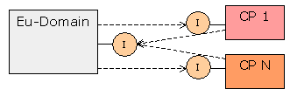
Some of the Content Providers willing to plug in to eu-DOMAIN will have its own SOAP interfaces in place, and most likely they will not be syntactically compatible with the eu-DOMAIN interface for a given Domain. So in order to achieve interoperability there are two main options:
- Force Content Providers to offer an interface 100% compatible with eu-DOMAIN’s, or

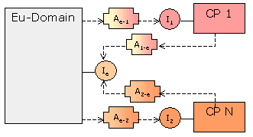
- Create adapters to translate operations between the eu-DOMAIN interface and the CP one

Figure 40. Options to interface with Content

In the option b) there are several sub-options:
- The Content Provider creates the adapters (which makes it more or less like a)
- Eu-DOMAIN creates the adapters by manual programming
- Eu-DOMAIN creates the adapters assisted by automatic tools like semantics
The option b.2) is feasible, but if there are too many Content Providers it may become very difficult to manage. Because of this, the option b.3) can be very helpful.
Actually, none of the options or sub-options are incompatible: some Content Providers can go for the option a), and some other can go for some suboption of b). E.g. small Content Providers that have not a SOAP interface in place (which is a likely case) can choose option a), while for powerful Content Providers the best solution can be b.2) and/or b.3).
Thus, every option and sub-option listed here can happen in eu-DOMAIN. Therefore, eu-DOMAIN should be able to handle all of them, and the way it will do is described in the rest of the document.

Taking advantage of local calls when possible
eu-DOMAIN will have to be able to run on top of a distributed architecture, i.e. in which all of its components can be scattered across a number of different machines. This can be needed to be able to gracefully handle high loads and to achieve high availability.
But it also should be able to run efficiently when every or most of the components are inside the same machine, this meaning that there should not do unnecessary network calls to invoke a component that is available in the same process space.
This is really an important requirement to meet, since the SOAP mechanism that eu-DOMAIN will use for many of the interfaces can already impose severe performance penalties. So it would be better to be able to avoid them when they are not strictly necessary.

Mapping to actual implementations
As explained previously, here the Domain Model is considered only as the meta-information that describes the features (data and operations) available internally to eu-DOMAIN, but not the implementation of these features.
But these implementations will of course exist, either inside eu-DOMAIN (e.g. in some manager) or outside (e.g. in a Content Provider,) and for the system to operate they will have to be called. So it will be needed some mapping mechanism between the Domain Model meta-information and the actual implementations.

Some choices for implementing the Domain Model
Here, options for making a reality the Domain Model while fulfiling the requirements described before are evaluated, and a choice is made among them.
The main decision to be made from which most things depend is how the meta-information comprising the Domain Model will be represented inside the system: which techniques will be used to define, store and handle it.
This means how the features defined by the metamodel will be represented inside eu-DOMAIN; i.e. which precise mechanisms will be used to define the Domain Model. The same metamodel can be implemented in many different ways, but each one of these ways can make easier or harder to creating and update the Domain Model, i.e. of defining which features will offer a given eu-DOMAIN installation.
Also, although in principle all of the possible solutions should allow to represent the full metamodel, in practice some of them can have limitations influencing the features a given Domain Model will be allowed to have, which in turn highly influences the features a given installation of eu-DOMAIN will be able to offer to its users.

Here, the following options for represent the metamodel are considered:
- Use Semantic technologies
- Use Service Oriented Architecture (henceforth SOA) technologies, which as described earlier is the chosen solution
For each one of them it will be shortly discussed how the features to be defined by the metamodel will be represented. These features are not yet fully defined; however, we can be sure that the metamodel will express at least the following:
- The structure of the information, i.e.:
- Which data entities exist,
- Which properties do they have,
- Relationships between them, at least associations and generalizations (inheritance)
- The operations available on this information
- The mapping between the Domain Model features and its actual implementations (e.g. in managers or external Content Providers)
Next, all of these options are described, compared and one of them is chosen.
There are several other options, but that are not really considered here. However, two of them deserve at least to be mentioned:
- Use UML (Unified Modeling Language)
- Use an ad-hoc formalism
And so an small comment on them is included after the discussion of the other two options.

Using Semantic technologies to represent the metamodel
Semantic technologies aim to define things to the computer in some way that it is able to understand a little its semantics. There are several such technologies available, but for eu-DOMAIN the ones considered would be:
- To use OWL (Ontology Web Language) to model the concepts (or entities or classes) of the Domain Model, their structure and their relationships
- To use OWL-S (Ontology for Services) to model the operations of the Domain Model
For an introduction about these technologies, see [Hendler et al, 2002], [Semantic Web], [OWL] and [OWL-S].
Also, OWL is such a general model can be used to define anything, so any other thing the metamodel will need to express could be done so in OWL.
A diagram summarizing the solution in a nutshell would be the following one:
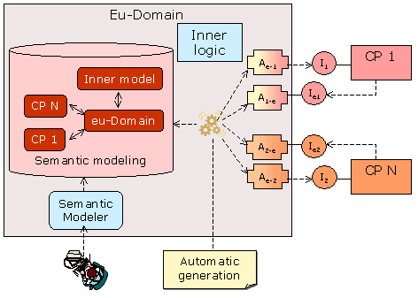

Figure 41. A graphical view of the Semantic Solution

In this solution, besides the “abstract” or conceptual eu-DOMAIN Domain Model, the running components that actually implement its features would be also described with OWL and OWL-S, i.e.:
- The implementation of the Domain Model operations inside eu-DOMAIN (e.g. the Billing Manager)
- The SOAP layers of the external Content Providers
For Content Providers, besides describing the model of each one, also the mapping of the concepts and operations in them to the eu-DOMAIN model would also be described using OWL.
Once all these definitions are in place, then using Semantic Web Services technologies it could be possible to:
- Perform the mapping between the Domain Model and the implementation, e.g. when some operation is just performed by an existing web service; and
- Perform automatic integration between eu-DOMAIN and the external Content Providers
Since the automatic Discovery and Composition possible with Semantic Web Services could solve many integration problems without human intervention.
In order to actually access the Domain Model from the inner eu-DOMAIN software classes, a Domain Model Layer could be automatically generated out of the semantic meta-information. This layer would be a software layer (i.e. Java or .Net classes) that would offer all the features defined in the Domain Model, and whose automatically generated code would just call the proper implementation of the Model. In this way it should be easy and transparent to invoke the Domain Model from inner eu-DOMAIN logic, since it would just be a large library of classes offering every needed feature.
Also, while OWL-S provides grounding only to SOAP web services, there would be several options to make it possible to also create groundings to Java or .Net classes, making thus possible the local call requirement previously mentioned.
Using Semantic Web Services technologies, the integration with external Content Providers would be eased, since they would allow to automatically generate at least a part of the needed integration code. At least, the glue to put together simple interactions involving several services (e.g. “1. Login, 2. Do this, 3. Do that”), and the transcoding or transformation of data could be achieved in an automatic way. For more complex adaptations probably they would fall short and manual programming would be needed to resolve the integration; but nonetheless there would be some percent of the job that would be done automatically.
The Content Providers would not be required to change its SOAP layer, but to define, by using some friendly tool, both the syntactic and the semantics of it; and also its mapping to the eu-DOMAIN model. From then, the adaptation would be, at least, computer assisted. It would be possible to generate adapters both for eu-DOMAIN to connect to Content Providers, and vice versa.
Please note that the use of OWL and OWL-S does not preclude the usage of Service Oriented architectures like XML Schema, WSDL or UDDI: OWL-S just stacks on top of these, and they would be needed at any rate to perform the actual SOAP communication among elements.
Each time some change is made in the model, the software Layer would be regenerated and deployed. This would reduce the flexibility of the solution, but would also provide of high performance operation. At any rate, changes of the model should not be so frequent to discourage this.
This diagram shows all the elements of the solution:
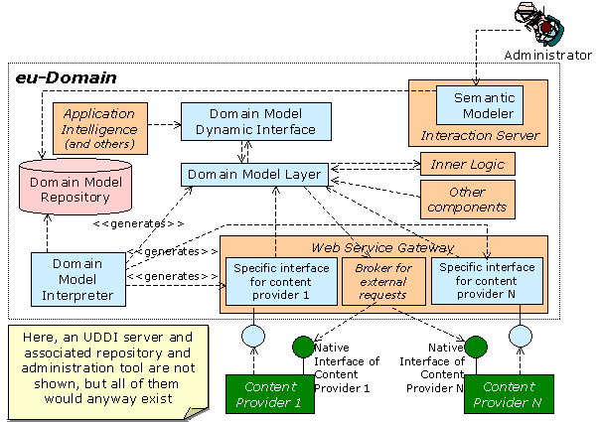

Figure 42. Architecture of the Semantic Solution

A short description of all these elements follows:
- The Domain Model repository stores all the meta-information describing the semantics of:
- The eu-DOMAIN Domain Model
- The Inner Model
- The models of the Content Providers
- The mapping between the Domain Model and all the other models
- The Semantic Modeler would be a web application running inside the Interaction Server and allowing to define and manage all the information in the Domain Model Repository. Its users would be:
- eu-DOMAIN administrators
- Content Provider administrators
- eu-DOMAIN inner model developers
- The Domain Model Layer would be a set of of software classes, automatically generated by the Domain Model Interpreter, running inside eu-DOMAIN and providing all other components of the architecture access to all the Domain Model features.
There would be both a Java and a .Net version of the layer, to be accessed by other components developed in either language
- The Web Service Gateway (or Server) would provide connectivity to external Web Services, through the “Broker for external requests” shown here
- The Inner Model is the manual implementation of functions to be performed inside eu-DOMAIN, available as Java or .Net classes, or as web services. The Domain Model Layer will invoke them to implement the Domain Layer features they are programmed to perform. And, as the rest of components, the Inner Model invokes the Domain Model Layer to perform any Domain Model operation.
- The various Specific interface for content providers would allow Content Providers to connect to eu-DOMAIN by providing them interfaces compatible with the own model of each Content Provider
- The Domain Model Interpreter processes the semantics stored in the repository and automatically generates:
- The Domain Layer (both Java and .Net versions)
- The specific interface for each content provider to connect to eu-DOMAIN
- All the Other Components of eu-DOMAIN would call the Domain Model Layer. Java [.Net] components will call the Java [.Net] Domain Model Layer. Some components would call the Domain Model Dynamic Interface instead of directly the layer.
- The Domain Model Dynamic Interface exists because some components, like the Application Intelligence or the Notification Manager, may have to process invocations made to the Domain Model that are stored as strings or as XML.
The Domain Model Dynamic Interface would take these invocations as strings and will translate into operations performed against the actual Java or .NET classes of the Domain Model Layer.
This component would have to offer both a local and a Web Services interface, in order to be called from modules developed in other languages. This will allow e.g. the .Net Domain Layer to invoke operations in the Inner Model that are implemented as Java classes.
However, maybe in the end there would have to be also duplicated implementations of this module in .Net and Java

And the following diagram shows an example of its interaction to solve a typical billing scenario:
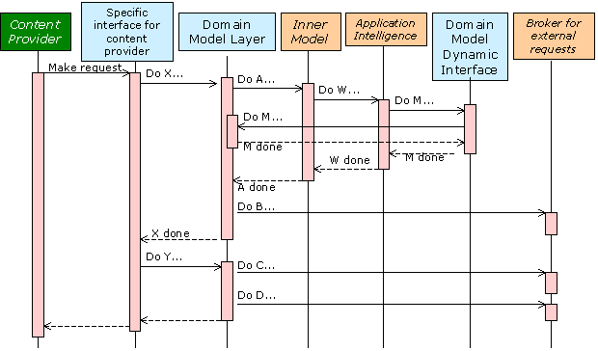

Figure 43. Example of the Semantic Solution dynamics

Using Service Oriented Architecture standards to represent the metamodel
Service Oriented Architecture is an approach to implement IT systems in which the basic element of the system is a service, which in turn is a software component offering some operations to the rest of the system.
Strictly, this concept is not bound to SOAP Web Services, since those services can be implemented by other means than SOAP. But in practice in most cases where it is used, it is meant to be so. In this document, we also when we talk about Service Oriented Architecture (SOA) we are meaning SOAP Web Services.
In this solution, the metamodel for defining the Domain Model would be represented by using several SOA formalisms like:
- The information structure of the Domain Model is modelled in XML Schema (see [XML Schema] and [XML Schema 1.0 primer]).
- Every operation of the Domain Model is modelled as a Web Service
- It has an associated WSDL document (see [WSDL 1.1] and [WS-I Basic Profile 1.1])
- It is catalogued in at least one UDDI taxonomy (see [UDDI])
- The mapping of every operation of the Domain Model to its implementations is made by a UDDI server, who returns the WSDL of the implementation

To call a Domain Model operation, first it must be found who implements it by querying the mapping in the UDDI server. Then, the implementation can be one of:
- Manually created logic (e.g. a manager implemented in C#)
- A Content Provider WS
- Semantic integration of other WSs (e.g. providing adaptation of Content Provider services)
So, the UDDI server is the central part of the architecture. Through UDDI v3 it could be integrated with other UDDI servers from Content Providers. SOA and UDDI are designed for a multi-organization environment like eu-DOMAIN’s, so they help to manage different implementations of the same operation for different organizations. E.g. every UDDI entry is associated to an organization.
Note that this solution does not solve the problem of the complex integration with many different Content Providers, but neither does it preclude the usage of Semantic Web Services for performing it – SOA just makes Semantics one more option among others.
No further details about this solution are given here, since it is described in detail in section 4. But here, the election of SOA is justified.

Conclusions and choice of a solution

The commons of both Semantics and SOA solutions
First, please note that both solutions actually have many things in common:
- Both make use of the same technologies:
- XML Schema, WSDL and UDDI are needed anyway since SOAP web services was already chosen both as internal and external communication mechanism
- OWL and OWL-S are needed if Semantic, automatic integration is needed, and it is in both solutions
- Both use redundant models for describing the same information:
- WSDL and XSchema when using Web Services and its associated data, and
- OWL, OWL-S when semantics are needed (OWL-S is built on top of WSDL and XML Schema)
- Both require in principle for every operation to be modelled as a Web Service (although in the SOA solution this will not be so strict, as described later in the description of the Domain Model Interpreter)

The differences between the Semantics and SOA solutions
The main difference among them is not the elements they include, but how they use them. In the Semantics approach, OWL and OWL-S are central to the solution and XML Schema, WSDL and UDDI are secondary, being just an option to invoke existing implementations.
In the SOA approach, they are XML Schema, WSDL, UDDI and others the ones that are central, and OWL and OWL-S are just one among several ways to implement the Domain Model. They are not even required.
The Semantics solution depends fully in the existing (yet recent) standard OWL, and in the not yet standard OWL-S. It does not formally depend on XML Schema, WSDL or UDDI, but in practice they are the only viable ways to communicate in eu-DOMAIN.
The SOA solution depends on XML Schema, WSDL, UDDI and several other industry standards, but not on OWL and OWL-S.
The Semantic solution is more homogeneous and elegant, since everything is OWL (even OWL-S is). However, this is not the real way the IT landscape is, but it is much more like in the SOA solution. The SOA solution is more realistic and better aligned with the current industry trends.
In the SOA solution, besides XML Schema, WSDL and UDDI, several other mechanisms will be needed to represent the definitions of the metamodel. For example, XML Schema has not a good way to represent associations between data entities; for this, some ad-hoc means will be used if no feasible standard is found. Also, other mechanisms like WS-Profile could be used to represent general meta-information about both the requirements and features of a web service.

The choice of SOA
The SOA solution has been chosen. It is viewed as a solution that uses more mature technologies (or at least more established) than the Semantics one, with more support and with less uncertainties, while not precluding the usage of Semantic technologies – any of the web services inside eu-DOMAIN could be implemented using Semantic technologies, if appropriate.
The actual outcome of the Semantics solution is not clear. A couple of experiments on Semantic Web Services integration have been made prior to the choice, and although some promising results have been achieved, it seems clear that most real world integrations will anyway need of manual intervention. The key point is the percent of effort that semantics solve (e.g. if it is 60%, then it is great; if it is only 20%, it probably is not worth it), and this percent can not be determined until a full implementation is tested in real world scenarios.
If eu-DOMAIN would be a Semantics-centred project, then one of its goals would be precisely to clear this uncertainty; however, its focus is mobile Ambient Intelligence, and integration is not one of its goals, but just a need in order for the rest of the system to be able to work.
Besides, the Semantics solution would need of a considerable development effort right now at the start of the project, an effort that was not accounted for in the original planning, and with SOA it can be left for later, when the main infrastructure is working and more attention can be put in complex integration with Content Providers.
The SOA solution does not rely in a single, homogeneous meta-information mechanism (like would be OWL), but as said above this is the way the world is. The focus of the SOA solution is not in modelling an abstract, idealistic model that has no close relationship to the actual implementation; it is more appropriate to say that its main approach is to describe the actual machinery of the system in order to better manage it. This may have the disadvantage of some things being more cluttered (although this depends much on the tools used); but the main advantage of being sure to deal with the real thing and not with a nice, but maybe fake, façade.

Why not UML?
One obvious choice for modelling the Domain Model would be using UML. There are many factors supporting this choice:
- It is the standard for modelling in Information Technologies
- Most IT systems already use UML for its models
- There are a wide range of tools supporting it, which could be used in eu-DOMAIN
- There is large expertise on it in the IT community, and it is also quite understandable by not technical users
- There is a processable XML representation of it (XMI)
- Things like Model-Driven architecture (MDA) are very trendy

However, there are also other factors because of which XML (SOA) has been deemed a better choice here:
- The actual implementation of eu-DOMAIN is to be based in SOA standards (XML web services and so on), so a XML modelling is much more closer to it
- The own complexity of UML / XMI, and the fact that additional mapping between UML and XML would be needed, could make the implementation of a UML model more complex
- The goal of eu-DOMAIN is not to build the best possible Domain Model, but to create an Ambient Intelligence service platform – i.e. the Domain Model is just a means in eu-DOMAIN, not a goal
Because of this, using a XML modelling should be both less costly to implement and easier to manage than using an UML modelling; although probably using UML the resulting models would be easier to understand and more elegant.
However, would the goal of eu-DOMAIN have been to create a Domain Modelling tool for IT systems, UML would have been the best choice.

Why not using an ad-hoc formalism?
This option is expressed just out of completeness, but it is not really considered as a valid one. By “ad-hoc formalism” we mean to define the metamodel and implement it just as any IT model, using a database schema that perfectly represents every aspect defined in the metamodel. This would have the main advantage in that the representation of the metamodel would be a perfect fit of this metamodel, not more, not less; something that none of the other approaches have.
However, the benefits stop here. The issue of mapping the metamodel to the actual machinery of the system (i.e. Web Services) is not solved by this approach, and the same as in the Semantics or the UML solution it has to be dealt with. And, unlike the Semantics or the UML options, the ad-hoc approach could not benefit from any work performed outside eu-DOMAIN.
In general we can say that, given the large number of existing meta-information solutions, there is not much point in creating yet another new.

Dynamics of the Domain Model SOA solution
Here it is shown how the elements of the SOA solution would behave in two scenarios that eu-DOMAIN should be able to solve. For each scenario, first it is described, and then the behaviour of eu-DOMAIN will be shown.

A Billing scenario
Billing is something not much appealing or related to Ambient Intelligence; but it should not be forgotten that eu-DOMAIN should anyway be able to handle it.

The scenario
The proposed scenario is related to the billing functions of eu-DOMAIN, and it has been extracted for the larger ESN scenario, although here it has been supposed that Grundfos is not the Service Operator, but just one more Content Provider. Its actors are the following ones:
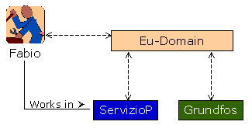

Figure 44. Billing scenario for describing the dynamics

Both ServizioP (Servizio Provinzia) and Grundfos are Content Providers, and Fabio is a technician working in Servizio Provinzia.
The scenario consists in that Grundfos requests eu-DOMAIN to bill Servizio Provinzia for services previously provided to Fabio from Servizio Provinzia, consisting in technical support for solving some problem Fabio had with a pump. Now, eu-DOMAIN cannot bill a Content Provider just because other one says so, so the bill must be approved by the right person at Servizio Provinzia.
So the expected behaviour of these elements is as follows:
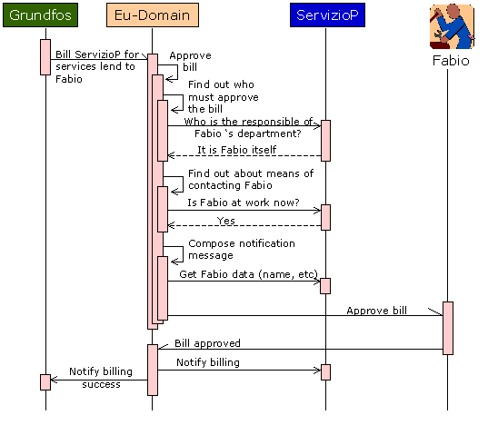

Figure 45. Billing scenario: Expected behaviour of the elements

Involved eu-DOMAIN elements
Entering in the internals of the “eu-DOMAIN” box, the elements inside it that would take part in the interaction will be the following ones:
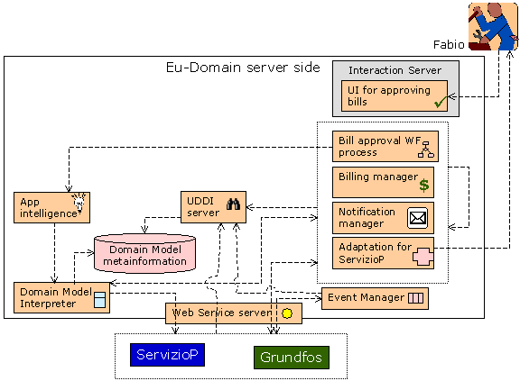

Figure 46. Billing scenario: Elements intervening in the implementation

These elements are as follows:
- ServizioP and Grundfos are the SOAP layers offered by those Content Providers
- The UDDI server is as described before in this document
- The Billing Manager will implement the needs of eu-DOMAIN related to handling bills. Thus it will implement the part of the Domain Model related to billing.
- The Notification Manager performs notification to end-users, thus implementing the part of the Domain Model related to notifications
- The Bill approval WF process will be some workflow running inside the Workflow Manager, and that perform the task of approving some bill. This workflow would have been configured previously, using some end-user tool, by some Servizio Provinzia administrator.
- Some of the decisions of the Workflow process will be taken by evaluating some rules, and it will be the Application Intelligence the one that will perform this evaluation.
- The Domain Model Interpreter will allow both the Application Intelligence and the Notification Manager to access dynamically the Domain Model, as described previously
- The Adaptation for Servizio Provinzia will be some module implementing the needed adaptation between the models of eu-DOMAIN and Servizio Provinzia, which in this scenario are not 100% compatible. Thus it exposes some web services implementing the Domain Model features that eu-DOMAIN expects from Servizio Provinzia, and also other web services implementing the features that Servizio Provinzia expects from eu-DOMAIN.
How this component has been developed (e.g. by hand or by semantic technologies) is not discussed in this scenario.
- The UI for approving bills would be an end-user tool allowing end users to approve the payment of some bill. It will provide just the user interface and some flow controlling, since the actual billing logic will be defined in the Domain Model and implemented by the Billing Manager.

The Content Provider SOAP layers
As it has already been said, it is supposed that the Servizio Provinzia SOAP layer is not 100% compatible with the eu-DOMAIN Domain Model, and thus it needs of some adaptation performed by the Adaptation for Servizio Provinzia component described before.
For Grundfos, it is assumed that its SOAP layer is indeed 100% compatible with the eu-DOMAIN Domain Model, and thus direct bidirectional communication between the eu-DOMAIN components and this SOAP layer is possible.

Workflow rules
As previously said, the Bill Approval Workflow will use some rules to make some decisions during the Approval process. Here it is assumed that these rules will be as follows:
- To decide which person must approve the bill, the following rules have been defined by some Servizio Provinzia administrator:
- If $bill/totalAmount < X then the approval must be done by the $bill/solicitor
- If $bill/totalAmount between (X, Y) then the approval must be done by getDepartmentOf( $bill/solicitor, $bill/solicitorActingAs)/responsible
These rules are expressed here in a sort of pseudo-expression language, and it is supposed to mean the following:
- $bill/totalAmount is be the total amount being billed, which is a datum that has been provided by the one that request the billing (i.e. Grundfos.)
- $bill/solicitor is the person who originally requested the services being billed (i.e. Fabio.) It is a datum that has been provided by the one that request the billing (i.e. Grundfos.)
- getDepartmentOf(Person,Role) is some operation available in eu-DOMAIN that, given a Person and a Role, returns the Department of this person in which he or she performs the role. It is assumed that there is only one such department.
- $bill/solicitorActingAs is the role of the person who requested the services billed, and it is a datum provided by the one that request the billing (i.e. Grundfos.)
- Department/responsible is the Person that is responsible of a given Department.
All the items in italics are elements defined in the Domain Model. “$bill” is a variable representing some concrete object (instance) of some Bill class (or entity) defined in the Domain Model, and represents the concrete Bill that Grundfos submitted to eu-DOMAIN for its processing and for which the approver is being sought.
Probably, such a syntax will be needed to represent rules and other things in eu-DOMAIN. The part of the rules that is related with the Domain Model will be handled by the Domain Model Interpreter. For it, a XPath-like syntax has been deliberately chosen here, since the Domain Model will be defined using XML Schema, but this is pending to be further defined.
- To decide which is the channel to use to notify a given Person about that he or she must approve some Bill, there are the following rules:
- If not isWorking($person,now) then notify by SMS
- If isWorking($person,now) then notify by email
now means the current date and time, and isWorking(Person,Time) is another Domain Model operation telling whether a given Person is working at a given Time.

The email template to notify Servizio Provinzia people about notifying bills
The Notification Manager will have to send some message to Fabio to approve the bill, and for composing the text of this message some template will have to have been configured in the system by some Servizio Provinzia administrator, using some end-user tool accessed through the Interaction Server. This template could be something like this:
“Dear ${$person/Treatment } ${$person/Name},
eu-DOMAIN kindly requests you to approve the bill issued on date ${$bill/date} by ${$bill/issuer/name} amounting to ${$bill/totalAmount} and in due pay to the following services:
${For every service in $bill/Service}
…
${End-For}
…”
The syntax shown here is not normative, it is pending to be designed. As before, the italics terms are elements of the eu-DOMAIN Domain Model. “$person” is supposed to be the object (instance) representing the Person to be notified, and “$bill” the object representing the Bill the person must approve.

The behaviour of the SOA solution to solve this scenario
Once the scenario has been defined, now the interaction among the elements in order to perform the expected behaviour previously explained will be described. Since it is a long interaction it will be split into several sequence diagrams, of which the following is the first one:
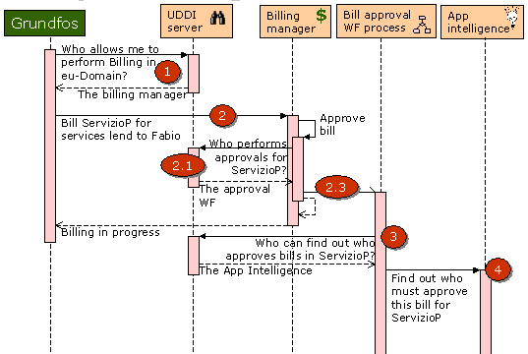

Figure 47. Billing scenario: Grundfos requests a billing

- Grundfos queries the UDDI server for the implementation of the ProcessBill operation of the Domain Model inside eu-DOMAIN
  - The UDDI server returns some service inside the Billing Manager
- Grundfos requests the Billing Manager to process the bill
  - The Billing Manager knows (e.g. because it has been programmed manually) that the bill must be approved first, and it queries the UDDI server about who performs bill approvals for Servizio Provinzia
  - The UDDI server replies with some service inside the Bill Approval WF Process component
  - The Billing Manager asynchronously requests the Bill Approval WF Process to perform the approbal for the bill
  - Since the request was asynchronous, the Billing Manager regains control and responds Grundfos that the billing is in progress
- In parallel, the Bill Approval WF Process starts. It knows (e.g. it is configured) that it must first request some person to approve the bill, and for this it must first find out who is this person. It thus queries the UDDI server about who can find out about this approver for Servizio Provinzia
  - The UDDI server replies with some service inside the Application Intelligence
- The Bill Approval WF Process requests the Application Intelligence to find out who approves this bill
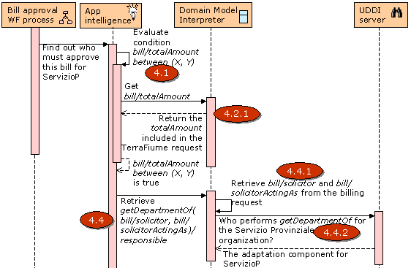

Figure 48. Billing scenario: Approving the bill

  - The Application Intelligence evaluates the rules associated with bill approval in Servizio Provinzia. Eventually it will have to evaluate whether bill/totalAmount is between (X, Y), for which it will have to obtain the bill/totalAmount.
  - So it requests this to the Domain Model Interpreter.
    - The Domain Model Interpreter finds out that the bill already contains the totalAmount, so it just extracts it from the bill and returns it to the Application Intelligence
  - The Application Intelligence determines that bill/totalAmount is indeed between (X, Y), so that the rule will have to be executed
  - The rule consequence specifies that the getDepartmentOf( bill/solicitor, bill/ solicitorActingAs)/ responsible must be retrieved, and so it request it to the Domain Model Interpreter
    - The Domain Model Interpreter starts by retrieving bill/solicitor and bill/solicitorActingAs out of the explicit bill data
    - For resolving getDepartmentOf it must invoke the Domain Model, so first the UDDI server is queried about who performs this operation for Servizio Provinzia
      - The UDDI server replies with a service implemented inside the Servizio Provinzia adapter
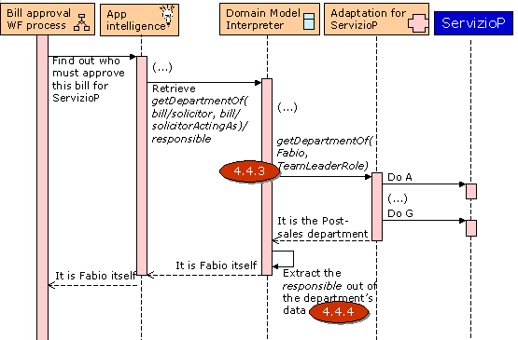

Figure 49. Billing scenario: Finding out the approver

    - The Domain Model Interpreter requests the Servizio Provinzia adapter to perform getDepartmentOf() on the previously found data
      - The Servizio Provinzia adapter executes whatever operations are needed to perform getDepartmentOf(), and in the end it replies with the data about the post-sales department
    - The Domain Model Interpreter must now find the responsible of the post-sales department, and it happens to be that this datum is already contained in this response. The responsible is Fabio itself, and so it returns this value to the Application Intelligence
  - Which in turn returns it to the Bill Approval WF Process
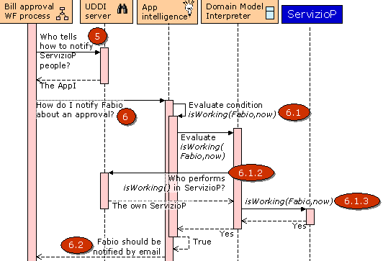

Figure 50. Billing scenario: Finding out how to notify Fabio

- Once the Bill Approval WF Process knows that it must notify Fabio, it must find out through which channel it must be notified, so it asks the UDDI server about who can know about this.
  - The UDDI server replies with some service inside the Application Intelligence
- The Bill Approval WF Process asks the Application Intelligence to find out how to notify Fabio about the approval of the bill
  - The Application Intelligence evaluates the rules and it finds out that it must resolve isWorking(Fabio,now)
    - It asks so to the Domain Model Interpreter
    - The Domain Model Interpreter asks the UDDI server about who performs the isWorking() operation in Servizio Provinzia
      - The UDDI server replies with a service inside the own Servizio Provinzia
    - The Domain Model Interpreter asks Servizio Provinzia to perform isWorking(Fabio, now)
      - Servizio Provinzia replies that Fabio is working
    - The Domain Model Interpreter tells so to the Application Intelligence
  - From which the Application Intelligence is able to determine that Fabio must be contacted by email, and it replies so to the Bill Approval WF Process
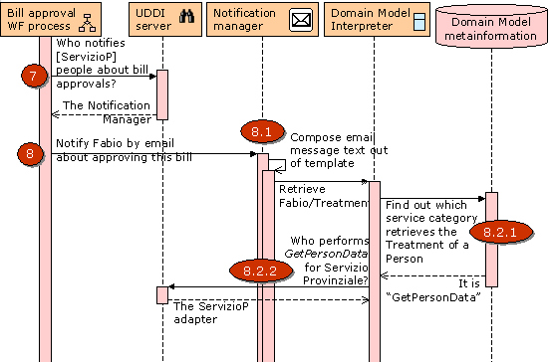

Figure 51. Billing scenario: Notifying Fabio

- The Bill Approval WF Process now asks the UDDI server about who can notify Servizio Provinzia about bill approvals, and
  - The UDDI server replies that it is the Notification Manager, so
- The Bill Approval WF Process requests the Notification Manager to notify Fabio about the bill by email
  - The Notification Manager first has to compose the text of the message out of the configured template
  - For this, it asks the Domain Model Interpreter to retrieve Fabio/treatment
    - The Domain Model Interpreter is not able to find the treatment of Fabio, and then, out of the Domain Model Meta-information, it learns that treatment is not a defined operation but just a simple data item. Thus, it must find which service is able to return this information, as described previously, and then it learns that it is GetPersonData
    - The Domain Model Interpreter asks the UDDI server about who performs GetPersonData for Servizio Provinzia
      - The UDDI server replies with a service from the Servizio Provinzia adapter
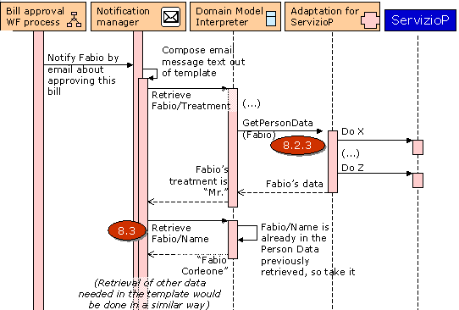

Figure 52. Billing scenario: Composing the notification message

    - The Domain Model Interpreter asks the Servizio Provinzia adapter to perform the GetPersonData for Fabio
      - The Servizio Provinzia adapter executes whatever operations are needed to perform that operatiopn, and in the end it replies with the data about Fabio
    - From the Fabio personal data, the Domain Model Interpreter extracts the treatment and returns it to the Notification Manager
  - The Notification Manager now asks the Domain Model Interpreter for the Fabio/Name
    - The Notification Manager finds the Name of Fabio in the personal data previously obtained, and extracts it from there
(The rest of the data needed by the Notification Manager would be obtained in a similar way)
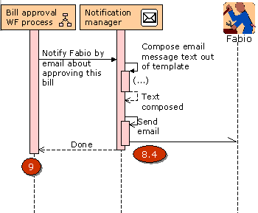

Figure 53. Billing scenario: Sending the email to Fabio

  - Once the Notification Manager has composed the whole text, it sends the email to Fabio and ends
- The Bill Approval WF Process is left waiting for the approval of Fabio
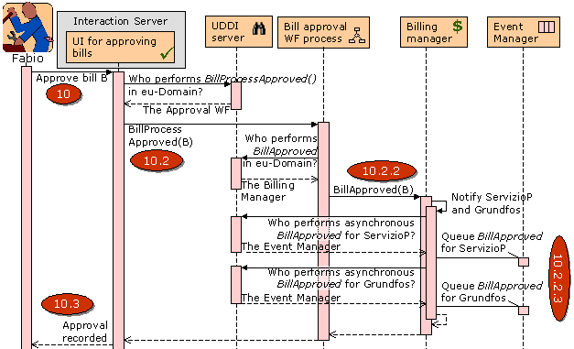

Figure 54. Billing scenario: Fabio approves the bill

- Eventually, Fabio receives the email, reads it and decides to approve the bill, what does by using the corresponding end-user function
  - The logic of the UI for approving bills queries the UDDI server about who performs the BillProcessApproved function
    - The UDDI server replies with some service implemented by the Bill Approval WF Process
  - The UI for approving bills tells the Bill Approval WF Process to perform BillProcessApproved
    - Once the bill has been approval, the Bill Approval WF Process knows that it must execute the BillApproved function and finish the workflow, and so it asks the UDDI server about who implements it
      - The UDDI server replies with some service implemented by Billing manager
    - The Bill Approval WF Process tells the Billing Manager BillApproved
      - The Billing manager knows that, once the bill is approved, it must notify both Content Providers
      - So it asks the UDDI server about who implements the BillApproved function in each one of them, but in an asynchronous way since it is not expecting any reply from them
      - And then it queues the requests for both Content Providers for asynchronous execution. The handling of this queuing is done by the Event Manager, as described before in section 4.
      - Once the notification requests are queued, the Billing manager returns
  - Fabio receives a confirmation about that its approval has been recorded
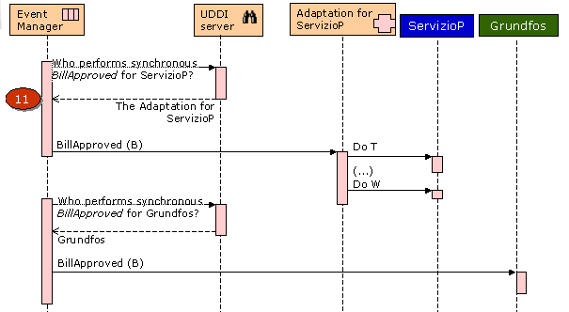

Figure 55. Billing scenario: Notifying Content Providers about the approval

- Eventually, the Event Manager will process the queued requests and will invoke the remote services.

And this is the end of the sequence.

Monitoring scenario
This sub-scenario is taken out from the “Patients as Customers” scenario: Dr. Hayworth sets up a monitoring schema on Tahira (its patient) blood pressure, to alert him if her mean blood pressure is outside preset limits for more than three consecutive days.
The realization of this scenario focuses in showing different parts of eu-DOMAIN, and so it has some different structure.

The scenario
The elements involved in the scenario are the following ones:
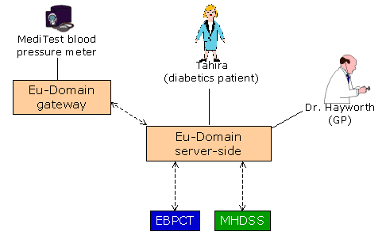

Figure 56. Monitoring scenario

- Tahira is the patient that suffers from diabetics
- Dr. Hayworth is its General Practicioner physician
- The Meditest blood pressure meter is a device in Tahira’s house that she uses to monitor its blood pressure
- The Eu-DOMAIN gateway is the gateway to which the pressure meter is connected, e.g. in Tahira’s house
- The EBPCT is the East Birmingham Primary Care Trust, which is a health care organization that uses eu-DOMAIN to provide health care services
- The MHDSS is the Muslim Health Diabetes Support Service, another health care organization to which EBPCT outsources some health care services

Tahira’s health is mainly treated by EBPCT, but some services are also performed by the MHDSS. In this document it has been assumed that the Patient Record of Tahira is not centralized inside eu-DOMAIN, but that the current IT systems of both EBPCT and MHDSS are used to store and manage it. This is, the Patient Record is split between the two organizations. For example, when Tahira visited the MHDSS, its blood pressure was taken and uploaded to the Patient Record inside MHDSS; but other measures are in the Patient Record managed by EBPCT.
Here it has been assumed that both EBPCT and MHDSS SOAP layers are 100% compatible with the eu-DOMAIN Domain Model. This would be not so at all in a real world scenario; however, it would be solved by using adapters like the one shown in the billing scenario before, and since the point should be already made this has not been shown here.

Expected behaviour
The behaviour that eu-DOMAIN must show to outside eyes can be described as follows:
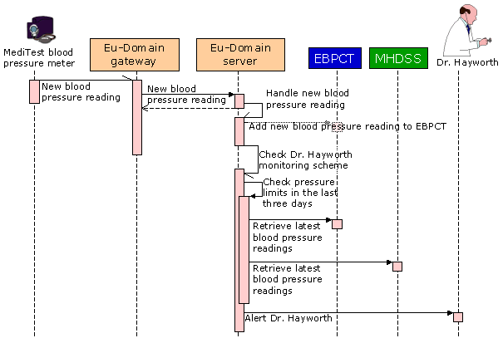

Figure 57. Monitoring scenario: expected behaviour
This is:
- The measures taken by the pressure meter must go to the gateway and from there to the server
- The measures must be sent to EBPCT for its storage in Tahira’s Patient Record, since it is her primary health care centre
- For checking Dr. Hayworth’s monitoring scheme, the blood pressure values of the last three days must be retrieved from the EBPCT and/or the MHDSS
- If they do not fulfilfulfil the conditions established by Dr. Hayworth, he must be alerted

A possible Domain Model for the scenario
The model for the Domain of this experiment could be something like this:
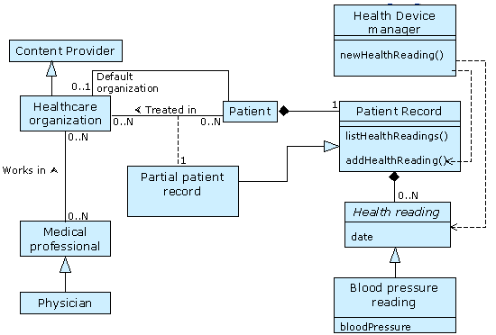

Figure 58. Monitoring scenario: Domain Model

Its elements are as follows:
- The Health Device manager offers an interface for health devices to report its measures. Since devices and its software (bundles) should be usable without any change across different implementations of eu-DOMAIN in the Health domains, this interface should not change across them, and this is why devices do not talk directly with the Patient Record.
Following the SOA solution, newHealthReading() would be a web service allowing a device to report a new health measure, and some component inside the eu-DOMAIN server side would have to implement.
- The Patient Record manages the Health Record of the patients. In this simple scenario it contains just a collection of Health readings, each one of which can be a Blood pressure reading. The Patient Record allows to listHealthReadings() and to addHealthReading(), which again would be web services that some server-side component would have to implement.
- Here it has been assumed that a Patient can be associated to more than one Healthcare organizations, and that in each one of them there is a Partial Patient Record, which is a piece of the full Patient Record. Also, each Patient has a Default healthcare organization, that will be the one to which eu-DOMAIN sends new Health readings received.
This is the part of the Domain Model most related to the Health care domain, but also other more common elements will be needed in the Model:
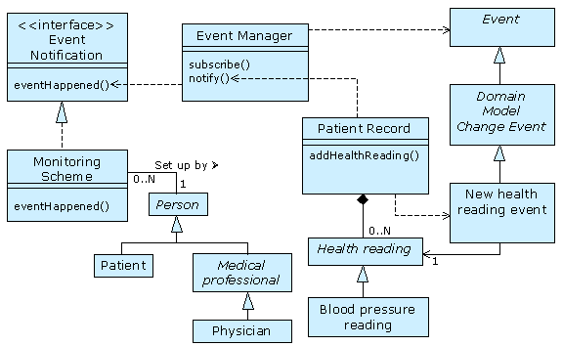

Figure 59. Monitoring scenario: some elements of the Common Model

These elements are as follows:
- The Event Manager offers publish/subscribe capabilities, thus allowing other components to subscribe to events and being notified when they happen, through the operations defined in the Event Notification interface. For this, there is a Event class defined, of which the New health reading event is a specific type of event.
- The Monitoring Scheme subscribes to such New Health reading events in order to perform its duties
Again, all operations shown here (Event Manager.subscribe(), Monitoring Scheme. eventHappened() ) would be web services, to be implemented by some manager.
An interesting note to make is that the model is here defined using UML, not SOA formalisms. The reason is that at least for sketching diagrams to communicate among technical people, UML is the best means currently available. Nonetheless, for precisely defining the existing infrastructure of a live system, SOA formalisms can be better, or at least simpler to implement, as discussed earlier in this document.

Involved eu-DOMAIN elements
Here we focus in the eu-DOMAIN server-side, where at least currently the Domain Model concept most applies, and do not show the details of how this scenario would be handled in the gateway. Thus, the elements that would allow for this scenario to become a reality would be the following ones:
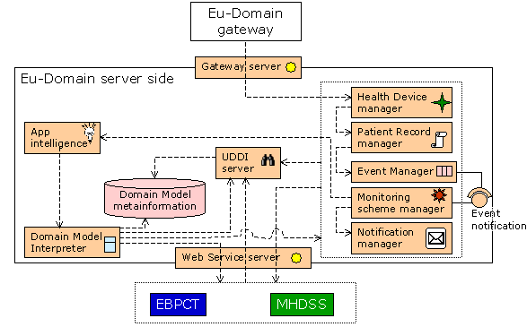

Figure 60. Monitoring scenario: Intervening elements

A short description of them follows:
- The Health Device Manager would implement the Domain Model features defined for the Health Device Manager class; i.e. it would implement the server-side capabilities allowing health devices to report measurements, and other needs they can have. Thus, here it will mainly implement the newHealthReading() web service.
An interesing way of seeing this component is as an adaptor between the interface the Health Devices expect, and the actual interface the particular Domain Model of eu-DOMAIN instance. I.e. just the same as the adaptor of Content Providers seen in the billing scenario.
- The Patient Record Manager would implement the features of the Patient Record class of the Domain Model in the eu-DOMAIN organization, namely the addHealthReading() and listHealthReadings() web services.
- EBPCT and MHDSS are the SOAP layers of the corresponding health care organizations. They are supposed to implement at least the addHealthReading() and listHealthReadings() web services for each organization.
As pointed out earlier, here it is assumed that both offer a 100% compatible interface just for the sake of simplicity, because the way the SOA solution solves adaptation of non-compatible interfaces was shown before in the billing scenario, and to some extent also here with the Health Device Manager.
- The Monitoring Scheme Manager would implement the features related to monitoring schemas in eu-DOMAIN. In this scenario, this means it is able to subscribe to New health reading events in the Event Manager, and process these events when they happen, for which it implements the Notification interface; i.e. the eventHappened() web service.
Note that there would be many components implementing such web service, which in principle is not a problem for the UDDI server to manage. For the Event Manager to find the proper web service to be called when some event happens, mechanisms like plain URLs or UDDI unique identifiers can be used.

The rest of the components have been described before in this document.

The behaviour of the SOA solution to solve this scenario
As in the previous billing scenario, the whole sequence has been split into several stages in order to be able to show it fully. Also, as already pointed out, the interactions inside the eu-DOMAIN Gateway are not shown here:
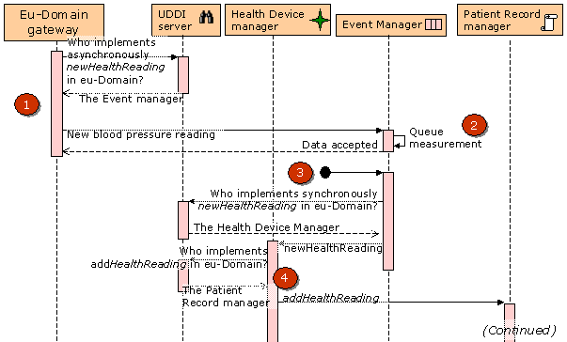

Figure 61. Monitoring scenario: A new blood pressure is reported
- The eu-DOMAIN gateway reports the new blood pressure measurement to the server. It does so by calling the newHealthReading operation, according to the Health Device interface.
- The new measure is queued inside the Event Manager, in order to free the gateway of being in hold until the whole processing of the new measurement has been completed. So the response to the gateway is not “data processed”, but “data accepted”.
- Eventually and according to its policies for queue management (e.g. it can be immediately, or after some time), the Event Manager will forward the processing of newHealthReading to the actual logic implementing it, who is inside the Health Device Manager.
- The Health Device Manager knows how to handle new health measures received from devices, which in this particular eu-DOMAIN installation and for that particular measure received means that it must be added to the Electronic Patient Record of Tahira. In this case, this means he must invoke the addHealthReading operation, and it is registered in the Domain Model that it is the Patient Record Manager who implements it.
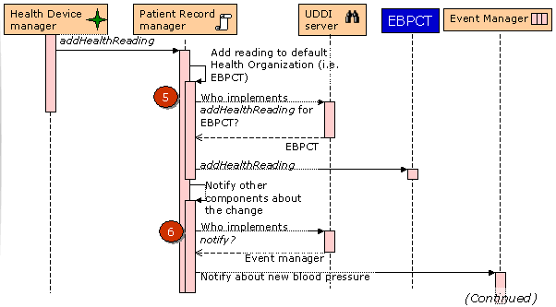

Figure 62. Monitoring scenario: The new measure is added to the EPR

- The Patient Record Manager knows that for registering this measure it must be sent to one of the Health Organizations Tahira is related to, and in particular to the default one, that happens to be EPBCT . So, addHealthReading is called, now inside EBPCT.
- After having updated the EBPCT patient record, the Patient Record Manager knows that it must generate a notification about this fact, just in case other components are interested on it. So it creates a proper Event document informing about the new measure, and contacts the notification interface of the Event Manager.
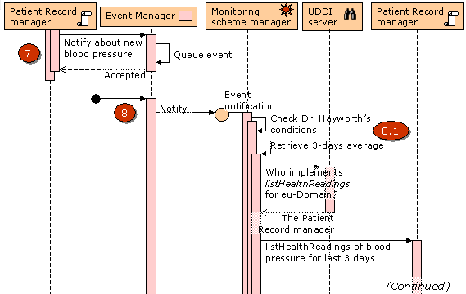

Figure 63. Monitoring scenario: Checking the Monitoring Scheme

- The Patient Record Manager notifies the Event Manager about the new blood pressure event. The Event Manager queues this event and frees the Patient Record Manager of being waiting until the event has been fully processed.
- Eventually (again, the timing depends on queuing policies), the Event Manager reviews the event queue and processes this new Event and looks for the components that are subscribed to it. Of course there may be more than one, so it invokes the Event Notification interface on each one of them, waiting until the processing of the event is complete. In this case, the Monitoring Scheme Manager was subscribed to this particular event and thus its eventHappened() web service gets invoked.
  - The Monitoring Scheme Manager retrieves Dr. Hayworth’s schema conditions and starts analyzing them, for which it (or maybe more properly the Application Intelligence and the Domain Model Interpreter) will have to obtain the average blood pressure of Tahira during the last three days. In the end, this leads to invoking the listHealthReadings() operation, which for eu-DOMAIN is assigned to the Patient Record Manager.
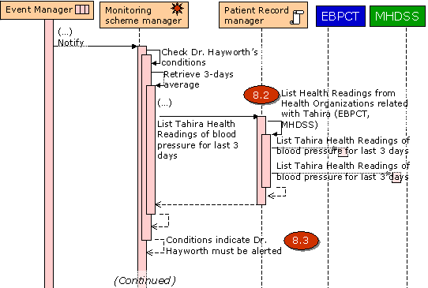

Figure 64. Monitoring scenario: Consulting latest blood pressures

  - The implementation of the listHealthReadings() operation of the Patient Record Manager knows that blood pressure readings can be stored in any of the Health Care Organizations to which Tahira has a recent relationship, and so it finds out whose are these organizations and invokes the listHealthReadings() operation in each one of them, merging the results and returning them.
  - Once the Monitoring Scheme Manager knows about the recent measures, it can determine that indeed the Dr. Hayworth’s monitoring scheme specifies that he must be alerted.
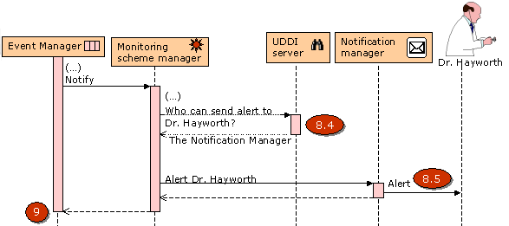

Figure 65. Monitoring scenario: Notifying Dr. Hayworth

  - The Monitoring Scheme Manager inquiries about who can do this alerting. It turns out to be the Notification Manager.
  - The Notification Manager would act much like in the previous billing scenario, so this is not repeated here. Suffice to say that the most appropriate notification mechanism is decided upon, and the template corresponding to the event type and the mechanism is found and processed. Then, the data needed to fulfil the template is retrieved via the Domain Model Interpreter and the Domain Model, and in the end in the end Dr. Hayworth is notified with the resulting message.
- After the notification is complete, the Monitoring Scheme Manager ends the processing of the event and yields control to the Event Manager, who can clear the queue for this event and subscriber.
And this is the end of the sequence.

More details about some of the components of the architecture
The work done for describing some of the components goes beyond what is needed in an Architectural Design, and starts entering the realm of the Detailed Design of the component. Nonetheless it is useful work, and so it is included also here.

The Event Manager
The Event Manager provides Publish/Subscribe and Store-And-Forward mechanisms to queue and distribute messages in an asynchronous way between eu-DOMAIN components. This is very important for allowing:
- Scalability of the system in the case of “message storms”, when a lot of messages are sent to the server (by either Gateways or Content Providers), or have to be sent from the server (to either Gateways or Content Providers). The store-and-forward capability allows it to handle these messages in a manageable way, while also allowing for taking into account messages with different priorities.
- Temporal decoupling between components; i.e. making possible for a component to request features from other component even though this second component is not available at the very same moment of the request, but will be available later. Examples of this is are when the consequence of an Application Intelligence rule commands some device to change its behaviour and the Gateway of the device is not reachable just now, or when the Billing Manager notifies some Content Provider of a bill being processed.
- Functional decoupling of components: components can communicate without knowing each other, by publishing events to which other components subscribe. E.g. when the Patient Record Manager of a Health care scenario adds new information to the Patient Record it could publish such event in the Event Manager, and so other components subscribed to this kind of event like a Monitoring Scheme Manager could know about this change, and the Patient Record Manager has not to know about the Monitoring Scheme Manager in advance.
It is worthy to stress again that the Scalability and Temporal decoupling features are needed for the interaction of the server both with the Gateways, and with the Content Providers. Even the Functional decoupling could apply to both.
The Event Manager could be included in the regular “manager” category, but it is shown as part of the SOA solution because it is actually an infrastructure service enabling part of the working of the SOA.
The above features are at least part of the ones typically performed by the so-called Enterprise Service Bus (ESB) found in many Service Oriented Architectures. An ESB acts as the integration hub across the services of the architecture, receiving messages from them, transforming and performing other processes on them, and distributing them to the right peers. It provides mainly decoupling of services, since the services just publish messages to the hub, and then the hub contains the needed logic to know which other services are interested on those messages (routing), or on variations of them (transforming of messages). Thus, the services (or subsystems) do not know about each other, but just about the hub.
This collides in part with the role of a UDDI server, since it is supposed to allow discovery of services in order to directly contact them instead of using an intermediate bus. It is unclear when to use UDDI and when to use an ESB, but both have its role, depending on the way the services are designed to interact between them:
- If the services are supposed to interact in a synchronous way, then they should contact each other directly (i.e. no bus is required) and then the UDDI server is paramount.
- If the services are supposed to interact in an asynchronous way, then an ESB is required to provide publish/subscribe capabilities, and maybe transformation of messages.
An in many cases, the decision between synchronous or asynchronous is not a technical one, but some needed functions are best suited to be implemented as synchronous, while other are best suited for asynchronous implementation.
Synchronous communications are more suited when there is more coupling, while asynchronous are more proper when the peers are more decoupled. It is not yet clearly defined, but it looks clear that in eu-DOMAIN both types will be needed.
There exists more coupling when the requester of the service expects something from the provider of the service, because it cannot continue otherwise. For example, if the Application Intelligence needs a datum like the age of a patient, it must wait until the service providing this information (e.g. an external Content Provider) replies with it. In this case, an ESB makes no sense, but UDDI does.
But there are other cases where the service requests is more of a notification or command in which no reply is actually needed. For example, when the Application Intelligence determines that the flow of some pump should be increased, the Application Intelligence may not have to matter about the actual performing of this command – others can worry about this, like an ESB that queues the command and waits until it has been completed. Or when some Content Provider, like a Weather Service, notifies eu-DOMAIN about some bad storm coming in order to shut down windows or whatever.
So eu-DOMAIN will need both of an UDDI server and of an ESB, and this one will be the Event Manager. However it is not envisioned by now that the Event Manager provides transformation or routing of messages. These two features should be performed by some other services in the architecture (e.g. inside a manager), just like the adaptors to external Content Providers described in other parts of the document.
Standards like WS-Addressing [WS-Addressing] can be of much applicability in the design of the store-and-forward interface offered by the Event Manager.

The Domain Model Client
Of course, one of the main advantages of using a Service Oriented Architecture is that it is standard. This makes possible that any component able to use UDDI, SOAP and maybe other technologies should be able to communicate with eu-DOMAIN.
So for the server-side eu-DOMAIN components being able to communicate with each other, they just should fulfil these requirements. However, there is indeed a number of common operations in this fulfilment, like:
- Be a UDDI client, to contact the UDDI server
- Have a in-memory UDDI cache, to enhance performance
- Have WSIF-like capabilities, to be able to invoke locally implemented web services
- Be a SOAP client, to be able to invoke remotely implemented web services
- It would be nice to be able to access a system wide cache for remote web services (e.g. the ones implemented in Content Providers,) following the rules specified in the Domain Model meta-information
And those capabilities should be accessed through a local interface (not networked,) in order to not add yet more performance penalties. While of course every component could be left free to implement such local logic, a basic principle of modularization demands to having a common library performing all of them, in order to ease both development, quality and maintenance.
Such a library could be called the Domain Model Client, and could be used by internal server-side eu-DOMAIN components to communicate with the Domain Model:
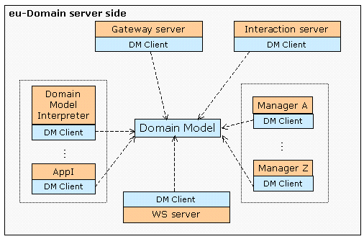

Figure 66. The Domain Model Client in the architecture

I.e., in more detail:
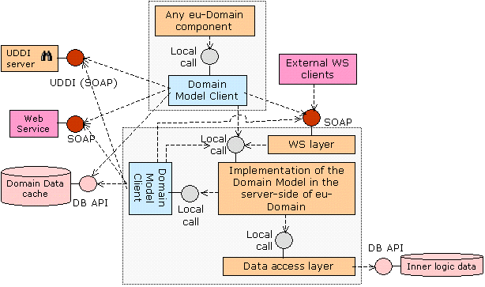

Figure 67. The role of the Domain Model Client

Thus internally the Domain Model Client could look like this:
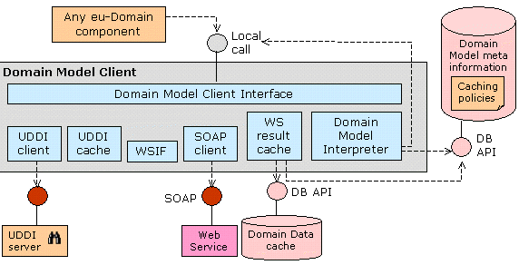

Figure 68. Domain Model Client modules

These sub-components inside the Domain Model Client would be as follows:
- The Domain Model Client Interface would be a layer of locally called classes offering access to all the features of the Domain Model Client, by orchestrating the rest of the sub-components described below
- The UDDI client would contact the eu-DOMAIN UDDI server to find out who implements the Domain Model operation requested by the user of the Domain Model Client
- The UDDI cache would be an in-memory (i.e. not persistent) cache of the results returned by the UDDI server
- The WSIF module refers to the Apache WSIF and would allow to perform calls to web services that are implemented locally, thus avoiding the performance penalty of a networked call
- The SOAP client would perform calls to remote web services using SOAP over HTTP
- The Web Service Results Cache would store the results of the remotely invoked web services, in order to reuse them when appropriate to avoid repeating the same calls. These results would be stored in the Domain Data Cache, which would be a persistent repository of the Domain Data returned by the Domain Model web services.
However, not every web service being invoked would be cached in the same way, differing in things like:
- Whether they are cached or not altogether
- During how much time the cached data is valid
- For repetitive data, how many occurrences are cached
- Which are the key values from the web service invokation parameters that make two requests equal or different
And possibly several others. All this additional meta-information on the web services defined in the Domain Model would be stored in the Domain Model meta-information repository, and thus they would be entered and managed by using the SOA modeller interactive tool described early in this document.
- If the Domain Model Client is to give access to the Domain Model, then it is logical that it includes the Domain Model Interpreter as described before in this document, although this is not something that matters.
Also, the detailed design of the Domain Model Client will have to resolve several issues, some of which are presented now.

Implementations of the Domain Model Client
The Domain Model Client must be callable locally, since if it is always called remotely the performance would probably be not acceptable, and the capability of being able to locally call web services would be spoiled altogether.
This means that in principle it should exist both a Java implementation and a .Net implementation. For Java there exists the Apache WSIF, although it is pending to be evaluated. But in .Net there is no WSIF (or at least we do not yet know about it,) so something similar could be implemented. Otherwise, the .Net components of the eu-DOMAIN server-side would not perform as well as the Java ones, and they could be harder to develop and maintain.

The Domain Model Client interface
It has already been determined that this interface must be locally callable, but still it must be designed. The first issue to decide on is whether this interface (whose main purpose is to invoke web services) will be based in XML documents, or in native (i.e. Java/.Net) data types and classes.
It seems clear that the interface should not be based in XML documents, since otherwise the marshalling and unmarshalling on data from Java/.Net into XML and back would spoil the performance gainings of having local calls. I.e. if to call a local class its parameters must be converted into XML text, and then the class must parse them from the text back in native data in order to work, then performance will clearly not be good.
So the interface should be based in native data types. The next question to answer is whether the interface should be the same for all services (e.g. “domainOperation=new DomainOperation(“GetPersonData”); domainOperation.addParameter(…); domainOperation.call(…)”), or whether it should be customized for every service to be called (e.g. ope=new GetPersonData(param, …); ope.getPersonData()), by creating class stubs for each one of them.
Using specific stubs for each operation would make more productive the development of the server-side components using them and could provide the most efficient implementation; however, it also would make the implementation less dynamic, since changes to the Domain Model would cause regeneration and redeployment of classes. Probably a good option would be to support both types of interfaces, being the specific stubs based in the dynamic native interface.
For Java, open source libraries like Apache Axis could be adapted to the needs of eu-DOMAIN, e.g. for generating stubs. Then, these stubs may be based in the WSIF, if necessary.
For .Net it remains to be seen whether the stubs generated by the framework can be adapted to the eu-DOMAIN needs or not, and if not, some alternative should be taken. At any rate, it is a must to leverage the SOA machinery built-in in the .Net framework (UDDI queries, SOAP calls and so on,) instead of replacing it by new implementations that sooner or later would become obsolete.
Thus, this is still an open issue.

The Semantic Integrator
The Semantic Integrator module will have the responsibility of implementing some integrations between eu-DOMAIN and Content Providers in a way that is at least partially automatic. Here it is hinted how this could be achieved.
The main part of the Semantic Integrator would be some Semantic Resolver, which would take as parameters the OWL-S profile of some service to be performed, and then would return the precise instructions to do so in terms of the web services available in the Domain Model. This is no trivial task that, at least if done with OWL and OWL-S, requires of some logic deduction capabilities.
This could possibly be implemented using some smart procedural modules backed by some databases, but it probably would be better to use some logic programming and implemented by logic inference engine. Software AG Enterprise Information Integrator (EII) 2.1 includes such capabilities, and while not (yet) able to perform Semantic Web Services integrator, it surely could be used to do so.
This is a schema of how this could be done:
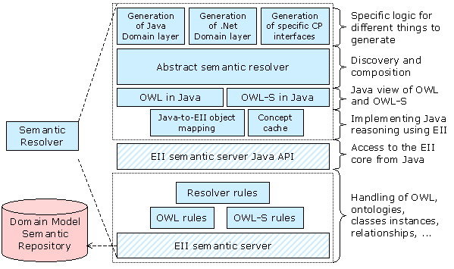

Figure 69. Possible implementation of the Semantic Resolver

The elements in this diagram are as follows:
- The EII semantic server is the part of EII that offers the logic computing capabilities needed for Semantic Integration
- The OWL rules and OWL-S rules would be logic programming modules running inside the EII semantic server that would complement the default handling of OWL by EII to support the resolution logic
- The Resolver rules would be logic programming modules specifically created to support the computing tasks required by the Abstract semantic resolver depicted above and described below
- The EII semantic server Java API is the built-in API in EII that provides access to the EII semantic server, and to the rules described above, from Java programs
- The so-called Java-to-EII concept mapping, the Concept cache and other modules not yet identified would allow the development of Java classes whose logic is implemented at least in part by the capabilities of the EII semantic server and the rules defined into it
- The OWL in Java and OWL-S in Java modules would be the precise Java objects that would represent the OWL and OWL-S models in Java
- The Abstract Semantic Resolver would implement the main part of the Semantic Integration capabilities, performing both the Discovery and Composition of the existing services to perform the requested services and returning some kind of generic, yet easily computable by procedural software, description of the steps to be taken for doing so; i.e. sort of a generic / pseudo code program that would orchestrate the available services
- The Generation of Java/.Net/etc would be specific modules that would translate from this generic description into specific Java/.Net/etc programs
The Domain Model Semantic Repository would be as described early in this document, containing the semantic modelling of the fragments of the Domain Model that are needed for the Semantic Integrations to be performed. Its precise database schema would have to fulfil the requirements EII imposes, in order for the later to being able to access the former.

Elements of the SOA solution
In this chapter the static architecture of the SOA solution is shown, i.e. which elements compose it and which are its relationships.
This diagram shows all of the elements of the solution:
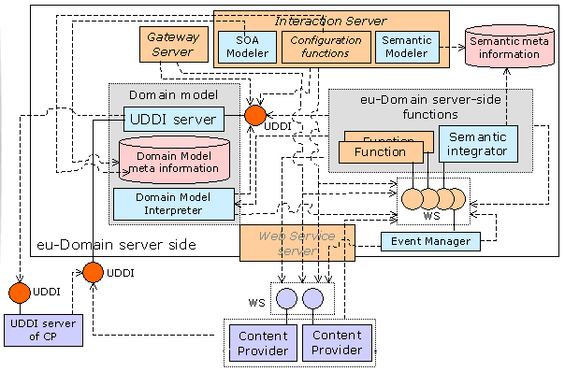

Figure 70. Architecture of the SOA solution

And now follows a description of each one of them.

The Domain Model meta-information
The Domain Model would be defined mainly as follows:
- The data structures, using XML Schema
- The operations, as Web Services, described by its WSDL documents
- One or more UDDI taxonomies used to catalogue and find the services. For example, there can be a taxonomy to catalogue the eu-DOMAIN domain model, and other for each one of the Content Providers. Or also different taxonomies for different eu-DOMAIN subsytems can be devised.
Other meta-information will be needed, like:
- Relationships between information structures (associations)
- Mapping between data elements used in operations (e.g. input parameters) and data items
- Security attributes of each model element, like ACLs or credentials
- Cache policies of data elements (see The Domain Model Client later)
- Additional meta-information like WS-Policy documents and others
This additional meta-information will be defined in more detailed design documents, as the metamodel gets clear. If a suitable existing standard for defining it is found, it will be used; otherwise, ad-hoc techniques will be applied.

The SOA modeller
The SOA modeller would allow to create, maintain and manage all of the Domain Model meta-information. It would be used by eu-DOMAIN administrators, with also controlled usage by CP administrators to enable them to update the information on its SOAP layers.
Since most of the information handled by the modeller are standard (XML Schema, WSDL, …) there exist many market tools and libraries allowing to manage them, and we could take advantage on that.

The UDDI server
It is the central piece of the Domain Model operation, acting as a dispatcher towards the implementation of the Domain Model features.
Once every one of the functions involved in the operation of eu-DOMAIN are defined as a Web Service in the Domain Model, to invoke them, any other component of the system must first look up who implements it in the UDDI server.
Of course, constant calls to the UDDI server would cause very bad performance, so caches should be used (see also The Domain Model client later on.)
The Content Providers could also have its own UDDI servers, that could be integrated in the eu-DOMAIN one through UDDI v3.

The Web Service Server
This component is not exclusive of the SOA solution to the Domain Model, but it is a common component of the eu-DOMAIN architecture. However, with the SOA solution, some of the tasks originally assigned to this component may no longer be needed.
Originally this server would act more as a gateway or proxy to contact external web services, and also for these services to contact eu-DOMAIN. However, since in the SOA solution every server-side component is SOAP enabled, then there is no need of having a gateway, since every component can contact every other component without the need of an intermediary.
However, still there are several tasks that such a component could perform, like:
- Handling of security issues (Web Service firewall) related to external requests, like:
- Verifying its authentication and authorization
- Verrifying its validity (e.g. checking for malformed or malicious messages)
- Queuing and handling of both inbound and outbound asynchronous web service operations, which will be strongly needed for the proper operation of the system. In the Dynamics of the SOA solution later there is some example of this.
Also it could be seen as a tool supporting the easy implementation of some web services of the eu-DOMAIN server side (e.g. adaptation to content providers, orchestration of other web services, etc,) assimilating it to products like CNet Visual XML Server or Software AG EntireX XML Mediator .

The Gateway server
This component is described in other parts of the architecture. However, it is of interest here since some of the tasks originally assigned to it could actually be performed by other parts of this SOA solution.
Originally the Gateway Server would act as a proxy to contact gateways: when any of the eu-DOMAIN components wanted to interact with some device bundle, it would contact the Gateway Server who in turn would forward the request to the proper Gateway. Equally, when some Gateway component would want to contact the eu-DOMAIN server, it would do so through te Gateway Server.
However, if the Gateway bundles would also be Web Services, the own SOA mechanisms would be enough to cover the communication between them and server-side components. E.g. when an Application Intelligence rule would consequence in the execution of some operation of a pump, the Application Intelligence would just find the proper WSDL for this operation on this pump and invoke it as a web service.
Equally, when some thermometer wants to report a new temperature measurement, it could lookup in the UDDI server (in front of which there would be a cache) for the implementation of some “reporting service”, and then just invoke it through SOAP.
If this would be so, the role of the Gateway Server as proxy would not really be needed. In fact, the Gateway Server would look quite much like the Web Service Server described above, being things like queuing and handling of asynchronous requests its most important role, and maybe both could be joined in a single component.

The eu-DOMAIN server side functions
Actually these have been already discussed early in this document. They are the implementation of the tasks to be performed inside eu-DOMAIN, both common to every application domain and specific of a given one. They can be things needed to perform domain services (e.g. handling of ESN work orders), value-added services (e.g. searching for a suitable physician across several Content Providers) or internal bookkeeping (e.g. billing to end users and Content Providers.)
Note that they do not include the actual end-user functions, but they support them – the end-user functions, in order to work, will constantly invoke the server-side functions. All of the “managers” described in other parts of the architecture fall in this category.
In the SOA solution, every feature offered by these server side functions must be available as a web service, and must be defined in the Domain Model (i.e. UDDI server et al.) Although this in principle would mean that in order to invoke the service a SOAP / HTTP call must be done, in many cases this will not be desirable because the service can be called locally (e.g. as a Java method.) Technologies like Apache WSIF should be used in order to allow this, although this will need of further design.
The implementation of these web services can be done in at least three ways:
- By manual programming, using Java, .Net or whatever development tool
- Using orchestration / web service scripting tools, like CNet Visual XML Server or Software AG EntireX XML Mediator
- Performing automatic integration using Semantic technologies (see The semantic integrator section below)
The SOA solution does not enforce any of these options,nor preclude any others as far as they are standard web services.

The semantic integrator, meta-information and modeller
Those three components would be used to implement some Domain Model functions by calling other web services, mainly the ones from external Content Providers. As described previously in the Semantic Solution option, the point of using semantic technologies for this is that they would allow for at least some degree of automatic integration, instead of using manual programming.
The Semantic Integrator component would expose web services defined in the Domain Model, just as other components do; only it will implement them using semantic technologies. For this it would use the Semantic meta-information, which would be a repository containing the OWL and OWL-S modelling of the parts of the Domain Model to implement, and of the web services used for that; e.g. the ones from a Content Provider. Note that this semantic meta-information would be tightly related with the Domain Model meta-information, making a lot of references to it.
In turn, this meta-information would be created and managed by using the Semantic Modeler, an interactive web-based component allowing eu-DOMAIN administrators and Content Provider administrators to enter all these semantic definitions.
For further information about the implementation of this component, see Semantic Technologies later in this document.

The Content Providers
As described in other parts of the architecture and implied by the SOA solution, the Content Providers would expose a layer of SOAP web services that eu-DOMAIN will call in order to perform its duties. They also will contact eu-DOMAIN through SOAP to notify it about relevant events, perform internal housekeeping or whatever other operation defined as needed in the Domain Model.
They will implement several of the Domain Model operations, and thus its web services and associated model will be defined in the Domain Model meta-information repository and will be searchable through the UDDI server. Since the Content Providers could also have its own UDDI server, it would be useful to use UDDI v3, which allows for federated repositories in the DNS way.
Different content providers could implement the same Domain Model operation (e.g. “GetTechnicianPersonalData”;) however, they would do so for different organizations, which is a built-in concept in UDDI. So when querying the UDDI server for some operation, it would return every implementation of it (along with the organization it belongs to,) or if queried for the operation of a given organization it would return just this one. This should suite very much the multi-organizaation structure of eu-DOMAIN, but it will require that the web service clients would be aware and properly identify the organization in which they want to invoke the operation. Some of this is shown in the Dynamics of the SOA architecture example, later in this document.
In the SOA solution, when any of the eu-DOMAIN server-side components needs to invoke some functionality of some Content Provider, it would just invoke some web service through SOAP after finding its WSDL in the UDDI server. However, this will be possible only if the Content Provider operation is 100% compatible with the definition of the operation in the Domain Model (i.e. it has a compatible WSDL.) If this is not the case (because many possible reasons, ranging from different encodings to not existing such a similar operation altogether,) then adaptation will be needed.
Options for implementing this adaptation have been discussed before in this document, but in the end, in the SOA solution, it means that this adaptation will expose a SOAP Web Service performing a task 100% compatible with the one in the Domain Model, and then it will be registered in the UDDI server so that other components of eu-DOMAIN can just call it in the same way as if it would be directly offered by the Content Provider.
The same is true for the opposite interaction, i.e. when a Content Provider contacts eu-DOMAIN: it would query the eu-DOMAIN UDDI server (or its own UDDI server, if they have one linked to the eu-DOMAIN’s through UDDI v3) and then just call the web service found, whether its implementation is directly served by a eu-DOMAIN manager, or by some adaptation code created manually or automatically.

The Domain Model Interpreter
This component will allow dynamic access to the Domain Model, i.e. accesses that are not preknown in advance by a developer. This need for such a service has been explained before in this document, and will probably be used by components like the Application Intelligence and the Notification Manager.
In principle this component will just take a list of Domain Model operations to be performed, sort of a simple script, and it will just execute it by invoking the UDDI server and so on. However, for retrieval of simple data it will have to do some more. For example, the Notification Server will typically need to retrieve single data items like the name of a person, some address or some date, because they are referenced in a message template and it must include them in the text of a notification.
However, the typical granularity of a SOAP web service is not so fine to only retrieve single data items like the name of a person, but it usually retrieves whole data structures like the personal data of a person.
So the Domain Model Interpreter needs to be able to resolve Domain Model requests at a finer granularity than typically web services are. There are some solutions for this:
- Model these finer level operations in the Domain Model, but mapping them to Web Services that retrieve more information than actually needed (e.g. GetName -> GetPersonalData). Using this additional meta-information, the Domain Model Interpreter could easy perform the required task, although it should be aware of the different I/O interface needed to invoke the service and handle it properly.
- Make the Domain Model Interpreter to automatically analyze the definitions of the existing services in order to find out the more appropriate to retrieve the requested data, in a sort of simple semantic web service discovery and composition.
Which of the two options is best suited is not yet decided, but probably the first one conforms better to the Domain Model concept in which all needed meta-information is included.
The Domain Model Interpreter can have a networked SOAP interface. However, in order to take full advantage of the possibility of invoking services locally, the interface of the Domain Model Interpreter should be also local, which means that it should be both Java and .Net versions of it.
Although here the Domain Model Interpreter is shown as a separate component, it can also be included in the Domain Model Client described later in this document.

The so-called “Configuration Functions”
Which in this diagram are called “Configuration Functions” are supposed to be interactive functions allowing the end-user to configure at run time the access that some components will do to the Domain Model, like the Application Intelligence or the Notification Manager. These functions, as described in the Requirements section of this document, will make heavy usage of the Domain Model meta-information in order to assist the users in selecting the right Domain Model elements to make the system perform the function they want.

The Event Manager
The Event Manager provides of a Publish/Subscribe mechanism to queue and distribute messages in an asynchronous way between eu-DOMAIN components. It performs the role of the so-called Enterprise Service Bus or ESB found in many Service Oriented Architectures. It could be included in the box of all managers because it actually does not differ from them, but it is shown outside because it is actually an infrastructure service enabling part of the working of the SOA.
An ESB acts as the integration hub across the services of the architecture, receiving messages from them, transforming and performing other processes on them, and distributing them to the right peers. It provides mainly decoupling of services, since the services just publish messages to the hub, and then the hub contains the needed logic to know which other services are interested on those messages (routing), or on variations of them (transforming of messages). Thus, the services (or subsystems) do not know about each other, but just about the hub.
This of course collides in part with the way of working when a UDDI server (which is also common in SOAs and is supposed to allow discovery of services in order to directly contact them, instead of using an intermediate bus), and this is why in many papers about SOA one ends up not knowing when to use UDDI and when to use an ESB. But both have its role, depending on the way the services are designed to interact between them:
- If the services are supposed to interact in a synchronous way, then they should contact each other directly (i.e. no bus) and then the UDDI server is paramount.
- If the services are supposed to interact in an asynchronous way, then an ESB is required to provide publish/subscribe capabilities, and maybe transformation of messages.
Synchronous communications are more suited when there is more coupling, while asynchronous are more proper when the peers are more decoupled. It is not yet clearly defined, but it looks clear that in eu-DOMAIN both types will be needed.
There exists more coupling when the requester of the service expects something from the provider of the service, because it cannot continue otherwise. For example, if the Application Intelligence needs a datum like the age of a patient, it must wait until the service providing this information (e.g. an external Content Provider) replies with it. In this case, an ESB makes no sense, but UDDI does.
But there are other cases where the service requests is more of a notification or command in which no reply is actually needed. For example, when the Application Intelligence determines that the flow of some pump should be increased, the Application Intelligence may not have to matter about the actual performing of this command – others can worry about this, like an ESB that queues the command and waits until it has been completed. Or when some Content Provider, like a Weather Service, notifies eu-DOMAIN about some bad storm coming in order to shut down windows or whatever.
So eu-DOMAIN will need both of an UDDI server and of an ESB, and this one will be the Event Manager. However it is not envisioned by now that the Event Manager provides transformation of messages, but mainly publish/subscribe capabilities (i.e. like the Java Messaging System and Message Oriented Middlewares in general) and some routing. The transformation should be performed by some other services in the architecture (e.g. inside a manager), just like the adaptors to external Content Providers.
The interfaces handled by the Event Manager will be designed in further documents, but probably they would be something like this:
- There will be specific interfaces for publishing events, subscribing to them and being notified about them happening. If no suitable market standard is found, they will be eu-DOMAIN specific.
- For asynchronous operations not related to events, a good approach could be to register a version of every asynchronous web service in the UDDI as implemented by the Event Manager, so that those wanting to use such asynchronous service would use the same mechanism of looking up in the UDDI and issuing a SOAP call that would return no actual XML content, but just some HTTP 202 Accepted. Then it would be up to the Event Manager to queue and distribute the message. Also, the Domain Model meta-information would be a good place to put queuing options like number of retries, timeouts, and action on failures.

Some advance on detailed design
Here there are included some ideas on what should be the advanced design of some of the parts of the SOA solution, because there are thought to improve the understanding of it.

The Domain Model Client
Of course, one of the main advantages of using a Service Oriented Architecture is that it is standard. This makes possible that any component able to use UDDI, SOAP and maybe other technologies should be able to communicate with eu-DOMAIN.
So for the server-side eu-DOMAIN components being able to communicate with each other, they just should fulfil these requirements. However, there is indeed a number of common operations in this fulfilment, like:
- Be a UDDI client, to contact the UDDI server
- Have a in-memory UDDI cache, to enhance performance
- Have WSIF-like capabilities, to be able to invoke locally implemented web services
- Be a SOAP client, to be able to invoke remotely implemented web services
- It would be nice to be able to access a system wide cache for remote web services (e.g. the ones implemented in Content Providers,) following the rules specified in the Domain Model meta-information
And those capabilities should be accessed through a local interface (not networked,) in order to not add yet more performance penalties. While of course every component could be left free to implement such local logic, a basic principle of modularization demands to have a common library performing all of them, in order to ease development, quality and maintenance.
Such a library could be called the Domain Model Client, and could be used by internal server-side eu-DOMAIN components to communicate with the Domain Model:

Figure 71. The Domain Model Client in the architecture

I.e., in more detail:

Figure 72. The role of the Domain Model Client

Thus internally the Domain Model Client could look like this:

Figure 73. Domain Model Client modules

These sub-components inside the Domain Model Client would be as follows:
- The Domain Model Client Interface would be a layer of locally called classes offering access to all the features of the Domain Model Client, by orchestrating the rest of the sub-components described below
- The UDDI client would contact the eu-DOMAIN UDDI server to find out who implements the Domain Model operation requested by the user of the Domain Model Client
- The UDDI cache would be an in-memory (i.e. not persistent) cache of the results returned by the UDDI server
- The WSIF module refers to the Apache WSIF and would allow to perform calls to web services that are implemented locally, thus avoiding the performance penalty of a networked call
- The SOAP client would perform calls to remote web services using SOAP over HTTP
- The Web Service Results Cache would store the results of the remotely invoked web services, in order to reuse them when appropriate to avoid repeating the same calls. These results would be stored in the Domain Data Cache, which would be a persistent repository of the Domain Data returned by the Domain Model web services.
However, not every web service being invoked would be cached in the same way, differing in things like:
- Whether they are cached or not altogether
- During how much time the cached data is valid
- For repetitive data, how many occurrences are cached
- Which are the key values from the web service invokation parameters that make two requests equal or different
And possibly several others. All this additional meta-information on the web services defined in the Domain Model would be stored in the Domain Model meta-information repository, and thus they would be entered and managed by using the SOA modeller interactive tool described early in this document.
- If the Domain Model Client is to give access to the Domain Model, then it is logical that it includes the Domain Model Interpreter as described before in this document, although this is not something that matters.
Also, the detailed design of the Domain Model Client will have to resolve several issues, some of which are presented now.

Implementations of the Domain Model Client
The Domain Model Client must be callable locally, since if it is always called remotely the performance would probably be not acceptable, and the capability of being able to locally call web services would be spoiled altogether.
This means that in principle it should exist both a Java implementation and a .Net implementation. For Java there exists the Apache WSIF, although it is pending to be evaluated. But in .Net there is no WSIF (or at least we do not yet know about it,) so something similar could be implemented. Otherwise, the .Net components of the eu-DOMAIN server-side would not perform as well as the Java ones, and they could be harder to develop and maintain.

The Domain Model Client interface
It has already been determined that this interface must be locally callable, but still it must be designed. The first issue to decide on is whether this interface (whose main purpose is to invoke web services) will be based in XML documents, or in native (i.e. Java/.Net) data types and classes.
It seems clear that the interface should not be based in XML documents, since otherwise the marshalling and unmarshalling on data from Java/.Net into XML and back would spoil the performance gainings of having local calls. I.e. if to call a local class its parameters must be converted into XML text, and then the class must parse them from the text back in native data in order to work, then performance will clearly not be good.
So the interface should be based in native data types. The next question to answer is whether the interface should be the same for all services (e.g. “domainOperation=new DomainOperation(“GetPersonData”); domainOperation.addParameter(…); domainOperation.call(…)”), or whether it should be customized for every service to be called (e.g. ope=new GetPersonData(param, …); ope.getPersonData()), by creating class stubs for each one of them.
Using specific stubs for each operation would make more productive the development of the server-side components using them and could provide the most efficient implementation; however, it also would make the implementation less dynamic, since changes to the Domain Model would cause regeneration and redeployment of classes. Probably a good option would be to support both types of interfaces, being the specific stubs based in the dynamic native interface.
For Java, open source libraries like Apache Axis could be adapted to the needs of eu-DOMAIN, e.g. for generating stubs. Then, these stubs may be based in the WSIF, if neccessary.
For .Net it remains to be seen whether the stubs generated by the framework can be adapted to the eu-DOMAIN needs or not, and if not, some alternative should be taken. At any rate, it is a must to leverage the SOA machinery built-in in the .Net framework (UDDI queries, SOAP calls and so on,) instead of replacing it by new implementations that sooner or later would become obsolete.
Thus, this is still an open issue.

Semantic technologies
The Semantic Integrator module will have the responsibility of implementing some integrations between eu-DOMAIN and Content Providers in a way that is at least partially automatic. Here it is hinted how this could be achieved.
The main part of the Semantic Integrator would be some Semantic Resolver, which would take as parameters the OWL-S profile of some service to be performed, and then would return the precise instructions to do so in terms of the web services available in the Domain Model. This is no trivial task that, at least if done with OWL and OWL-S, requires of some logic deduction capabilities.
This could possibily be implemented using some smart procedural modules backed by some databases, but it probably would be better to use some logic programming and implemented by logic inference engine. Software AG Enterprise Information Integrator (EII) 2.1 includes such capabilities, and while not (yet) able to perform Semantic Web Services integrator, it surely could be used to do so. The following is an schema of how this could be done:

Figure 74. Possible implementation of the Semantic Resolver

The elements in this diagram are as follows:
- The EII semantic server is the part of EII that offers the logic computing capabilities needed for Semantic Integration
- The OWL rules and OWL-S rules would be logic programming modules running inside the EII semantic server that would complement the default handling of OWL by EII to support the resolution logic
- The Resolver rules would be logic programming modules specifically created to support the computing tasks required by the Abstract semantic resolver depicted above and described below
- The EII semantic server Java API is the built-in API in EII that provides access to the EII semantic server, and to the rules described above, from Java programs
- The so-called Java-to-EII concept mapping, the Concept cache and other modules not yet identified would allow the development of Java classes whose logic is implemented at least in part by the capabilities of the EII semantic server and the rules defined into it
- The OWL in Java and OWL-S in Java modules would be the precise Java objects that would represent the OWL and OWL-S models in Java
- The Abstract Semantic Resolver would implement the main part of the Semantic Integration capabilities, performing both the Discovery and Composition of the existing services to perform the requested services and returning some kind of generic, yet easily computable by procedural software, description of the steps to be taken for doing so; i.e. sort of a generic / pseudo code program that would orchestrate the available services
- The Generation of Java/.Net/etc would be specific modules that would translate from this generic description into specific Java/.Net/etc programs
- The Domain Model Semantic Repository would be as described early in this document, containing the semantic modelling of the fragments of the Domain Model that are needed for the Semantic Integrations to be performed. Its precise database schema would have to fulfil the requirements EII imposes, in order for the later to being able to access the former.

Security

Responsibilities
The responsibilities of the Security Manager have already been described, but the actual task of enforcing the access control policy on the server is handled by the web service container. On the client side, the Security Manager will enforce the access control policies when communicating with devices where web services are not used. Devices will handle access control themselves.

Choice of technology

Abstract
We chose to use credentials and access control lists because they provide a flexible solution where each node on a network can manage its own security and not necessarily have access to a central server all the time, which is needed on the client side.
Credentials are used to identify nodes and their group memberships. The exact implementation of the credentials has not been decided yet. On the server side it should be something simple and efficient, but on the client side it would be something more advanced such as an anonymous credential scheme.
Access control lists have the disadvantage that it’s nearly impossible to get an overview of who allows what, but since this in general is not needed in eu-DOMAIN, the flexibility of access control lists makes it worth it. Still, if it is needed the Security Manager can query the object to retrieve the access control list for that object.
Furthermore, this choice of technology allows us to implement role based access control since a credential can identify the owner as having some role. This is a requirement for integrating with some external service providers. Also, depending on the implementation of the credentials, this solution allows us to solve some of the privacy problems of roaming devices identified.

Concrete
We need a way to represent credentials and access control lists in the system and also a way to pass credentials between entities. Since calls are made using SOAP, a solution supporting SOAP was needed. We have decided to use WS-Security which defines a set of SOAP headers to implement security. For representing the credentials in these SOAP headers, SAML is chosen. The reason for this is that both WS-Security and SAML are standards, and also that SAML is flexible enough to represent credentials no matter what implementation of the credentials we choose. Furthermore, SAML has already adopted WS-Security as a way of binding SAML to SOAP messages.
XACML is a standard for representing access control and will be used to represent the access control lists.
Encrypted data as well as signed data to protect integrity can be represented as XML Encryption and XML Signatures or simply provided at a lower level when appropriate, such as SOAP messages over a TLS connection.
On the client side, there might be a need for custom protocols since we are not using web services between for example devices and the gateway.

Device categories
For the devices we propose an adaptive security architecture where devices with different capabilities and security requirements can operate together through a gateway without the server having to worry about different kinds of devices.
Devices are divided into three different categories and will be referred to as category 1, 2 or 3 devices. The properties of the different categories are listed below.

Category 1
Devices in this category are devices with a minimum of possibilities for configuration. An example could be a thermometer connected to the gateway via a serial cable. Such a device can claim that it has an identity (by being physically connected to some port on the gateway), but not prove that it actually is the device it claims to be.

Category 2
Devices in this category still have a minimum of possibilities for configuration, meaning that we cannot equip them with access control lists, credentials and key material. Still they provide some mean of secured communication using a symmetric scheme. This means that the device can prove its identity towards one other device such as a gateway, but not to other devices. Pairing in Bluetooth is an example of this.

Category 3
Devices in this category are capable of storing access control lists, credentials and key material and can also perform asymmetric cryptography. This means that the device can prove it’s identity towards all who wants to know. It can also show its credentials when required.

Devices and gateways
Since category 1 and 2 devices can’t store credentials or perform public key cryptography the gateway will act on behalf of these devices by storing and verifying access control lists, credentials and key material for them. The difference between category 1 and 2 in this case is that a category 2 device can prove its identity to the gateway who will act on behalf of the device. This is not possible for a category 1 device. Here the gateway must blindly trust the device.
Registration of category 1 and 2 devices means setting access control lists, credentials and key material for these devices on the gateway so the gateway can act on their behalf. It also includes setting permissions on the gateway to communicate with these devices. Furthermore, for category 2 devices some shared secret is used to identify the device. Registration for category 3 devices means setting the ACL on the gateway to accept certain data from the device and nothing else. This allows category 3 devices to roam between gateways as long as they have some acceptable default entry in their ACL.
In an ideal world we would only have category 3 devices, but the reality is that we will have a lot of category 1 and 3 devices for some years to come.

Other issues regarding the security architecture
Here we describe other important elements of the security architecture that are not directly represented as components in the system.

Registration
Registration is concerned with the fact of bringing new entities into the system. Examples include gateways, devices and users that must be registered in the system, assigned credentials, etc.

User authentication
While authentication of devices might follow naturally from the device having some credentials issued by a trusted third party, user authentication is a different matter. Here we have two participants. One is the user’s digital identity in the system with all the associated credentials and the other is the physical user himself. There need to be a way for the physical user to identify him towards the system so the system can act on his behalf using his digital identity.

External providers
The security architecture needs to be able to handle the task of interfacing to content providers outside the eu-DOMAIN. This includes securing the communication between the content provider and eu-DOMAIN, but also how to gain access to resources on both sides.
The requirements we have so far is that we need to support Role-Based Access Control, which is the access control model used in eu-DOMAIN anyway.

Trusted computing base
The trusted computing base is the software and hardware in the system that we believe will always behave as intended. The TCB is responsible for enforcing the security policy by implementing the security architecture.
On the server side, all software running on the eu-DOMAIN server is regarded as the trusted computing base. This means that there will be no restrictions on which software components the server can access data in the different domains.
Maintaining the TCB on the server requires reliable and secure code, but more important training of the staff so security failures due to invalid use of the system is reduced. It also requires physical as well as logical access control preventing unauthorised users to interfere with the eu-DOMAIN servers and thereby the TCB.
On the client side, things are a bit different. While we can’t technically have a TCB on the client side because we are placing some device outside of our control, we can still try to make it difficult to attack the devices. Still, the most important thing to realise here is that we have to minimise the possible effect on the rest of the system by a compromised device or gateway outside the system

Performance considerations
The following tasks might decrease performance of the system to an unacceptable level
- Each method invoked on a domain model object causes a security check which might involve looking up some keys and verifying a credential.
- Each time a credential is used, the verifier must query some central place to check that that it has not been revoked.
- Each SOAP request will need to carry an extra SAML document that contains credentials of the caller, as well as possibly a signature on/encryption off the SOAP data itself.
- Each time data is signed, verified, encrypted, decrypted or a credential is verified, a fairly computational operation is needed. This might especially pose a problem for smaller devices with very limited resources.
There are ways to reduce the impact of these. Caching can limit the need to lookup information, simple credentials can be used in a trusted environment such as the server, etc.
The overhead of SOAP communication is relevant to the entire architecture, so at least the security is not worse performance-wise than the rest of the architecture.

References
[Barbacci et al., 2003] Barbacci, M., Ellison, R., Lattanze, A., Stafford, J., Weinstock, C., and Wood, W. (2003). Quality Attribute Workshops, 3rd Edition. Technical Report CMU/SEI-2003-TR-016, Software Engineering Institute.
[Bass et al., 2003] Bass, L., Clements, P., and Kazman, R. (2003). Software Architecture in Practice. Addison-Wesley, 2nd edition.
[Dey, 2001] Dey, A.K. (2001). Understanding and Using Context. Personal and Ubiquitous Computing Journal. 5(1), 4-7.
[Hendler et al, 2002] Hendler, James, Berners-Lee, Tim and Miller, Eric. (2002) Integrating Applications on the Semantic Web. Journal of the Institute of Electrical Engineers of Japan, Vol 122(10), October, 2002, p. 676-680. Also available at http://www.w3.org/2002/07/swint
[OMG, 2004] Object Management Group (2004). UML 2.0 Superstructure. Ptc/04-10-02. http://www.omg.org/cgi-bin/doc?ptc/04-10-02
[OSGi, 2003] Open Services Gateway initiative (2003). OSGi Service Platform. Release 3. Available at http://www.osgi.org
[OWL] W3C, 2004. OWL Web Ontology Language Overview. http://www.w3c.org/TR/owl-features/
[OWL-S] Martin, D. et al. (2004). OWL-S: Semantic Markup for Web Services. http://www.w3.org/Submission/2004/SUBM-OWL-S-20041122/ and http://www.daml.org/services/owl-s/
[Pawson and Matthews, 2002]. Pawson, R. and Matthews, R. (2002) Naked Objects. Wilrey
[Semantic Web] W3C (2001). Semantic Web. Available at http://www.w3c.org/2001/sw/
[UDDI] Organization for the Advancement of Structured Information Standards (OASIS). http://www.uddi.org/
[WS-Addressing] W3C, 2004. Web Services Addressing – Core. http://www.w3.org/TR/2004/WD-ws-addr-core-20041208/
[WS-I Basic Profile 1.1] Web Services Interoperability Organization (2004). Basic Profile Version 1.1. http://www.ws-i.org/Profiles/BasicProfile-1.1-2004-08-24.html
[WS-Policy] IBM, BEA, Microsoft and others (2004). Web Services Policy Framework (WS-Policy). http://www-106.ibm.com/developerworks/library/specification/ws-polfram/ and http://msdn.microsoft.com/library/default.asp?url=/library/en-us/dnglobspec/html/ws-policy.asp .
[WSDL 1.1] W3C (2001). Web Services Description Language (WSDL) 1.1. http://www.w3c.org/TR/wsdl
[XML Schema] W3C. XML Schema. http://www.w3.org/XML/Schema
[XML Schema 1.0 primer] W3C (2004). XML Schema Primer Second Edition. http://www.w3.org/TR/xmlschema-0/

http://www.osgi.org
http://www.softwareag.com/tamino/
E.g., http://www.danbit.dk/produkter/0515.phtml
E.g., http://www.nonin.com/products/4000.asp
Such a device is being prototyped in eu-DOMAIN by wrapping a Grundfos pump accessible via the Grundfos GENIbus RS485 fieldbus
http://www.bluetags.com
Here quality scenario summaries from the utility tree are presented in italics
I suppose that in turn the metamodel is defined in terms of something else, but the metamodel level looks enough.
At least for components inside eu-DOMAIN, UDDI queries would be associated to a memory cache in order to improve performance (see The Domain Model Client later in this document)
As described later in The Domain Model Client, it is assumed that there will be some system-wide Domain Data cache in which all this information would be stored. Besides, the Domain Model Interpreter will have to receive some context with each request.
It is plausible that Bills would contain an explicit data of totalAmount, but in many other cases this kind of calculated data would not be explicit, but calculated by some piece of code out of the explicit data. This is a non trivial issue solved by Object Oriented Design but that is pending to data or document centric representations. Something will have to be done.
As show here, in many UDDI queries the organization is an important datum, so it will have to be ensured that it is available whenever needed. E.g. in this case it could have been provided by the Application Intelligence.
It can be the same service as before, or not; this is a matter of the design of the Domain Model
E.g. in this case there is no adaptation needed, so the adapter has not to be involved
How the Health Device Manager knows about this depends on its implementation; it can be manually programmed and/or based in configuration, semantic technologies, etc.
again, how does it know depends on its implementation
For finding out about this fact, it may be needed to invoke other web services inside the Patient Record Manager. But this is not shown here.
If the Event Manager is invoked remotely, performance may suffer from too many notifications being issued. A solution for avoiding this is to perform some previous check by using solely local calls. This is a matter of the detailed design of the Event Manager.
For performing all this, some other web services must be called, more noticeabily the Application Intelligence that could process the rules defined by Dr. Hayworth, and thus the Domain Model Interpreter. This is however not shown here, because the dynamics of these two components was already shown in the billing scenario.
See also the description of Domain Data caches later, in the Domain Model Client
Actually, the end-user functions, like the rest of components, will invoke the features of the Domain Model, but many of these will be implemented by the server-side functions

