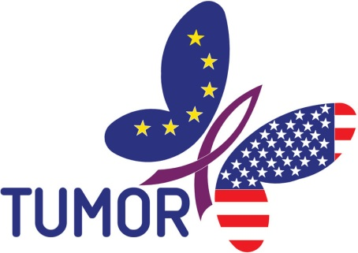

**Transatlantic TUmour MOdel Repositories**

**Deliverable D6.2**

**Public Transatlantic TUMOR Workshop**

Project Number: FP7--IST-247754

Deliverable id: D 6.2

Deliverable name: Public Transatlantic TUMOR Workshop

Submission Date: 13 November 2012



|  |  |
| --- | --- |
| ***COVER AND CONTROL PAGE OF DOCUMENT*** | |
| Project Acronym: | TUMOR |
| Project Full Name: | Transatlantic TUmour MOdel Repositories |
| Document id: | D6.2 |
| Document name: | D6.2 - Public Transatlantic TUMOR workshop |
| Document type (PU, INT, RE) | PU |
| Version: | 3 |
| Submission date: | 13 November 2012 |
| Editor: Organisation: Email: | Georgios Stamatakos  ICCS  gestam@central.ntua.gr |

Document type PU = public, INT = internal, RE = restricted

|  |
| --- |
| **ABSTRACT:**  The present deliverable outlines the major scientific and organizational aspects of the TUMOR project workshop which was also the 5th International Advanced Research Workshop on *In Silico* Oncology and Cancer Investigation ( 5th IARWISOCI). The focused workshop being technically co-sponsored by the Institute of Electrical and Electronics Engineers (IEEE) – Engineering in Medicine and Biology (EMB) took place in Athens, Greece on October 22-23, 2012. It turned out to be a complete success since it proved a unique forum for extensive and in depth presentations of cutting edge interdisciplinary and clinically oriented research work as well as for constructive discussions and interactions. The workshop aimed *inter alia* at the shaping of the emergent discipline of *in silico* oncology and its clinical translation. |

|  |
| --- |
| **KEYWORD LIST**: TUMOR, TUMOR Project Workshop, 5th International Advanced Research Workshop on *In Silico* Oncology and Cancer Investigation, 5th IARWISOCI, multiscale cancer modelling, *in silico* oncology, transatlantic cooperation, model repositories, dissemination |

|  |  |  |  |
| --- | --- | --- | --- |
| ***MODIFICATION CONTROL*** | | | |
| Version | Date | Status | Author |
| 1.0 | 30 October 2012 | Draft | Georgios Stamatakos |
| 2.0 | 6 November 2012 | Revision | Dimitra Dionysiou |
| 3.0 | 13 November 2012 | Final | Georgios Stamatakos |

Contents

contents………………………………………………………………………………….. .4

TUMOR Project and Workshop Executive Summary………………………..5

1. INTRODUCTION…………………………………………………………………………..6

2. ORGANIZING COMMITTEE……………………………………………………………...7

3. IN SILICO ONCOLOGY…………………………………………………………………...7

4. THE TUMOR PROJECT……………………………………………………………………8

5. THE WORKSHOP PROGRAMME………………………………………………………..8

6. LIST OF PARTICIPANTS………………………………………………………………...12

7. SPONSORS……………………………………………………………………………......14

8. IEEE-EMB TECHNICAL CO-SPONSORHIP……………………………………………14

9. CONCLUSIONS…………………………………………………………………………...15

10. REFERENCES……………………………………………………………………………15

TUMOR Project and Workshop Executive Summary

The TUMOR project aims at developing a European *clinically oriented* semantic-layered cancer digital model repository from existing EU projects that will be interoperable with the US grid enabled semantic-layered digital model repository platform at CViT.org (Center for the Development of a Virtual Tumor, Massachusetts General Hospital (MGH), Boston, USA) which is NIH/NCI-caGRID compatible. This interoperable, CViT interfaced, environment will offer a range of services to international cancer modelers, bio-researchers and eventually clinicians aimed at supporting both basic cancer quantitative research and individualized optimization of cancer treatment. This ‘Transatlantic’ project will therefore be the starting point for an international validation environment which will support joint applications, verification and validation of the clinical relevance of cancer models. To ensure the clinical relevance of this joint effort, the development of the project is based upon specific clinical scenarios that will be implemented within an integrated EU-US workflow environment prototype for predictive, *In Silico Oncology-*guided clinical studies that are being deployed. As an end result, a specific, clinically relevant workflow involving both EU and CViT models will be demonstrated, which will clearly highlight the need for and added value of interoperability. To achieve these goals, multiscale models/tools developed and data collected within the framework of three ongoing EC funded research projects, namely ACGT [Advancing Clinicogenomic Trials on Cancer], ContraCancrum [Clinically Oriented Cancer Multilevel Modeling] and the VPH NoE [Virtual Physiological Human Network of Excellence], in conjunction with models and data from the NIH supported ICBP Program CViT.org drive the development, optimization and validation of the integrated system. Thus, a new module of the Virtual Physiological Human (VPH) environment will emerge. The present deliverable outlines the major scientific and organizational aspects of the TUMOR project workshop which has also been the 5th International Advanced Research Workshop on *In Silico* Oncology and Cancer Investigation (5th IARWISOCI). The focused workshop ([www.5th-iarwisoci.iccs.ntua.gr](http://www.5th-iarwisoci.iccs.ntua.gr) ) which was technically co-sponsored by the Institute of Electrical and Electronics Engineers (IEEE) – Engineering in Medicine and Biology (EMB) took place in Athens, Greece on October 22-23 , 2012. It turned out to be a complete success since it proved a unique forum for extensive and in depth presentations of cutting edge interdisciplinary and clinically oriented research work as well as for constructive discussions and interactions. The workshop aimed *inter alia* at the shaping of the emergent discipline of *in silico* oncology and its clinical translation. The Proceedings of the workshop will be made available on both the workshop website (open access) and the IEEE Xplore system at about one month after the workshop ( i.e. about Nov. 24, 2012)

1. **Introduction**

Cancer is a *natural phenomenon* and as such it should be amenable to mathematical and computational description. Clinically driven complex multiscale cancer models can produce rather realistic spatio-temporal simulations of concrete clinical interventions such as radio-chemotherapy applied to individual patients. Clinical data processing procedures and computer technologies play an important role in this context. Following clinical adaptation and validation within the framework of clinico-genomic trials, models are expected to enhance individualized treatment optimization.  The latter constitutes the long term goal of the emergent scientific, technological and medical discipline of *in silico* oncology.  
Treatment optimization is to be achieved through experimentation *in silico* i.e. on the computer. Moreover, provision of insight into tumour dynamics and optimization of clinical trial design and interpretation constitute short- and mid-term goals of this new domain.

The TUMOR workshop which was also the 5th International Advanced Research Workshop on In Silico Oncology and Cancer Investigation (5th IARWISOCI) proved an excellent opportunity for both shaping and advancing the discipline. Researchers working either in the area of *in silico* oncology or in the broader cancer research domain yet with an interest in computational oncology were invited to submit short IEEE formatted four page papers. The Proceedings of the workshop will be made available on both the workshop website and the IEEE Xplore system at about one month after the workshop ( i.e. about Nov. 24, 2012).

The workshop took place in Athens, Greece on 23-24 October 2012. The venue was the Royal Olympic Hotel ([www.royalolympic.com](http://www.royalolympic.com)). Fig. 1 and Fig.2 provide two screenshots of the workshop webpage.

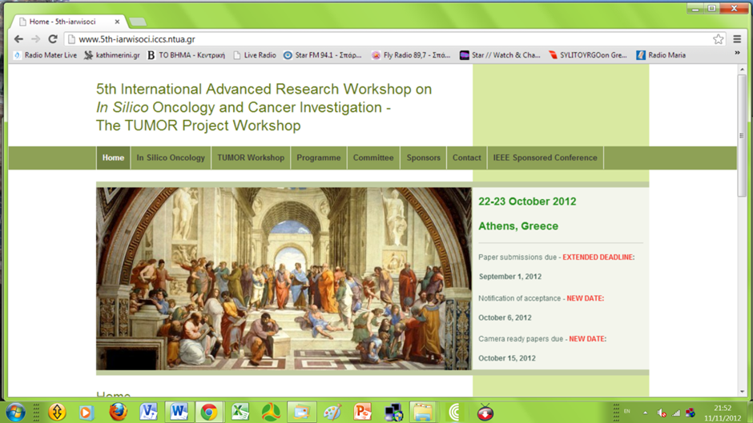

Fig.1 A screenshot of the home page of the workshop website [1]

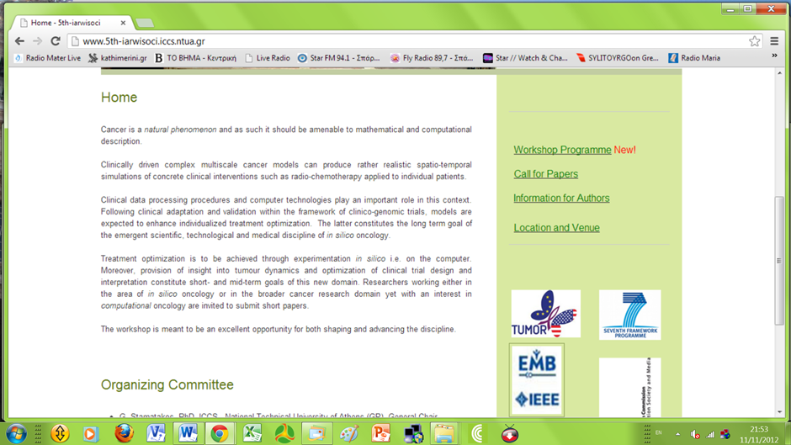

Fig.2 A screenshot of the workshop website [1]

1. **Organizing Committee**

The Organizing Committee consisted of the following persons and workshop participants:

G. Stamatakos, PhD, ICCS - National Technical University of Athens (GR*), General Chair*

Ν. Graf, MD, University Hospital of Saarland (DE)

K. Marias, PhD, Foundation for Research and Technology – Hellas (GR)

M. Akay, PhD, University of Houston (USA)

R.Radhakrishnan, PhD, University of Pennsylvania ( USA)

D. Dionysiou, PhD, ICCS - National Technical University of Athens (GR)

V. Sakkalis, PhD, Foundation for Research and Technology – Hellas (GR)

N. Uzunoglu, PhD, ICCS - National Technical University of Athens (GR)

**3. *In Silico* Oncology**

*In Silico* Oncology is a complex and multiscale combination of sciences and technologies intending to simulate malignant tumour growth and tumour and normal tissue response to therapeutic modalities at all levels of biocomplexity. The long term goal is to quantitatively understand cancer and related phenomena and optimize therapeutic interventions by performing *in silico* (on the computer) experiments based on the individual patient’s clinical, imaging, histopathological, molecular and pharmacogenomic data. In order to achieve such an ambitious goal translation of cancer models into the clinical trials arena is a *sine qua non* condition and therefore this aspect was particularly emphasized throughout the workshop.

1. **The TUMOR Project**

The TUMOR project workshop was also the 5th International Αdvanced Research Workshop on *In Silico* Oncology and Cancer Investigation.The TUMOR project aims at developing a European clinically oriented semantic-layered cancer digital model repository from existing EU projects that will be interoperable with the US grid enabled semantic-layered digital model repository platform at CViT.org (Center for the Development of a Virtual Tumor, Massachusetts General Hospital (MGH), Boston, USA) which is NIH/NCI-caGRID compatible.This interoperable, CViT interfaced, environment will offer a range of services to international cancer modelers, bio-researchers and eventually clinicians aimed at supporting both basic cancer quantitative research and individualized optimization of cancer treatment. This ‘Transatlantic’ project will therefore be the starting point for an international validation environment which will support joint applications, verification and validation of the clinical relevance of cancer models.

To ensure the clinical relevance of this joint effort, the development of the project is based upon specific clinical scenarios that are implemented within an integrated EU-US workflow environment prototype for predictive, *In Silico* Oncology-guided clinical studies that are under deployment. As an end result, a specific, clinically relevant workflow involving both EU and CViT models will be demonstrated, which will clearly highlight the need for and added value of interoperability.

To achieve these goals, multiscale models/tools developed and data collected within the framework of three ongoing EC funded research projects namely ACGT [Advancing Clinicogenomic Trials on Cancer], ContraCancrum [Clinically Oriented Cancer Multilevel Modeling] and the VPH NoE [Virtual Physiological Human Network of Excellence], in conjunction with models and data from the NIH supported ICBP Program CViT.org drive the development, optimization and validation of the integrated system.Thus, a new module of the Virtual Physiological Human (VPH) environment will emerge.

1. **The Workshop Programme**

In the following the final workshop programme is presented.

**Monday, 22 October**

**8:30-9:00 Participants’ Arrival – Registration (no admission fee) - Coffee**

**WELCOME AND INTRODUCTORY TALK**

**9:00-9:25** *Welcome Address*

*Introductory talk: “****Towards in silico medicine: the in silico oncology paradigm****”*

*by G.Stamatakos, Institute of Communication and Computer Systems - National Technical University of Athens, Greece*

**9:25-9:30 *Opening greeting by Norbert Graf****, University Hospital of Saarland, Germany*

**9:30-9.35** ***Opening greeting by Kostas Marias****, Foundation for Research and Technology Hellas, Greece*

**9.35-9.40 *Opening greeting by Vangelis Sakkalis****, Foundation for Research and Technology Hellas, Greece*

**9.40-9.45 *Opening greeting by Nikolaos Uzunoglu****, Institute of Communication and Computer Systems - National Technical University of Athens, Greece*

**TECHNICAL PROGRAM**

**9.45-10.30** *Norbert Graf, University Hospital of Saarland, Germany (Invited talk)*

*“****Clinical evaluation of the DoctorEye platform in nephroblastoma****”*

*by Ruslan David, Norbert Graf, Ioannis Karatzanis, Holger Stenzhorn, Georgios C. Manikis, Vangelis*

*Sakkalis, Georgios S. Stamatakos and Konstantinos Marias*

**10.30-11.15** *Metin Akay, University of Houston, USA (Invited talk)*

*“****3D high throughput in vitro cancer models****”*

*by Feng Xu, Yasemin Akay and Metin Akay*

**11.15-11.45 Coffee Break**

**11.45-12.30** *Roger Dale, Imperial College London, UK (Invited talk)*

*“****Quantification of cytotoxic chemotherapy effects within the linear-quadratic model of radiotherapy****”*

*by Roger Dale*

**12.30-13.15** *Ravi Radhakrishnan, University of Pennsylvania USA ( Invited talk)*

*“****Computational methodology for mechanistic profiling of kinase domain mutations in cancers****”*

*by Peter J. Huwe, and Ravi Radhakrishnan*

**13.15-14.15**  **Lunch**

**14.15-15.00** *Stavroula Giatili, Institute of Communication and Computer Systems - National Technical University of Athens, Greece*

*“****The continuous mathematics based glioblastoma oncosimulator: application of an explicit three dimensional numerical treatment of the skull-glioblastoma Neumann boundary condition on real***

***anatomical data****”*

*by Stavroula G. Giatili and Georgios S. Stamatakos*

**15.00-15.45** *Caterina Guiot, University of Torino, Italy*

*“****Prostate tumour growth modelled by a statistically –modulated PUN scheme****”*

*by C. Guiot, E. Garibaldi, D. Gabriele and P. Gabriele*

**15.45-16.30** *Steve McKeever, University of Oxford, UK*

*“****Modular markup for simulating vascular tumour growth****”*

*by David Johnson, Anthony J. Connor and Steve McKeever*

**16.30-17.00 Coffee Break**

**17.00-17.45** *Eleftherios Ouzounoglu, Institute of Communication and Computer Systems - National Technical University of Athens, Greece*

*“****Towards patient personalization of an acute lymphoblastic leukemia model during the oral administration of prednisone in children. Initiating the ALL oncosimulator****”*

*by Eleftherios N. Ouzounoglou, Dimitra D. Dionysiou, Martin Stanulla and Georgios S. Stamatakos*

**17.45-18.30***Eleftheria Tzamali, Foundation for Research and Technology Hellas, Greece*

*“****Solving the PIHNA model while accounting for radiotherapy****”*

*by Alexandros Roniotis, Vangelis Sakkalis, Eleftheria Tzamali, Georgios Tzedakis, Michalis Zervakis and*

*Kostas Marias*

**END OF THE SCIENTIFIC PROGRAMME OF THE FIRST DAY**

**SOCIAL PROGRAMME**

**19.30***Start of walk from the venue to the KUZINA restaurant through the Acropolis archeological sites (for those interested in “peripatetic sightseeing”)*

**20:00** *Workshop**Dinner at the KUZINA restaurant (marked by the star on the following map)*

*Address: Adrianou 9 Thissio tel. +(30) 210-3240133, fax +(30) 210-3240135*

*http://www.kuzina.gr/*

**Tuesday, 23 October**

**8:30-9:00 Participants’ arrival – Coffee**

**TECHNICAL PROGRAM**

**9.00-9.45** *Eleni Georgiadi, Institute of Communication and Computer Systems - National Technical University of Athens, Greece*

*“****Modeling nephroblastoma treatment response cases with in-silico scenarios****”*

*by Eleni Ch. Georgiadi, Dimitra D. Dionysiou, Norbert Graf and Georgios S. Stamatakos*

***9.45-10.30*** *Emilio Sanfilippo, University of Saarland*

*“****The Health Data Ontology Trunk (HDOT). Towards an ontological representation of cancer-related knowledge****”*

*by Emilio M. Sanfilippo, Ulf Schwarz and Luc Schneider*

**10.30-11.15** *Katerina Argyri, Institute of Communication and Computer Systems - National Technical University of Athens, Greece*

*“****Modeling the interplay between pathological angiogenesis and solid tumor growth: the anti-angiogenic treatment effect****”*

*by Katerina D. Argyri, Dimitra D. Dionysiou and Georgios S. Stamatakos*

**11.15-11.45 Coffee Break**

**11.45-12.30** *Eleftheria Tzamali, Foundation for Research and Technology Hellas, Greece*

**“*Hybrid model for tumor spheroids with intratumoral oxygen supply heterogeneity****”*

*by Georgios Tzedakis, Eleftheria Tzamali, Vangelis Sakkalis, Alexandros Roniotis, and Kostas Marias*

**12.30-13.15** *Vangelis Sakkalis,* *Foundation for Research and Technology Hellas, Greece*

*“****Scientific workflows to support in silico modeling in cancer research****”*

*by Stelios Sfakianakis, Vangelis Sakkalis and Kostas Marias*

**13.15-14.15 Lunch**

**14.15-15.30 *Round table discussion***

**15.30-16.00 Coffee**

**END OF THE WORKSHOP**

1. **List of Participants**

In the following two pages the original signed participants list is incuded.

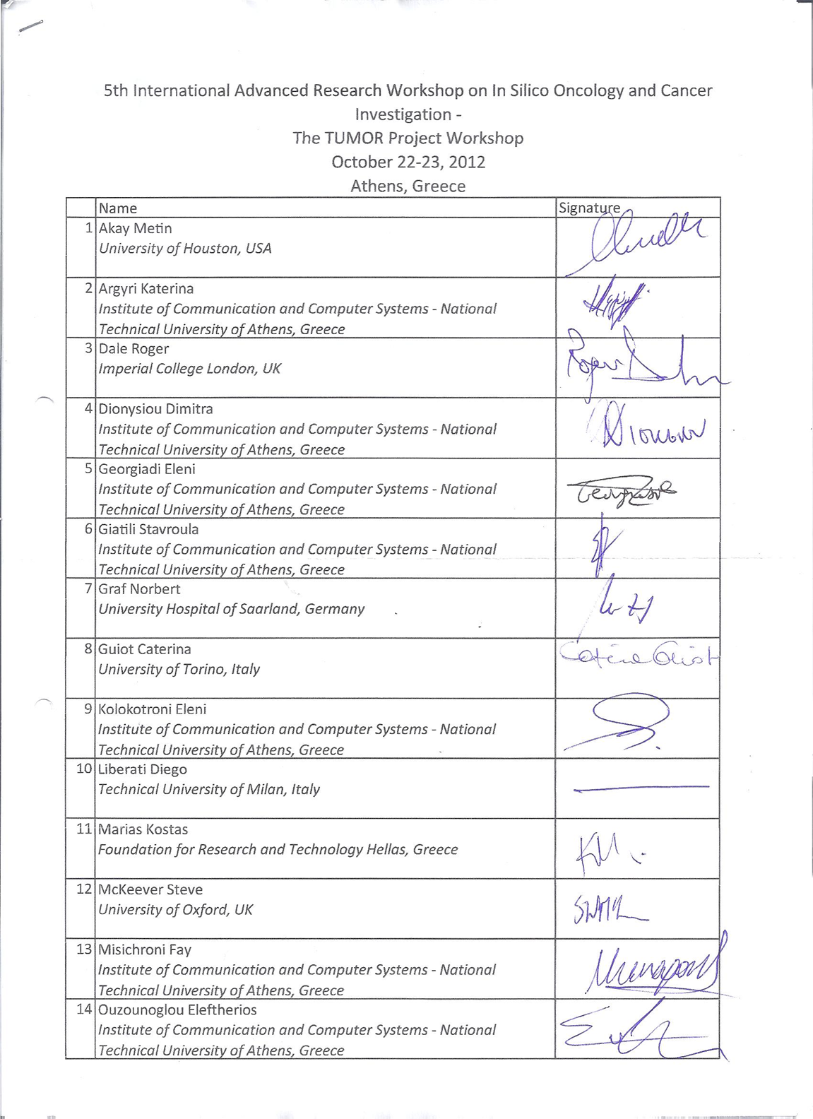

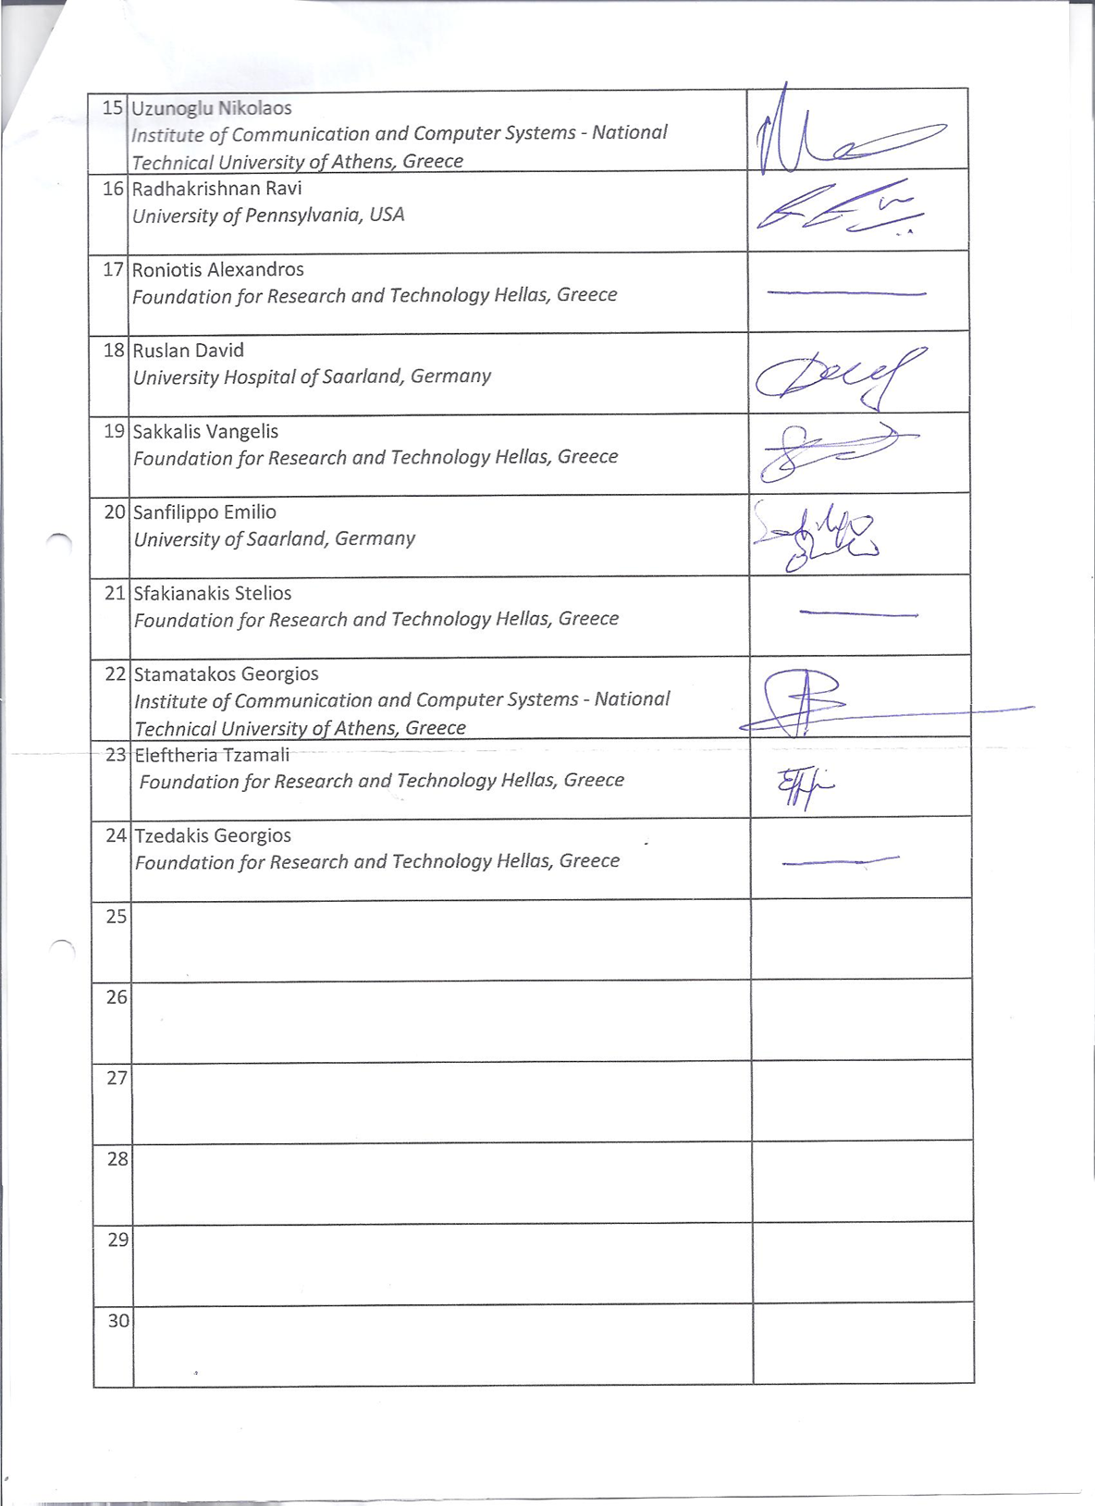

1. Sponsors

The workshop was sponsored by the European Commission Directorate-General for Information Society and Media Virtual Physiological Human initiative through the [TUMOR project](http://tumor-project.eu/).

It was also technically co‐sponsored by the Institute of Electrical and Electronics Engineers (IEEE), Engineering in Medicine and Biology Society (EMB).

1. IEEE-EMB Technical Co-Sponsorhip

Following a strict evaluation procedure, the workshop was approved by IEEE-EMB to be designated as an *IEEE-EMB technically co-sponsored event*. Therefore, the whole scientific and organizational procedure met the high IEEE standards. Particular attention was paid to the manuscript review procedure which was implemented according a detailed Memorandum of Understanding (MoU) signed by IEEE-EMB and the General Chair of the workshop (G. Stamatakos). Fig.3 shows a screenshot of the workshop’s webpage in the IEEE website.

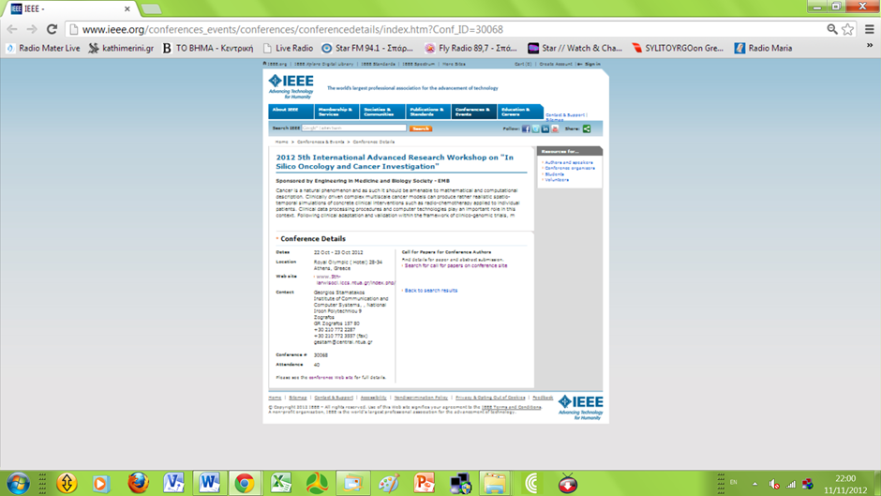

Fig. 3 A screenshot of the IEEE webpage of the workshop

<http://www.ieee.org/conferences_events/conferences/conferencedetails/index.htm?Conf_ID=30068> [2]

Additionally, following a thorough examination of the content and the data of the workshop along with the content and the Proceedings of the two previous workshops of the series, IEEE-EMB decided that the Proceedings of the workshop will be acquired by IEEE and made widely available through the IEEE Xplore system. Fig. 4 shows part of the letter of proceedings acquisition sent by IEEE to the General Chair of the workshop.

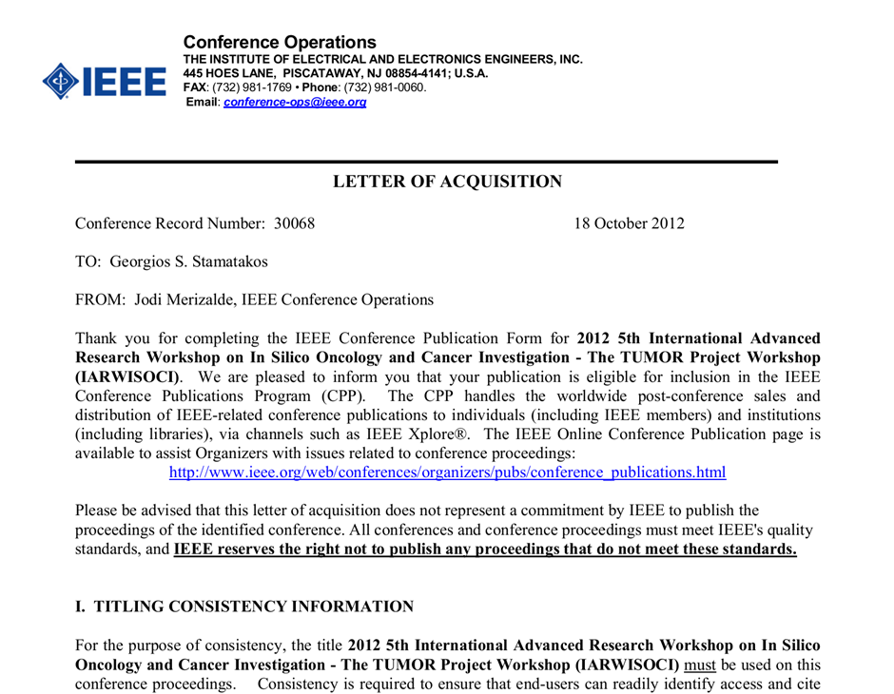

9. Conclusions

In this document an outline of the major aspects of the TUMOR project workshop which was also the 5th International Advanced Research Workshop on *In Silico* Oncology and Cancer Investigation ( 5th IARWISOCI) has been provided. The workshop proved a very successful event since it was attended by top researchers from both the European Union and the United States and provided the opportunity for in depth research work presentations as well as for extensive discussions aiming at the advancement and clinical translation of the emergent discipline of *in silico* oncology constituting a branch of the new domain of *in silico* medicine.

10. References

[1]. The TUMOR Project Workshop Website <http://www.5th-iarwisoci.iccs.ntua.gr/>

[2]. The workshop’s IEEE-EMB webpage

<http://www.ieee.org/conferences_events/conferences/conferencedetails/index.htm?Conf_ID=30068>