

**Transatlantic TUmour MOdel Repositories**

**D6.1**

**External TUMOR Web-site**

Project Number: FP7--IST-247754

Deliverable id: D 6.1

Deliverable name: External TUMOR web-site

Submission Date: 4 August 2010



|  |  |
| --- | --- |
| ***COVER AND CONTROL PAGE OF DOCUMENT*** | |
| Project Acronym: | TUMOR |
| Project Full Name: | Transatlantic TUmour MOdel Repositories |
| Document id: | D6.1 |
| Document name: | D6.1 - External TUMOR web-site |
| Document type (PU, INT, RE) | PU |
| Version: | 6 |
| Submission date: | 4 August 2010 |
| Editor: Organisation: Email: | Georgios Stamatakos  ICCS  gestam@central.ntua.gr |

Document type PU = public, INT = internal, RE = restricted

|  |
| --- |
| **ABSTRACT:**  The present deliverable describes the website of the TUMOR project (<http://www.tumor-project.eu>) which has been developed in the context of the dissemination activities of the project. |

|  |
| --- |
| **KEYWORD LIST**: TUMOR, multiscale cancer modelling, in silico oncology, transatlantic cooperation, model repositories, website, dissemination activity |

|  |  |  |  |
| --- | --- | --- | --- |
| ***MODIFICATION CONTROL*** | | | |
| Version | Date | Status | Author |
| 1.0 |  | Draft | Ioanna Lykourentzou |
| 2.0 |  | Draft | Dimitra Dionysiou |
| 3.0 |  | Final | Georgios Stamatakos |

List of Contributors

All TUMOR partners

Contents

Contents 4

1 TUMOR Project Executive Summary 5

2 D6.1 - Deliverable description 6

3 References 15

TUMOR Project and Website Executive Summary

The TUMOR project aims at developing a European *clinically oriented* semantic-layered cancer digital model repository from existing EU projects that will be interoperable with the US grid enabled semantic-layered digital model repository platform at CViT.org (Center for the Development of a Virtual Tumor, Massachusetts General Hospital (MGH), Boston, USA) which is NIH/NCI-caGRID compatible. This interoperable, CViT interfaced, environment will offer a range of services to international cancer modelers, bio-researchers and eventually clinicians aimed at supporting both basic cancer quantitative research and individualized optimization of cancer treatment. This ‘Transatlantic’ project will therefore be the starting point for an international validation environment which will support joint applications, verification and validation of the clinical relevance of cancer models. To ensure the clinical relevance of this joint effort, the development of the project will be based upon specific clinical scenarios that will be implemented within an integrated EU-US workflow environment prototype for predictive, *In Silico Oncology-*guided clinical studies that will be deployed towards the end of the project. As an end result, a specific, clinically relevant workflow involving both EU and CViT models will be demonstrated, which will clearly highlight the need for and added value of interoperability. To achieve these goals, multiscale models/tools developed and data collected within the framework of three ongoing EC funded research projects, namely ACGT [Advancing Clinicogenomic Trials on Cancer], ContraCancrum [Clinically Oriented Cancer Multilevel Modeling] and the VPH NoE [Virtual Physiological Human Network of Excellence], in conjunction with models and data from the NIH supported ICBP Program CViT.org will drive the development, optimization and validation of the integrated system. Thus, a new module of the VPH environment will emerge. The present deliverable describes the TUMOR project website, which has been developed to fulfill part of the dissemination activities of the project. This public website will thus serve as the first information point of the research community regarding the objectives, approaches and results obtained through the TUMOR project. The address of the website is [**http://www.tumor-project.eu**](http://www.tumor-project.eu) . The design and the development of the website focuses on two main axes: a) accessible and user-friendly design and b) information provision regarding the TUMOR project.

D6.1 - Deliverable description

The present deliverable describes the TUMOR project website, which has been developed to fulfill part of the dissemination activities of the project. This public website will thus serve as the first information point of the research community regarding the objectives, approaches and results obtained through the TUMOR project.

The address of the website is the following: **http://www.tumor-project.eu**

The design and development of the website focuses on two main axes: a) accessible and user-friendly design and b) information provision regarding the TUMOR project.

**Accessible Design**

As far as accessibility and user-friendliness is concerned, every effort has been taken to render the website functional, accessible, interoperable and easy-to-use.

To this end, the markup of the website has been successfully evaluated as HTML 4.01 Transitional, through the formal W3C markup validation service[1].

The cascading style sheets (CSS), used in the website, have also been validated to conform to the W3C recommendations [2].

Finally, the color contrast and brightness of the website have been evaluated as successfully meeting the W3C recommended standard [3].

The above are depicted through the respective W3C validation logos, at the bottom right corner of each website page (figure 1).

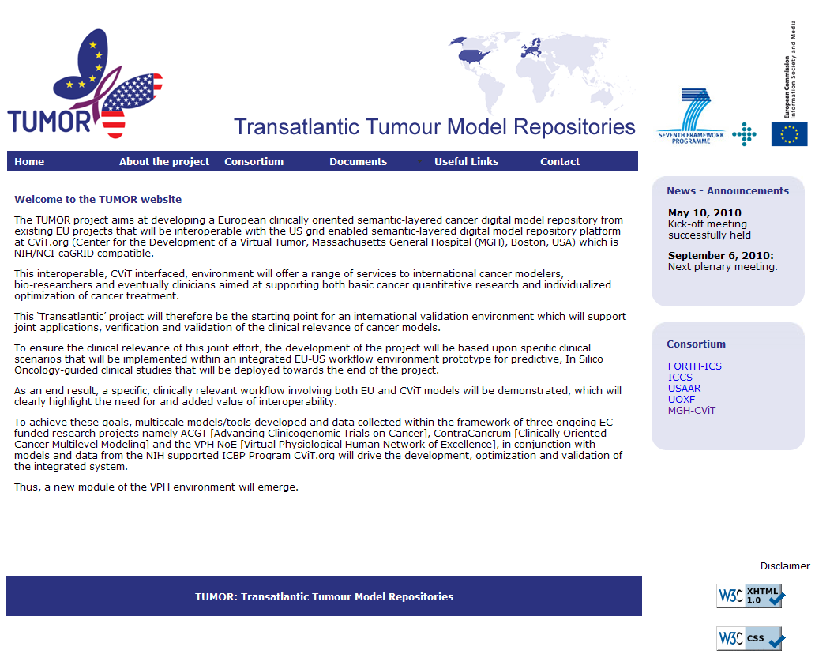

**Figure 1. Home page of the TUMOR project website**

**Information provision**

As far as information provision is concerned, the website consists of six main categories:

1. *Home*: This page provides a brief overview of the TUMOR project and introduces the reader to its main scope.
2. *About the project*: This page provides information general information regarding the TUMOR project (such as its start and end date, its duration in months and its funding schema), as well as information regarding its concepts and objectives (figure 2).

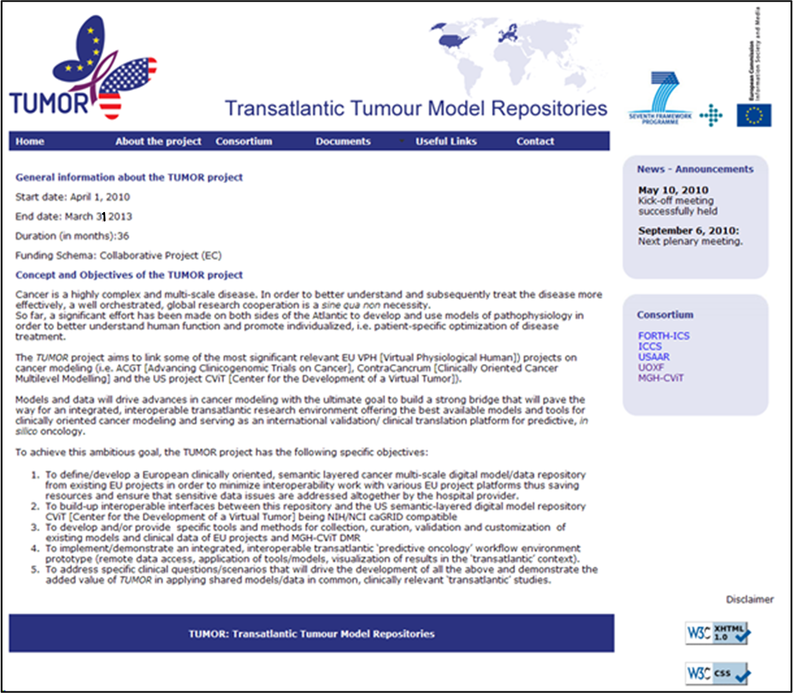

**Figure 2. The “About the project” page of the TUMOR website**

1. *Consortium*: This page offers information regarding the members of the TUMOR project consortium, as well as links to their individual websites (figure 3).

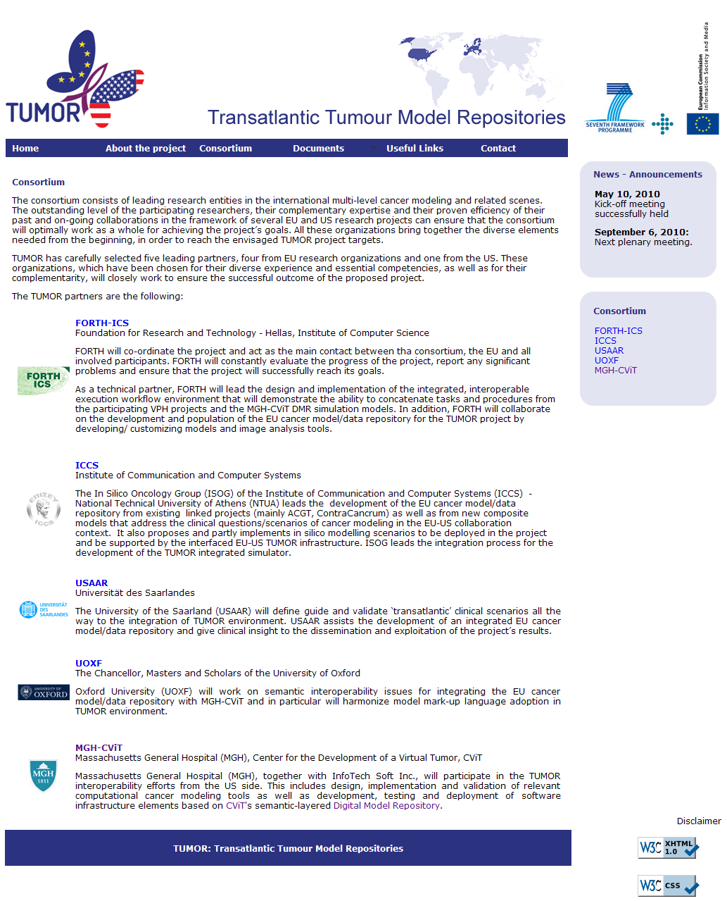

**Figure 3. The “Consortium” page of the TUMOR website**

1. *Documents*: This page is intended to contain all the documents related to the project. It includes the following sub-sections:
   1. *News*: This section includes the recent news (also included in the dedicated *News* section) and the archive news related to the project activities (figure 4).

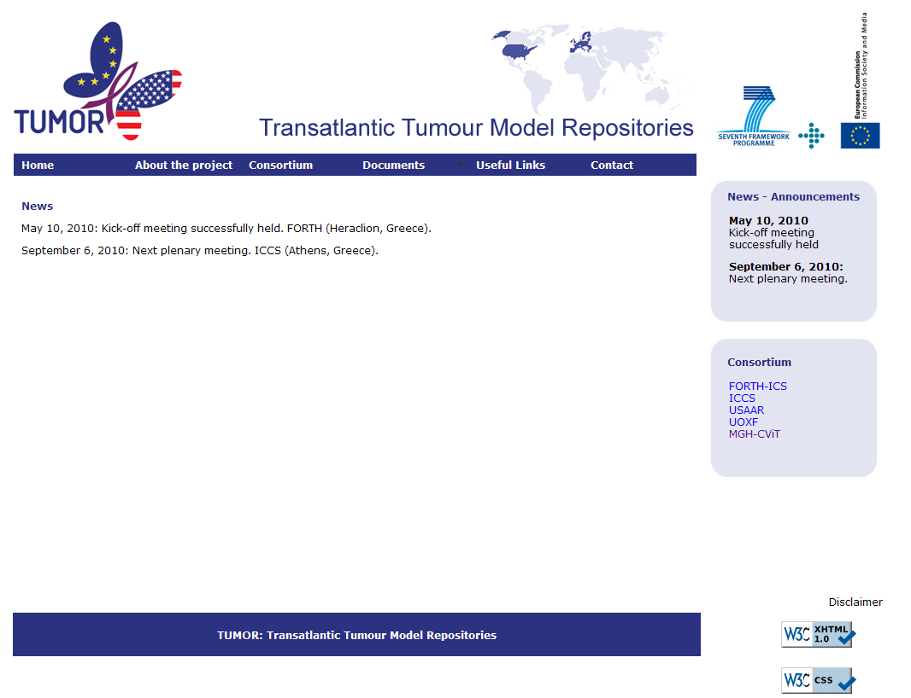

**Figure 4. The “News” page of the TUMOR website**

* 1. *Public deliverables*: This sections lists public-access project deliverables.
  2. *Publications*: Includes all other publication data of the project, such as articles and material from participation at events, presentation slides, keynote speeches, as well as published journal articles and conference proceedings.

Aiming at reflecting the most current project status, this section will be continuously updated as new information becomes available.

1. *Useful links*: To add value and promote the dissemination of the project result, this section includes links of the broader research community that the TUMOR project belongs to, such as links to the CViT.org community, the VPH initiative, as well as to the ACGT and ContraCancrum projects (figure 5).

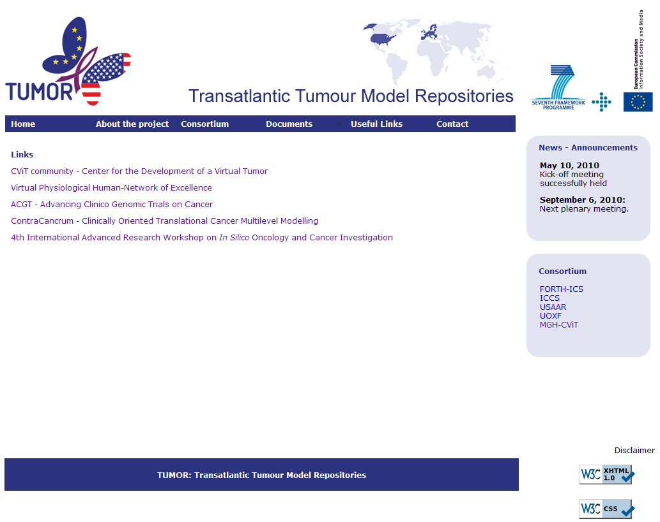

**Figure 5. The “Useful Links” page of the TUMOR website**

1. *Contact*: In this section contact information related to the TUMOR project can be found (figure 6).

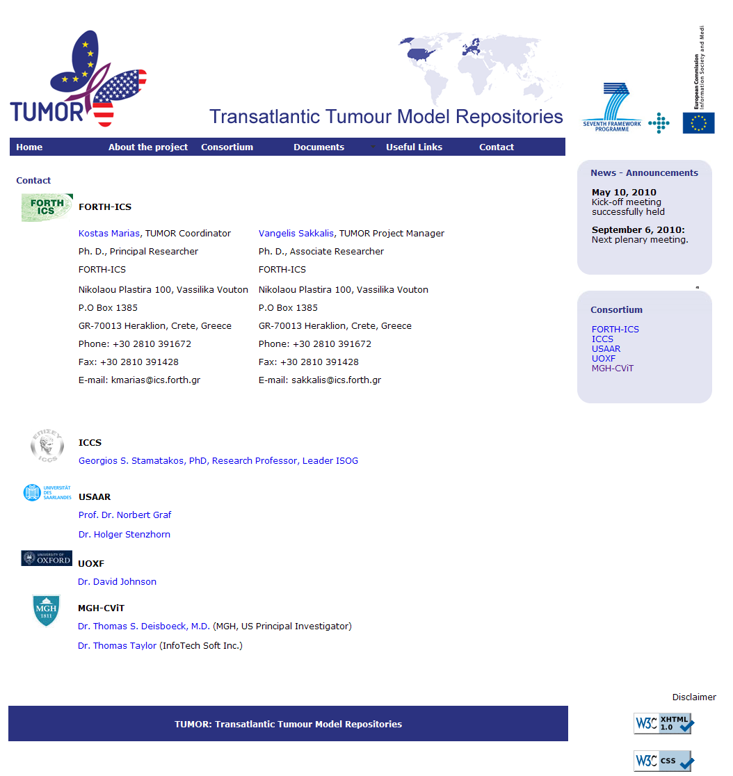

**Figure 6. The “Contact” page**

1. *News - Announcements*: This section, placed in the right side of each page of the website, presents news and announcements related to the project. Similarly to the documents section, this section will also be updated regularly.

*EC funding*: A clear acknowledgment to the provided EC funding has been included in all pages of the website, through the following disclaimer (figure 7):

“*This project is partially funded by the European Commission under the seventh framework programme. The content of this web site is the sole responsibility of the project partners and in no way represents the view of the European Commission or its services. Project Identifier: FP7-247754* ”.

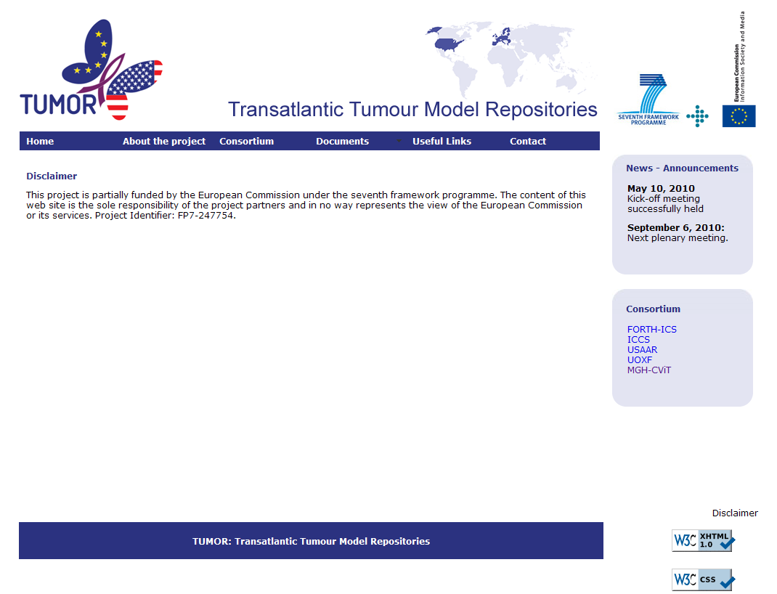

**Figure 7. The “Disclaimer” page of the TUMOR website.**

References

[1] W3C markup validation service, http://validator.w3.org/, retrieved on 25 June 2010.

[2] W3C CSS validation service, http://jigsaw.w3.org/css-validator/, retrieved on 25 June 2010.

[3] AccessColor analyzer, http://www.accesskeys.org/tools/color-contrast.html