

ICT-2010-270253

INTEGRATE

Driving excellence in Integrative Cancer Research through Innovative Biomedical Infrastructures

STREP
Contract Nr: 270253

Deliverable: 3.1 Canonical models of CTMS and HER systems

Due date of deliverable: (01-31-2012)
Actual submission date: (MM-DD-YYYY)

Start date of Project: 01 February 2011 | Duration: 36 months

Responsible WP: UPM

Revision: outline

Project co-funded by the European Commission within the Seventh Framework Programme (2007-2013)
Dissemination level
PU | Public | x
PP | Restricted to other programme participants (including the Commission Service
RE | Restricted to a group specified by the consortium (including the Commission Services)
CO | Confidential, only for members of the consortium (excluding the Commission Services)

DOCUMENT INFO

Author

Author | Company | E-mail
Alejandro García | UPM | agarcia@infomed.dia.fi.upm.es
David Pérez del Rey | UPM | dperez@infomed.dia.fi.upm.es
Víctor Maojo García | UPM | vmaojo@infomed.dia.fi.upm.es
Gema Molina | UPM | gmolina@infomed.dia.fi.upm.es
Jasper Van Leeuwen | Phillips | jasper.van.leeuwen@philips.com

Documents history
Document version # | Date | Change
V0.1 | 15/11/2011 | Starting version, template
V0.2 | 15/11/2011 | Definition of ToC
V0.3 | 05/01/2012 | First complete draft
V0.4 | 05/01/2012 | Integrated version (send to WP members)
V0.5 | 13/01/2012 | Updated version (send PCP)
V0.6 | 13/01/2012 | Updated version (send to project internal reviewers)
Sign off | 27/01/2012 | Signed off version (for approval to PMT members)
V1.0 |  | Approved Version to be submitted to EU

Document data

Keywords
Editor Address data | Name: Alejandro García Ruiz  Partner: UPM  Address: Facultad de Informática  Universidad Politécnica de Madrid  Campus de Montegancedo, s/n  28660 Boadilla del Monte, Madrid, Spain  Phone: +34 91 336 74 67  Fax:  E-mail: agarcia@infomed.dia.fi.upm.es

Delivery date

Distribution list
Date | Issue | E-mailer

Table of Contents

0 DOCUMENT INFO 2
0.1 Author 2
0.2 Documents history 2
0.3 Document data 2
0.4 Distribution list 2
1 Introduction 5
2 Data sources 6
2.1 Case Report Forms (CRF) 6
2.2 TOP trial 7
2.2.1 CRF metadata and data 8
2.2.1.1 Schedule of Assessment and Registration checklist 8
2.2.1.2 Eligibility criteria: Inclusion or exclusion 8
2.2.1.3 Patient’s characteristics 9
2.2.1.4 Primary breast cancer and pre-treatment tumour characteristics 10
2.2.1.5 Tumour assessment 11
2.2.1.6 Administration of Epirubicin 11
2.2.1.7 Toxicity 12
2.2.1.8 Primary treatment completion and surgery 12
2.2.1.9 Residual tumour characteristics, lymph nodes and final response 12
2.2.1.10 Post-surgery treatments 13
2.2.1.11 Follow up 14
2.2.2 Aggregated clinical data 14
2.2.3 Genomic data 15
2.2.3.1 Microarrays Standards: 15
2.3 NeoALTTO 17
2.3.1 CRF metadata 19
2.3.1.1 Screening 19
2.3.1.2 6 weeks 22
2.3.1.3 12 weeks 23
2.3.1.4 Surgery 24
2.3.1.5 FEC 26
2.3.1.6 34 weeks 26
2.3.1.7 Next 10 years 27
3 Common Data Models 29
3.1 I2B2 29
3.1.1 Data Repository (CRC) 30
3.1.2 Ontology Management (ONT) 32
3.1.3 Architectural Considerations for i2b2 33
3.2 OMOP 34
3.2.1 Logical Data Model 34
3.2.2 Architectural Considerations for OMOP 38
3.3 HL7 RIM 39
3.3.1.1 ACT 40
3.3.1.2 ENTITY 42
3.3.1.3 ROLE 42
3.3.1.4 ACT RELATIONSHIP 44
3.3.1.5 PARTICIPATION 44
3.3.1.6 ROLELINK 45
3.3.1.7 Specializations 45
3.3.2 HL7 Version 2.5 (ORU-OUL) 49
4 Common Information Model 50
4.1 Core dataset 50
4.1.1 MedDRA 50
4.1.2 SNOMED-CT 51
4.1.3 LOINC 53
4.1.4 MeSH 54
4.1.5 ICD-10 54
4.2 Data management and linkage 54
5 CONCLUSIONS 56
6 REFERENCES 58
7 Bibliography 59

Introduction

The main aim of the INTEGRATE project is to develop flexible infrastructure components and tools for data and knowledge sharing in biomedical research. Based on the input provided by real-life clinical trials this infrastructure will bring together heterogeneous multi-scale biomedical data generated by standard and novel technologies in post-genomic clinical trials and seamlessly link to existing research and clinical infrastructures, such as clinical trials management systems, CRFs, hospital EHRs, and to relevant external biomedical infrastructures.

The INTEGRATE project is composed of a several work packages. This deliverable is part of work package 3, which main objective is to enable interoperability between the project environment and the relevant external research and clinical infrastructures. At the core of the INTEGRATE semantic interoperability layer lies a standards-based semantic core dataset which is linked to the canonical information models that represent the other relevant systems. The semantic core dataset together with the devised mappings will enable the linkage between the data sets and models stored and managed by the INTEGRATE infrastructure and the data in the relevant external systems.

This deliverable is created in the context of task 3.2: "Create an information model of the clinical and research infrastructures” and also task 3.1: "Define a semantic core dataset" and task. First, the data sources of the pilot sites are described, using two clinical trials as specific examples: the TOP Trial and the NeoALLTO trial. Below there are presented suitable ontologies and vocabularies that could be included within semantic core dataset of the project MedDRA, SNOMED-CT and LOINC. And finally, candidates to define the common data model, required to store and manage patient-based data are analysed: i2b2, OMOP and HL7 RIM.

Data sources
In the current practice, the compilation of patient data is collected through the filling of clinical trial-specific forms, focusedonly on obtaining required information to perform the investigation derived and related with this particular trial. In order to alleviate this wasting of data, the INTEGRATE project arises, aiming to provide the accumulated data, enabling sharing of useful information between clinical investigations. The objective is to improve the obtained results and to facilitate the work of researchers as much as possible.

The INTEGRATE project mission requires, not only to process and store all the collected clinical data, but also to understand and manage all the metadata associated to each part of every processed clinical trial. Specifically, in the NeoBIG program, there is a wide variety of expected information which range from the own trial protocol (eligibility criteria or informed consent templates) to the specified clinical trial data (clinical reports forms or informed consent forms filled in by the patient).

Case Report Forms (CRF)

The Breast European Adjuvant Studies Team (BrEAST) is a specialized clinical trial unit (data centre) created in order to conduct large, international Phase III studies in breast cancer aiming to register new drugs. The unit is responsible for setting-up, coordinating and managing the data collected in these trials, which are run in collaboration with pharmaceutical companies and the Breast International Group (BIG). The participating sites used paper or electronic questionnaires to collect data that are called Case Report Forms (CRF). These documents collect all data of patients, from eligibility criteria to outcome and adverse events.

The Breast European Adjuvant Studies Team makes use of the “Oracle Clinical” Clinical Data Management System to manage and to store the data captured on the CRFs. Therefore it is essential to understand the Oracle Clinical structure in order of understand the composition of trials that are defined using this standard.

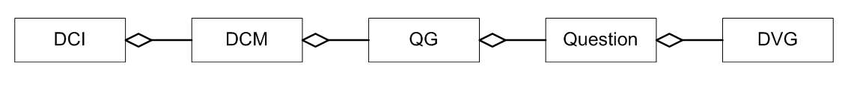
Figure 1 – Composition and structure of the Oracle Clinical Database

The Figure 1 shows the exact structure of the Oracle Clinical database that is divided in five different groups:

- Discrete Value Group (DVG): A set of allowed possible values for a parameter or all the possible answers to a specific Question

- Question: A particular question on a CRF and its respective answer

- Question Group (QG): A group of related questions which can be handy used to reuse groups of questions on different CRFs

- Data Collection Module (DCM): Represents each of the sections of a CRF. They should be answered during a single clinical visit

- Data Collection Instrument (DCI): Corresponds to a CRF

In the subsequent sections, two of the most relevant NeoBIG trials are specified in order to allow the understanding of the clinical trials structure and its performance. These trials are the “TOP Trial” and the “NeoALTTO”, both of them will be processed and managed by initial versions of the INTEGRATE platform.

TOP trial
Validated biomarkers predictive of response and resistance to a class of drugs called anthracyclines in breast cancer are currently lacking. The neoadjuvant Trial of Principle study (TOP) was specifically designed to evaluate the predictive value of topoisomerase II-α (TOP2A) and develop a gene expression signature to identify those patients who do not benefit from anthracyclines.
In other words, the Trial of Principle is a prospective evaluation of topoisomerase II alpha gene amplification and protein overexpression as markers predicting the efficacy of epirubicin (an anthracycline drug) in the primary treatment of patients with breast caner.
The TOP trial included 149 patients, 139 of whom were evaluable for response prediction analyses. The primary end point was pathologic complete response (pCR). TOP2A and gene expression profiles were evaluated using biopsies collected prior to administration of epirubicin. Gene expression data from estrogen receptor (ER)-negative samples of the EORTC (European Organisation for Research and Treatment of Cancer) 10994/BIG (Breast International Group) 00-01 and MDACC (MD Anderson Cancer Center) 2003-0321 neoadjuvant trials were used for validation purposes.
In the subsequent sections, the composition of the study is going to be described, with particular emphasis in the specification of the data requested to complete the forms.

CRF metadata and data

The Trial of Principle is composed of a series of Oracle clinical DCMs. Each DCM collects the required data to perform the investigation. Below, TOP Trial DCMs are described in detail.

Schedule of Assessment and Registration checklist

A schedule of assessment to be carried out on patients enrolled in the trial is specified in the study Protocol. The schedule consists of different tests and exams to be performed in 3 different visits:

- A baseline, (upto 28 days before the first infusion of Epirubicin)
- During the Epirubicin treatment period
- Once the Epirubicin treatment is finished

The following data items will be collected in the three visits: physical examination, a tumour assessment, a breast biopsy (TRU-CUT), measurements of hormone receptors, analysis of a serum and whole blood samples and different hematology & biochemistry tests (Red blood cells, Hb, Platelets, WBC, ANC,Total Bilirubin, Serum Creatinine, GOT/GPT, Alkaline Phosphatase). A bilateral mammography and a breast ultrasound will be performed for visits 1 and 3. Some examinations and data collection procedures are performed only for the baseline visit, i.e. the medical history of the patient, an electrocardiogram, the measurement of the left ventricular ejection fraction (LVEF), X-ray tests, bone scans, and liver ultrasounds.

Finally, it is necessary to complete a patient registration form in which investigators add the relevant personal information of the patient (date of birth, initials). They include their own personal relevant information that will be associated to the trial (institution, name) and determines if the patient is eligible for the trial (if not, justifies the reason of the exclusion). If the patient is included, a date of inclusion and a patient number that will be used as his identification is provided.

Eligibility criteria: Inclusion or exclusion

This section helps investigators to decide if the patient could be considered for enrolment in the trial not. The patient has to complete two forms –lists of medical conditions–, inclusion and exclusion, marking if each condition is true or false. Once the forms are completed, the investigator will decide if the patient is suitable for enrolment in the investigation. A patient must fulfil all the inclusion criteria, and none of the exclusion criteria to be suitable for enrolment.

- Inclusion criteria: The form checks if the patient has an operable, locally, advanced or inflammatory breast cancer; his/her gender, if his/her age is under 70 years, if the tumour is larger than 2 cm (measured by ultrasound examination), if the tumour is ER-negative, if there exist fixed and frozen samples from the primary tumour –or from a multifocal tumour in such case–, if the performance status is under 1 in the Eastern Cooperative Oncology Group (ECOG) scale, if there exists a signed informed consent form (ICF), if the left ventricular ejection fraction (LVEF) as measured by Echocardiography is normal, if a pregnancy test has been performed and is negative in the case of a woman with childbearing potential, if the value of the absolute neutrophil count (ANC) and from platelets is larger than 1500/mm3 and 100.000/mm3 respectively, if the level of haemoglobin is higher than 10g/dl, the bilirubin and serum creatinine levels lower than the laboratory normal value, if the GOT/GPT liver enzymes are lower than 1.5 times the laboratory normal value and if the alkaline phosphatase (AP) level is under 2.5 times the laboratory normal value.

- Exclusion criteria: This form checks if the patient has a metastatic breast cancer, a concomitant contralateral invasive breast cancer, or some kind of serious medical conditions like: congestive heart failure, unstable angina pectoris, previous history of myocardial infarction within 1 year from study entry, uncontrolled arrhythmias, history of significant neurologic or psychiatric disorders, active uncontrolled infections, active peptic ulcers or unstable diabetes mellitus. Also checks if the patient has received a previous treatment with anthracyclines or is receiving concurrent treatment with hormonal replacement treatment or with any other anti-cancer therapy.

Patient’s characteristics

This section of the CRF collects information about physical characteristics of the patient, including the height (in centimetres), the weight (in kilograms) and the body surface area or BSA (measured in square metres).

In addition, if the patient is female, it collects her menopausal status which can take four different values:

- Premenopausal: less than 6 months since last menstrual periods and no prior ovariectomy and no estrogen replacement therapy
- Postmenopausal: Prior bilateral ovariectomy or less than 12 months since last menstrual period with no prior hysterectomy and not receiving LHRH analog.
- Above category not applicable and less than 50 years
- Above category not applicable and more than, or equal to 50 years

Finally the patient is enquired about his/her medical history, whether he/she has suffered from significant diseases and if so, investigating the current status of these diseases (ongoing, terminated, when they had started and when they ceased).

Primary breast cancer and pre-treatment tumour characteristics

First of all, some concise and simple data is collected about the primary breast cancer, specifically the date when the tru-cut biopsy took place, the identification number of the biopsy and the laterality (left or right) of the breast in which the lesion is located.

Data is collected regarding primary breast tumour characteristics prior to treatment, including: date of histologic diagnosis of the tumour and Estrogen and Progesterone receptor status. The value of both of these measurements could be: negative, positive or unknown. In case of a positive value the result of the percentage of positive cells found is requested too. In addition, the specific histological type of the tumour is collected (invasive ductal, invasive lobular or some other histological type, which then has to be specified), the presence of an in-situ, and in that case the specific histological type of that in-situ component.

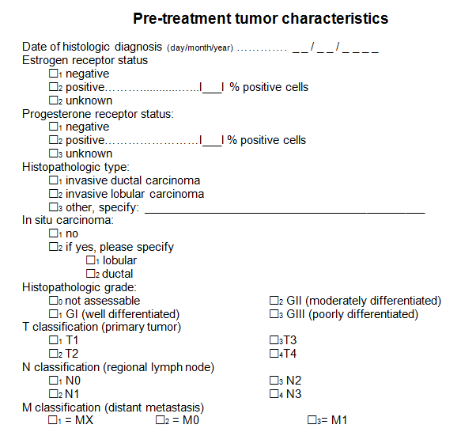

Figure 2 – Composition of the trial section relative to pre-treatment tumour characteristics

Finally the investigator has to fill the tumour grade and the TNM tumour classification:

- Histopathologic grade (G): Possible values are GI, GII or GIII, namely well, moderately or poorly differentiated respectively. Also it could be considered as “not assessable”

- T classification: Describes tumour size and the spread to the skin or to the chest wall under the breast. Could be T1, T2, T3 or T4, a higher number means a larger or more widely spread tumour

- N classification: Indicates if the cancer has spread to lymph nodes and, if so, the number and location of the affected lymph nodes. Can be N0, N1, N2 or N3

- M classification: Presence of metastases: indicates if the cancer has spread to different organs. It is possible values could be MX (unknown), M0 (no known metastases) and M1 (metastases present)

Tumour assessment

Tumour assessments are carried out at two different time points: at baseline, and after the Epirubicin has been administered. Evaluations are performed by two methods, by clinical examination and by ultrasound, with the results of both of them measured in millimetres.

Four measurements are made:

- Measurement of the primary tumour
- Measurement of a second primary tumour in case of multifocal or multicentric lesions
- – (d) Lymph node involvement for two lymph nodes

Administration of Epirubicin

In this section, information is requested regarding Epirubin administration, including:

- Cycle number (up to six administration cycles are possible)
- Date of last administration
- Dose administered
- Whether the treatment dose has been reduced or delayed for that cycle. In that case, the reason for delay or dose reduction is asked. Some possible reasons include the appearance of toxicity (indicating if it is hematological or non-hematological) or infections
- In case of dense dose chemotherapy schedule, it is enquired whether Granulocyte Colony-Stimulating Factor (GCSF) was given according to the protocol during the cycle, asking also in case of an affirmative answer about the date of administration and the total dose administered

Toxicity

This section reports adverse effects and diseases that the patient suffers from at the moment of evaluation and during Epirubicin administration cycles. For each of the adverse effects checked, meaning that the patient suffers from the corresponding condition at the moment of evaluation, some addition information is requested:

- Grade of intensity of the adverse event (in a scale between 1-4)
- Date of start and stop of the event or else the indication that this adverse event is ongoing
- Likelihood of a relation between the medication and the adverse event
- An investigator's assessment whether the condition has to be considered as a serious condition or not

The adverse events evaluated are grouped in different categories classified by system organ class : Gastroinstestinal (Nausea, Vomiting, Diarrhea or Stomatitis), Pulmonary (Cough, Dysphea or Pleural effusions), Neurological (Sensor or Motor neuropathies), Cardiovascular (Arrhythmia, Edemas or Hypotension), Skin (Alopecia or Nail disorders), Constitutional symptoms (Asthenia or Fever), Pain (Myalgia or Arthalgia), Sexual or reproductive function (Irregular menses), Infections (Neutropenia or generic infections), Allergies or other adverse effects.

Primary treatment completion and surgery

This section is an evaluation of the treatment once it is completed and a specification of, in case the tumour has been surgically removed the kind of breast surgery received by the patient. Collected data about the treatment consist of: the total number of Epirubicin cycles administered, the dose-density, the final cumulative dose administered, and reason to end the treatment.

Ending the treatment may occur due the following reasons:

- Patient has received the maximum number of cycles according to the protocol
- Progression or disease relapse during treatment
- A specific adverse event (must be specified)
- Patient has been lost to follow-up
- A major protocol violation
- Patient death
- Another reason to be specified

On the other hand the information collected about breast cancer surgery consist of date of intervention and specific type of surgery performed, that can be: Lumpectomy, Quadrantectomy, Mastectomy, Axillary node dissection or other specific type of surgery.

Residual tumour characteristics, lymph nodes and final response

This section collects the characteristics of the residual tumour, that is:

- If tumour is considered multifocal and multicentric
- Size in square millimetres of the invasive component
- Histological type (ductal, lobular or other) of carcinoma and of its possible in-situ component

The surgical margin of the tumour refers to the normal tissue that is found between the surgical cut margin and the tumour tissue in the resected specimen, and is evaluated and classified, as one of three different levels: Negative (size greater than 1 mm), Close (size lower than 1 mm) or involved. The histopathologic grade described above that could take the value of GI level (well differentiated), GII level (moderately differentiated), GIII level (poorly differentiated), or not assessable.

Pathologic stage (pT) is also calculated: pT codifies the degree of radial extension of the tumour at its deepest point of invasion. This cancer staging code is sub classified as follows:

- pTX: Primary tumour cannot be assessed
- pT0: No evidence of any primary tumour
- pTIS: Carcinoma in situ as sole remaining tumour. Intraductal carcinoma of lobular carcinoma in situ or Paget disease of the nipple as all remaining tumour
- pT1: Invasive tumour of 2cm or less in its greatest dimension
- pT2: Invasive tumour more than 2cm but lower than 5cm
- pT3: Invasive tumour more than 5 cm in its greatest dimension
- pT4: Invasive tumour of any size with direct extension to chest wall or skin

Information about regional lymph nodes is collected, including:
- Number of resected axillary lymph nodes
- Number of positive axillary lymph nodes
- Pathologic lymph nodes pN staging, subclassified as follows

- pNx: Regional lymph nodes cannot be assessed
- pN0: No regional lymph nodes metastasis
- pN1: Metastasis to movable ipsilateral axillary node(s)
- pN2: Metastasis to ipsilateral lymph node(s) that are fixed to one another or to other structures
- pN3: Metastasis to ipsilateral internal mammary lymph node(s)

Finally the pathological complete response (pCR) is evaluated, and can be considered as “not observed” or pT0, pTis and pN0.

Post-surgery treatments

This section collects the description of treatments carried out after surgery, including:
- Radiotherapy
- Hormonal treatments and their specific type: Tamoxifen, Aromatase inhibitor, LHRH, or other hormonal treatments to be specified
- Any kind of adjuvant chemotherapy (for example Docetaxel) specifying the number of cycles given and the cumulative dose administered
- Any adjuvant treatment given in the context of any trial (for example HERA)

Follow up

The final section of the CRF tracks the patient periodically in periods of time from 4 months to 5 years. The follow up has a start date. Analyses are performed if the patient disease status has changed. Possible status changes reported are:

- Breast cancer relapse: The target and the date of recurrence must be specified. Recurrence site must be classified as Local, Regional and/or Distant
- Second primary malignancy: Specifies the date of the event and the target site, either the contralateral breast or another site to specify
- Death: In case of patient death, date and cause of death must be reported

Aggregated clinical data

This data contains additional clinical information for all the patients with available microarray and specifies supplementary useful information for the TOP trial.

The clinical information added is the following:

- Age of the patient, specially remarking if it’s more or less than 50 years old

- Information about the tumour size in a range of five different options:

  - T: Primary tumour
  - T1: Less or equal to 2 cm
  - T2: More than 2 cm and less than 5cm
  - T3: More than 5 cm
  - T4: Any size but with direct extension to the chest wall or the skin

- The axillary lymh node status in a range of four different options:

  - N0: No axillary lymph node metastasis
  - N1: Metastasis in movable ipsilateral axillary lymph node(s)
  - N2: Metastasis in fixed ipsilateral axillary lymph node(s) or in clinically apparent ipsilateral internal mammary lymph node(s) in the absence of clinically evident axillary lymph node metastasis

  - N3: Metastasis in ipsilateral infraclavicular lymph node(s) with or without axillary lymph node involvement; or in clinically apparent ipsilateral interna-mammary lymph node(s) in the presence of clinically evident axillary lymph node metastasis; or metastasis in ipsilateral supraclavicular lymph node(s) with or without axillary or internal mammary lymph node involvement

- Many different Biomarker status expressions that evaluate:
  - Estrogen receptor status
  - Progesterone receptor status
  - HER2 by fluorescent in situ hybridization status
  - TOP2A by fluorescent in situ hybridization status

- Several clinical endpoints such as:
  - Pathological complete response
  - Distant metastasis-free survival
  - Overall survival

- And finally, the tumour grade according with the most commonly used system of grading, defined by the guidelines of the American Joint Commission on Cancer. The grading categories are the following:

  - GX: Grade cannot be assessed
  - G1: Well differentiated (Low grade)
  - G2: Moderately differentiated (Intermediate grade)
  - G3: Poorly differentiated (High grade)
  - G4: Undifferentiated (High grade)

Genomic data

A large amount of information on genomic data is collected within NeoBIG trials. These genomic data are commonly derived from Microarray experiments (where DNA strands of different origin will hybridize to complementary bases that compose them). “DNA Microarrays are small, solid supports onto which the sequences from thousands of different genes are immobilized, or attached, at fixed locations”.

Microarrays Standards:

- MIAME: Which means/describes the Minimum Information About a Microarray Experiment that is necessary for the interpretation of the results of an experiment unambiguously and potentially to reproduce this experiment.

Note that MIAME is determined by the content provided, not by the submission format or route.

MIAME guidelines outline the minimum information that should be included when describing a microarray experiment. Many journals and funding agencies require microarray data to comply with MIAME. GEO deposit procedures enable and encourage submitters to supply MIAME compliant data.
The six most critical elements contributing towards MIAME are:

- Raw data for each hybridization (CEL, GPR files...).
- Final processed (normalized) data for the set of hybridizations in the experiment (study) (e.g., the gene expression data matrix used to draw the conclusions from the study).
- Essential sample annotation including experimental factors and their values.
- Experimental design including sample data relationships
- Sufficient annotation of the array (gene identifiers, genomic coordinates, probe oligonucleotide sequences…).
- Essential laboratory and data processing protocols (e.g., what normalization method has been used to obtain the final processed data).

It is recommended to use MAGE-TAB or MAGE-ML formats (based on spreadsheets) to represent the data. MIAME does not specify any particular format, but if access to data is provided, data are more useful.

- Microarray probe files:
The Affymetrix CEL format and the Illuminia Infinium Methylation Assay are examples of microarrays probe files formats. The CEL files (Affymetrix) stores the computed probe results (the results of the intensity calculations on the pixel values of the DAT file [the raw image file]). Depending on the version, the file format is different. For example, in version 4, the format of the CEL file is binary file were values are stored in little-endian format.

Given the user scenario's, the CEL files can be considered as blobs (binary files), as each CEL file is always retrieved completely and the platform never needs to query the (specific) content of a CEL file. This implies that CEL files can be stored as binary objects in the platform, while the metadata necessary for finding the data and analyzing the data can be provided separately. Below, three of these examples (2 Affymetrix microarrays and the HumanMethylation27) are described:

- Affymetrix GeneChip® Human Genome U133 Plus 2.0 Array
This microarray contains probes for more than 38,500 transcripts corresponding to well-characterized genes and Unigene genes, giving a full-genome view of gene expression. The analysis will start from the “raw” .cel files that contain probe-level intensity data. This allows various schemes of data normalization and probe set data aggregation. The .cel files also contain the necessary information for array and hybridization quality assurance. The size of a .cel file for this microarray is around 32MB. In addition, there are 9,921 new probe sets representing approximately 6,500 new genes. These test data are available for 120 patients from the TOP trial. The recommended analysis tool for these data are the numerous packages of the Bioconductor package devoted to Affymetrix-specific (affy, annaffy…) and downstream data analyses (differential expression, supervised learning…)

- Affymetrix SNP 6.0 Array
This microarray contains probes for more than 906,600 single nucleotide polymorphisms (SNPs) and more than 946,000 probes for the detection of copy number variation (CNV). This corresponds to a median inter-marker distance in the genome of less than 700 nucleotides. Again, the analysis will start from the .cel files, which allows maximum flexibility in the choice of the algorithms for CNV genotyping. The size of a .cel file for this array is around 61MB. For these types of data, the Bioconductor project also provides a rich set of analysis modules. These data are available for 70 patients from the TOP clinical trial.

- Illumina Infinium HumanMethylation27 BeadChip
This array allows to interrogate the methylation status of 27,578 highly informative CpG sites ("CpG" is shorthand for "—C—phosphate—G—", that is, cytosine and guanine separated by only one phosphate) located in the proximal promoters of 14,475 protein coding genes. This corresponds to an average of two interrogated CpGs per genes although subsets of more than 200 cancer-related genes have 3-20 interrogated CpGs. The Infinium assay uses a pair of probes for every CpG, with one probe measuring the level of the methylated CpG and the other probe measuring the level of the unmethylated CpG. The methylation of the CpG is then often expressed as a beta value, which is the ratio of the methylated signal on the sum of the methylated and unmethylated signal. Thus, beta values vary from 0.0 for a fully unmethylated CpG to 1.0 for a fully methylated CpG.

NeoALTTO
Neo–Adjuvant Lapatinib and/or Trastuzumab Treatment Optimisation (NeoALTTO).

NeoALTTO is a trial performed in over 450 women that “its primary objective is to compare the rate of pathological complete response (total disappearance of the tumour) at the time of surgery between three treatment arms”. This trial compares three drug therapies (Lapatinib, Trastuzumab and Paclitaxel) in various combinations to find the most effective treatment. Women with HER-2 positive tumors larger than 2 cm are randomly assigned to one of the following treatment:

- Lapatinib for 6 weeks followed by the addition of weekly paclitaxel for an additional 12 weeks

- Trastuzumab for 6 weeks followed by the addition of weekly paclitaxel for an additional 12 weeks

- Trastuzumab plus lapatinib for 6 weeks followed by the addition of weekly paclitaxel for an additional 12 weeks

Definitive surgery is performed within 4 weeks of the last dose of paclitaxel. After surgery, patients receive 3 cycles of adjuvant chemotherapy (FEC: 5-fluorouracil, epirubicin and cyclophosphamide) followed by the same assigned pre-operative targeted therapy for 34 weeks, with the intention to complete 1 year of anti-HER-2 therapy. contains the design of this trial, the 3 treatment arms.

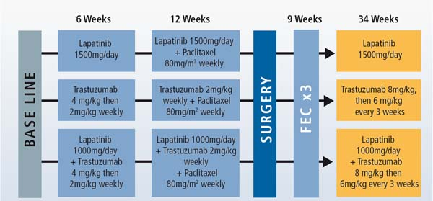

Figure 3 – Design
ELEGIBILITY CRITERIA:

A partial list of eligibility criteria for this trial is:

• Inclusion Criteria:
- Female gender
- Age ≥18 years
- Histological confirmed invasive breast cancer (primary tumour greater than 2 cm diameter, any N, no evidence of metastasis)
- Over expression and/or amplification of HER2 in the invasive component of the primary tumor

• Exclusion Criteria:
- Received any prior treatment for primary invasive breast cancer
- Previous (less than ten years) or current history of malignant neoplasm, except for curatively treated
- Basal and squamous cell carcinoma of the skin
- Carcinoma in situ of the cervix
- Pregnant or lactating women

CRF metadata

A CRF (case report form) is a questionnaire used in clinical trial research to collect data from each participating site. It is a set of DCM (Data Collection Module). Each DCM is a QG (Question Group) or a group of them. The QG collects the related data by grouping related questions, for example, in our case, QG=CANC includes CANC1, CANC2, CANC3 and CANC4. The DCM represents each screen of the data entry.
The DCM of the Base Line () is divided into six sections:

- It represents the baseline status of the patient. DCMs about patient eligibility are performed at this stage, inclusion criteria (ELI1) checking:
- If the patient is a woman older than 18 years
- With an ECOG (Eastern Cooperative Oncology Group) status <= 1
- Who has invasive breast cancer
- With invasive HER2 according to one of its definitions
- With hormonal status (ER (Oestrogen Receptor) status AND PR (Progesterone) status) both known
- With absolute neutrophil count more or equal than 1.5x10⁹/L
- With platelet count more or equal than 100x10⁹/L
- With hemoglobin at least 9 g/dL
- With bilirubin is less or equal to 1.5xULN (Upper Limit of Normal), AST and ALT less or equal to 2.5xULN and alkaline phosphatase less or equal than 2.5xULN, the creatinine has to be less or equal than 2.5 mg/dL
- Not pregnant
- If fertile, that she uses effective contraception
- That she has signed an informed consent form and has accepted to make available tumours samples for submission to central laboratory

Note that all of these criteria have to be passed for patient enrolment
- The exclusion criteria (ELI2) checks:
  - If the patient has received any prior treatment for primary invasive breast cancer
  - If she has (or has had in the last ten years) a history of malignant neoplasms
  - If she has been diagnosed with inflammatory breast cancer or bilateral cancer
  - If she has a known history of uncontrolled or symptomatic angina, clinically significant arrhythmias, congestive heart failure, transmural myocardial infarction, uncontrolled hypertension, unstable diabetes mellitus, dyspnoea at rest, or chronic therapy with oxygen, concurrent disease or condition (or any serious medical disorder)
  - If the patient has serious adverse events from prior administration of other drug, active or uncontrolled infection
  - If she has any psychiatric condition or any gastrointestinal disease
  - If she is being treated with concurrent neoadjuvant cancer therapy
  - If she is currently part of any other therapeutic clinical trial
  - If she has a known immediate or delayed hypersensitivity reaction or idiosyncrasy or contraindication to drugs of the study treatment (or their excipients)
  - If the women is pregnant or lactating
  - If the patient used concomitantly CYP3A4 inhibitors or inducers
  - If any of the exclusion criteria are marked YES, the patient can’t be included in the trial

- Randomization DCM (RND) indicating the starting date of randomization and the treatment arm that will follow (lapatinib, trastuzumab or both together). INF (informed) is focused on signatures of patients consenting to participate in PET/CT Scan study, CTC analysis and in Pharmacogenetic research.
- Demography DCM records the date of birth of the patient and her race. GYN1 reflects the menopausal status, last time of menstrual period and if a pregnancy test has been performed, and if so its date and outcome.
Treatment DCM (TR1 and TR2) tests if the patient has had hysterectomy (TR1) and in positive case if it has been total or partial, and its date. TR2 check unilateral ovariectomy/oophorectomy, and in positive case specify its side (right or left), and date.
- VS1 collects data about vital signs and physical measurements as the date of the physical exam. If results have been normal or abnormal, height, weight, blood pressure, heart rate and the ECOG (Eastern Cooperative Oncology Group), scale used to measure, in a practical way, the quality of life of a patient performance status. Electrocardiogram DCM (EKG), storing the date on which it was done and its result (normal, abnormal –not clinically significant– and abnormal –clinically significant).
- Left Ventricular Ejection Fraction DCM (LVEF), where date of examination is collected, its value, the method of evaluation, if there is symptomatic CHF (Congestive Heart Failure) and in positive case, specify its NYHA (New York Heart Association) classification.
Knowing that this trial is performed only in patients with positive HER2, the next six modules (from the same question group – SLAB) specify the HER2/neu status and its results from the lab (Certified Local Lab or Central Lab) with an ID number.
The first three DCMs are focused on certified results of IHC (immunohistochemistry), FISH (fluorescent in situ hybridisation) and CISH (chromogenic in situ hybridization) and the last three are about not certified results of IHC, FISH and CISH.
“Certified” modules collect the date (if finished) and test results. For IHC (certified), one collects whether the antibody used is DAKO Herceptest and the percentage of invasive tumour cells with complete membrane staining. Certified FISH also include the kit or test type and the FISH Her2/neu Chromosome 17 ratio and copy number (not evaluated, polysomy, monosomy or normal). The last of the certified, CISH, include the kit or test type and the Chromosome 17 copy number (not evaluated, polysomy, monosomy or normal). In the case of the IHC (non certified), the difference between the certified one is that here one has to specify the used antibody (DAKO, CB, TAB, etc). Non Certified FISH and CISH are equal then the certified one, but without the date.
- CANC1 contains the history of primary breast cancer (date of the initial diagnosis, biopsy, method of evaluation, the side of the tumour (right or left), size in MD (maximal diameter) and LPD (largest perpendicular diameter), clinical N stage (different from –more precise than– lymh node status in TOP Trial, see ) and its method of evaluation, and the invasive histological type.

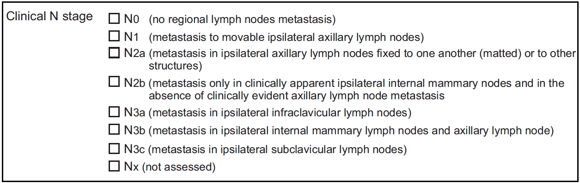

Figure 4 – N stages of lymph nodes

- CANC2 deals with the history of primary breast cancer too; there are four questions: if the carcinoma in situ is present (if yes, define if DCIS –ductal–, LCIS –lobular– or both), if there is lymphovascular invasion, if Paget’s disease of the nipple is present and if the tumour is multifocal/multicentric (if yes, also requests if is one of the following lesions occur: same HER2 and ER/PgR, different HER2, different ER, different PgR or/and other).
- HERPGR is also about history of primary breast cancer but only point laboratory name, city and postal code.
The two following modules belong to the same QG, ERPG. The first one is for ER status (if positive, negative or unknown) and if oestrogen receptor analysis results are available, if yes, specify them and second one is for PgR status (if positive, negative or unknown) and if progesterone receptor analysis results are available, if yes, specify them.
- SURG note if surgery is available since initial diagnosis, if not, specify why (locally advanced, T4a-c or T4d). In next module (TR3) surgery type is specified (lumpectomy, quadrantectomy, etc.).
- LAB shows the date of the last blood drawn and it results. It’s a haematology and biochemistry test.
The following GC of DCM (DIAG, diseases) contains if the patient has had a history of cardiovascular diseases (DIAG1) and if agreed, specifies which one (hypertension, hypotension, arrhythmia, etc), if it has been resolved or is ongoing, their grade and if a treatment is required. DIAG2 contains if the patient has had a history of any other disease other than breast cancer and cardiovascular.
The cext three modules are from the same Question Group (DPRO, radiological examinations). They include questions about the type of radiological examination. The first two modules report which radiological examinations (like Chest X-ray or Chest CT-scan in DPRO1 or left and right mammogram in DPRO2) have been performed, their dates and if there are any clinically significant abnormality (if yes the abnormality is specified). In DPRO2 tumour size is also reported. DPRO3 allows reporting of the type of radiological examination performed using a code table (BS = Bone Scan, CT = CT scan, etc), of its anatomical site (according to a code too), its side (left or right) and the test date. As in DPRO1 and DPRO2, DPRO3 also reports clinically significant abnormalities (and their specifics), if any.
Data about the PET / CT (Positron Emission Tomography – Computed Tomography) that the patient undergoes follows: the SCAN DCM includes assessment date, data about patient preparation including her weight, the injection site, pre-injection blood glucose, etc. The data acquisition protocol (start and end time, FOV (field of view) time, number of FOVS, if the PET has been in two or three dimensions, etc) is also reported. There is a section to describe any problem during data acquisition protocol. PETL1 is a continuation of last DCM (SCAN). It includes a description of lesions : the number of lesions (breast or lymph nodes), the side (left or right), the location within the organ, CT largest bidimensional measurement of lesion, volume of lesion, If there has been uptake or not and the maximum and mean of SUV (Standardized Uptake Value).
The last DCM for screening is TRAN1. This is biological tissue samples. There are six samples (FFPE (Formalin Fixed Paraffin Embedded) tumor core biopsy, blood sample for PGx (Pharmacogenetics), for proteomics (serum and plansma), for CTC (circulatin tumor cells) and snap frozen tumor sample), and for each sample available, specimen collection date ​​is recorded.

6 weeks
- After the initial screening tests, for six weeks, knowing the arm that the patient has been randomized into (lapatinib, trastuzumab or both together), a total of nine different tests (some are repeated) are going to be performed at weeks 2, 4 and 6:VS2 collects data about the patient status (the date of the physical exam and if the result has been normal or abnormal) and vital signs and physical measurements as weight, blood pressure, heart rate and the ECOG performance status.
- CANC3 reports the results of a breast palpation with tumor measurements (its size, MDxLPD) and nodal status. It also reports whether new lesions have been discovered, the clinical cN lymph node stage and an overall clinical tumor response.
- The SCAN DCM follows, with the same data as described for the screening above.
- PETL2 and PETL3 are a continuation of last DCM (SCAN). PETL2 provides a description of lesions : number of lesions (breast or lymph nodes), side (left or right), location within the organ, CT largest bidimensional measurement of lesion, volume of lesion, If there has been uptake or not, maximum and mean of SUV (Standardized Uptake Value) and the lesions’ metabolic response. PETL3 is like PETL2 (side, location, volume, max and mean SUV, etc) but with the difference PETL3 may include all organs, not only breast or lymph nodes.
- TRAN2 is used translational research with tissue samples. It is just like TRAN1. There are six (FFPE (Formalin Fixed Paraffin Embedded) tumor core biopsy, blood sample for PGx (Pharmacogenetics), for proteomics (serum and plansma), for CTC (circulatin tumor cells) and snap frozen tumor sample), and for each collected sample, specimen collection date ​​is recorded.
- LAB is a very important DCM that is repeated many times throughout the trial. It reports the date of the last blood test and its results. It’s a haematology and biochemistry test.
- LVEF (Left Ventricular Ejection Fraction) reports test date, its value, the method of evaluation, if there is symptomatic CHF (Congestive Heart Failure) and in positive case, specify its NYHA (New York Heart Association) classification.
- DPRO2 consists of questions about the type of radiological examinations performed, whether they were performed or not (left and right breast mammogram, left and right breast echography and MRI), their dates, the measured tumour size and if there are any clinically significant abnormality (if so they are specified).
- VS2 and CANC3 are done at each assessment (i.e. at weeks 2, 4 and 6).

12 weeks

Next set of data is collected over 12 weeks (from week 7 to 18). There are only three different DCMs (LAB, VS2 and CANC3). During weeks 10, 13 and 16 the same tests are performed (VS2, CANC3 and LAB) and in weeks 8/9, 11/12, 14/15 and 17/18 only LAB is done to record blood test results:
- LAB reports the date of the last blood test and its results. It’s a haematology and biochemistry test. There are two types of LAB in these 12 weeks: the ones that are made in weeks 10, 13 and 16 (they are like all the LABs before in the trial, see ) and the ones that are made in weeks 8/9, 11/12, 14/15 and 17/18, the only difference is this second type of LAB module reports (in the same module) data for two lab tests (one for each week) (see ).
- VS2 reports data about the patient status (the date of the physical exam and if the result has been normal or abnormal) and vital signs and physical measurements as weight, blood pressure, heart rate and the ECOG performance status
- CANC3 reports breast palpation and clinical tumor measurements (its size, MDxLPD) and nodal status. It also reports whether new lesions have been discovered, the clinical cN lymph node stage and an overall clinical tumor response.
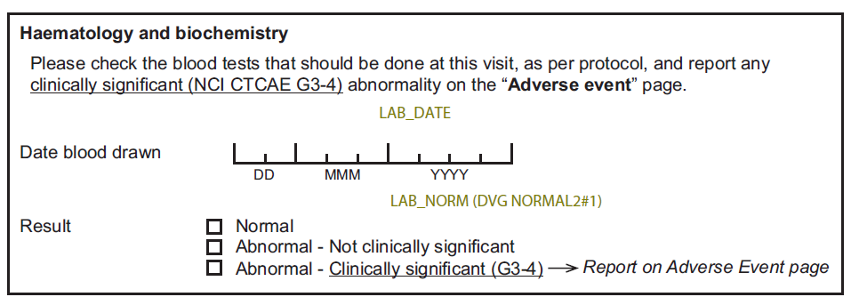

Figure 5 – LAB CDM

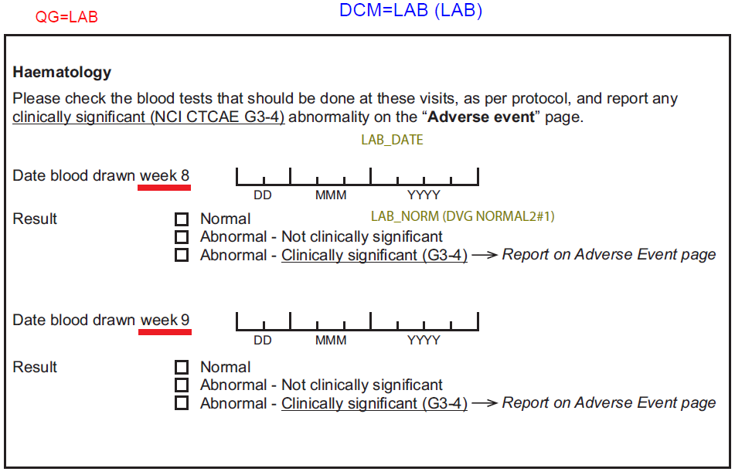

Figure 6 – LAB (for 2 weeks) DCM

Surgery

Surgery is divided into three phases of DCMs:
- Pre Surgery Visit
- Surgery
- Neo-adjuvant treatment completion
Pre Surgery Visit is composed of the following modules:
- VS2 reports data about the patient status (the date of the physical exam and if the result has been normal or abnormal) and vital signs and physical measurements as weight, blood pressure, heart rate and the ECOG performance status
- CANC3 reports breast palpation and clinical tumor measurements (its size, MDxLPD) and nodal status. It also reports whether new lesions have been discovered, the clinical cN lymph node stage and an overall clinical tumor response.
- LVEF (Left Ventricular Ejection Fraction) reports test date, its value, the method of evaluation, if there is symptomatic CHF (Congestive Heart Failure) and in positive case, specify its NYHA (New York Heart Association) classification.
- LAB reports the date of the last blood test and its results. It’s a haematology and biochemistry test.
- DPRO4 consists of questions about the type of radiological examinations performed, whether they were performed or not (left and right breast mammogram, left and right breast echography and MRI), their dates, the measured tumour size and if there are any clinically significant abnormality (if so they are specified).

Surgery is composed of:
- TR4 which only contains the date of axillary dissection and the side (left orright) if done.
- Next DCM is ASES. It contains the number of lymph nodes examined and how many of them are positive.
- TR5 reports whether surgery was done, which type of surgery (lumpectomy, quadrantectomy/segmentectomy, partial mastectomy, radical mastectomy or other), the side and the date.
- TRAN2: Used for translational research with tissue samples. It is just like TRAN1. There are six samples (FFPE (Formalin Fixed Paraffin Embedded) tumor core biopsy, blood sample for PGx (Pharmacogenetics), for proteomics (serum and plansma), for CTC (circulatin tumor cells) and snap frozen tumor sample), and for each sample available, specimen collection date ​​is recorded.

And finally, Neo-adjuvant treatment completion include three modules:
- CMPL is a DCM which reports the reason for treatment discontinuation. The first three questions are about the drugs used (lapatinib, tratuzumab and paclitaxel), if the preoperative administration schedule of the three drugs has been completed or not and the reasons why (adverse events, protocol violation, death, etc). It also reports the date of last study drug administration.
- COM is for additional comments (referencing the document page).
- And finally SIGN (Signature) has the investigator’s signature and the date. By signing this, the investigator states that "All data entered in this case report form have been entered under my authority and to the best of my knowledge are accurate and complete".

FEC

After surgery, during a period of 9 weeks, patient data is collected in three cycles. These cycles are composed of the same tests (VS3 and LAB). Cycle 1 begins in week 1 (after surgery), and cycles 2 and 3 in weeks 4 and 7 respectively.
The modules made in each cycle are these:
- VS3 reports data about the patient status (the date of the physical exam and if the result has been normal or abnormal) and vital signs and physical measurements as weight, blood pressure, heart rate and the ECOG performance status
- LAB reports the date of the last blood test and its results. It’s a haematology and biochemistry test.

34 weeks

Finally, the following 34 weeks (weeks 10 to 43), a dose is given, which in the case of Lapatinib is equal to the initial one, and which is lower than the initial one in the case of Trastuzumab.
Five assessments (DCMs) are recorded (VS4, VIS, LVEF, LAB and TRAN3) during this period: at weeks 22 (month 3), 34 (month 6) and 43 (month 9) the same modules are done (VS4, VIS, LVEF and LAB) and at week 10 the test done is similar than in the rest of weeks but with a change, TRAN3 instead of VIS.
Some of these modules are described above (LVEF, LAB and TRAN3:
- VS4 reports data about the patient status (the date of the physical exam and if the result has been normal or abnormal) and vital signs and physical measurements as weight, blood pressure, heart rate and the ECOG performance status
- VIS reports whether there are any changes since previous assessment. If the answer is yes, changes must be specified according to with the list in :
- LVEF (Left Ventricular Ejection Fraction) reports test date, its value, the method of evaluation, if there is symptomatic CHF (Congestive Heart Failure) and in positive case, specify its NYHA (New York Heart Association) classification of the CHF.
- LAB reports the date of the last blood test and its results. It’s a haematology and biochemistry test.
- TRAN3 is used for translational research with blood sample for CTC (circulating tumor cells) and if collected, the specimen collection date ​​is recorded.

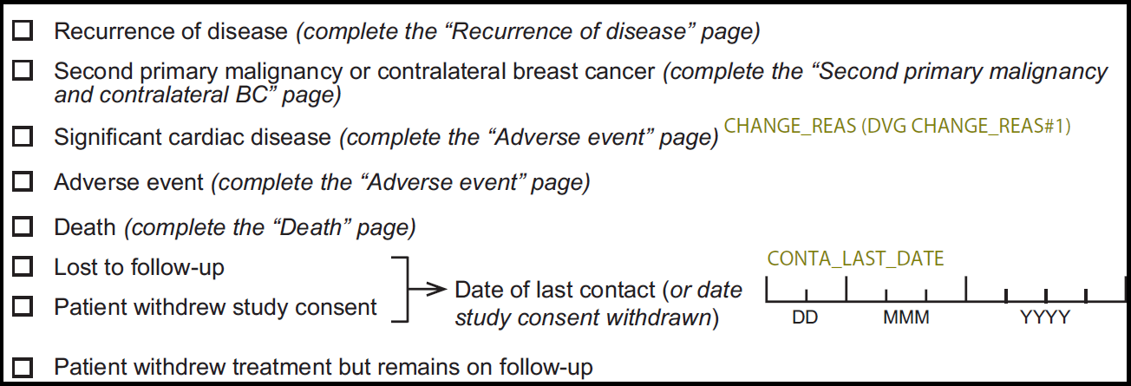

Figure 7- Possible changes since last visit

Next 10 years

The next ten years is a patient follow-up period. First patient assessment is performed one year after her enrolment in this trial; then during the second year, assessments are done every 3 months; from second year to fifth assessment is performed every 6 months, thereafter patients are monitored once a year. shows a schematic detail:

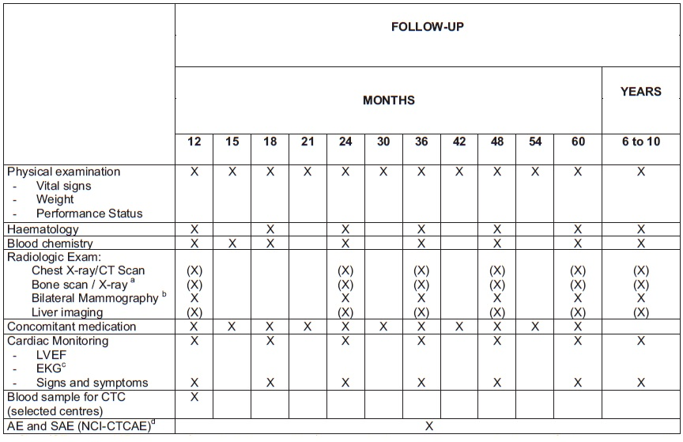

Figure 8 – Follow up

Common Data Models
Within the environment of the INTEGRATE project, a Common Data Model to store data from multi-centric Clinical Trials is essential to provide semantic interoperability. The following sections describe data models used in similar projects: i2b2, OMOP and HL7 RIM.

I2B2
Informatics for Integrating Biology and the Bedside (i2b2):

i2b2 is a framework developed for the i2b2 Center, it's scalable and will enable researchers to use the clinical data for discovery research. It aims to facilitate the design of targeted therapies for individual patients with diseases having genetic origins when combined with IRB-approved genomic data.

The i2b2 software is designed as a set of “cells” (SOA services), in an environment named “hive” (the set of all SOA services).
The core services are:

- Project management, used to provide user authentication and manage group and role information. It also keeps track of what cells are parts of the hive.
- File repository, holding large files of data including radiological images and genetic sequences. The files are generally referenced from the Data Repository cell.
- Identity management, used to manage a patient's protected health information in a manner consistent with the HIPAA privacy rule. Patient data is available only as a HIPAA defined "Limited Data Set" to most of the i2b2 services.
- Workflow framework, used to process information in steps through various parts of the hive. Most processed information will come to reside in the Data Repository Cell or as a display to the user.
- Ontology management, managing the terminology and knowledge information typically used in the hive. It is contacted for, or distributes knowledge to, cells during most of the hives transactions.
- Data repository (CRC), containing the clinical data (phenotypic and genotypic data) in a structured format. Data queries and visualizations are available through this service.
As shown in , the hive doesn't consist only in this core services (dark blue cells), it also has other cells like the Web Application (collection of client-side components that communicate with i2b2 Cells and allow the investigator to query and display the data of the hive), the CRC plug-in (this server-side CRC plug-in calculates patient count breakdown for the children of a given concept), 8 workbench and 2 optional cells (one for the language of processing, to extract specific terms and knowledge, and another for PFT Processing for a pulmonary specific function).

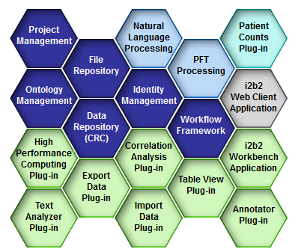

Figure 9 – i2b2 Hive
Within the core cells, of particular interest for INTEGRATE are the design of the clinical data warehouse and the ontology. Therefore, there are going to be analyzed the Data Repository (CRC) cell and the Ontology Management service.

Data Repository (CRC)

The Data Repository cell, also called CRC (Clinical Research Chart), is one of the core cells of the hive. It is designed as a data "warehouse of patient phenotypic and genotypic data that interacts with other cells of the hive to provide information for users". Its main requirements are:

- It should allow fast queries and hold healthcare information from different sources
- Must be able to easily join to other repositories to form a larger one
- Objects present in the genomic data should be stored in the CRC

Data in the CRC is de-identified, except for encrypted patient notes (notes from hospitals). The CRC relies on the Project Management cell (for authentication) and on the Ontology cell (metadata management module that has the concepts to define the CRC requests).

The CRC Server use two webservices: setFinder and PDO (Patient Data Object) (see ).

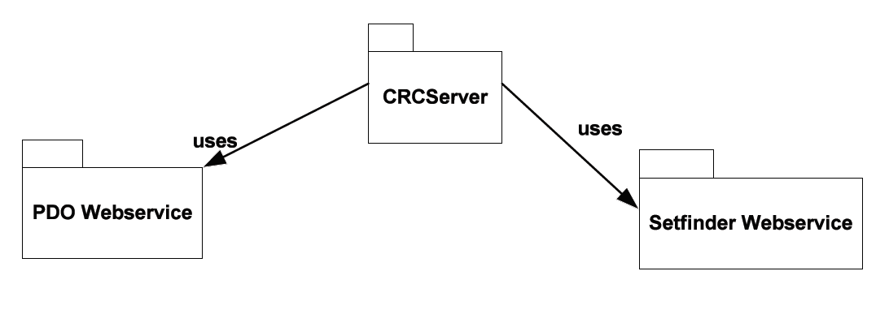

Figure 10 – Part of the Context Diagram
- Setfinder manages a user’s Setfinder queries. The queries are used to create a set of patients that satisfy specified criteria. Setfinder queries are composed of query constraints, a list of panels and its items.

- The PDO webservice exposes the clinical data, providing access to patient information such as clinical observations, demographics and provider data

In terms of design, as it was mentioned before, the CRC is designed as a data warehouse. This data warehouse can be subdivided into data marts.

The data mart uses a star schema as information model (see ), with patient observations as fact table and visits, patient, concept and provider tables as dimensions, that provide additional information about fields in the fact table. It also has another dimension table, modifier, but as it is not always used, this is why it is not within the star schema.

Each observation has an associated visit (a particular patient encounter), patient, concept and provider instance (referenced with the PK). An observation contains various attributes to store details such as the (measured) value of the observation, its units, the confidence interval, the begin date and end date of the observation, etc. A short description of each table is presented below:

- Data Tables: (Observation_Fact is a data table too)

- Visit_Dimension: this table stores the events. Each row represents a visit (an event). In a visit, you may have more than one observation. The observations made during the visit of a patient are aggregated using the visit table.

- Patient_Dimension: the patient table uniquely identifies the patient and contains patient specific data such as demographics.

- Lookup Tables:

- Concept_Dimension: in this table, each row represents a concept. A concept can be diagnoses, procedures, medications or lab tests.

- Provider_Dimension: the provider table represents the physician or provider at the institution, involved in an observation.

The PDO (that is the XML representation of patient data) returns data according to this information model.

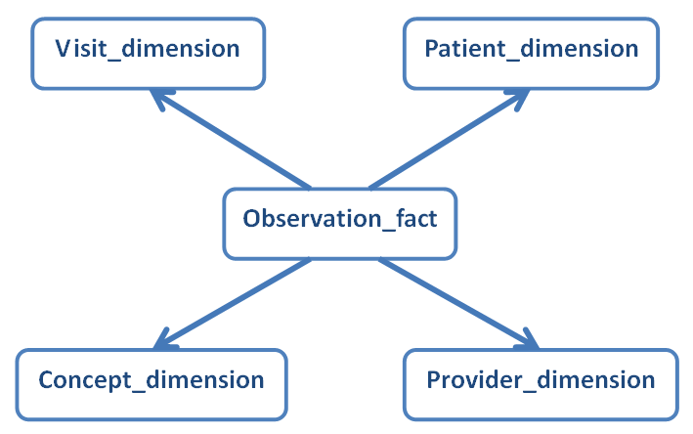

Figure 11 – CRC star schema

Ontology Management (ONT)

The Ontology Management cell contains the definitions of i2b2 vocabulary. ONT contains information about the relationships between concepts of total i2b2. Other cells have access to it to acquire the semantic meaning of data. The ONT cell is organized in a hierarchical way, representing relationships the "parents" (top levels) and "childrens" (lower levels) nodes. Note that nodes (levels of the hierarchy) are different from categories (group of related data, set of data with a common rule/s for querying against the CRC). describes the categories of the ONT cell. In the second picture, a number of categories displayed until the nodes, among themselves are ‘siblings’ (because they are at the same level).

this workbench can be accessed online at https://www.i2b2.org/webclient/ or downloaded as a demo version to your computer.
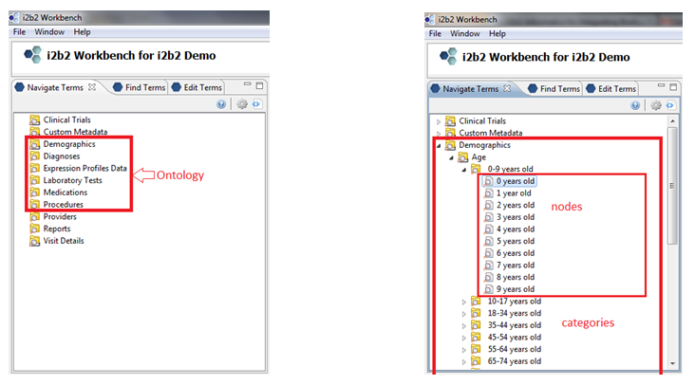

Figure 12 – Ontology tree structure and nodes and categories

It is important to note that “vocabularies in the ONT cell may originate from different sources, and the codes from each source are distinguished from the others by a unique prefix which is appended to the source code. Each distinct vocabulary and their associated codes is called a scheme.”

Architectural Considerations for i2b2

The upside of the i2b2 data model is that it is very simple. With relative little effort, data can be imported and queried. But in i2b2, relationships are not modeled explicitly, preventing the possibility of (explicitly) relating observations (except through the “Visit” dimension). i2b2 combines persons and roles in Patient and Provider tables.

Analyzing the ontology, there are four main issues:

- The first issue is that the ontology cell only allows one type of relationship (hierarchical relationship). When importing different types of ontologies using a different type of relationship, these ontologies are “unnaturally” homogenized.

- The second issue is that some (relevant) ontologies use multiple relationship types (like SNOMED CT). This information cannot be recorded in the current i2b2 implementation.

- In addition, some ontologies (again with SNOMED CT as example) allow for the subsumption of multiple parent nodes, which is also not supported.

- Finally, the i2b2 data model only references to pre-coordinated terms in an ontology, whereas (again) SNOMED CT allows for the use of post-coordinated terms, making it difficult to import data when post-coordination is used.

OMOP

Observational Medical Outcomes Partnership (OMOP):

OMOP is a “public-private partnership designed to help improve the monitoring of drugs for safety. The partnership is conducting a multi-year initiative to research methods that are feasible and useful to analyze existing healthcare databases to identify and evaluate safety and benefit issues of drugs already on the market”.

OMOP is considered "public" because "promotes transparency by placing all information of interest in the public domain as quickly as possible". It provides a public website to inform about the research and keep awareness for consumers, patients, and providers.

One of the OMOP main objectives is “to assess the feasibility and utility of using observational data to identify and evaluate associations between drugs and health-related conditions.”

The OMOP common data model consists of 2 models, a conceptual data model (which describes the overall development approach) and a logical model (relational model) with two components:

- Logical Entities and Attributes of the CDM Core Module
- Logical Entities and Attributes of the Dictionary

Logical Data Model

The Dictionary component is composed of 7 entities (Concept, Concept_Synonym, Concept_Retlationship, Concept_Ancestor, Vocabulary_Ref, Source_To_Concept_Map and Relationship_Type) and the CDM Core Module has 13 (Person, Drug_Exposure, Drug_Era, Drug_Exposure_Ref, Condition_Ocurrence, Condition_Era, Condition_Ocurrence_Ref, Visit_Ocurrence, Procedure_Ocurrence, Proc_Ocurrence_Ref, Observation, Observation_Type_Ref and Observation_Period).

The two components (CDM Core Module and Dictionary) interact with each other to provide a data source mapping.
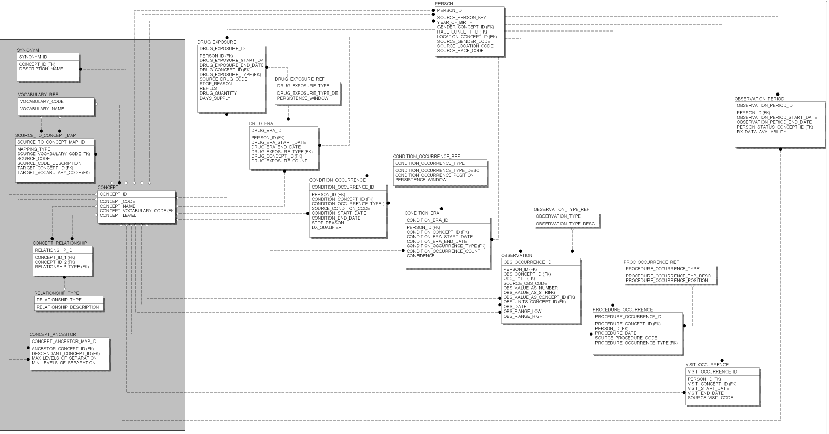
Figure 13 – Logical View of the OMOP Common Data Model
The 13 tables that compose the CDM Core Module are described below:

- Person:

Storing data from demographics, e.g. gender, race or location data. It has a fix value (person_id, which is the Primary Key) and several optional, including 3 FK (gender_concept_id, race_concept_id and location_concept_id)

- Drug_Exposure:

"Contains individual records that reflect drug utilization from within the observational source". The PK is drug_exposure_id. It has 3 FK, 2 of them are required (person_id and drug_exposure_type from tables Person and Drug_Exposure_Ref) and the other (drug_concept_id) is optional. It also has more columns if more data is available.

- Drug_Era:

Refers to a time interval in which a person is exposed to a particular drug of a particular strength. Keep in mind that Drug_Era and Drug_Exposure are not the same. Drug_Era is the combination of successive Drug_Exposure. The PK here, as in the rest of the tables, is the id (drug_era_id). There are 3 FK (person_id, drug_exposure_type and drug_concept_id). 2 of them (person_id and drug_exposure_type) are related to Person and Drug_Exposure_Type (as in the table Drug_Exposure, because the Drug_Era is the combination of several Drug_Exposure, so it fields should be the same in the Drug_Exposure that form a Drug_Era). The FK drug_concept_id is for the mapping with the Dictionary.

- Drug_Exposure_Ref:

A list of reference codes for the different types of Drug_Exposure. It is used to define the data source and the type of representation of the Drug utilization recorded. Drug_exposure_type (that is FK in Drug_Exposure and Drug_Era tables) is the PK.

- Condition_Ocurrence:

It records individual instances of Person conditions. These conditions are recorded in different data sources in different ways (various levels of standarization). The PK is condition_occurrence_id, which is an identifier to uniquely identify each Person condition. There are 3 FK (person_id, condition_occurrence_type and condition_concept_id). 2 of them (person_id and condition_occurrence_type) are related to Person and Condition_Occurrence_Ref, and both are always required. The FK condition_concept_id is for the mapping with the Dictionary.

- Condition_Era:

It’s similar to Drug_Era. Condition_Era is the combination of successive Condition_Occurrence. The PK is the id (condition_era_id). There are 3 FK (person_id, condition_occurrence_type and condition_concept_id). 2 of them (person_id and condition_occurrence_type) are related to Person and Condition_Occurrence_Type (as in the table Condition_Occurrence, because the Condition_Era is the combination of several Condition_Occurrence, so it fields should be the same in the Condition_Occurrence that form a Condition_Era). The FK condition_concept_id is for the mapping with the Dictionary. All FK are always required.

- Condition_Ocurrence_Ref:

“Reflects the indicator(s) from which the Condition_Occurrence was drawn or inferred, and indicates whether a condition (diagnosis) was primary or secondary and the relative positioning within a Person’s condition record”. Condition_ocurrence_type (that is FK in Condition_Occurrence and Condition_Era tables) is the PK.

- Visit_Ocurrence:

It contains all the visits a Person has made to health care providers. The PK is the id (visit_occurrence_id) and has 2 FK (required): person_id, to know who Person is, and visit_concept_id, used for the mapping with the Dictionary.

- Procedure_Ocurrence:

"Record individual instances of Person procedures extracted from source data". These instances are recorded in different data sources in different ways (various levels of standarization). The PK is procedure_occurrence_id, which is an identifier to uniquely identify each procedure occurrence. There are 3 FK (person_id, procedure_occurrence_type and procedure_concept_id). 2 of them (person_id and procedure_occurrence_type) are related to Person and Proc_Occurrence_Ref. The FK procedure_concept_id is for the mapping with the Dictionary. All fields in this table (in which you have procedure_date and source_procedure_code too) are always required.

- Proc_Ocurrence_Ref:

Reflects the indicator/s from which the Procedure_Occurrence was drawn or inferred, and indicates whether a procedure was primary or secondary and the relative positioning within a Person’s procedure record. Procedure_ocurrence_type (that is FK in Procedure_Occurrence) is the PK.

- Observation:

Contains all general observations (Lab observations from Medical Claims, EHR (Electronic Health Records), Person chiefs, others…). The PK, as in the rest of the tables, is the id (obs_ccurrence_id). There are 5 FK (person_id, obs_concept_id, obs_type, obs_value_as_concept_id and obs_units_concept_id). Person_id is related to Person table, to know who is being observed. The other 4 FK are used for the mapping, they are some codes to identify the concept, type, value and units of the observation.

- Observation_Type_Ref:

It Represents the type of observation to be made ​​in Person. Observation_type (that is FK in Observation) is the PK.

Its values can be:

  - CHC → Chief Complaint.
  - EHR → Observation recorded from Electronic Health Records.
  - LAB → Laboratory Observation.
  - PRL → Problem List from Electronic Health Records.
  - TEM → Observation recorded from Electronic Health Records.

- Observation_Period:

This entity is used to track the status of a Person during a period of study.
The PK is observation_period_id, which is an identifier to uniquely identify each observation period. Has 2 FK (required): person_id, to know who Person is, and person_status_concept_id. Knowing the FK person_status_concept_id during a period of time (observation_period_start_date and observation_period_end_date) will help refine active drug surveillance.

- The status can be: Active
- Inactive
- Obsolete
- Deceased
- Unknown
- Other

Architectural Considerations for OMOP

Similar to i2b2, the OMOP common data model is very simple. The most important consideration to bear in mind is that, in addition to the CDM, OMOP has a Dictionary that performs the mapping between different data sources and the tables of the database (like an ETL). Relationships are not modeled explicitly, preventing the possibility of (explicitly) relating observations. And some ontologies such as SNOMED CT, allow for the subsumption of multiple parent nodes, which is not supported in this model.

HL7 RIM
Health Level 7 Reference Information Model (HL7 RIM)

HL7 is an organization involved in the development of international healthcare informatics standards. This organization was created in order to: “create the best and most widely used standards in healthcare”.

In our context, HL7 refers to some of the specific standards created by this organization. In particular in this document is going to be analysed specifically the HL7 RIM.

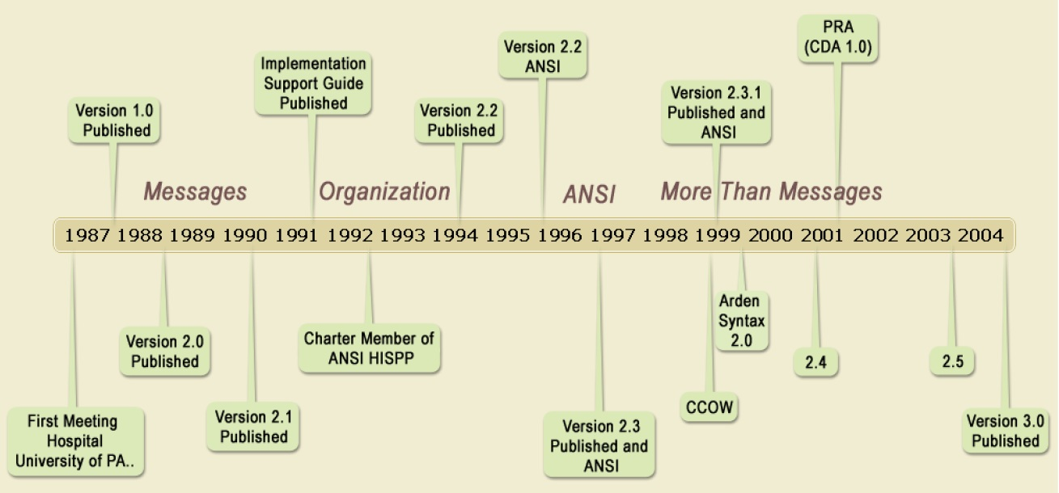

Figure 14 – History of HL7
In , It can be seen the evolution of different versions of HL7 over the time.

HL7 v3 makes an extensive use of international ontologies (LOINC, ICD-10, SNOMED CT, etc) for the representation of the terminology used in the stage of providing health services. It implements the use of XML (as a language for exchanging structured information between different platforms) to encode it messages. HL7 RIM is the most important concept (cornerstone) in the development process of HL7 Version 3. RIM is an object model created as part of the Version 3 methodology. It represents the HL7 clinical data and identifies the life cycle that a message will carry. RIM is an ANSI standard.

RIM (Reference Information Model, which consists of a generic set of classes from which more specific health classes are derived) uses UML to plot a class model that allows contextualize any event that occurs within the operation of health services. Based on RIM many specifications of specific messages for different domains of health scenarios can be built.

3.3.1 Reference Information Model (RIM)

Figure 15 depicts a detailed scheme of the Core Classes and their relations.

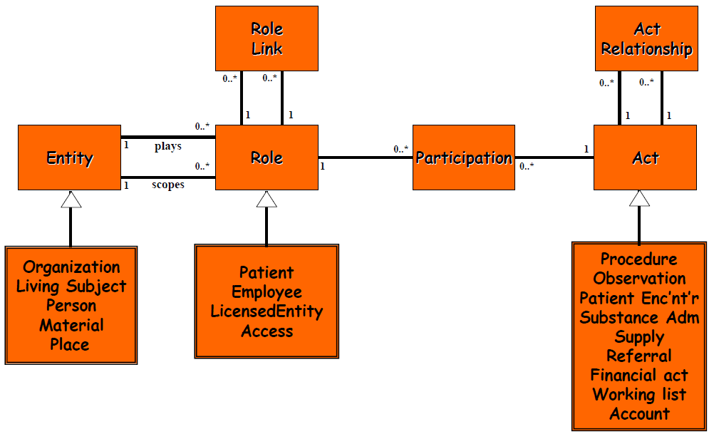
Figure 15 – RIM Core Classes
As it can be observed within the figure above, the RIM has 3 main classes:
- Act
- Role
- Entity

That is related to each other with 3 association classes:
- ActRelationship
- Participation
- RoleLink

Classes related to each main class are UML specialization/generalization relations. Structural attributes reduce the size of the RIM in over 100 classes. They are used to provide meaning to the RIM classes in the messages. Below, the list of the structural attributes of the RIM main classes and association classes is provided:

- Act: classCode, moodCode, negationInd, levelCode.
- Role: classCode, negationInd.
- Entity: classCode, determinerCode.
- ActRelationship: typeCode, contextControlCode.
- Participation: typeCode, contextControlCode.
- RoleLink: typeCode.

ACT

“Act is a record of something that has happened or may happen”

An action of interest that has happened, can happen, is happening, is intended to happen, or is requested/demanded to happen. An act is an intentional action in the business domain of HL7. Healthcare (and any profession or business) is constituted of intentional actions. An Act instance is a record of such an intentional action.

Any intentional action can exist in different "moods". Moods describe activities as they progress in the business cycle, from defined, through planned and ordered to complete.

Any instance of an Act assumes one and only one mood and will not change its mood during its life cycle. The moods (definition, intent, order and event) seem to specify the life cycle of an activity. However, the participants in the activity in these different moods are different, as is the data. Therefore, the mood of an Act instance is static. The progression actualization (i.e., the progression from defined, through planned and ordered, to being performed) is called the "business cycle" to distinguish it from the "life cycle" of a single act instance. Related Act instances that form such a "business cycle" are linked through the Act_relationship class.

Examples for acts in health care are: a clinical test, an assessment of health condition (such as problems and diagnoses), the setting of healthcare goals, the performance of treatment services (such as medication, surgery, physical and psychological therapy), assisting, monitoring or attending, training and education services to patients and their next of kin, and notary services (such as advanced directives or living will).

Acts have participants, which can be actors or targets. Examples of actors are nurses, doctors, family members, notary publics, and service organizations - every person or organization that is capable of independent decisions and can thus is responsible (and liable) for the actions performed.

Target participants in an act may include the patient, the patient's spouse, family, or community, a specimen drawn from the patient or from any object of interest. As patients do play active roles in their own healthcare, the patient can be both an active participant and a target participant at the same time (self-administered or reflexive services.)

An act can have multiple active participants and multiple target participants, their specific role being distinguished in the "type_cd" of the respective instance of the Participation class. In particular, an act involving coordination of care may involve two or more active participants, playing different roles, who interact on behalf of a patient, family, or aggregate in the role of target participant.

For example, a nurse (active participant) calls Meals on Wheels (active participant) on behalf of the patient (target participant).

An Act includes the "results", "answers" or informational "procedure products" gained during the act. In this model, "results" do not exist without an act, and every clinical result, including those results gained accidentally, is gleaned via an act. In other moods, such as "definition" or "intent", the results are the possible results, the expected or aimed-for results, or the tested-for results.

ENTITY

An Entity is any living or non-living thing (person, animal, organisation, thing) which has or will have existence

The only exception to this is Organization, which while not having a physical presence, fulfils the other characteristics of an Entity. The Entity hierarchy encompasses living subjects (including human beings), organizations, material, and places and their specializations. It does not indicate the roles played, or acts that these entities participate in.

It does not include events/acts/actions, or the roles that things can play (patient, provider)

ROLE

A Role is a relationship between two entities in their roles. This includes all relationships between entity objects that have a scope and extent larger than one Act. For example: whole-part, generalization-specialization, definition-instance, parent-child, group-member, husband-wife, employer-employee, patient-provider,etc.

The Role_relationship is a directed link between entities in their roles. This means, the relationship is like an arrow with a butt and a point. The role and entity at the side of the butt is called the "source," and the role and entity at the point is called the "target" of the relationship.

With the Role_relationship two entities participate in the relationship with one of their roles. Deliberately there is no other way to relate entities without their roles, since this would have created two ways to accomplish very similar tasks, and committees would have to repeatedly debate the decision between those two ways. In the case where the choice of role seems irrelevant, the Role.type_cd may be left unspecified (known as "NULL-Role").

Note: Any asymmetric relationship generates the notion of roles on either of its sides. For example, a part-whole relationship generates the role-like notions "part" and "whole". However, "part" and "whole" are not meaningful roles independent from a part-whole relationship, since anything can be a part in one relationship and a whole in another relationship. Do not generate a special role object for each side of a role-relationship, but instead reuse existing roles played by the related entities.
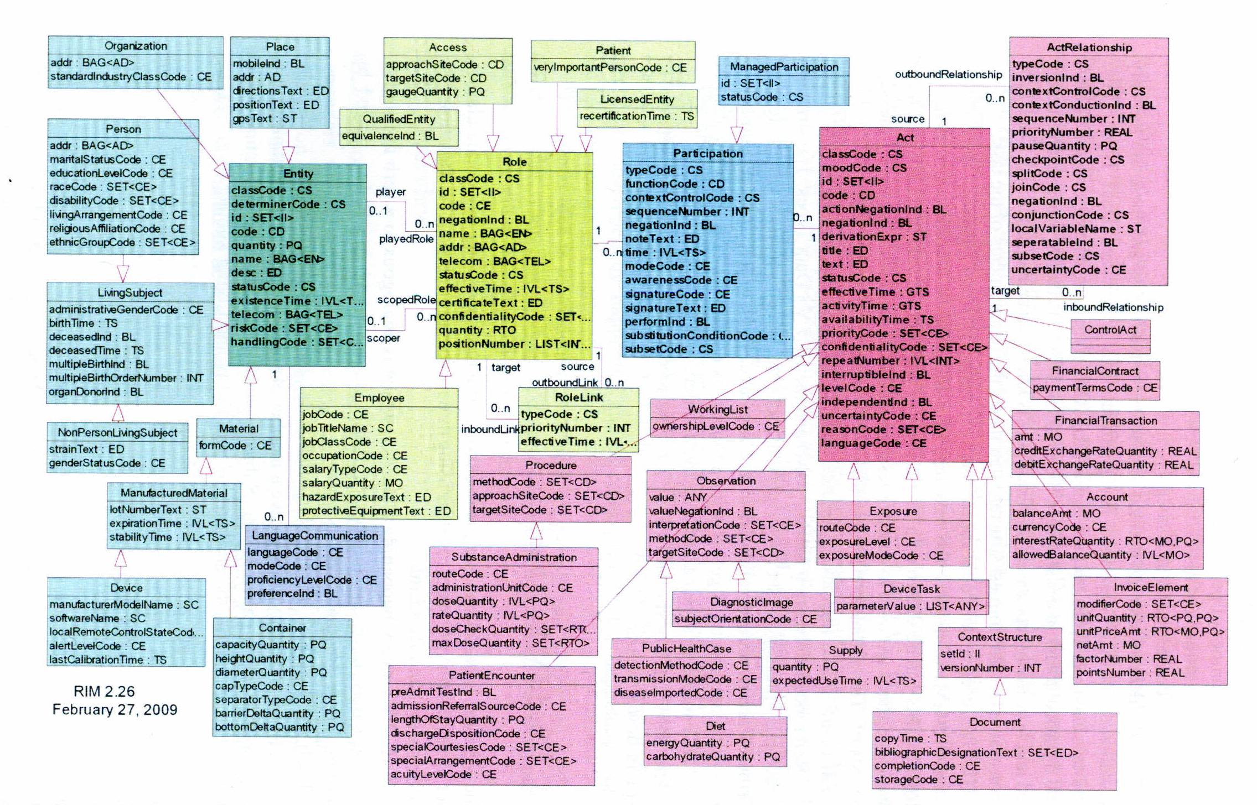
Figure 16 – HL7 RIM backbone classes

Figure 16 contains all specializations and relationships between the main classes (Act, Role and Entity). Next subsection describe HL7 RIM relations.

ACT RELATIONSHIP

A directed association between a source and a target Act.

- ActRelationship on the same source Act are called the "outbound" act relationships of that Act

- ActRelationships on the same target Act are called the "inbound" relationships of that Act

In the ActRelationship.typeCode attribute is specified the meaning and purpose.

The relationships associated with an Act are considered properties of the source act object. This means that the author of an Act-instance is also considered the author of all of the act relationships that have this Act as their source.

The ActRelationship class used to construct action plans and to represent clinical reasoning or judgments about action relationships. Prior actions can be linked as the reasons for more recent actions. Supporting evidence can be linked with current clinical hypotheses.

One of the most commonly used ActRelationship types is "has component" to describe the composition and decomposition of Acts. The relationship type allows specifying detail of Acts to varying degrees.

PARTICIPATION

Participation is the "association between an Act and an Role with an Entity playing that Role". Each Entity involved in an Act in a certain way is linked to the act by one Participation instance. Participation.typeCode. specified the kind of involvement in the Act. For Example, performers of acts: surgeons, observers, practitioners...

Participation represents performance while Roles represent competence. Participations specify the actual performance of an Entity in a certain Act, and thus Participation is scoped by its specific Act.

For example, the professional credentials of a person (Role) may be quite different from what a person actually does (Participation).

An Act can have multiple participations of the same type, which indicates collaborative activities or group involvement.

ROLELINK

The relation/connection between 2 roles expresses a dependency between them. For example, a role of assignment depends on another role of employment, such that when the employment role is terminated, the assignments would be terminated as well. This is the dependency of the assignment role with the employment role, what it means that, the assignment is "part of" the employment. RoleLink specifies the relationships between roles, not between people (or other entities).

Specializations

The specializations are "subclasses" of the main classes. They inherit all the attributes of its parent class. Here are the most important subclasses in the RIM.

Act:
- Exposure: Subtype of Act that indicates the level and the mode to which a patient has been exposed to any treatment, drug, etc.

- Observation: “An Act of recognizing and noting information about the subject, and whose immediate and primary outcome (post-condition) is new data about a subject. Observations often involve measurement or other elaborate methods of investigation, but may also be simply assertive statements” .

The observations are name-value-pairs, where:

- Observation.code (that is inherit from Act) is the name and
- Observation.value is the value of the property.

The Observation class is always used to hold generic name-value-pairs or variables, although the evaluation (variable) may not be the result of an observation method developed. It may be a simple answer to a question. Observation statements describe what was done (As with Act statements) and Observation statements includes too a description of what was actually observed ("results" or "answers"); and those "results" or "answers" are part of the observation and not split off into other objects.

The composite observation may not have an Observation.value for itself. Thus, as long as an Act is essentially, an Observation is any Act of recognizing and noting information about a subject (regardless of whether it has a value itself or through sub-observations). "Even though observations are professional acts and as such are intentional actions, this does not require that every possible outcome of an observation be pondered in advance of it being actually made". Example: diagnoses, findings, symptoms, etc. are Observations.

Observation.code specifies the kind of diagnosis (e.g. "chief complaint" or "discharge diagnosis"). Observation.value specifies the diagnosis code or symptom code.

- Procedure: Is a specialization of Act, and in turn has another specialization (SubstanceAdministration). It is any act that includes some form of intervention in a patient, a planned alteration or the manipulation of the structure of the body. This may require the disruption of somebody surface, usually through an incision (e.g. "surgical procedure" or "operative procedure"). Appendectomy, Back massage or Dental filling are consider like procedures.

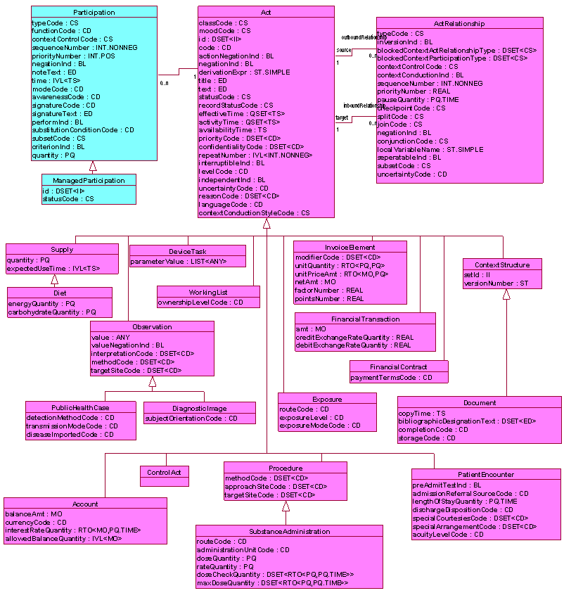
Figure 17 – Act Subject Area

Entity:

- Place: A physical place or site with its contained structures. Place may be natural or man-made. The geographic position of a place may or may not be constant. For example, as Places it can be considered: field, lake, city, county, state, country, lot (land), building, pipeline, power line, playground, ship, truck...etc.
Places may be work facilities (where relevant acts occur), homes (where people live) or offices (where people work) (relationships are bracketed on the role of each place). Places may contain sub-places (floor, room, booth, bed.)
Places may also be sites that are investigated in the context of health care, social work, public health administration (e.g., buildings, picnic grounds, day care centres, prisons, counties, states, and other focuses of epidemiological events).

- Organization: Subtype of Entity representing a formalized group of people with a common purpose (e.g. administrative, legal, political) and the infrastructure to carry out that purpose, e.g.: companies and institutions, a government department, an incorporated body that is responsible for administering a facility, an insurance company.
While not a physical item, organizations have the ability to play Roles (RoleLink relationship) and participate in Acts (Participation relationship). Many of the attributes associated with physical entities are also applicable to organizations.

- LivingSubject: Subtype of Entity representing an organism (NonPersonLivingSubject specialization) or complex animal (Person Specialization), alive or not, e.g.: a person, dog, microorganism, a plant of any taxonomic group...
Instances of this class encompass mammals, birds, fishes, bacteria, parasites, fungi and viruses.
This class contains "static" or "administrative" attributes of interest to medicine that differentiates living organisms from other Entities.

- Person: A subtype (specialization) of LivingSubject that represents a human being. This class can be used to represent either a single individual or a group of individuals based on the value of Entity.determinerCode (kind of human) and Entity.quantity (more than 1 person).

- Material: The Material class personalizes the physical and physiological objects that are used, assessed, and acted upon in a service action. Includes: pharmaceutical substances or disposable supplies (as durable medical equipment, prostheses, implantable devices, accesses, drains... everything).
It should be noted that this class includes facilities, such as immovable service locations or ambulances. It has a subclass (ManufacturedMaterial, specialization) which it also has 2 specializations (Device and Container) that define the concepts named. There is some complexity with the connection to Location.

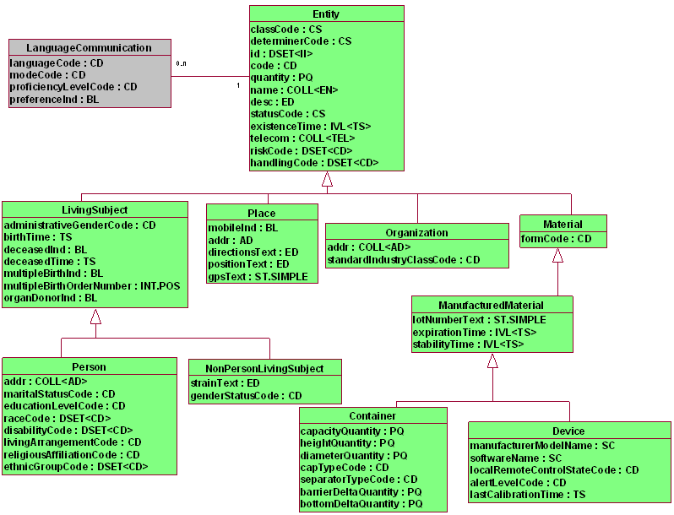
Figure 18 – Entity Subject Area

Role:
- Employee: Role played by a Person associated to a company (called "employer") to receive a salary. The purpose of this role is to identify the type of relation the employee (role) has to the employer (company) rather than the type of work the employee performs “per se”.

- Patient: Role of a LivingSubject (player) as a recipient of health care services from a healthcare provider.

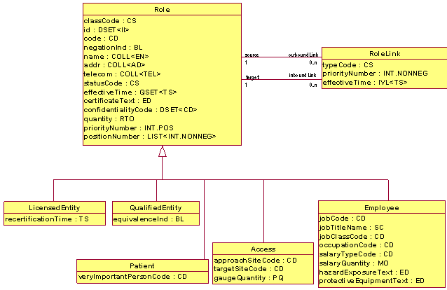
Figure 19 – Role Subject Area

HL7 Version 2.5 (ORU-OUL)

HL7 Version 2.5 was released in 2003. The main objective of version 2 was to create a standard that could encode all the different data flows created in a hospital.
Version 2.5 includes several message types. For our purposes, there are two interesting types, namely the ORU and the OUL message types.
An ORU message, as it is described in the HL7 standard is an “unsolicited transmission of an observation message”. This type of message is used to send observations or results, about a patient, between systems; from the system that produce the observation to a system that order it or to a stored system. ORU messages are also used to register or to link the data with a clinical trial.
OUL messages are described in the HL7 standard as “unsolicited laboratory observation message”. They are used to send information from a laboratory about different kinds of samples (not necessary for a patient).

Common Information Model
The Common Information Model (CIM) is composed of the common data model, the core dataset and the mechanisms to relate them.

Core dataset
Different clinical vocabularies have been considered as core dataset candidates and are described in subsequent sections.

MedDRA

MedDra (Medical Dictionary for Regulatory Activities, developed by the IFPMA -International Federation of Pharmaceutical Manufacturers and Associations) is a medical vocabulary used to classify adverse events associated to the use of biopharma and other medical products on human.

This terminology has a hierarchical structure defined by five levels, .

Figure 20 - Structural Hierarchy of the MedDRA Terminology

It is necessary to obtain a commercial license if it is intended to be used within commercial software. True not-for-profit organizations qualify for free basic subscription.

MedDRA include all the virtues of a taxonomy but within the INTEGRATE project, it could be not enough to represent all the possible concepts needed. In a first approximation to data sources, MedDRA only covered around 50% of the concepts.

SNOMED-CT

SNOMED-CT (Systematized Nomenclature of Medicine - Clinical Terms) could be considered as the most important medical terminology nowadays. It was property of the International Health Terminology Standards Development Organization (IHTSDO) but created by the College of American Pathologists (CAP).
SNOMED-CT is divided in concepts, descriptions and relationships. In total, SNOMED-CT has over a million of medical concepts. This terminology has an is_a hierarchical structure; each concept could have multiple parents and roles.
These concepts have associated different properties:
- Fully Specified Name: A unique way to name and denominate the concept
- Preferred Term: The common phrase used by clinics to name the concept
- Synonym: Additional phrases/terms that could represent the concept

The large size of this vocabulary is one of its great advantages because in a first approximation of the project, SNOMED-CT cover around 80% of concepts defined. Other advantage of the terminology is the possibility of create new concepts by using existing ones; this process is called “post-coordination” or even extensions with completely new concepts. On the other hand, the large size and the irregular structure of the taxonomy suppose also disadvantages because it makes it more complex and disperse, which would make its management and its comprehension to be more difficult.
SNOMED-CT is free for research purposes. It could be downloaded in a txt file or consult in a web-based taxonomy browser, like SNOMED-CT core browser (developed by the Virginia-Maryland Regional College) or BIOPORTAL. It can be also transformed into ontology representation languages.

LOINC
LOINC (Logical Observation Identifiers Names and Codes) was developed in 1994 by the Regenstrief Institute to provide a standard to identifying clinical information in electronic reports. The purpose of LOINC is to facilitate the exchange, pooling and management of results for clinical care and research. The context of LOINC includes laboratory test and other clinical observations but has expanded to include nursing diagnosis, nursing interventions, outcomes classification and patient care data.
LOINC actually have about 50.000 tests and observations with about 45.000 concepts Figure 21. Talking about LOINC structure is divided in six axes:
- Component: name of the component measured
- Property observed
- Time aspect: timing of measurement
- System: type of sample
- Scale: the scale of measurement
- Method: the method of measurement

Figure 21 - Example of LOINC representation

There exist an agreement between LOINC, NPU and SNOMED-CT to begin a trial of cooperative terminology. This terminology is available as a Microsoft Access database file and a web search application. Also LOINC provides a Windows application called RELMA to facilitate searches through the database and to assist efforts to map local codes to LOINC codes.
Regarding its use within the INTEGRATE project, LOINC represent the best way to represent clinical results but it has the inconvenient of being too much specific focused to clinical and laboratory test. In a first approximation of the project, SNOMED-CT only covers about a 65% of concepts defined.

MeSH

MeSH (Medical Subject Headings) was developed by the United States National Library of Medicine. The main goal of this vocabulary is standardize the terms for indexing journal articles and books in the life sciences.
Regarding the MeSH structure, this taxonomy is composed by descriptors, the lasts versions of MeSH have about 26.000 descriptors (everyone has a list of synonym and a list of qualifiers) including twelve hierarchy levels. Every descriptor represents the concept name but it can appear in several places of the hierarchy with a unique ID.
MeSH can be obtained free of charge on the PubMed website in txt or xml format file. This taxonomy has been transformed into numerous languages and allows retrieval of documents from different languages.
For the use in the INTEGRATE project, MeSH only represent a taxonomy with a very simplified structure that it’s only oriented to represent diseases.

ICD-10

ICD-10 (International Statistical Classification of Diseases and Related Health Problems 10th Revision) was developed by the World Health Organization (WHO). ICD-10 is a vocabulary of diseases and all the relative information to external causes of injury.
The main goal of ICD-10 is to classify and encode this kind of information, i.e. ICD is not a taxonomy. Regarding its use within the INTEGRATE project, ICD-10 provides the benefits of being a well defined and greatly expanded vocabulary but the lack of relationships would prevent a powerful semantic interoperability. ¿?

Data management and linkage

In relation with composition and structure of each of the proposed technologies, for the CDM it is important to take in account the way the core dataset is going to be managed and how data is going to be stored. The three CDM proposals can be divided in two groups: OMOP and i2b2 against the HL7 RIM.

- OMOP and i2b2 share how they store the concepts from the dataset and all the required data. Both of them store the source data in a database structure composed of different classes representing each of the most habitual topics of the biomedical field. All the relations between these database classes are defined by each respective own clinical model structure. On the other hand, they use a “dictionary structure” to relate all the concepts from the core dataset with the data stored in the platform, storing also all the core dataset concepts in its particular database.

- HL7 RIM has a different and more abstract way of manage and store the data. A few classes (Act, Role, Participation and entity) are provided in order to define a specific model that will define the way the data will be stored in. On the other hand the concepts of the core dataset are linked with the information stored, by the concept field of each class, with the respectively core dataset code.

The next section summarize the advantages and disadvantages of the different possibilities that each alternative would provide after analyzing the existing standards.

CONCLUSIONS
In this section there are going to be summarized the available options, approaches and alternatives for designing the semantic layer of the INTEGRATE project. In particular, three topics have been evaluated in this document: the semantic core dataset, the common data model and the data sources provided by our clinical partners.

It have been described the data sources, detailing the two available trials. The main goals of these trials have been described and a detailed description has been given. The idea of this detailed description is to get an understanding of the information and data. In the common data models section, it have been explained the structure of each of the three proposal technologies and have been explained the architectures of the systems in order to facilitate the decision of what structure is better to store and manage the data.

The following advantages and disadvantages were discovered during the analysis of the proposed information models:

 | Advantages | Disadvantages
I2b2 | • Easy management  • Simple structure | • Can’t manage post-coordination  • Can’t relate observations  • Not flexible as HL7 RIM
OMOP | • Easy management  • Simple structure | • Can’t manage post-coordination  • Can’t relate observations  • Not flexible as HL7 RIM
HL7 RIM | • Can represent any relationship  • Can relate observations  • More descriptive | • High complexity of management  • Time-consuming translation  • Possible ambiguity

OMOP and i2b2 has a simple structure which may suppose an easy way to work with the expected amount of data. However, they don’t allow the user to relate more than one core dataset concept to a specific class (that is to say that they don’t allow post-coordination), and something still more important: they don’t allow the establishment of relations between different classes something that is a crucial point in the storing of the data.

HL7 RIM seems to be a perfect paradigm to represent information because of its ambiguity that provides the ability to manage the data from multiple and open ways. However this range of possibilities of representation implies a greater complexity in the design and management of the model compared to OMOP & i2b2.

It can be assumed that if finally i2B2 or OMOP are chosen as the base of our common data model it would be necessary to extend and modify the data model of these solutions, the existing data models are not sufficient to store and manage the available data. In addition, both solutions are lacking the possibility of post-coordinating terms/relationships from the core dataset, and lack a way to relate observations between each other. On the other hand, if it is decided to make use of HL7 RIM it will be necessary to prune the large structure of the model in order to reduce the complexity, since the majority of the model is not needed.

Finally, there have been assessed three popular medical ontologies that could be used as the core dataset of the platform on their own or by combining them. The following advantages and disadvantages arose from the assessment of the core dataset candidates:

 | MedDRa | SNOMED-CT | LOINC
Objective | Adverse events of medical products in relation to humans | Accurate record of electronic healthcare | Clinical care and laboratory results
Content | Diseases, diagnosis, reactions and results | All clinical areas | Laboratory & Clinical
Structure | Hierarchical: 6 Levels | Non defined number of levels | None

It can be concluded with the fact that LOINC and MedDRA cannot be used alone, since they are oriented to specific (confined) medical fields. Therefore one possible solution would be to use SNOMED-CT in combination with one of the other ontologies. However, it is also possible to use only SNOMED-CT by making use of post-coordination. This technique could be a solution to the semantic problem of the non-existence of certain concepts/terms but has the disadvantage of finding problems on the management of the post-coordinated concepts. Another possibility to solve this problem is to use extensions of the ontologies, a strategy that will extend the structure of the ontology if it would be necessary by the definition of new concepts not represented yet on the ontology.

After a comprehensive analysis of the scientific literature and available solutions in this field, it can be concluded that there is a lack of standardized solutions providing the semantic interoperability required for a sustainable multi-centric and post-genomic clinical trial platform. However, architectural considerations, domain vocabularies supported by a large community and lessons learned from previous projects in the area have been presented in this document. And they will be considered to achieve the challenge envisioned by the INTEGRATE project.

REFERENCES
- https://www.i2b2.org/
- http://omop.fnih.org/
- http://www.hl7.org/
- http://www.affymetrix.com
- http://www.illumina.com/
- http://www.breastinternationalgroup.org/
- https://www.br-e-a-s-t.org/breast.php
- http://docs.oracle.com/cd/E22982_01/doc.462/e18821/de.htm
- http://www.cancer.org/Cancer/BreastCancer/DetailedGuide/breast-cancer-staging
- http://www.informedicalcme.com/colon-cancer/assessing-pT/
- http://www.informedicalcme.com/colon-cancer/assessing-pN/

Bibliography

- Benson, T. "Principles of Health Interoperability HL7 and SNOMED". 1st Edition, 2010, Health Informatics Series.

- Murphy SN, Mendis ME, Berkowitz DA, Kohane I, Chueh HC. “Integration of clinical and genetic data in the i2b2 architecture”, AMIA Annu Symp Proc. 2006:1040.

- Viangteeravat T, Anyanwu MN, Nagisetty VR, Kuscu E, Sakauye ME, Wu D. “Clinical Data Integration of Distributed Data Sources Using Health Level Seven (HL7) v3-RIM Mapping”. J Clin Bioinforma. 2011 Nov 21;1(1):32.

- Heymans S, McKennirey M, Phillips J. “Semantic validation of the use of SNOMED CT in HL7 clinical documents”. J Biomed Semantics. 2011 Jul 15;2(1):2.

- Overhage JM, Ryan PB, Reich CG, Hartzema AG, Stang PE. “Validation of a common data model for active safety surveillance research”. J Am Med Inform Assoc. 2012 Jan 1;19(1):54-60. Epub 2011 Oct 28.

- Qi M, Wang P, O'Toole N, Barboza PS, Ungerfeld E, Leigh MB, Selinger LB, Butler G, Tsang A, McAllister TA, Forster RJ. “Snapshot of the eukaryotic gene expression in muskoxen rumen--a metatranscriptomic approach”. PLoS One. 2011;6(5):e20521. Epub 2011 May 31.

- Inaki K, Hillmer AM, Ukil L, Yao F, Woo XY, Vardy LA, Zawack KF, Lee CW, Ariyaratne PN, Chan YS, Desai KV, Bergh J, Hall P, Putti TC, Ong WL, Shahab A, Cacheux-Rataboul V, Karuturi RK, Sung WK, Ruan X, Bourque G, Ruan Y, Liu ET. “Transcriptional consequences of genomic structural aberrations in breast cancer”. Genome Res. 2011 May;21(5):676-87. Epub 2011 Apr 5.

- Irizarry RA, Bolstad BM, Collin F, Cope LM, Hobbs B, Speed TP. “Summaries of Affymetrix GeneChip probe level data”, Nucleic Acids Res. 2003 Feb 15;31(4):e15.

- Desmedt C, Di Leo A, de Azambuja E, Larsimont D, Haibe-Kains B, Selleslags J, Delaloge S, Duhem C, Kains JP, Carly B, Maerevoet M, Vindevoghel A, Rouas G, Lallemand F, Durbecq V, Cardoso F, Salgado R, Rovere R, Bontempi G, Michiels S, Buyse M, Nogaret JM, Qi Y, Symmans F, Pusztai L, D'Hondt V, Piccart-Gebhart M, Sotiriou C. “Multifactorial approach to predicting resistance to anthracyclines”. J Clin Oncol. 2011 Apr 20;29(12):1578-86

- Saini KS, Azim HA Jr, Metzger-Filho O, Loi S, Sotiriou C, de Azambuja E, Piccart M. “Beyond trastuzumab: new treatment options for HER2-positive breast cancer”. Breast. 2011 Oct;20 Suppl 3:S20-7.

- Ahn ER, Vogel CL. “Dual HER2-targeted approaches in HER2-positive breast cancer”. Breast Cancer Res Treat. 2012 Jan;131(2):371-83. Epub 2011 Sep 29.

- Lyman JA, Scully K, Tropello S, Boyd J, Dalton J, Pelletier S, Egyhazy C. “Mapping from a clinical data warehouse to the HL7 Reference Information Model”. AMIA Annu Symp Proc. 2003:920.

- Livne OE, Schultz ND, Narus SP. “Federated Querying Architecture with Clinical & Translational Health IT Application”. J Med Syst. 2011 Oct;35(5):1211-24. Epub 2011 May 3.

http://www.meddramsso.com/
http://www.nlm.nih.gov/research/umls/Snomed/snomed_main.html
http://loinc.org/
http://www.breastinternationalgroup.org/Research/NeoBIG.aspx
http://www.breastinternationalgroup.org/
http://docs.oracle.com/cd/E22982_01/doc.462/e18821/de.htm
http://www.informedicalcme.com/colon-cancer/assessing-pT/
http://www.informedicalcme.com/colon-cancer/assessing-pN/
http://www.cancer.org/Cancer/BreastCancer/DetailedGuide/breast-cancer-staging
http://www.ncbi.nlm.nih.gov/About/primer/microarrays.html
http://www.mged.org/Workgroups/MIAME/miame.html
http://www.ncbi.nlm.nih.gov/geo/info/MIAME.html
http://www.affymetrix.com/browse/products.jsp?productId=131455&categoryId=35760#1_1
http://www.affymetrix.com/browse/products.jsp?productId=131533&navMode=34000&navAction=jump&aId=productsNav#1_1
http://www.illumina.com/products/infinium_humanmethylation27_beadchip_kits.ilmn
https://www.br-e-a-s-t.org/trials.php?s=4
https://www.br-e-a-s-t.org/trials.php?s=4
http://clinicaltrials.gov/ct2/show/study/NCT00553358
http://clinicaltrials.gov/ct2/show/study/NCT00553358
https://www.i2b2.org/
https://www.i2b2.org/software/index.html
https://www.i2b2.org/software/index.html
https://www.i2b2.org/software/files/PDF/current/CRC_Architecture.pdf
https://www.i2b2.org/software/files/PDF/current/CRC_Design.pdf
http://en.wikipedia.org/wiki/Star_schema
https://www.i2b2.org/software/files/PDF/current/Ontology_Messaging.pdf
http://omop.fnih.org/node/22
http://omop.fnih.org/researchoverview
http://omop.fnih.org/ETLProcess
http://omop.fnih.org/ETLProcess
http://omop.fnih.org/ETLProcess
http://www.hl7.org/about/index.cfm?ref=common
http://www.hl7.org/documentcenter/public_temp_82FA0ADD-1C23-BA17-0CE002E6D5DB7961/calendarofevents/himss/2009/presentations/Reference%20Information%20Model_Tue.pdf
http://www.hl7.org/documentcenter/public_temp_82FA0ADD-1C23-BA17-0CE002E6D5DB7961/calendarofevents/himss/2009/presentations/Reference%20Information%20Model_Tue.pdf
Benson, Tim "Principles of Health Interoperability HL7 and SNOMED". 1st Edition, 2010, Health Informatics Series.
Benson, Tim "Principles of Health Interoperability HL7 and SNOMED". 1st Edition, 2010, Health Informatics Series.
www.meddramsso.com
MedDRA Guide v14.1
http://www.ihtsdo.org/
http://snomed.vetmed.vt.edu/sct/menu.cfm
http://bioportal.bioontology.org/
http://loinc.org/
http://loinc.org/news/owners-of-loinc-npu-and-snomed-ct-begin-trial-of-cooperative-terminology-development-joint-press-release.html
http://loinc.org/relma
http://www.nlm.nih.gov/mesh/
http://www.ncbi.nlm.nih.gov/pubmed/
http://www.who.int/classifications/icd/en/

