|  |  |
| --- | --- |
|  | P:\EuroPartners-General\EU-Program\FP7-ICT\Running projects\EURECA\Logo\EURECA-Logo-Final.jpg |

ICT-2011-288048

EURECA

Enabling information re-Use by linking clinical Research and CAre

IP

Contract Nr: 288048

Deliverable: <D10.2 External Project Website>

Due date of deliverable: (07-31-2012)

Actual submission date: (07-19-2012)

|  |  |
| --- | --- |
| Start date of Project: 01 February 2012 | Duration: 42 months |

Responsible WP: <BIG>

Revision: <outline, draft, proposed, accepted>

|  |  |  |
| --- | --- | --- |
| **Project co-funded by the European Commission within the Seventh Framework Programme (2007-2013)** | | |
| **Dissemination level** | | |
| **PU** | Public | X |
| **PP** | Restricted to other programme participants (including the Commission Service |  |
| **RE** | Restricted to a group specified by the consortium (including the Commission Services) |  |
| **CO** | Confidential, only for members of the consortium (excluding the Commission Services) |  |

# DOCUMENT INFO

## Author

|  |  |  |
| --- | --- | --- |
| Author | Company | E-mail |
| Jon Birch | *e*cancer | jon@ecancer.org |
| Albert Testani | *e*cancer | albert@ecancer.org |
|  |  |  |
|  |  |  |

## Documents history

|  |  |  |
| --- | --- | --- |
| Document version # | Date | Change |
| V0.1 |  | Starting version, template |
| V0.2 |  | Definition of ToC |
| V0.3 | 19.07.2012 | First complete draft |
| V0.4 |  | Integrated version (send to WP members) |
| V0.5 |  | Updated version (send PCP) |
| V0.6 |  | Updated version (send to project internal reviewers) |
| Sign off |  | Signed off version (for approval to PMT members) |
| V1.0 |  | Approved Version to be submitted to EU |
|  |  |  |

## Document data

|  |  |
| --- | --- |
| Keywords | Eureca website |
| Editor Address data |  |
| Delivery date |  |

## Distribution list

|  |  |  |
| --- | --- | --- |
| Date | Issue | E-mailer |
|  |  |  |
|  |  |  |
|  |  |  |

Table of Contents

0 DOCUMENT INFO 2

0.1 Author 2

0.2 Documents history 2

0.3 Document data 2

0.4 Distribution list 2

1 Introduction 4

2 Content of the website 5

2.1 Home page 5

2.2 About page 5

2.3 Partner page 6

2.4 News page 7

2.5 Video page 7

2.6 Events page 8

2.7 Resource centre page 8

2.8 Newsletter page 9

2.9 Contact page 10

**2.10 Intranet login page …………………………………………………….12**

**3 SUMMARY**

# Introduction

This document reports on the external public website (see Figure 1) that has been created for the EURECA project. The website can be found at <http://eurecaproject.eu/>

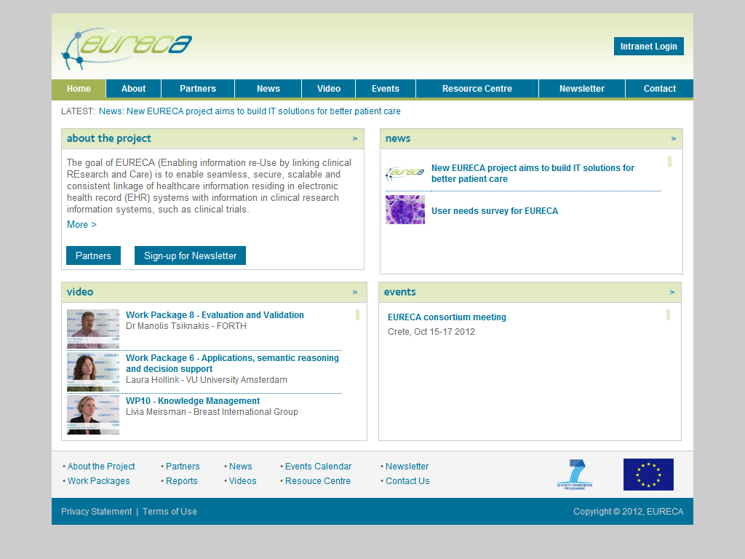

Figure 1 - EURECA website

The website is part of EURECA’s communication strategy, aiming to communicate effectively with parties outside the consortium, such as the European Commission, other European project consortia, other potential users of the technology and standardisation committees, and other interested parties. The website will contain the latest news, newsletters, activities, external and public events, and results of the project.

The design and initial content was created by *e*cancer. Once the website was built and populated with content, the partners were emailed and asked if they wanted to change any details. The website will be kept up-to-date, relying on contributions from all partners.

The remainder of this document will show some of the website’s current content.

# Content of the website

## Home page

The home page acts as landing spot for visitors. When the website is loaded, the home page is displayed (see Figure 2). On the homepage, the visitor can find a short introduction about EURECA, and the latest news, events and videos relating to the project. The page provides links to the different parts of the website.

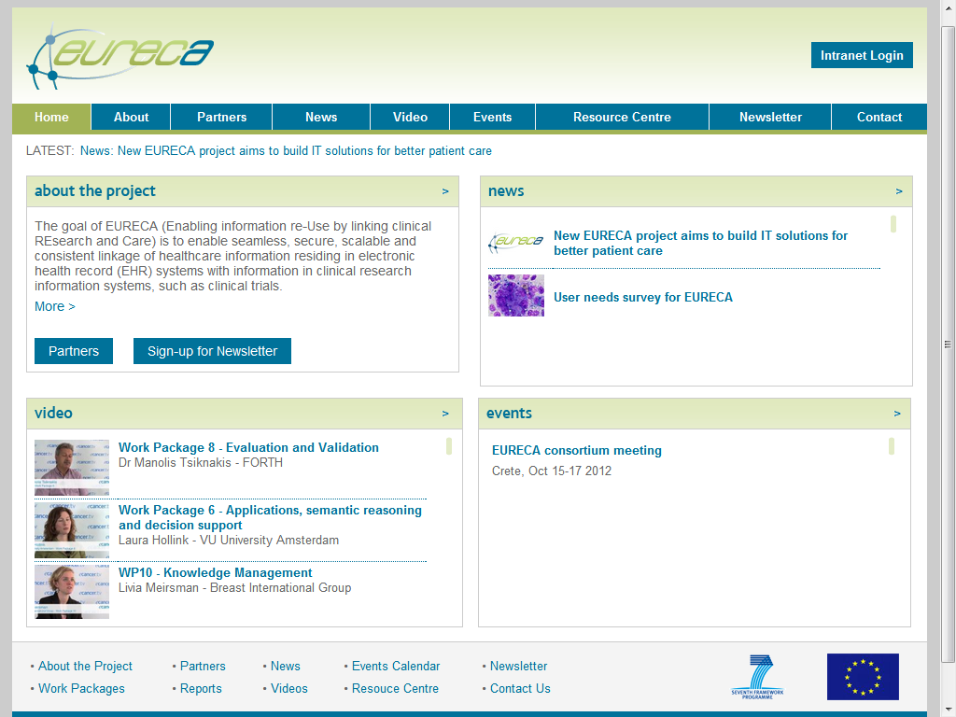

**– Homepage**

## About page

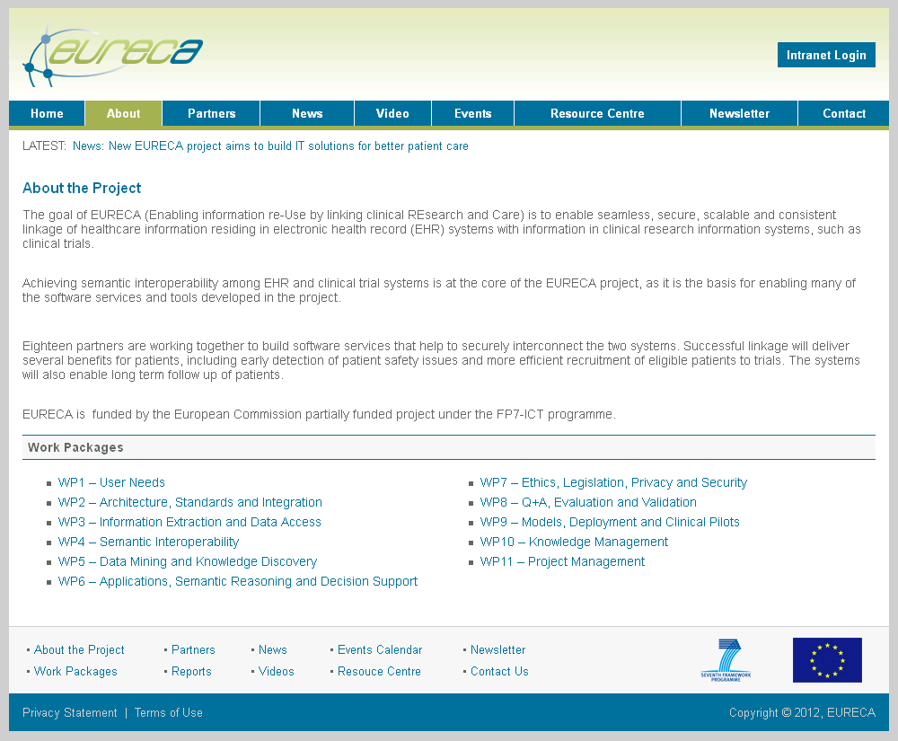

Figure 3 - About page

The About page (Figure 3) describes the goal and context of EURECA. It also contains links to the description of the work packages.

The goal of EURECA (Enabling information re-Use by linking clinical REsearch and Care) is to enable seamless, secure, scalable and consistent linkage of healthcare information residing in electronic health record (EHR) systems with information in clinical research information systems, such as clinical trials.

Achieving semantic interoperability among EHR and clinical trial systems is at the core of the EURECA project, as it is the basis for enabling many of the software services and tools developed in the project.

Eighteen partners are working together to build software services that help to securely interconnect the two systems. Successful linkage will deliver several benefits for patients, including early detection of patient safety issues and more efficient recruitment of eligible patients to trials. The systems will also enable long term follow up of patients.

## Partner page

The partner page shows the location of all partners on a map (Figure 4). A visitor can click on a map pin to find out more about the EURECA Partners (Figure 5).

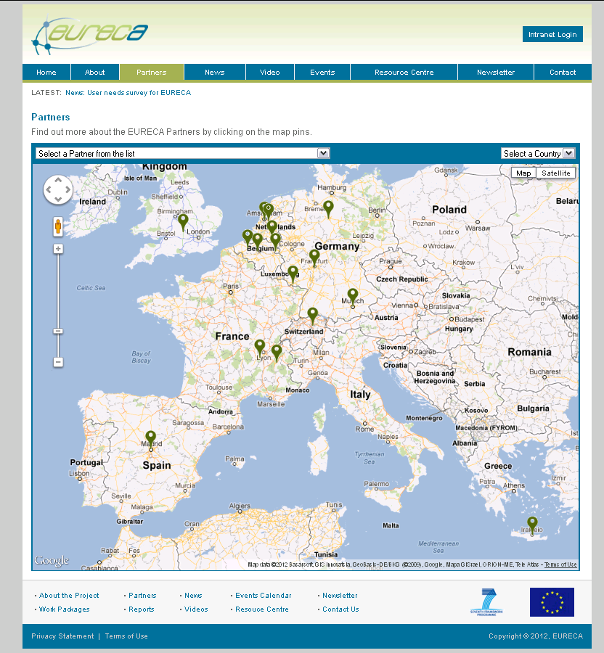  
**Figure 4**

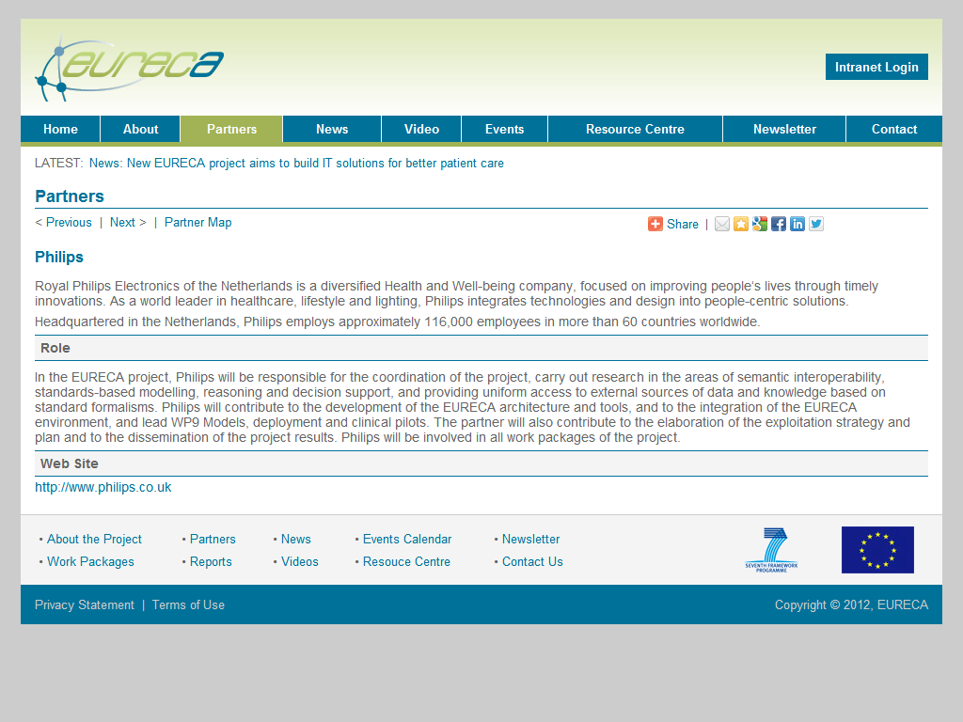 **Figure 5**

## News page

The News page will contain an up-to-date overview of the news related to the EURECA project.

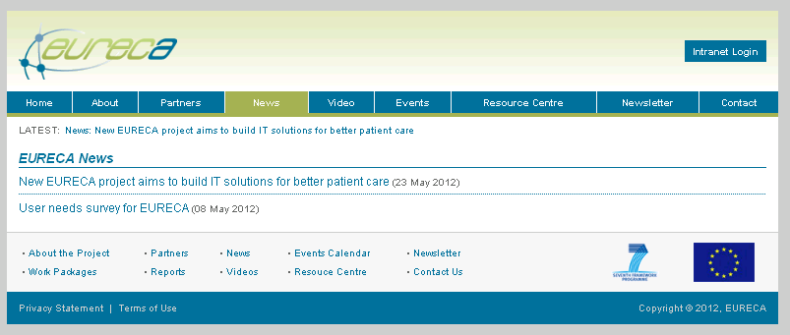

Figure 6 - News page

## Video page

The video page will contain videos related to the goals of EURECA.

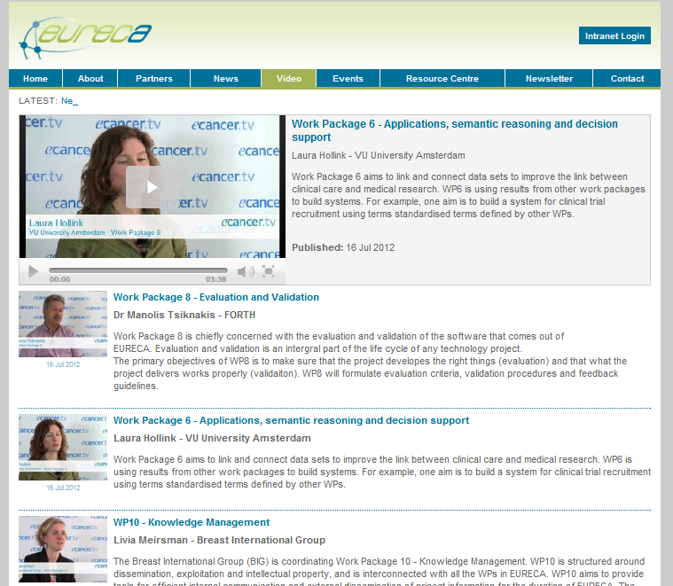

**Figure 7 - Video page**

The first videos posted were filmed at the Consortium meeting held on the 21st and 22nd June 2012 in Homburg, Germany.

Interviewees included:

**Prof. Dr. Norbert Graf** (Universitat Des Saarlandes) - [WP1:User needs and scenarios](http://eurecaproject.eu/video/2)  
**Dr Francesca Buffa** (University of Oxford) - [Work Package 5: Data Mining and Knowledge Discovery](http://eurecaproject.eu/video/6)

**Dr Manolis Tsiknakis** (FORTH) - [Work Package 8: Evaluation and Validation](http://eurecaproject.eu/video/5)

**Laura Hollink** (VU University Amsterdam) - [Work Package 6:Applications, semantic reasoning and decision support](http://eurecaproject.eu/video/4)

**Livia Meirsman** (Breast International Group) - [WP10:Knowledge Management](http://eurecaproject.eu/video/3)

## Events page

The Events page shows the past and upcoming EURECA events.

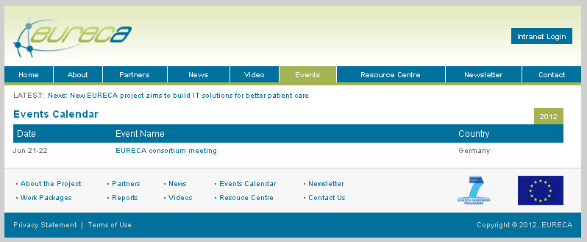

Figure 8 - Events page

## Resource centre page

The Resource centre page will contain various resources such as public surveys.

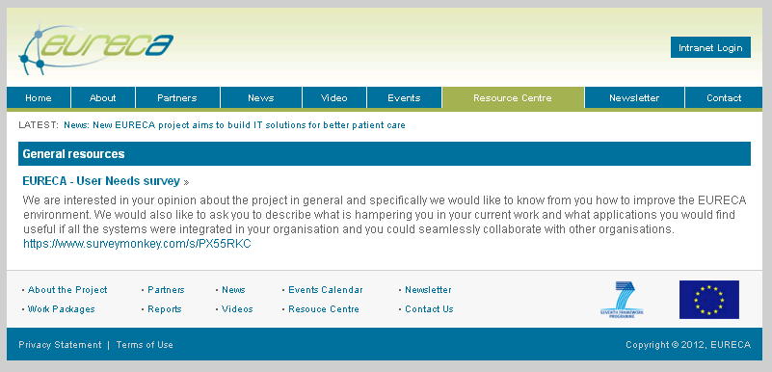

Figure 9 - Resource centre page

## Newsletter page

As part of Work Package 10, a project newsletter will be created (D10.5), which will give updates about what has been happening in the project, forthcoming events and any project news that the partners wish to disseminate.

Visitors to the EURECA external website are able to sign up to receive a copy of the newsletter each time it is published.

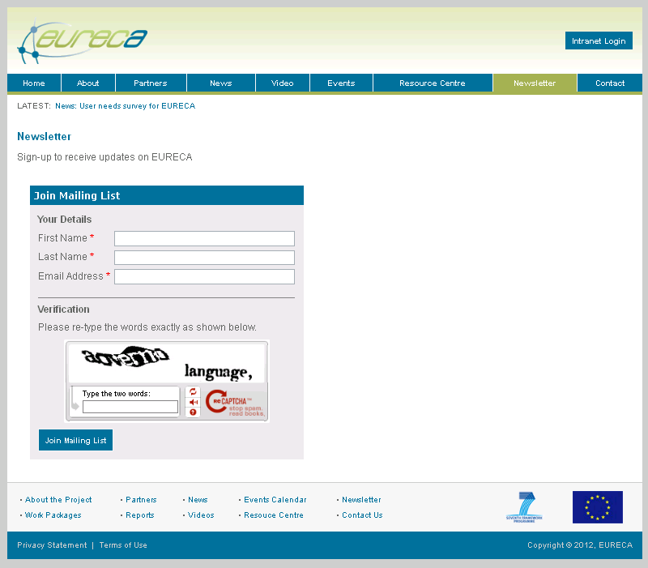

Figure 10 - News letter page

## Contact page

The contact page contains the contact details for the EURECA project.

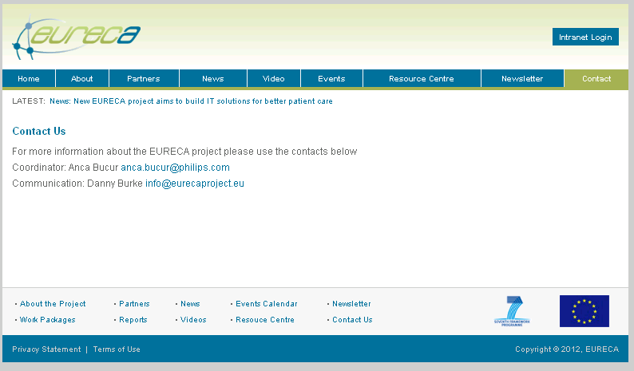

Figure 11 - contact page

**2.10 Intranet login**

From this external project site, partners of the project can access the internal project workspaces (Figure 12): The EURECA Wiki and the BSCW Shared Document Server. The landing page gives a brief description of what each portal is to be used for and how to register.

**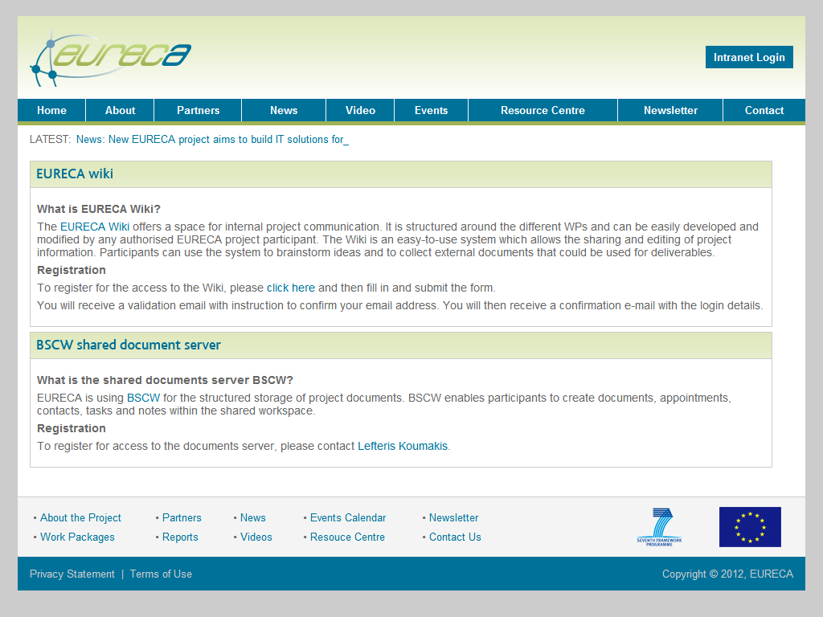  
Figure 12**

**3 Summary**

The external project website ([www.eurecaproject.eu](http://www.eurecaproject.eu)) provides the EURECA project with a solid platform for disseminating updates and results to the general public and interested parties. The website will be regularly updated throughout the duration of the project with input from all partners.