

D10.1 External Contra Cancrum
web-site

Project Number: FP7--IST-223979
Deliverable id: D 10.1
Deliverable name: External Contra Camncrum web-site
Submission Date: 5/12/2008



COVER AND CONTROL PAGE OF DOCUMENT
Project Acronym: | CONTRA CANCRUM
Project Full Name: | Clinically Oriented Translational Cancer Multilevel Modelling
Document id: | D 10.1
Document name: | External ContraCancrum web-site
Document type (PU, INT, RE) | PU
Version: | 1
Submission date: | 5/12/2008
Editor:  Organisation:  Email: | Kostas Marias  FORTH  kmarias@ics.forth.gr
Document type PU = public, INT = internal, RE = restricted

ABSTRACT:
This deliverable describes the external Contra Cancrum website focusing on its functionality.

KEYWORD LIST: web-site, Contra Cancrum, collaborative environment

MODIFICATION CONTROL
Version | Date | Status | Author
1.0 | DD/MM/YY | V1 Submitted | K. Marias

List of Contributors
- CUNI (all)
- FORTH

Contents

Contents 4
1 Executive Summary 5
2 Introduction 5
3 http://www.contracancrum.eu/ description 6
Structure of the Deliverable 6
3.1.1 Project summary 6
3.1.2 Participants 6
3.1.3 Contact 6
3.1.4 Member Area 6
4 Conclusion 7

- Executive Summary

The Contra Cancrum external website has been designed and created in order to serve as the first point of information for the research community on the objectives, approaches, and results of Contra Cancrum. In addition, the website provides services such as email and videoconference in order to also serve as a collaborative environment for members of the consortium. The web-site will be continually updated during the project.

- Introduction

This document presents a short description of the Contra Cancrum website. This has been done with Google Apps technology, allowing the use of a number of tools to be used.
The main actions taken so far are:
- User accounts for have been created for all Contra Cancrum partners and email redirections to their permanent email addresses have been set.
- Specific email lists have been created for all WPs (1 to 10) of the projects in order to facilitate communication within each WP. Also, an email list for management issues has been created as well as a list for all project participants. For security reasons, only users with administrating rights can add and/or remove people from the list. This can be done from a web interface.
- From the website, the Contra Cancrum members can easily access a site for document sharing, providing also other useful services (e.g. chat, calendar, videoconference).
- After several efforts, the use of the website has been explained in detail and all the partners have already adopted its mail and document services. This ensures that there is a dedicated functional space for each user with only the Contra Cancrum relevant emails and documents and facilitates communication using WP lists.

- http://www.contracancrum.eu/ description
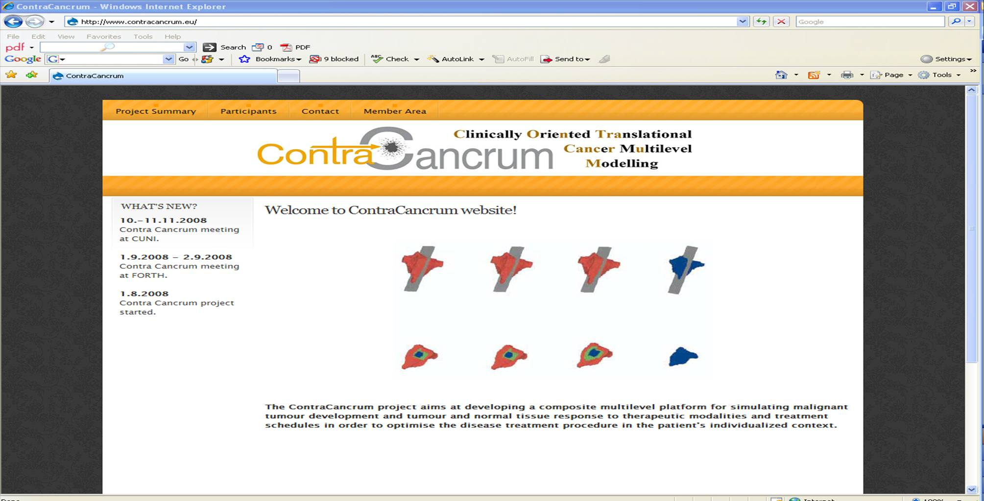Figure 1: The Contra Cancrum website
Structure of the Deliverable
In the introductory screen there is a window displaying “What’s new” regarding the project’s progress and implementation. The main features of the website are described in the following sections
    - Project summary
This is the first section of the website providing a short, generic description of the project. The web
    - Participants
In this section, information about the consortium can be found.
    - Contact
In this section, contact information about the coordinator of the project can be found.
    - Member Area
In this section, there is a link to dedicated services (mail, calendar, documents), only for registered Contra Cancrum users. A prompt asks for the user login (e.g. kostas.marias@contracancrum.eu ) and the password. The user can then access the dedicated services as is shown in the next picture:

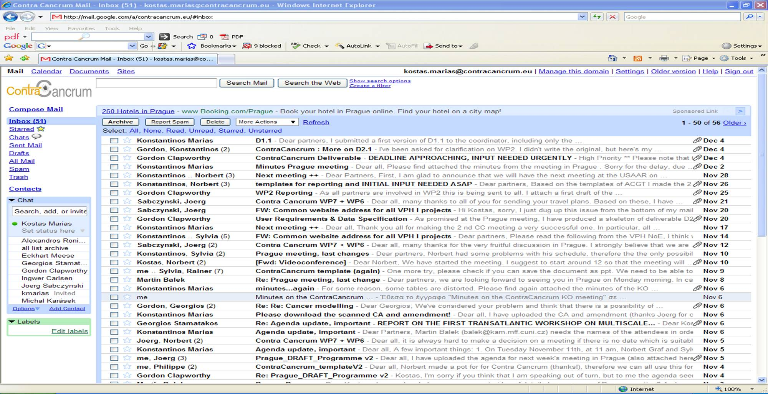
Figure 2: The Contra Cancrum email, calendar and document services interface

- Conclusion

The Contra Cancrum external website offers information on the objectives, approaches, and results of ContraCancrum with the main goal to disseminate it to the wider VPH research community. The website provides services including mail calendar and videoconference for its registered members in order to also serve as a collaborative environment the consortium. The web-site will be continually updated during the project and will the plan is to be linked with the VPH NoE website in the near future.

