

Revised Dissemination Plan

Project Number: FP6-2005-IST-026996
Deliverable id: D15.5
Deliverable name: Revised Dissemination Plan
Submission Date: 08/01/2008



COVER AND CONTROL PAGE OF DOCUMENT
Project Acronym: | ACGT
Project Full Name: | Advancing Clinico-Genomic Clinical Trials on Cancer: Open Grid Services for improving Medical Knowledge Discovery
Document id: | D15.5
Document name: | Revised Dissemination Plan
Document type (PU, INT, RE) | INT
Version: | 2
Submission date: | 08/01/2008
Editor:  Organisation:  Email: | Aurélie Fouré  HealthGrid  disseminate@healthgrid.org
Document type PU = public, INT = internal, RE = restricted

ABSTRACT:
This deliverable reports on the changes from the original dissemination plan and shows the way the ACGT project should take.

KEYWORD LIST: Dissemination, Website, Newsletter, Audiences and Messages.

MODIFICATION CONTROL
Version | Date | Status | Author
0.1 | 02/10/2007 | Draft | A. Fouré
0.2 | 08/01/2008 | Draft | A. Fouré, Y.Legré, N. Verhaeghe
1.0 |  | Final

List of Contributors
- HealthGrid
- ERCIM

Contents

1 Introduction 5
2 Executive Summary 6
3 Report on dissemination activities 7
3.1 Relationships and responsibilities 7
3.1.1 Dissemination dimensions 7
3.1.2 What is WP15 generally responsible for? 7
3.1.3 Partners (from DoW_V8) 8
3.2 The dissemination instruments of the project and other activities 9
3.2.1 The Editorial Board 9
3.2.2 Websites 10
3.2.3 Media relations 12
3.2.4 ACGT Conference 12
3.2.5 Other events 12
3.2.6 Internal Mailing lists 13
3.2.7 Publicity Material 13
3.2.8 Government relations 15
3.2.9 Newsletter 15
3.3 Measurement and evaluation 17
4 Updated plan for dissemination 18
4.1 Objectives 18
4.2 Identifying audiences and messages 19
4.2.1 What kind of messages needs to be communicated? 19
4.2.2 Key audiences for the project 19
4.2.3 Audiences dissemination details 20
4.3 Dissemination summarised guidelines 26
4.3.1 Next dissemination methods 26
4.3.2 Ethical, Legal and Security Issues 27
4.4 Next steps 30
4.4.1 Time-line of the project 30
4.4.2 The goals 32
5 Conclusion 33

1 Introduction
Purpose
Dissemination and Outreach are key areas for ACGT (Advancing on Clinico-Genomic Trials on cancer). The project must be attractive and interesting so that participations from many different scientific disciplines, academia, business and government are included and can be identified.

The first Dissemination Report (ref. D15.3) highlighted the areas in which the project was successful these last months. In the same way, the initial plan showed up the key messages, the potential audiences, the roles and the responsibilities, the methods of communication to be used and measures for success.

The purpose of this Revised Dissemination Plan is to provide again a formal planning document for using and disseminating knowledge throughout the project taking into account results from the first dissemination plan.
It also identifies a number of aspects, like the roles or responsibilities, potential audiences, messages, methods of communication that should be utilised by WP15 partners and measures for success.

Status of WP15
The WP15 has created strong relationships with its partners and gathers the effort and the energy to the creation of major tools for ACGT dissemination.
It has also provided the last version of the website and the support for the first issue of the newsletter in which news releases from ACGT partners were implemented.

References
- Initial Dissemination Plan (D15.2)
- First Dissemination Report (D15.3)
- Description of Work DoW_V8 (updated 18/07/07)

2 Executive Summary

From the latest Dissemination Report, which was written recently, it is clear that ACGT is moving to the right direction. The first EU Review in April 2007 first confirmed this when the Reviewers said the EU would continue to support the project due to a great impression and other great technical demonstrations.
This updated dissemination plan points out the many progresses that have been generated since the beginning of the project. Although ACGT had many expectations regarding the dissemination tools, it preferred to concentrate its efforts on specific and strategic means such as the newsletter or the development of the website in order to get a stronger impact on patients, scientists and industries.
Thus, dissemination efforts have been conducted to activities and elaboration of specific dissemination tools gathering at the best all the necessary resources. Furthermore, scientific publications and participations to major events took also a great part of dissemination carrying out great results by publics’ feedback and the increase of interest from other projects and other communities.

ACGT is then aiming in the next period at producing the design of other dissemination tools to better target the audience. ACGT will also intend in the near future to define in a more precise way the targeted audience in order to adapt the tailored message to the right public, notably thanks to the website.
It expects also to participate always more to conferences which topic is in relation with the project’s purposes.

Finally, the Revised Dissemination Plan provides guidance for using and disseminating knowledge both within the project and to those outside it. All the efforts gathered during the last period will continue to elaborate other great dissemination means.

3 Report on dissemination activities

3.1 Relationships and responsibilities
Dissemination is at the heart of all attention. The WP15 has been building a strong relationship with the other workpackages taking in charge the dissemination of ethical, legal and QA (Quality Assurance) issues, the clinical trials, the evaluation and validation, the training, the market investigation & exploitation. All these topics need such communication strategy in order to spread its messages.

3.1.1 Dissemination dimensions

For a general dissemination dimension, the WP15 is responsible for:
- the identification of the messages that need to be communicated
- the identification of target audiences to which the messages needs to be conveyed and the delivery of the messages through appropriate and effective channels, taking into consideration the resources allocated to such an activity

For the scientific dissemination dimension:
As said in the initial plan (D15.2), the responsibilities of the WP15 are to assist the scientific and technical coordinators providing:
- a link to the most relevant scientific conferences, journals, etc to the project and online notification of relevant calls for papers, workshops, etc and
- a repository of the scientific dissemination of the project, i.e. PDF versions of papers and conference presentations made by the project, so that it can be accessible through the public website of the project.

3.1.2 What is WP15 generally responsible for?

- The website of the project
- The newsletter
- The organisation of events (from the workshops to the conference)
- Publicity material
- Finding out new interesting collaborating contacts or institutions
- Publishing scientific articles in important scientific journals

3.1.3 Partners (from DoW_V8)
Partic. Role | Partic. Number | Participant name | Participant short name | Country
CO | 1 | GEIE ERCIM | ERCIM | FRA
CR | 2 | Foundation for Research and Technology – Hellas | FORTH | GRE
CR | 3 | Institut National de Recherche en Informatique et en Automatique | INRIA | FRA
CR | 4 | Universiteit van Amsterdam | UvA | NED
CR | 5 | Philips Electronics Nederland B.V. | Philips | NED
CR | 6 | Association Hospitaliere de Bruxelles – Centre Hospitalier Universitaire Bordet – Association de droit public ASBL | IJB | BEL
CR | 7 | Institut Suisse de Bioinformatique | SIB | SUI
CR | 8 | Lunds Universitet | LundU | SWE
CR | 9 | Universidad de Malaga | UMA | ESP
CR | 10 | Universidad Politechnica de Madrid | UPM | ESP
CR | 11 | Fraunhofer-Gesellschaft zur Foerderung der angewandten Forschung E.V | FHG | GER
CR | 12 | A. Persidis & SIA O.E. | BIOVISTA | GRE
CR | 13 | University of Crete | UOC | GRE
CR | 14 | Gottfried Wilhelm Leibniz Universität Hannover | LUH | GER
CR | 15 | Instytut Chemii Bioorganicznej pan w Poznaniu | PSNC | POL
CR | 16 | Custodix | Custodix | BEL
CR | 17 | Healthgrid | Healthgrid | FRA
CR | 18 | Institute of Communication and Computer Systems | ICCS | GRE
CR | 19 | Universitaet des Saarlandes | USAAR | GER
CR | 20 | SIVECO ROMANIA SA | SIVECO | ROM
CR | 21 | Facultes Universitaires Notre-Dame de la Paix | FUNDP | BEL
CR | 22 | Universitaet Hamburg | UH | GER
CR | 23 | The Chancellor, Masters and Scholars of the University of Oxford | UOXF | GBR
CR | 24 | Istituto Europeo di Oncologia s.r.l | IEO | ITA
CR | 25 | Hokkaido University | UHok | JPN

3.2 The dissemination instruments of the project and other activities

A variety of methods of communication have been developed. Direct or indirect methods are worth to be used. Today, Internet seems to be the best means to attract and to be interactive with the visitor or potential users. Conscious of this fact, the WP15 puts a lot of effort in the development of the website and newsletter.

The project needs to establish appropriate dissemination instruments and allocate concrete responsibilities in order to be coherent, targeted, effective and efficient for the dissemination strategy.

3.2.1 The Editorial Board
The Editorial Board was part of WP15 initiative and of the Management Board. It was created before the first Review in order to have a direct contact with the partners so that messages can efficiently be delivered.
Its role is to assist the Workpackage Leader and the Management in the production of required material for the general and targeted dissemination of the project.

Name Organisation
Norbert Graf University of Saarland, Germany
Christine Desmedt Jules Bordet Institute, Belgium
Francesca Buffa Oxford University, UK
Dimitris Kafetzopoulos Institute of Molecular Biology and Biotechnology, FORTH, Greece
George Stamatakos ICCS/NTUA, Greece
Andreas Persidis Biovista, Greece
Regina Kollek UoH, Japan
Alberto D'Onofrio IEO, Italy
Nathanaël Verhaeghe HealthGrid, France

Another special Editorial Board has also been recently established for the newsletter production. It is composed of four main people coming from the ACGT consortium:
Name Organisation
Andreas Persidis Biovista SA, Greece (Editor in Chief)
Norbert Graf University of Saarland, Germany
Alberto D’Onofrio European Institute of Oncology, Italy
Nathanaël Verhaeghe HealthGrid, France
3.2.2 Websites
The project has developed in one hand one external website which offers to users the opportunity to enter the public site and to know more about the project and its purposes.
In the other hand, the internal websites give the possibility to the ACGT partners to emphasize the internal communication and to produce better results, notably at the dissemination level.

Public (external) website (http://www.eu-acgt.org)
The fact to keep the information updated is a continuous process, and input from partners is essential, particularly regarding news items. WP15 partners are also required to give HealthGrid all the documentation for translation so that it can be added to the website.
After having identified the targeted audiences, the external website has been produced for a more specific message. Now, each audience has the information it is expecting to.
It always responds to the very interdisciplinary nature of the project and its complexities. It became apparent to the management of the project that support of the main dissemination group was needed in order to be effective in this dimension.

Internal websites
The intranet
An intranet is available and this internal tool will help to keep the information and other data updated. This allows the dissemination efforts to always be at maximum capacity and to suggest more events where ACGT could attend or participate in.

Training Website (http://www.siveco.ro:8080)
The Training website is to be developed by the Training Activity (i.e. WP14) and is part of the main portal of the project. WP14 is also responsible for updating the Training Events section on the public site. The WP15 will collaborate with the training workpackage by hosting the training portal and by helping with the trainings and events organisation. The WP14 will provide the content afterwards.

BSCW Server (https://bscw.ercim.org)
The BSCW server belongs to and is maintained by ERCIM. It is a very frequently used tool among the project ACGT as it is the main document server of the project. All documents which need to be shared across the partners or a subset of them are uploaded on the BSCW Server. This server ease to share the information and to achieve a team work as it allows a better feedback from all the workpackages, which get access to that server.

Wiki Website (http://wiki.healthgrid.org)
A wiki website is one of the best ways both to support internal collaboration, document decisions and the discussions leading to take such decisions as well as to stimulate, in the future, involvement of a wider community to ACGT.
This internal tool has become more and more acknowledged among the whole ACGT consortium during the last period and is continuing in this way now.

Source: statistics HealthGrid
What we can make out from the figures above is that the number of visits on the wiki (or interface used as internal communication tool) for ACGT increases slightly according to exploitation percentages of the most recurrent users coming from Spain, France, Germany, Belgium and Switzerland. Non-Profit Organizations and commercials are also counted among the most frequent users of the wiki.

The usage of the wiki increases globally in the fact that it has first to be understood by the partners and by the ones who are willing to participate in order to enrich the content. Therefore we can say that little by little, it has become more and more acknowledged among the ACGT consortium. April, for example, shows well the interest in the new website renewed just after the annual Review in Poznan, in Poland. Indeed, the number of pages, which were worked on increased significantly in April, whereas the number of visits stays stable.

Today, the wiki is always more used by the ACGT partners showing a great interest in this tool as efficient internal exchanges generates better results.

3.2.3 Media relations
Media relations are a key dissemination method for all WP15 partners.

It is also important that the ACGT partners concentrate on establishing and maintaining personal contacts with specific journalists, who will help to establish the placement of ACGT actions in the future.
The main media ACGT is in relation with are newspapers and other scientific publications.

3.2.4 ACGT Conference
According to the previous initial dissemination plan, the first main ACGT conference should have been held in April 2007.

It has been decided the conference will better be held in 2008 and will try to collocate with other more important events that would focus on the same purpose as ACGT.
These conferences are:
- EBCC.6 in Berlin, Germany (15-19 April 2008)
- UICC 2008 in Geneva, Switzerland (27-31 August 2008)
- SIOP 2008 in Berlin, Germany (1-6 October 2008)

The conferences are primarily managed by HealthGrid, FORTH and ERCIM but the WP15 partners are expected to help publicising these events both within their countries and to wider audiences through media relations, advertising on their websites and publicity.

3.2.5 Other events
Another way to reach wider audiences is to ensure that ACGT is publicised at events where known target audiences attend like:
- workshops
- meetings
- training

Workshops are preferably organised during other significant events. Until now, ACGT is still seen as a young project and therefore needs time to be acknowledged among the other projects supported by the European Commission, like the EGEE-II annual conference in Budapest, in October 2007.
3.2.6 Internal Mailing lists
A central mailing list has been set up for people wishing to learn more about ACGT.
The already existing mailing lists are:
- general ACGT mailing list including all the partners participating to the project
- the editorial board list including the partners in charge of providing the content for dissemination tools such as the website
- the management board list including the workpackages leaders
- the newsletter editorial board list including the partners in charge of providing the content for the newsletter

Another mailing list has been created to have a concrete database used to send the newsletter and other news about ACGT. These external people on this mailing list will receive the quarterly newsletter and any other news releases issued.

3.2.7 Publicity Material
A range of information sheets have been written, notably on bookmarks and leaflets.

Templates for specific documents such as posters and flyers have been designed by the WP15. The flyer for the oncosimulator is a concrete example (see below).
ACGT plans to develop and/or update more publicity material, including the general flyer which can be used for general dissemination, such as more information sheets and leaflets about more technical aspects.

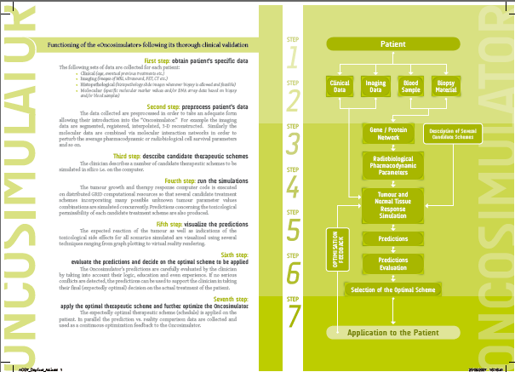
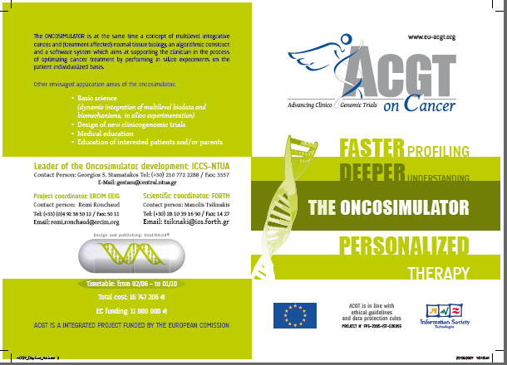

3.2.8 Government relations
As it is a European project involved in medical research, government relations are highly important for finance and support.
It remains important for the project to present all the work generated to the partners’ respective country government in order to inform them about the various progress of research. Their support will participate in the improvement of healthcare research overall in these countries, where the ACGT partners are coming from.

3.2.9 Newsletter
The Newsletter first issue has now been published. It was based on the applications and technological approach, as well as on the project’s achievement and life. As decided, it will be produced quarterly and will be provided to the scientific and professional communities in order to spread the results of the project to relevant user groups. ACGT will continue to enrich this great tool in the following period thanks to the Newsletter Editorial Board that has been established to that purpose.
The newsletter has a role of disseminating the latest news, events and achievements of ACGT. Printable and on-line versions are available.
The newsletter has been thought to attract the interest of the wide scientific community and general public and to increase the flow of communication between the people involved in the project.
Same topics will appear on a regular basis in each newsletter edition, notably articles in regards with clinical trials, grid news or legal and ethical issues for example.
Here is the list of themes which articles will always be renewed in newsletters:
- Clinical Trials,
- Grid news,
- Products and Services,
- Feature Article,
- Community view,
- Legal and Ethical issues,
- Events,
- Life in ACGT,
- ACGT people.
- and of course, the Editorial at the beginning of each edition.

The online version
The printable version
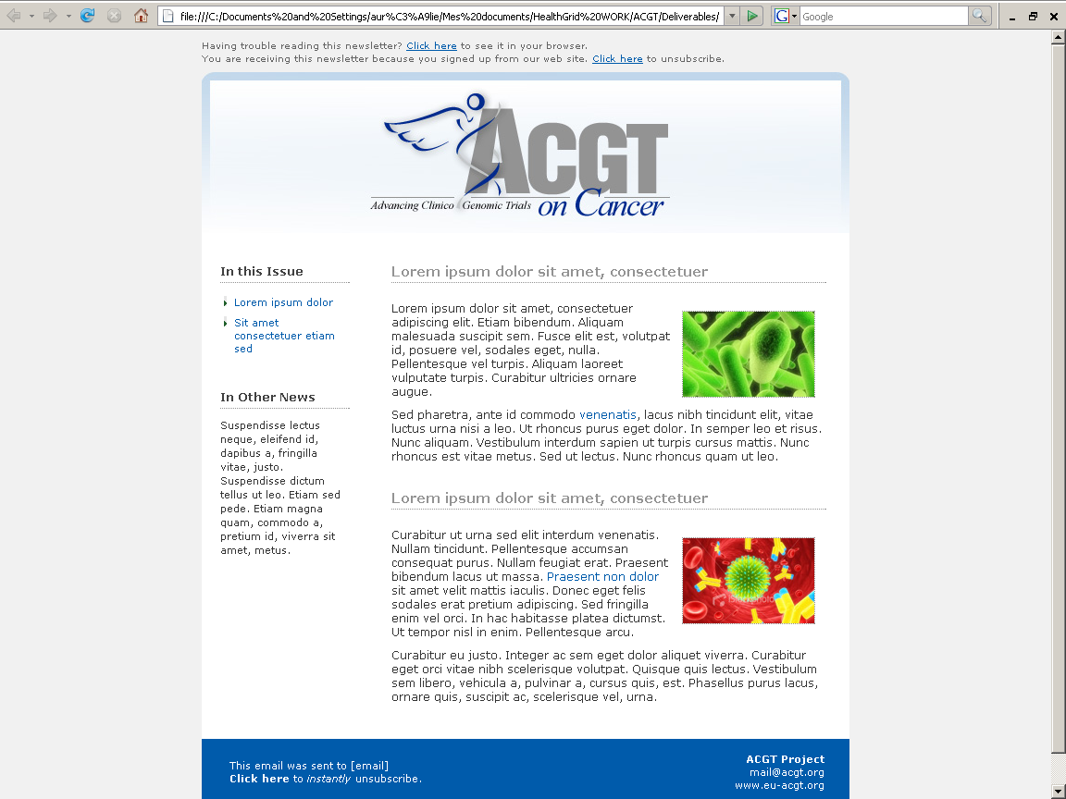
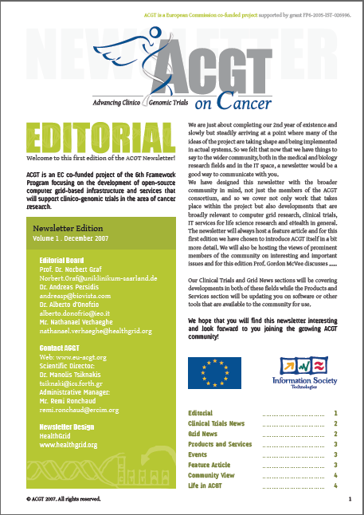
The printable version
The online version

3.3 Measurement and evaluation
It is important to set some measures for success in order to know if WP15 is achieving its aims. The following evaluation was already reported, the First Dissemination Report (ref. D15.3).
Dissemination is a delicate domain that allows reactions from different perspectives, and measuring its success becomes really difficult. However, the number of events where ACGT is presented and promoted and all the meetings and demonstrations are proving the increasing interest among the society and overall from the scientific audience.
Furthermore the researchers’ and other scientists’ feedback are well received and show their real intention to know more, their awareness of the last technologies’ use and the advances within the biomedical sector, notably regarding the ways to cure cancers.

Also, a lot of effort has been concentrated on particular tasks. Although many dissemination tools should have been provided within a lapse of few months, the WP15 and its partners decided to concentrate the time and the work only on specific tools, notably on the newsletter and on the website in order to have a better impact on the targeted audience.
At another level, the ACGT consortium decided, after having thought carefully, to delay the production of publicity material as it might be too soon to approach directly the targeted audience. Indeed, ACGT cannot risk loosing the audiences if they get disappointed.

The first annual Review in Poznan

The first official review took place in Poznan (Poland) on April, 23rd and 24th 2007. About 20 members of the project consortium gathered in order to present to the European Commission and its external reviewers the improvements and the project’s advances covering the period from February, 1st 2006 to January, 31st 2007. The different topics were then developed and explained thanks to demonstrations and illustrations of grid’s use for ACGT purposes, like clinical trials, ontology or oncology. The review globally received a very positive impression thanks to impressive logistic organisation and technical supports. Regarding the project, the latest technologies were used and technical management appeared confident and respected among the consortium. Despite of an overall encouraging reaction, some subtle points still needed more time to be solved, like legal and ethical aspects and scientific conflicts of interests. The recommendations always concentrated on one point: to pay more attention on underestimated points, like clinical trials where legal and ethical requirements have become more complicated. Innovations of higher scientific and technological impact should also be in line with the project vision. Targets were also redefined and the website redesigned for a more attractive and better dissemination of the knowledge created by the whole ACGT consortium.
The website is then the centre of all of ACGT attention, because it represents the main show- case. Therefore, it is about to be improved all the time.
4 Updated plan for dissemination

4.1 Objectives
Dissemination targets three main objectives:
- to go on communicating about the project,
- to evolve within the new technologies area,
- to convince the researchers and the patients about the advantages of the project.

To go on communicating about the project
ACGT always keeps in mind to inform about the last advances in new technologies in relation with biomedical research.
Therefore conferences, workshops or exhibitions are considered as the best ways to communicate directly about the project. Such event conditions might also be the best manner to spread publicity materials and to talk about the other dissemination tools.

To evolve within the new technologies area
ACGT integrates the new technologies within its research. Thus, the project has always to be informed about the last new technologies advances so that the project can use the last interesting discoveries into its researchers.

To convince the researchers and the patients about the project
ACGT should always renew its target dissemination tools and should be careful on the design of project’s tools. Indeed, this objective includes the fact that the project still needs to be attractive. It needs also to be relevant, and therefore, dissemination tools should always be precise, easily readable and clear.

4.2 Identifying audiences and messages
The targeted audiences are mainly and always technical and scientists. Nonetheless, ACGT would be more convincing if it could address messages to a wider public, notably to patients or regulatory bodies.

4.2.1 What kind of messages needs to be communicated?
It provides WP15 a real challenge because it has to adapt the messages to all the partners, and should even more enlarge the audience targets.
It is necessary for the project to invest more time in target audiences so that it is possible for ACGT to convince more people.
With regard to specific scientific audiences, the WP15 partners may choose to concentrate their efforts on completely new sciences. Alternatively, as the application users already on board are clearly interested in using the Grid, they may choose to concentrate on bringing similar applications to the project from their own countries.
This fits with the regular questions partners should ask themselves: “Who are we talking to?”, “Who should we be talking to?” The chosen audiences will very much depend on the success of the last months (since the beginning of the project)

It is important to note that key messages will be delivered for each target. They will be more detailed in the next part.

4.2.2 Key audiences for the project
The targets already mentioned in the previous Dissemination Plan will be explained below.
Indeed, it is necessary to remind how to disseminate properly.

Major categories and audiences identified in the following list:
- Medical professionals and researchers involved in translational research
- Patients and patient organisations
- Bio-informaticians and other IT system developers
- Pharmaceutical Companies and other industry
- Relevant national or international initiatives
- Regulatory Bodies
- General Public

Medical professionals, life science researchers as well as bioinformaticians and other IT solution developers represent the most important target audiences of the project. It is obvious that each of these target audiences requires quite specific and different information with respect to the project. As a result, the main messages will have to be adapted to the specific role and expectations of each of these target groups. Also, dissemination information has to be made available in several alternative ways, whenever possible.

4.2.3 Audiences dissemination details
Medical professionals and researchers involved in translation research

How to disseminate?
Apart from textual material available on the website presenting its existing challenges, its vision and its main messages, ACGT has to be disseminated within scientific publications and at scientific meetings and congresses by all partners.

Main messages
The main message towards this community is the ACGT integration architecture as a response to this ever increasing challenge of data integration:
- ACGT will facilitate the procedure of clinico-genomic trials by physicians by providing an infrastructure
It spares time in the overhead work needed for clinical trials
It offers the same portal regardless of the underlying trial
It fulfils all legal, ethical and regulatory demands and
It offers within the RCTs, the best treatment a patient can get

- ACGT will help basic researchers by providing an infrastructure
It fulfils all legal, ethical and regulatory demands in clinical research
It offers the seamless integration of clinical data with research data and
It allows clinical relevant questions to be answered much faster

Material to produce
- Online visual demonstrators presenting the ACGT technologies and how they respond to real analytical and other discovery needs of clinical of life science researchers
- Scientific papers
- Flyers and other attractive dissemination material so that the research area appears more reachable

Time line
- Online visual demonstrators: T0+24
- Scientific papers: T0+48

Main contributors
- Mainly WP 2 and WP12, but also all technical WPs

Patient and patient associations

How to disseminate?
By
- providing information about benefits of prospective trials and the additional advantages of clinico-genomic trials in ACGT for physicians
- providing information about the expected benefits to result form the quick execution of post-genomic clinical trials for patients and the society
- taking active part in scientific meetings advertising ACGT to physicians for enrolling patients into clinical trials
- participate in patient meetings to inform patient groups and patients itself about the benefits of clinico-genomic trials within ACGT
- making sure that targets are informed about the strict security mechanisms implemented by the ACGT technologies and the procedures in place which make sure that they guarantee full compliance to the existing European legislation regarding management of sensitive personal data

Material to produce
- Website content: produced
- Information sheets for patients and physicians: done and currently being improved
- Newsletter: first issue delivered in T0+22 (December2007)

Contributors
- WP2: information regarding research priorities of multi-centric post-genomic clinical trials on Cancer and the expected benefits.
- WP10: the legal framework existing
- WP11: the security dimensions adopted by the project, thus making the use of personal genetic data secure

Bioinformaticians and other IT system developers
How to disseminate?
The main pillars of our dissemination plan to this community are:
- The vision and benefits of re-usable software services
- The ACGT Integration architecture and the conformance guidelines
Apart from general material available through the website, the main dissemination channel towards this audience exists in the scientific conferences, and workshops of the project.
Dissemination to vendors will strongly rely on technical and exploitation work packages, and it is a key factor for successful dissemination to listen to their needs. A good relation between the WP15 and the previously mentioned workpackages is therefore our focus.

Main messages
The main message here is to join an important infrastructure to the development of the modules in use

Material to produce
- website content on
- how to link to ACGT infrastructure development
- kinds of services to develop
- guidelines for developing ACGT compliant technology
- etc…
- flyers/information sheets
- scientific papers
Time line
- flyers / information sheets: T0+24

Contributors
The main contributors for this activity are WP3, providing the ACGT architecture and material explaining its rational, benefits and key technical aspects as well as WP9, providing the guidelines for integration with the ACGT architectural framework and conformance criteria.

Pharmaceutical Companies and other industry
How to disseminate?
The methods to be used include personal contacts and targeted electronic communication.
Post marketing surveillance of drugs and pharmacovigilance initiatives are also potential ACGT dissemination targets.

Main messages
The main messages are similar to those to be developed for targeting the clinical researchers. Specifically important for the pharmaceutical companies are the following facts:
- Life science researchers are experiencing a “data explosion” due to vast amounts or raw data being produced from both public sources and from high-throughput sequencing and other industrial-scale technologies being utilised in-house. This exponential growth curve is expected to continue. In fact, genomic data alone is not only doubling every 12 months.
- From a scientific perspective, this wealth of data creates exciting and unprecedented opportunities for new discoveries (including new drug discovery). But being able to quickly and effectively turn this data into knowledge has proved to be a serious challenge and a concerting drain on drug R&D productivity.
Ironically, huge gains in efficiency in the “front end” of the discovery pipeline have created huge “down stream” inefficiencies because the data cannot be accessed, integrated, and analysed quickly enough to meet the demands of drug R&D. This industry has outgrown traditional proprietary data capture and integration methods, and traditional “big IT” approaches solve only part of the problem. The first generation of integration solutions that centred on the concept of local repositories (silos, warehouses) have not scaled well, are costly to maintain, and are ultimately limited in long-term.

Material to produce
- Re-use of material developed in order to reach other target audiences in the beginning.
- Customisation and specialisation of such material specifically for the pharmaceutical companies

Time line
- Customised flyers / information sheets: T0+24

Contributors
- All WPs

Relevant national or international initiatives

How to disseminate?
We will disseminate to relevant national or international initiatives using the same strategy as with medical professionals.

Main messages
The integrative nature of the platform and the benefits (in terms of work optimisation) will be gained through its use.

Material to produce
- No additional material is required.

Time line
- Contacts with relevant national or international initiatives will be done on a continuous base
- Progress will be reported in the six monthly progress reports
- Explain the “critical path” issue and how ACGT could help make their approval process more efficient.

Contributors
- All WPs

Regulatory bodies
How to disseminate?
We will disseminate to regulatory bodies using the same strategy as with medical professionals and to national and international initiatives.

Main messages
- The ACGT infrastructure is in line with the European legal and ethical rules and guidelines.
- Argue about the level of security implemented in the ACGT technologies, and build confidence.

Material to produce
- Website content (done)
- Flyers

Time line
- Flyers / Information sheets: T0+24

Contributors
- WP 3
- WP 10
- WP 11

General Public
How to disseminate?
Similarly to the other targets, we will use the website as a basis for dissemination. Then, as soon as we will have first results, we will publish articles for magazines dedicated to a large public.

Material to produce
- Website content
- Popular articles
- Newsletter

Time line
- Articles: T0+24

Contributors
- WP2, WP8, WP12, WP10 & WP11
Slight changes have been made since the last Dissemination Plan. Although the identification of the targets has not been modified, their names and distinction have moved for some of them. Now, all these audiences are today identified on the website as:
- Medical professionals
- Researchers
- Industry
- Patient
- Regulatory bodies
- General public

Thus, the audience named “Researchers” includes the “Bioinformatics and IT development” and the audience named “Regulatory bodies” takes into account the “Relevant national and international initiatives”.
As said previously in this report, the targets will be redefined in order to better aim the dissemination.

4.3 Dissemination summarised guidelines
For a project of this size and geographic diversity it is vital for key messages of the dissemination campaign to remain consistent.

Thus, the key messages of the project are:
- The sense of the project
- The vision of the project
- The aim of the project
- The tools of the project
- The potential scientific advances of the project (computing new technologies use, like the oncosimulator or healthgrid)
- Participants in the project
- Major developments/achievements of the project
- New organisations/industries coming on board
- Key milestones in the project

All the key messages will be relevant to all identified audiences. For this reason, responsibility of the WP15 partners is to ensure that the right messages are tailored to the right audiences.

4.3.1 Next dissemination methods
The project is now at T0+22. Without specialised market research, it is difficult to know how many potential audiences have been reached so far, however we can say that dissemination goals have been achieved little by little although the project met some delays in some tasks achievements. Indeed, as all the workpackages are working together, some assignments needed feedback. Therefore interruptions might have occurred because of this task chain.

As for the last period, we will continue to use the following methods of communication.

Websites
- Internal Website
- Public Website (The public website is being improved every day, enriched by other partner knowledge.)
The website of the project will be linked to numerous other relevant sites and registered in the main search engines on the Internet. After termination of the pilots the website will also include all the relevant information about the results (already explained in D15.1).
Dissemination tools
Media Coverage
The media coverage will consider submission of journal papers as well as participation with technical papers in relevant scientific conferences

Publicity Material
Publicity material that needs to be produced mainly includes
- Information sheets that will deal with the main topics such as breast cancer, nephroblastoma, ethical and legal aspects, etc…,
- leaflets (or flyers),

Style and Design
Design guidelines have been defined by the consortium (colours, style, logo, and templates).
The documents templates (public presentations, newsletter, website, deliverables and other publicity material like bookmarks or leaflets) are created according to these charts and tend to be as harmonious as possible with the project spirit.

ACGT events
ACGT events include conferences, workshops, meetings and other events related to the project purposes. Meeting people, discussing or exchanging news items is of high importance for the project. It brings new information about technological and medical advances or discoveries and can create new interesting relations for the project acknowledgement.

Nevertheless and as said in previous reports, ACGT has had already a good scientific output. The WP15 still continues and increases the scientific production of the project in a coordinated manner, which is still expected to happen when the project matures.

4.3.2 Ethical, Legal and Security Issues
It is important to remember that the following aspects are of highest importance:
- the existence of a guaranteed continuous "chain of responsibility" in relation to the derivation, storage, handling and use of body materials and personal data;
- a clear definition of the subject’s free and informed consent; and issues of solidarity, altruism and justice.
Moreover
- The ethical and legal aspects have been well determined in the different publicity materials that have been created recently.
- The project continues to fulfil the legal, ethical and regulatory demands in clinical research.
- Legal and ethical aspects have got a too highly important part in the ACGT project development. Therefore the whole consortium agrees to distinguish this part.

What are the main objectives?
ACGT wants to obtain a better understanding of the optimal adjuvant therapy for the individual patient through translational research and aims to award the cancer research community an integrated Clinico-Genomic ICT environment enabled by a powerful Grid infrastructure.

Ethical requirements
ACGT aims at:
- awarding the cancer research community a European Biomedical Grid infrastructure, integrating clinical, biomedical and genomic information on cancer
- integrating clinical, biomedical and genomic information on cancer so as to provide the cancer community a Grid infrastructure on a European level.
- identifying genetic and other molecular components which are involved in cancer development and reaction to cancer treatment.
In a European context, the ethical challenges are:
- The revision of data protection and information flows. ACGT requires the careful establishment of data protection tools and systems because the structure of data and information flows is challenged by conflicting requirements.
- The community’s interests in implication of European health care administration

Legal requirements
ACGT aims at the exchange of data so that researchers can participate and access to the patient’s data for research purpose. It is essential the data are well-conducted lawfully.
According to the European Parliament and the Council the legal aspect is by far the best international policy instrument to achieve two main objectives:
- the achievement of the Internal Market (free movement of persons)
- the protection and fundamental rights and freedoms of individuals and the creation of an equivalent standard of data protection.
4.4 Critical success factors

In order to assure the success of ACGT Dissemination Strategy with dissemination of the ACGT project, a number of factors need to be pointed out.

Familiarity: it is vital that all WP15 partners familiarise themselves with the Dissemination Plan and identify the areas within their countries. If we are not working in the same direction, dissemination may fail!

Focus: everyone involved with dissemination should concentrate his efforts on what and who really matters

Communication within WP15 and the editorial board: for a project of this nature, it is vital that WP15 partners keep communicating with each other. Phone-conferences are held, in addition to the other essential e-mail contacts.

Communicate with other activities: it is imperative that other activities keep WP15 informed of progress in the project.

Guidance, support and assistance: WP15 is a team and as such, the partners are there to support, guide and assist each other when required.

Resources: the task is huge, the resources are not. This means that it is not always feasible to do everything we would like to do. We should, however, ensure that what we do, we do it well!

Success of other parts of the project: of course, WP15 can only disseminate information that is relevant, timely and progressive, and so the other activities have to make progress in their own areas.

4.4 Next steps

4.4.1 Time-line of the project
Previously planned in D15.2 |  | Planned in the next future
T0+18 | Newsletter  1st issue of the ACGT Newsletter published  Posters:  Medical professionals  Technology and tool developers  Post-genomic researchers  Flyers  Medical professionals  Information sheets  Patients  General public |  | Continuous improvements of the ACGT website
T0+20 | Flyers  Regulatory bodies  2nd issue of the ACGT Newsletter | T0+20 | Newsletter  1st issue of the ACGT Newsletter (online and printable versions)  Flyer  Oncosimulator
T0+24 | CD-ROM  Online demonstrations of the ACGT tools and services accessible through the project public website | T0+24 | Continuous improvements of the ACGT website  Continuous work on various information sheets  Posters  Oncosimulator  Technologies and tools developers  Post-genomic researchers  Newsletter  2nd issue of the ACGT newsletter  CD-ROM  Online demonstrations of the ACGT tools and services accessible through the project public website  Conferences participations  Workshops and sessions organisations for T0+26 (April 2008) and T0+30 (August 2008)
 |  | T0+26 | First conference participation in 2008 (EBCC.6 in Berlin)  Preparation of “Reporting Book”  It will gather all the reports, proceedings and of course the description of the ACGT project.
 |  | T0+30 | Second conference participation in 2008  (UICC 2008 in Geneva)
 |  | T0+32 | Third conference participation in 2008  (SIOP 2008 in Berlin)

4.4.2 The goals
What needs to be generated now is to:

- Redefine always more the targets lists
ACGT will tend to again better identify the audience in order to adjust at its best the dissemination tools.

- Organise and be present on conferences
ACGT is determined to find events to which the project could collocate or with which it could participate.

Workshops
The last workshop was organised in Budapest at the beginning of last October (04/10/07). This great event was prepared in the same place and at the same time as the EGEE annual conference (planned from 01/10 to 05/10/07). This was planned in order to give the project a great opportunity to be publicised and so to meet other people potentially interested in the project.

The annual conference
The conference of the project is preferably to be organised on an international level and should gather each year the ACGT project partners, users and other potential users.

- Increase performing publications
Scientific articles are regularly published in well-known scientific journals, so that scientists are aware of research advances.
During the next period, ACGT will always more publish news releases and edit publications about the project or at least articles about the topics of the project in order to inform as much as possible the audience, for example about any new applications running or new in silico trials experiences

- Attract early adopters and start success stories
It is important for ACGT to develop the contacts and to be acknowledged among the scientific sector. That is the reason why it regularly takes the opportunities to meet people and to participate to interesting events which are related to the project purposes.

.

5 Conclusion

The D15.3 (First Dissemination Report) described all the activities generated during the last period and demonstrated well the increasing interest from scientific and general public audiences. It is so obvious that the WP15 and the ACGT project are on the right way.
The first annual review in Poznan (Poland) confirmed the improvements made during the last period. It left indeed a very good impression on the European Officers. They support even more and encourage dissemination, so that the project can be better acknowledged. It is clear that there is a real willingness from the whole ACGT consortium to carry on the project.

In general, dissemination activities are highly considered among the project by all the partners, and the majority of them are now fully engaged. Yet, dissemination activities still need efforts and that is the reason why all the partners are participating. Then, if all the WP15 partners join the Dissemination Plan and concentrate their efforts, the project should see noticeable improvements in the following months. In order to bring better internal communication, reunions and/or internal phone meetings are regularly organised allowing the exchanges of information and results.

The objectives are now not only to go on gathering efforts on the website, the best ACGT showcase, and the newsletter but also to involve more people in production of dissemination tools so that messages reach efficiently any audience. It is a whole community matter.

