

Biovista
Technology
Introduction

Author: Dr. Andreas Persidis
Organization: Biovista

Document Reference: BVA-ACGT-6-1v1
Publication Date: 13/3/06

Biovista
34 Rodopoleos Street
Athens. 16777
HELLAS
T: +30.210.9629848
F: +30.210.9647606
email: biovista@ath.forthnet.gr
URL: www.biovista.com

 IST-026996

© Biovista, 2006. All rights Reserved

DOCUMENT INFORMATION

PROJECT DATA

IST Project Number | IST-026996 | Acronym | ACGT
Full title | Advancing Clinico-Genomic clinical Trials on Cancer: Open Grid Services for Improving Medical Knowledge Discovery
Project URL | Not available at time of publication of this report

DOCUMENT DATA

Deliverable Ref. | D6.1 | Title | Consolidated requirements analysis report for data mining analysis and the visualization environment
Task Ref. | 6.1 | Title | Consolidation of requirements analysis
Work package Ref. | 6 | Distribution |  | Consortium
Publication Date | 13/3/2006 |  | Version | 1 | final NO | Doc Type | TR

AUTHOR DATA

Author | Dr. Andreas Persidis | Organisation |  | Biovista
Email | andreasp@biovista.com | T | +30.210.9629848 |  | F | +30.210.9647606
Contributing Authors (Partner) | -

ARCHIVING DATA

Abstract | The report presents two of Biovista’s core technologies and systems that will be the basis for the tools it will develop for WP6. The goal is to familiarise user partners as well as fellow technology providers with the basic capabilities of these tools so as to facilitate the further design of the WP6 tools.
Keywords | Biovista tools, BEA, JAnaemia, literature analysis, Electronic Health Care Record

DISTRIBUTION LIST

Name | Organisation | Copy No.
ALL ACGT PARTNERS |  | 1

CONTENTS

1. INTRODUCTION 5

2. BIOLAB EXPERIMENT ASSISTANT 6

- What is BEA 6
- Benefits of BEA 7

3. JANAEMIA 8

- JAnaemia Capabilities 8
- JAnaemia Features 10

4. DISCUSSION 11

- Conclusion 11

- INTRODUCTION

The goal of this document is to provide a non-technical introduction to some of the technologies that Biovista intends to bring to bear on the ACGT project.

By familiarizing ACGT partners with the broad capabilities of our systems we aim to facilitate the discussion on the possible uses and extensions to its technology that Biovista envisages in the context of the project.

It is hoped that by providing this description, the discussion between ACGT technology users and developers will be facilitated and that a consensus on the ACGT system architecture, features and development will be reached more speedily, realistically and accurately.

Biovista has two main technological solutions from which it will draw in order to provide the envisaged s/w services to the ACGT grid. These are the following:

- Biolab Experiment Assistant (BEA): BEA is a literature analysis environment that supports effective search of documents as well as hypothesis generation and discovery. It covers a number of steps in the life cycle of information including creation, search, storage and sharing and thus offers a flexible and powerful environment for performing analysis tasks that are not collectively possible in currently available tools.

- JAnaemia: This is An Electronic Healthcare Record (EHCR) tool that combines storage and retrieval with ‘expert system’ type analysis capabilities. Currently JAnaemia handles beta-Thalassaemia but it can readily be extended to cover other disease areas.

The primary intended reader of this technical report is the end user (clinical trials practitioner) who is looking to benefit from the ACGT technology and platform in general. Software designers/developers who will create other parts of the ACGT system, who intend to interface their modules with our own and who need to understand the nature of Biovista's applications are also targeted. Finally the document can be read by other ACGT participants who wish to familiarise themselves with some of the technologies that will be made available within the project.

The remainder of the document is structured as follows:

Section 2 provides a non-technical introduction to the BEA tool. Section 3 provides a non-technical introduction to the JAnaemia tool. Finally Section 4 presents first thoughts on how these tools, or parts thereof, can be used in the context of the ACGT architecture and system capabilities. It also discusses issues from Biovista’s point of view that pertain to the development and integration of these technologies in the ACGT environment as well as their co-operation with technologies offered by other consortium partners.

2. BIOLAB EXPERIMENT ASSISTANT

The rapid increase in biological knowledge is increasingly making it difficult for most scientists focusing on a specific area of biology to integrate new information with existing one. The design of an experimental strategy for studying an individual pathway, gene or disease depends on a comprehensive scanning of the scientific literature and the ability to correlate published data with experimental methods used. This is often an arduous process whose success depends on having full-text access of the relevant publications and on performing a labor-intensive analysis of the data concerning the biological entity of interest (pathway, gene, etc.).

Moreover, information as a resource has a lifecycle which in simple terms consists of searching, creating and sharing processes. Biolab Experiment AssistantTM (BEA) is an “information lifecycle environment” that supports all three of these processes in an integrated way can serve its user community more effectively than individual systems that focus on only one of these at a time.

What is BEA?

BEA is an advanced life sciences literature analysis application that supports correlation-driven search of very large literature databases, experiment design and research hypothesis generation.

BEA correlates information on parameters such as experimental methods, genes, pathways, diseases, and reagents from tens of thousands of published experiment descriptions in the top science journals as well as over 12 million MedLine abstracts. BEA helps researchers better understand an area of investigation and ultimately design experiments more effectively and in less time.

Boolean type search engines are not very helpful when the search need cannot be specified exactly. This for example is often what librarians are confronted with when users describe in few and general terms their search needs. It is also the case when a novice e.g. a PhD candidate who is just embarking on a thesis, is searching for a novel research subject on which to work.

BEA encourages its users to search graphical representations of networks of domain specific concepts which are readily recognized by the user (genes, pathways, organisms, diseases, symptoms etc in the life sciences area) instead of lists of documents returned on the basis of a Boolean query.

Figure 2.1 below shows a typical BEA interface:

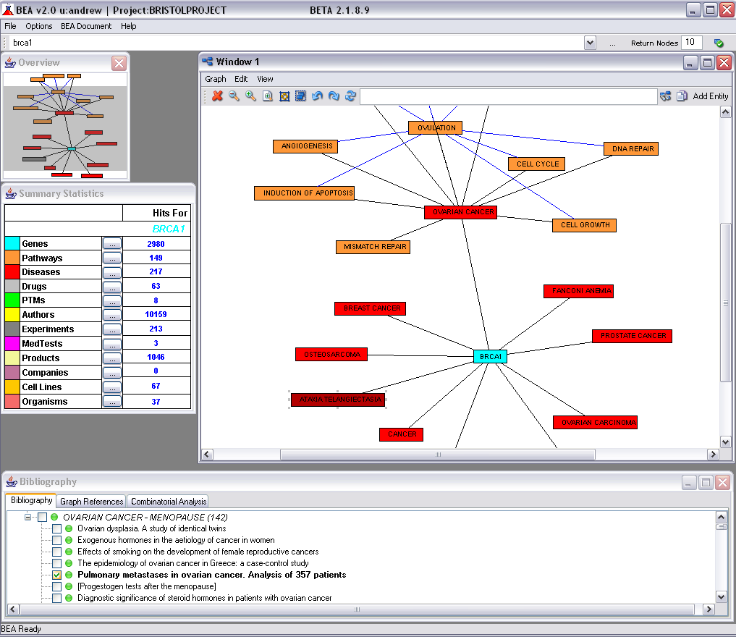
Bibliography pane

Figure 2.1: BEA main interface

The figure shows the graphical co-occurrence networks of concepts as these are extracted from the literature. The user can access these correlations through a simple right-click functionality. Underlying literature can be accessed via the links (lines) between the nodes (concepts) in the graph (see the window pane at the bottom of the interface).

The main advantage of the BEA approach is that using these graphical representations the user gets a feeling for the context of the area of interest and can discover related concepts that she/he might not have been aware of. BEA support queries of the form: What else is out there that is relevant and I might not be aware of?

Benefits of BEA

BEA helps users:

- explore and understand a research area of interest to them
- perform a comprehensive browse-directed literature review – you explore networks of associations between multiple parameters (genes, pathways, diseases, experimental methods, reagents etc.) and relevant literature is collected for you automatically
- rapidly assemble an overview of a problem area covering research, people, method/reagent and intellectual property issues.
- annotate the knowledge space they have been exploring with free text notes which they can exchange with their collaborators
- review the abstracts of selected articles and highlight areas of interest (you can collect and organize relevant quotations)
- use findings from other researchers to get a quick start in their problem area
- collaborate with their colleagues
- find related work and avoid duplication, if they are a member of a large research team

3. JANAEMIA

JAnaemia is an Electronic Healthcare Record (EHCR) application for the support of healthcare professionals in all data management tasks pertaining to beta-Thalassaemia. In a shared-care environment individual healthcare professionals need to communicate with their colleagues in a systematic way, for issues concerning each and every patient. Furthermore, they need elaborate and efficient data processing methods to assist them in their daily work, but also to support them in making, often difficult, clinical and scientific decisions pertaining to this rapidly evolving domain

The main intended applications of JAnaemia include the following:

- Patient Record Management
- Physician collaboration for shared care
- Medical data analysis for clinical research

Figure 3.1 shows one aspect of the JAnaemia interface (here the selected language is Greek) where the user is displaying various input forms in conjunction with results.

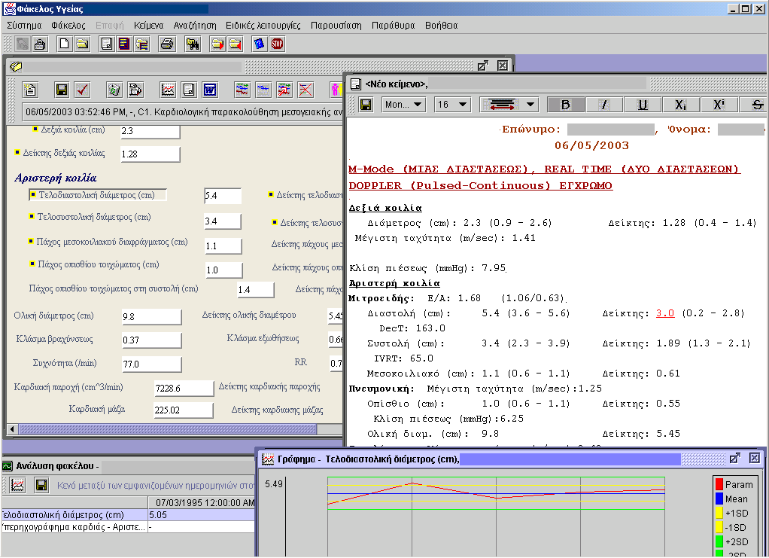

Figure 3.1: Typical JAnaemia user interface

JAnaemia Capabilities

JAnaemia offers the following capabilities:

- A flexible mechanism for designing user-friendly data entry forms, which can be customized to the exact needs of individual units and different healthcare professionals. The beta-Thalassemia customisation currently comprises separate forms for recording information on patient history and physical examination, blood transfusions and potential reactions, chelation scheme and complications, laboratory and radiology investigations, hepatological, endocrinological and cardiological assessments

- Decision support functionality tightly integrated with the data entry procedure. JAnaemia, for example, will automatically compute values for state-of-the-art cardiac ultrasound-derived indices, just as the cardiologist enters the basic measurements. And it will use this information to indicate abnormal values and to automatically determine the cardiac status of the patient, thus preventing misinterpretations. Built-in decision support even embodies statistical measures, such as those used for assessing the annual efficiency of transfusions.

- A powerful data extraction module capable of selecting patient records according to any number of criteria and of reporting the values of pre-defined parameters for matching records. Such functionality is invaluable for following-up the health status of entire populations and for creating patient and control groups for clinical studies.

- JAnaemia is based on the current European Standard, ENV13606, which defines a common Electronic Healthcare Architecture for Europe. As a result it can cope with the immense diversity of potential patient record contents, it allows efficient sharing of records within a healthcare unit or between disparate units and it ensures that all pertinent medico-legal issues are observed during this sharing. Maintaining the integrity of record contents during communication and preventing unauthorized access are only a few of these issues.

- Additional features of JAnaemia are its multilingual support (record contents are translated between languages in real time), its educational access mode (in which patient records are anonymized and can be used in class) and its patient-centric access mode (which allows patients to participate in the updating of their own record)

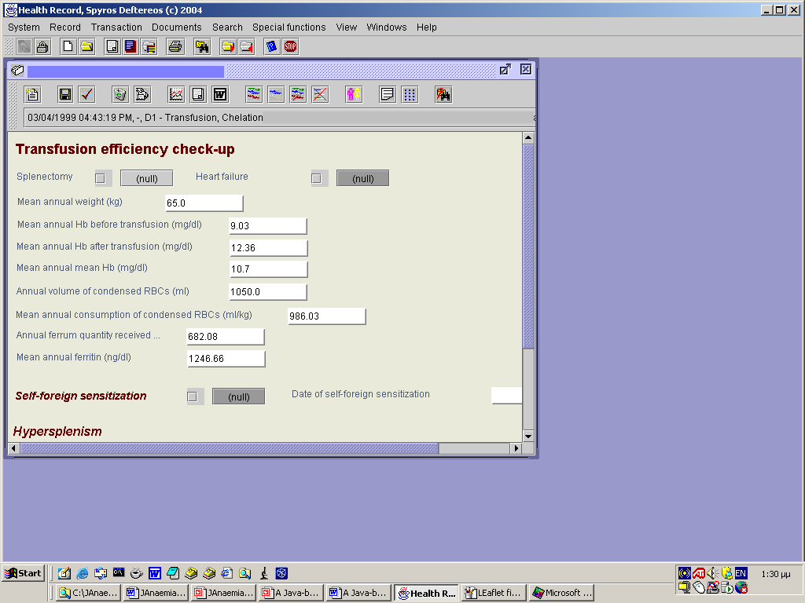

Figure 3.2: Typical input form.

Figure 3.2 shows another input form. Forms can be fully parameterised both in terms of data fields and in terms of language, data representation and other dimensions.

JAnaemia Features

Some of the main features of this tool are the following:

- JAnaemia is based on international standards. It handles efficiently the diversity of patient records contents, represents faithfully clinical meaning and allows sharing of patient information in shared-care environments.

- The tool incorporates decision support functionality applying complex rules on patient data in real-time and providing diagnosis and management guidelines.

- JAnaemia uses advanced data extraction methods for processing entire patient populations and for detecting those patients that meet user-defined criteria. Output can be used for the design of clinical studies and can be exported to industry standard statistical packages, for further processing.

4. DISCUSSION

Literature analysis capabilities are considered to be one of the technologies that will be available to ACGT users in support of knowledge discovery.

One of the limitations of the literature analysis technology is that it does not deal in its existing form with numeric data. Therefore this capability will either have to be used from other partners’ technologies or will have to be developed de novo. It is expected that versions of the capabilities mentioned in the previous two sections will be combined with other technologies from partners to provide an integrated knowledge discovery capability in the context of clinical trials.

In any case we believe that in a Grid architecture where a number of ‘services’ will be available to the user, more than one analysis capabilities that are based on different approaches, will provide useful complementarity and redundancy for the user, even if they are similar in scope.

Given this intention, interested/affected parties involved in or intending to use the results of WP6 should address amongst others the following issues:

- What uses of bibliographic data can they envision in principle, and how would these uses contribute to their current workflow and knowledge discovery requirements?

- Given that clinical data are a combination of numeric data and textual descriptions, how best can bibliographic analyses be combined with traditional data mining approaches in order to better support knowledge discovery and ultimately better clinical trial design and implementation?

- What kinds of knowledge that users would like to access and mine are hidden in bibliographic and clinical data repositories and what kinds of use do we have for these?

Conclusion

We have presented in this Technical Report two basic technologies that Biovista intends to develop for ACGT. The goal has been to allow consortium partners to familiarise themselves with these technologies so as to better understand how they can be put to use, what kinds of services can be based on them and how these can be combined with other technologies available to the consortium in order to achieve the project’s goals.

This document is therefore a starting point for further discussion amongst technology users and providers.

Additional information on Biovista’s technologies is available at our site at: www.biovista.com

