

Demonstration and report of a repository of knowledge-discovery-related metadata

Project Number: FP6-2005-IST-026996
Deliverable id: D 6.3
Deliverable name: Demonstration and report of a repository of knowledge-discovery related metadata
Submission Date: dd/mm/yyyy



COVER AND CONTROL PAGE OF DOCUMENT
Project Acronym: | ACGT
Project Full Name: | Advancing Clinico-Genomic Clinical Trials on Cancer: Open Grid Services for improving Medical Knowledge Discovery
Document id: | D 6.3
Document name: | Demonstration and report of a repository of knowledge-discovery related metadata
Document type (PU, INT, RE) | RE
Version: | 0.3
Submission date: | DD/MM/YYYY
Editor:  Organisation:  Email: | Johan Karlsson  University of Málaga  johan@ac.uma.es
Document type PU = public, INT = internal, RE = restricted

ABSTRACT:
This deliverable describes the metadata repository for knowledge-discovery related tools. The repository enables clients to find (discover) metadata instances of tools, functional descriptions and data types. Tool providers (service providers, workflow authors etc.) can publish metadata for their tools, making them instantly available for clients during discovery. This deliverable describes the architecture of the repository and shows examples of how clients can use the metadata for tool discovery.

KEYWORD LIST: Metadata repository, service integration, distributed services

MODIFICATION CONTROL
Version | Date | Status | Author
0.1 | 07/03/2008 | Draft | J. Karlsson
0.3 | 14/05/2008 | Draft | J. Karlsson

List of Contributors
- University of Málaga: Johan Karlsson, Maximiliano Garcia, Javier Ríos, Andrés Rodrígues, Sergio Ramirez, Victoria Martin Requena, Antonio Muñoz Mérida, Oswaldo Trelles.

Contents

Contents 4
Figures 5
1 Introduction 6
2 Metadata schema 8
2.1 Tool metadata 8
2.2 Data type metadata 10
2.3 Functional category metadata 10
2.4 Metadata scope 11
3 Metadata repository 12
3.1 Modular API 12
3.2 RepoServices API 13
4 Use cases 15
4.1 ACGT portal integration with the tool metadata repository 15
4.2 Interaction with the workflow editor and workflow enactor 16
4.3 Registering a service (GridR) 17
4.4 Other repository tools 21
4.4.1 Taxy 21
4.4.2 jOrca 23
5 Outlook 25
6 References 25
Appendix 1 - Abbreviations and acronyms 27
Appendix 2 – Modular API details 28

Figures
Figure 1. Important concepts in a typical service-oriented architecture. 6
Figure 2. ACGT Data Architecture (v2 revision 6) 7
Figure 3. Overview of the metadata entities and their relations 8
Figure 4. Repository deployment for ACGT metadata (RepoServices). Data storage layer corresponds to the DBServer, Data access layer with object persistence is made available with the Core Metadata Manager. The WS Metadata manager exposes the same functionality as in the Core Metadata Manager but as web services. 14
Figure 5. Service provider logs into the ACGT portal. 15
Figure 6. Service provider browses available data types.. 16
Figure 7. Service provider registers a new data type. 16
Figure 8. Selecting which repository to browse. 21
Figure 9. Browsing tree of data types (Object) and tools (Service). 22
Figure 10. Searching for services and data types with ‘blast’ in the name. User is selecting service ‘GridBlast’. 22
Figure 11. User selects ‘GridBlast’ and the metadata for this service is shown in the right frame. 23
Figure 12 Searching for keyword ‘blast’ in tool metadata. 23
Figure 13. Phylogenetic tree workflow. 24

- Introduction
This document reports on the implementation of a repository for knowledge-discovery-related tool metadata in the ACGT platform. The aim of this document is to provide an overview of the architecture and functionality of the repository. Detailed technical documentation can be found in [BIT2008].
In general, metadata can be defined as “data about data”. In deliverable 6.1, section 3.1.7, the role of metadata in the ACGT project is specified in detail, but the metadata in this document is used in the discovery and definition of data-mining tools through a tool metadata registry or catalogue. The approach of publishing tool metadata in public repositories is not new and there have been several published approaches. In deliverable 6.1 (section 3.1.9), an overview of such related approaches is provided.
Tools available over the internet are particularly useful in biomedical informatics, where large computational resources and access to large and constantly updating databases are requirements to solving many typical problems. This is the main motivation for delegation of tool invocation (execution) to remote servers with required computational resources. Common approaches to such distributed tools are web-services (software systems designed to support interoperable machine-to-machine interaction over a network) and workflows (pre-defined organized invocations of web-services).
Tools are intended to be used by other software components. Their interfaces must therefore be described in a machine-friendly way. However, tool suitability for solving a specific task will ultimately be decided by individual researchers and additional metadata such as documentation and authorship is important in this aspect.
Clients that use these distributed tools need to be able to dynamically discover and use new tools/algorithms. This discovery process is supported by tool metadata and this metadata is therefore shared in a public repository.

Figure 1. Important concepts in a typical service-oriented architecture.
In service-oriented architectures (SOA), several roles can be defined:
- Tool provider: This role provides access to a tool. This tool is accessible over the internet through a wrapping interface (web-based tools). This interface is described in a machine-interpretable format in a tool description entry. Typical examples of tool description formats are Web Service Description Language (WSDL) and Business Process Execution Language (BPEL).
- Tool registry: This role provides access to tool descriptions. Tool descriptions are typically annotated with some metadata.
- Tool requestor: This role is requesting a tool to solve a specific problem. This role already has some input data and is looking for a tool that a) solves the problem and b) can consume the data.
The following activities are typical for SOA (see figure 1):
- Publish: This activity is performed by the tool provider who publishes (announces) the tool by sending a tool description along with additional metadata to the tool registry.
- Find: This activity is performed by the tool requestor. The tool requestor sends metadata describing the requested tool to the registry. If successful, the tool registry returns matching tool descriptions.
- Bind: This activity is performed by the tool requestor by using the tool description from the find activity to initiate communication with one of the places where the tool is available.
In this document, we will explain how support for these basic activities was realised in ACGT. We use existing formats for tool descriptions and we have also defined a core set of metadata for tools. This metadata is connected to the tool description and improves the possibilities of finding the right tool description among a large set of tool descriptions. The repository allows tool requestors to filter available tools depending on the metadata that the tools are annotated with.
In figure 2, the ACGT data architecture is illustrated. The tool metadata repository (“workflow repository” in the figure) is shown in the upper right corner and is used to publish and find tool metadata for ACGT tools such as R-scripts [R2005] or Prep [NAV2003].

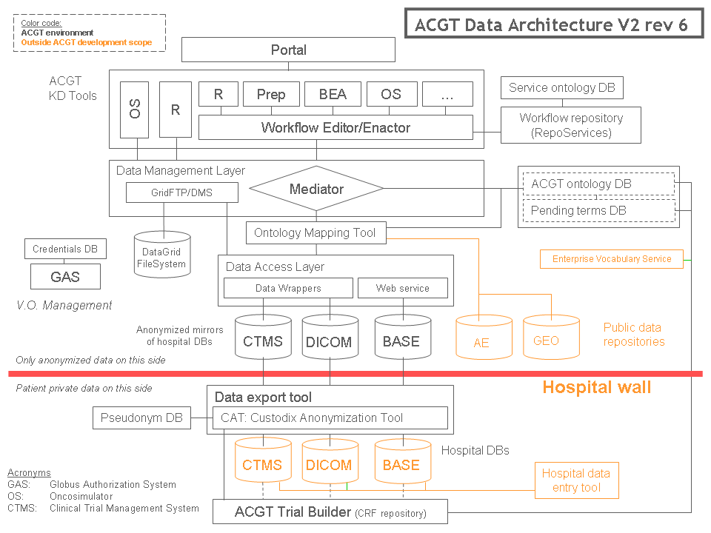
Figure 2. ACGT Data Architecture (v2 revision 6)
- Metadata schema
In this section, we will describe a metadata schema developed as part of this deliverable. The schema enables tool providers to define metadata and tool descriptions for their tools when publishing and for clients to find (discover) tool descriptions based on metadata (see activities in figure 1). For this metadata to be useful, it is important that its schema is well defined.
The schema includes information that is potentially interesting for tool discovery and invocation (tool description in figure 1). The domain of the metadata is services (tools), operations (specific functions of a tool), workflows (pre-defined flow of data between several operations), functional categories (descriptions of tool functionality) and data-types (the input or output data type of operation parameters). Of course, after receiving tool metadata, tool requestors should confirm the suitability of the tool/operation for the task by (manually) inspecting the documentation before invoking.
Figure 3. Overview of the metadata entities and their relations
The metadata schema is illustrated in figure 3. This is a simplified version intended to give brief overview. For the complete ER-diagram, please visit the documentation page of the repository [BIT2008]. In the following subsections, the main concepts are described. The activities of documentation, invocation (for web-services), enactment (for workflows) and discovery (find) are used to show what the main use of the attributes is.
  - Tool metadata
- Activity: Documentation
  - Name
  - Free-text descriptions (short and long)
  - Author information
  - Image (visualization of workflow structure)
- Activity: Invocation/Enactment
  - Operations (0..n)
    - Free-text descriptions
    - Parameters (input/output, data type, default values etc)
  - Tool location (URL, type of tool) / Location values (additional information)
  - Tool description (machine readable)
    - WSDL (for Service), BPEL/SCUFL etc (for Workflow)
- Activity: Discovery
  - Functional category
  - Operations (without internal structure) (for Workflow)
Tool represents a grouping of software components that can be used to solve a specific type of analytical problem. Each tool is associated with one or more tool locations. A tool location contains information about which type of tool it is. There are several possible tool types: web service (Generic SOAP service [SOAP2008], BioMOBY [WIL2003]), workflow (BPEL [BPEL2008], SCUFL (Taverna) [OINN2004]), or locally accessible applications on the machine of the client (command-line interface).
If the tool is a web service, it has conceptually zero or more operations. An operation is a software sub-component that solves a specific problem and has several parameters; either input or output. Each parameter is associated with a specific data type. Calls to operations are atomic. All operations belonging to a single service should have a closely related functionality. In this way, the service concept acts as a container of related operations.
Tools can represent both web services and workflows because it is possible to view a workflow as a web service in the sense that it requires inputs and produces outputs (like a service). Of course, there are some differences that require additional metadata to be stored specifically for workflows. If the tool is a workflow, specific metadata include an image representing the workflow (for documentation), which operations the workflow is composed by (useful for find/discovery) and the dataflow/control structures that controls enactment (workflow definition).
The metadata for tools include the author and authority (organisation of the author). This metadata could be useful during service discovery. For example: give a list of all services with a specific authority. The schema also contains metadata for tool versions. This enables metadata clients to know if there have been some changes. If such changes actually affect client behaviour depends on the usage of the metadata repository. One example when changes in the metadata would affect the behaviour is if user data is annotated with the URI of the data type. If the metadata changes (the data type is removed or altered), it is important that this change is recorded. Normally, this is useful for clients that locally cache the metadata. For example, if the client maintains a local cache of all data types, it needs to check periodically if the information in the repository is updated. One possible way to implement this checking mechanism is that the client only requests a list of all data types, containing only very basic information such as URI and version. The client can then compare the URI and version to the cached information and decide if to retrieve the full data type definitions (a more expensive operation in terms of execution time).
The guidelines for the versioning information are that if the semantics of the tool has changed, the URI should be changed but for smaller changes, such as description changes or fixing of spelling errors, tool providers should change the version information only.
Each tool and operation can be associated with human-readable descriptions (description and doc). The shorter version (description) is intended for quick browsing purposes and the longer version (doc) is intended for users that wish to more carefully study tool/operation documentation.
The type of the tool (in ToolLocation) allows tool providers to include information about the specific implementation of the tool. Such metadata can be important during discovery if a client is only able to communicate with a particular type of service or workflow.
If a service has a tool description with WSDL, this information can be specified when during the publish action. Typically, the bind operation will take place using the tool description. There is a special case for BioMOBY web-services where the tool description (in this case WSDL) is not possible to specify in full detail for the data types. In this case, the metadata specifies all information needed for calling to the services. For command-line tools, it is not possible to create a WSDL because the tool is not a web service. For command line execution, the schema includes the command to execute (path) and the definition of input/output parameters (both in LocationValues).
For workflows it is mandatory to store a tool description (workflow definition) because the schema does not capture all information needed for workflow enactment (i.e. the relations between the operations or iteration structures). In this way, the schema is not specific to the workflow format.
  - Data type metadata
- Activity: Documentation
  - Name
  - Free-text description
- Activity: Discovery/invocation
  - Data type relations (hierarchy)
The data type metadata can be used to define a taxonomy of data types shared between tools. This is a basic requirement when building coherent workflows. Integration of tools implies that tool providers agree about the data types their tools use. The module described here allows management of the taxonomy which is inspired by the object oriented paradigm.
The metadata schema allows data types to be related to other data types. Data types can inherit parts from another data type and add additional structure. Additionally, they may include (contain) or be arrays of other data types. The interpretation of such relations between data types is domain specific for the service type. For example, BioMOBY web services would interpret these relations as directly specifying the data format. For generic SOAP services, these tables would only be used to specify a hierarchy of data types without any assumptions of the data formats.
The taxonomy of data types can also be used to organise data types in order to facilitate human discovery of appropriated data structures.
  - Functional category metadata
- Activity: Documentation
  - Name
  - Free-text description
- Activity: Discovery
  - Category relations (hierarchy)
Tools can be associated with one or more functional category. A functional category is a keyword that describes the function of the tool. The functional categories can be related to other functional categories to create a taxonomy of keywords. If the keywords are arranged in a hierarchical structure, this makes it possible for clients to discover tools that are annotated with a more generic functional keyword and all inheriting keywords. For example, if the functional category taxonomy consists of the keyword “clustering” and two sub-keywords inheriting from clustering “hierarchical clustering” and “k-means clustering”, searching for a tool with annotation “clustering” would return also tools that are annotated with “hierarchical clustering” and “k-means clustering”.
  - Metadata scope
Potentially useful metadata such as security metadata, users/groups, file-related metadata is not included in the tool metadata repository. The main reason is that other components in the ACGT architecture (figure 2) already include such metadata. Virtual Organisations (VO) contains a set of members which correspond to users. Rights are also given on the basis of VO membership via GAS. The Data Management System (DMS) in the ACGT architecture stores data files together with their annotations (file-related metadata).
Because the metadata schema also allows storing of tool descriptions (WSDL for services and BPEL for workflows), it is necessary to discuss the relations between the concepts in external tool definitions and those defined in the ACGT metadata schema.
For web-services, there is a certain correspondence between the metadata and specific parts of the WSDL document for the web-service. This correspondence is not exact but roughly a tool can be said to be similar to the WSDL document itself (both are wrappers of specific functionalities). Operation is an abstract concept (specific functionality) and has a similar role as WSDL port-types. Parameters in our schema are connected to an operation and a data type, so they match WSDL messages. ToolLocation metadata is used for a similar purpose as WSDL bindings. Data types in the ACGT repository correspond to WSDL types (XML Schema).
Naturally, it is important that the operations, number of parameters etc. in the web service metadata correctly matches the equivalences in the WSDL document for the discovery process to be accurate. The metadata in no way replaces the information found in the WSDL because WSDL specifies information that is not present in the metadata repository. For example, with WSDL it is possible to specify transport protocols, how inputs/outputs are encoded etc. This information is crucial when invoking the web service (bind). Most metadata in the schema is used for tool discovery (find operation) while the tool description (for example WSDL) is used for tool invocation (bind operation).
The situation regarding data types is more complex. WSDL traditionally uses XML schema to describe the structure of the XML data for inputs and outputs of a service. XML Schema is a more expressive data description format compared to the approach in the meta-data schema. However, we believe it is very useful to maintain a shared hierarchy of data types to more easily answer discovery (find) queries such as “show all tools that have operations with data type X as part of the input”. WSDL files are normally used to describe a single service while the repository is intended to store a larger catalogue of services (and other types of tools). If the data type hierarchy supports polymorphism, tool compatibility can be improved since tools using data of simpler data types will remain compatible with data of extended (more complex) types.
For workflows, the metadata repository only stores information such as name, descriptions (documentation), operations that are part of the workflow (discovery) and workflow definition (enactment). In this way, the metadata for workflows is rather independent from the actual workflow definition since it does not capture information about the internal structure of the workflow.
- Metadata repository
The ACGT tool metadata repository handles metadata as specified in chapter 2 for the following main tasks:
- Publish (register) tools by service providers.
- Find (discover) tools by service clients.
- Bind (invoke) tools by service clients
- Modify existing tool metadata.
- Retrieve all tool metadata (for metadata browsing tools).
The repository has been implemented in several layers:
- Modular API: This Application Programming Interface (API) integrates different tool repositories and provides discovery/find functionality for tools, data types and functional categories. It uses an access module to integrate with the ACGT repository databases.
- RepoServices API: This API is used internally in the Modular API access layer to the ACGT repository databases. It is described in this section to provide a complete overview of the metadata repository architecture.
Technical information about the APIs can be found in [BIT2008].
  - Modular API
The Modular API is a high-level API for integrating tool repositories. There are several types of tool registries, for example BioMOBY. Fundamentally, each registry has a common set of information but the formats and specifics of the tool metadata make it difficult to maintain and discover metadata across several registries. In section 2, we designed of a tool metadata schema. This API can be used to map the metadata from different registries into this virtual metadata schema.
When using this API, the software developers only see the virtual metadata schema, regardless of how the metadata is actually stored. In ACGT, this API is used by the Java portlets of the ACGT portal for registering and browsing the metadata and by the workflow editor (AWE).
The Modular API provides the following functionality for the repository:
- Registering new entities
- Editing existing entities
- Removing existing entities
- A dynamic filtering approach to discover entities. Filters can be dynamically applied and combined to find the right tool. Filters can be according to any metadata in chapter 2, including input data type, output data type, functional category.
- Providing tool descriptions for invocation/enactment.
The repository has been designed to be generic and to potentially support many different types of services. It has been designed in a modular way and is split in several parts (Datatype, Tool, Mirror, and FunctionalCategory). The data type module is independent of the other modules. The Tool and Mirror modules need the data type module but not the functional category module. The Functional category module needs the tool and mirror modules and, by extension, the data type module. In this way, the modules can be combined to create very simple or more complex repositories.
Datatypes: This module can be used to define a shared taxonomy of data types. This is an important requirement when building workflows because the integration of tools implies that the tool providers agree on the data type used. The functionality of this module provides creation, administration and discovery of data types.
Tools: This module handles information about tools. Tools are presented in a homogenous way regardless of service/workflow type. For example, the interface to access ACGT type services is the same as to access BioMOBY services. The functionality of this module provides creation, administration and discovery of tools. The module can also produce the necessary information for generating a graphical user interface where the end-user may enter input data needed to invoke/enact the tool.
Mirrors: This module handles information about the endpoints of the tools. An endpoint represents a computer resource where a tool (in this case a web-service) is located and can be executed. The functionality of this module provides creation, administration and discovery of endpoints. Each tool may be associated with any number of endpoints. This allows clients to choose between several alternate endpoints and adds robustness to the service invocation when some endpoints are not available.
Functional category: This module handles information about functional categories. A functional category is a keyword that describes the functionality of the tool. Each tool can be annotated with one or more of these keywords. The functionality of this module provides creation, administration and discovery of functional categories. The keywords are arranged in a hierarchical structure, so it is possible to search for tools annotated with a more generic functional keyword.
The modular API connects to different repositories through access-classes. These classes abstract all necessary functionality in the specific repositories. There is also a generic access class to provide caching of metadata, allowing faster access/filtering. This cache access uses other access classes to contact specific repositories. Using the cache is completely transparent to client source code; the only change needed is in the repository configuration file.
  - RepoServices API
The access class to the ACGT repository databases connects through the RepoServices API. RepoServices is split in three modules (tool, functional category and data type). Each module is implemented in several layers (see figure 4):
- Data storage layer: The metadata schema is implemented as MySQL database tables with the relations indicated in figure 3. Scripts have been created that allow the construction of the database instance.
- Data access layer: Hibernate mappings are used to create persistent Java objects. The properties of the Java objects are mapped to columns in the database tables.
- Web service layer: Axis2 is the web service engine and Tomcat is used as the servlet container of the deployment. JiBX is also used as a framework in the development of the web service, binding XML to Java code.
This API is accessible locally or remotely. In the Modular API, the local access module uses the data access layer while the remote module uses the web service layer.

Figure 4. Repository deployment for ACGT metadata (RepoServices). Data storage layer corresponds to the DBServer, Data access layer with object persistence is made available with the Core Metadata Manager. The WS Metadata manager exposes the same functionality as in the Core Metadata Manager but as web services.
The repository is deployed in two different instances; one production instance (more stable) and one development instance (more up-to-date). Details about the instances and how to install and connect are available in the repository documentation [BIT2008].
- Use cases
This section describes some use cases and clients that interact with the tool metadata repository.
  - ACGT portal integration with the tool metadata repository
Several portlets (web pages) have been developed for the ACGT portal to let registry administrators manage the tool data. These portlets provide a graphical interface to the functionality in the Modular API. The portlets cover all functionality of the API but in this document we only exemplify functionality related to data types. In figure 7, a graphical interface that allows users to add new data types is shown. Additionally, there are links that provide a portlet that allows users to browse all data types or search for specific data types.
The goal for this simplified use case is to show how a new data type can be added to the repository using these portlets.
Actors: service provider, portlet pages, metadata repository
Preconditions: minimally populated metadata repository, user has privileges that allows modification of metadata in the repository.
Triggers: service provider requests a new data type for a service to use.
Basic course of events:
- Service provider logs in to ACGT portal (figure 5).

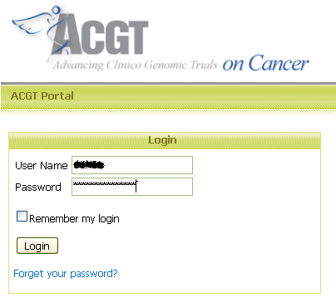
Figure 5. Service provider logs into the ACGT portal.
The username and password is entered in the ACGT Portal. Depending on the role assigned, different parts of the portal are accessible (at this moment the available roles are CLINICIAN, PROVIDER and RESEARCHER).
- Service Provider browses available data types to decide the proper relations to existing data types (figure 6).
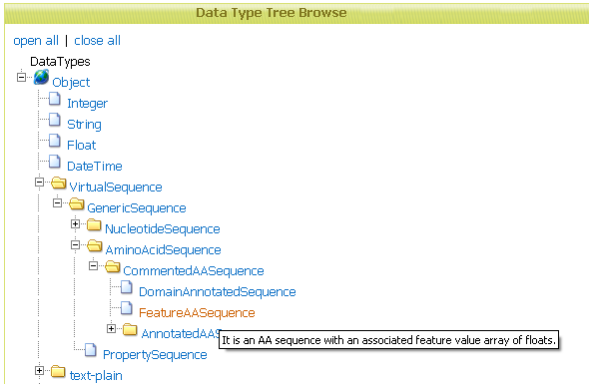
Figure 6. Service provider browses available data types..
By visualising the data types in a tree, it is easy to navigate through larger sets of data types.
- Service provider adds a new data type (figure 7).
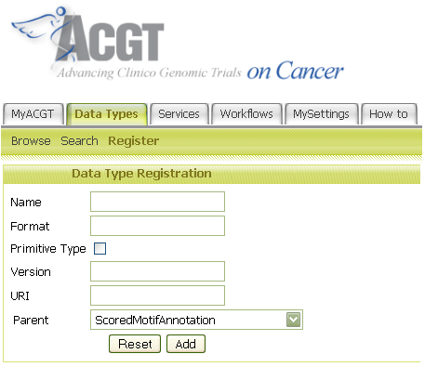
Figure 7. Service provider registers a new data type.
When registering a new data type, it is associated with a parent data type (see section 2.2).
Post conditions: the data type (with a unique URI) is added to repository
  - Interaction with the workflow editor and workflow enactor
AWE is a workflow editor and enactor for ACGT tools and connects to the repository through the Modular API to retrieve tool metadata. AWE is complex software and has additional functionality besides what is shown in this section. Additionally, some of the descriptions are simplified and involve additional aspects (security).
The goal for this simplified use case is to show how the workflow editor and enactor use metadata from the repository. It is not intended to demonstrate the functionality of the workflow editor.
Actors: workflow author, AWE, metadata repository
Preconditions: populated metadata repository
Triggers: several ACGT tools needs to be combined into a workflow
Basic course of events:
- Workflow editor connects to repository to get metadata about services and functional categories and visualises this information in a browsable tree. The Modular API has special operations for ‘mass-retrieval’ of metadata.
- Workflow author creates input(s) to the workflow and selects an operation from the tree to be included in the workflow. In this case, the workflow editor uses the metadata about operations and parameters to verify the consistency of the workflow.
- Workflow author saves the workflow. The editor collects tool descriptions (WSDL) and includes them in the workflow definition. These definitions are used later for workflow enactment to invoke specific services.

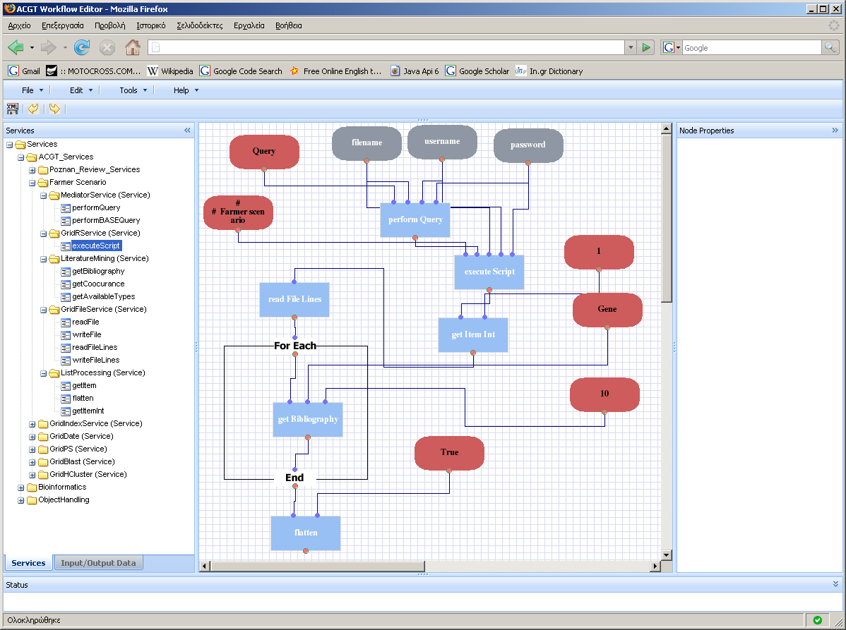
  - Registering a service (GridR)
The GridR service is a generic web service for running R-scripts or functions [WEG2007]. The motivation for describing this service in this use case is to exemplify which metadata are used for the registration of a typical ACGT web service. Please note that the exact operation names, data type and parameters of this service could change in future versions.
The typical steps to register a new tool are exemplified in this section:
- Determine the data types of the tool (register new data types or use existing).
- Determine the functional category of the tool (register new functional categories or use existing).
- Register tool metadata, specifying among other details which data types and functional categories should be used.
- Register tool-specific information (Tool Location). This includes type-specific such as the tool description (in WSDL or workflow definition formats).
GridR web service (description from service providers)
Operation | Input parameters | Output parameters | Description
executeRScript | “script”, “inputFileIDs”, “outputFileNames”, “executionMachine” | “gridRJobID” | Generic function for executing R scripts.
executeRFunction | “inputFileIDs”, "outputFileNames", "executionMachine" | “gridRJobID” | Generic implementation for computing functions in combination with the GridR client.
"getResult" | “gridRJobID” | “outputFileIDs” | Gets the result for a given R Grid job.

This service is designed to be generic and thereby it is difficult to annotate other than with a generic functional category.
Actors: service provider, portlet pages, metadata repository
Preconditions: populated metadata repository
Triggers: service provider wants to publish tool metadata in the repository.
Basic course of events:
- Choose existing or register new data type. In the case of this service, the format of the input is specific to R and therefore a new data type is registered with the following metadata, inheriting from the base data type Object:

RScript data type URI: urn:eu-acgt.org:datatype:rscript
Name | “RScript”
Description | “This data type represents an R-script and must be in the typical format for these scripts”
Data type relation | Extends “urn:eu-acgt.org:datatype:Object”

- Choose existing or register new functional category. In the case of this service, the functionality is generic and we choose the existing functional category “Generic” with URI “urn:eu-acgt.org:functionalcategoryinstance:generic”.
- Register the GridR service as a Tool with the functional category “Generic” and input/output datatype “RScript” for parameter “script”
Tool instance: urn:eu-acgt.org:toolinstance:gridr
- Name = “GridR”
- FunctionalCategory: 'urn:eu-acgt.org:functionalcategory:generic'
- Short Description = “Generic service for running R-scripts or functions.”
- Long Description = “This is a generic service for running R-scripts or functions. It offers asynchronous retrieval of results by use of GridR job identifiers.”
- WSDL = “<definitions …> … </definitions>”
- Operations
  - executeRScript
    - Name = “executeRScript”
    - Short Description = “Generic function for executing R scripts.”
    - Parameters
      - Input(s):
        - Name = “script”, Description = “This is the R-script to run”, Data type = “RScript”
        - Name = “inputFileIDs”, Description = “This is the input identifiers of the input data in DMS”, Data type = “Array of String”
        - Name = “outputFileNames”, Description = “This is the desired names of the output data in DMS”, Data type = “Array of String”
        - Name = “executionMachine”, Description = “This is the name of the machine where to run the script”, Data type = “String”
      - Output(s)
        - Name = “gridRJobID”, Description = “This is the identifier of the R job in the grid”, Data type = “String”
  - executeRFunction
    - …
  - getResult
    - …
- ToolLocation
  - LocationValues:
    - “author” = “Dennis Wegener”
    - “authority” = “Fraunhofer Institute AIS - Knowledge Discovery Department”
The details for the final two operations (executeRFunction and getResult) have been omitted but are similar to executeRScript.
Post conditions: The tool (web service) “GridR” and data type “RScript” are added to the repository and have been assigned a unique URI “urn:eu-acgt.org:toolinstance:gridr”.
Naturally, this service is intended for advanced users. For the typical user, a set (catalogue) of ready-made and quality-reviewed R-scripts that each solves specific problems will be made available. Each of these R-scripts in fact constitutes a tool from the point of view of the user. Therefore, each such “R-script” tool must be possible to document and classify with one or more functional categories in the tool metadata repository.
The solution has been to register R-scripts as a special tool type (GRIDRSCRIPT). A special operation (execute) is added and the actual input/output data types of the scripts are associated to this operation. The script itself is stored as a location value in the tool instance for the GRIDRSCRIPT tool.
For example, we show the metadata for a simple R-script “ColumnAppender”. This script takes as input a matrix (data type CSV) and outputs the same matrix but with an additional column (data type CSV):
Tool instance: urn:eu-acgt.org:toolinstance:columnappender
- Name: 'ColumnAppender'
- FunctionalCategory: 'urn:eu-acgt.org:functionalcategory:datatransformation'
- Short Description: 'Adds a column'
- Long Description: ‘This simple script adds a column to an existing matrix’
- Operation(s)
  - execute
    - Parameters
      - Input(s)
        - Name = “inmatrix”, Description = “This is the input matrix”, Data type = “CSV”
      - Output(s)
        - Name = “outmatrix”, Description = “This is the output matrix with an added column”, Data type = “CSV”
- WSDL = <null>
- ToolLocation
  - LocationValues:
    - “author” (the author)
    - “authority” (organisation)
    - “script” (the actual r-script)
  - Type = GRIDRSCRIPT
Note that in the metadata model, the input parameters have an order (paramindex), so we know that 'inmatrix' is the first input parameter, 'outmatrix' is the first output parameter. Naturally, this tool type is abstract and the actual call will go to the GridR service. Briefly, the workflow editor will have a specific component to handle GRIDRSCRIPTs. When the user requests to add an R-script to a workflow, this component will filter according to tools with GRIDRSCRIPT tool instances (i.e. only show R-scripts) and then prepare the call to the real service GridR. Specifically, this component will create an array based on the metadata in the repository for using as the inputFileIDs array. It will take the value (id) that the user has entered as input 'inmatrix' and put it in inputFileIDs[0]. If the R-script had several inputs, the additional file ids would be in inputFileIDs[1], etc. Since the parameters have an order (paramindex), the component can always determine the parameter order and can produce the inputs in the order expected by the script.
  - Other repository tools

    - Taxy
Taxy (http://sourceforge.net/projects/taxy/) is a graphical application for visualising, navigating and searching taxonomic data. It is designed to work with different sources of data but keeping a common GUI (Graphical User Interface) to represent the data.
A plug-in mechanism has been implemented to allow the addition of support for different sources of taxonomic information, so that the application can adapt to serve multiple taxonomic needs. A plug-in has been added to integrate with the ACGT repository. Web-service and data type metadata can be visualised.
The application provides methods for searching taxon nodes matching by identifier, scientific name or any synonym attached to the taxa. You can use wildcards (*) anywhere in the name to match the set of taxa that have a common part in their names/synonyms.
The goal for this use case is to show how Taxy can be used for tool discovery.
Actors: User, Taxy, metadata repository
Preconditions: populated metadata repository
Triggers: Researcher needs to locate metadata about a tool that can perform a BLAST procedure.
Basic course of events:
- User selects the ACGT tool metadata repository, in this case by choosing between “NCBI Species Taxonomy” and “ACGT Biomedical DataTypes and Services” (figure 8).
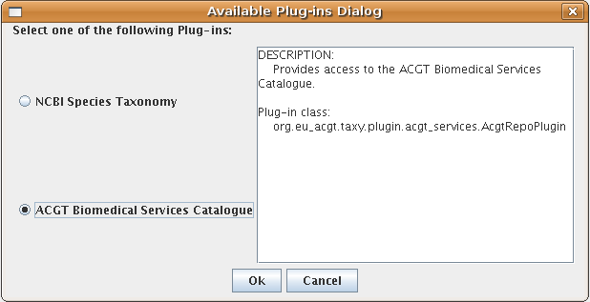
Figure 8. Selecting which repository to browse.
- Taxy connects to repository and downloads metadata about all data types, tools and functional categories and visualizes this information in a browsable tree (figure 9). The Modular API has special operations for ‘mass-retrieval’ of metadata.
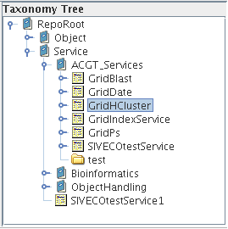
Figure 9. Browsing tree of data types (Object) and tools (Service).
- Once this metadata has been downloaded, the user can execute some search (by name or by Uri) and get a query result in a list (figure 10). There it is possible to navigate the tree by selecting the query results.
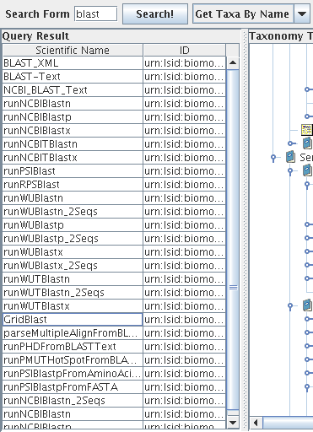
Figure 10. Searching for services and data types with ‘blast’ in the name. User is selecting service ‘GridBlast’.
- Finally, the metadata for the selected web-service is shown in the right frame (figure 11). This metadata was obtained from the ACGT tool metadata repository in event 2.
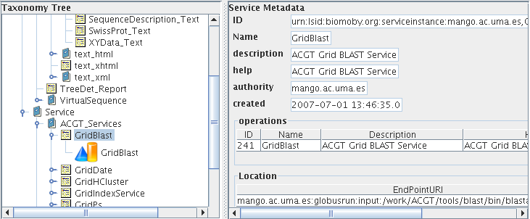
Figure 11. User selects ‘GridBlast’ and the metadata for this service is shown in the right frame.
    - jOrca
jOrca is a stand-alone application for discovery and invocation of web services registered in a repository. The application is currently able to recognize and execute BioMOBY services. jOrca can be used to visualize the ACGT tool repository and to discover ACGT tools (find). Support for DMS and the security architecture for ACGT is being added to jOrca to allow invocation of ACGT tools.
This software is intended to facilitate the use of distributed Web-Services by offering a tool able to easily and privately discover, call and monitor the execution of web-services in general, command line applications and R-scripts.
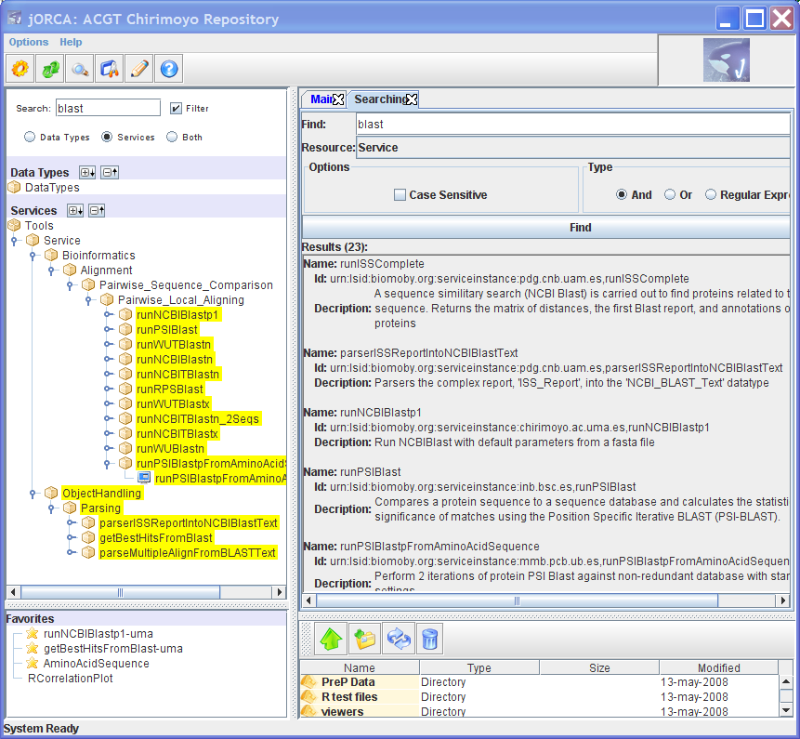
Figure 12 Searching for keyword ‘blast’ in tool metadata.
As a use case, we will describe steps performed by a researcher that wants to perform a phylogenetic reconstruction based on a new sequence stored in a sequence database (or starting with a new proprietary sequence). Phylogenetic trees are used to represent evolutionary relationships between different species. There are some on-line tools that allow a researcher to perform a study to generate a phylogenetic tree. The phylogenetic reconstruction can be performed in the following steps:
- Sequence retrieval: the researcher needs to specify an accession number of a nucleotide/ aminoacid sequence in a database). In the NCBI server (http://www.ncbi.nlm.nih.gov/) you can get a protein by searching with the accession number or a common name in the NCBI protein database (for example human keratin, accession number AAB3058). In the scenario it is assumed that the researcher already knows this accession number. The researcher searches the metadata repository using the keyword search for “aminoacid sequence ID” and finds the tool ‘getAminoAcidSequence’ by reviewing the tool descriptions. The tool is invoked and produces an output data of the data type AminoAcidSequence.
- Homology searching: Once the sequence is properly formatted, the second step is to perform a homology search to recover all known sequences similar to the query sequence. The researcher right-clicks on the data produced by the sequence retrieval tool and he is presented with a list of compatible services. The tool runNCBIBlastp is documented to perform the kind of analysis the researcher wants and is invoked with the sequence data as input. The output from this tool is of type Blast_Text.
- Hit selection: After reviewing the output from the blast, the researcher decides only the best hits of evolutionary related sequences from the blast should be processed further. By right-clicking on the data produced by the blast, the researcher is again presented with a list of compatible services. He finds a service (getBestHitsFromBlast) that can select the best hits based on a threshold value. After invoking this service and retrieving the most relevant sequences, the researcher has a set of sequences as result in FASTA format.
- Multiple sequence alignment with the multiple sequence alignment computer program Clustal. This step is performed by the tool runClustalWFast which takes as input data a collection of sequences in FASTA format. This tool is discovered by the input data type (again by right-clicking) and invoked (executed) by the user. The service produced result of the data type Clustalw_report.
- Visualisation: To visualise the results from the Clustal alignment, the user chooses a service that creates a visualisation as a tree. The data type if his data (Clustalw_report) is used in the service discovery.
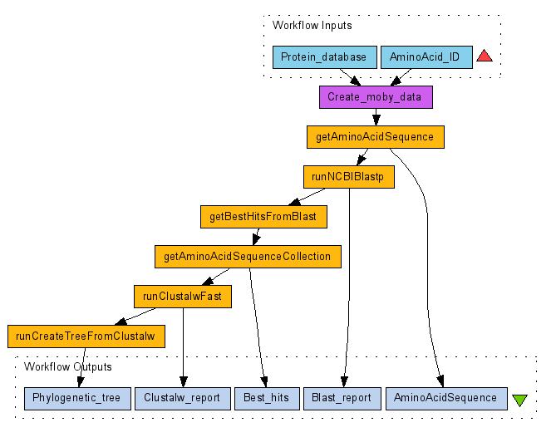
Figure 13. Phylogenetic tree workflow.
jOrca provides several ways to discover services based on the functionalities of the metadata repository (Modular API). We will describe a specific search for a blast tool (step 2) to illustrate the functionalities but all the services can be discovered in the same way. In the scenario description, the user directly used metadata about the data type of his data to discover compatible services but there are several other options to discover tools with jOrca (see figure 12):
- Using the keyword search: With ‘blast’ as keyword, the search produced several hits and the user may click on a tool in the list to see the tool invocation interface and to review the tool documentation.
- Tree search box in the upper left part of the application. This search tool can either highlight the matches or interactively filter away the non-matches in the tree as the user types the search term.
- Navigate the functional categories in the tree, interactively narrowing down the options. The user knows that the BLAST algorithm is a kind of alignment where the sequences are compared pair-wise. In this case, the available BLAST tools perform a local alignment (final functional category). This kind of interactive browsing is made possible by the inheritance relation between functional categories (for example, Pairwise_Sequence_Comparison ISA Alignment).
The difficult part is to know how to combine the tools to produce a good result (although the steps are quite simple in the example). It is likely that the steps described in this section must be repeated several times to fine-tune the parameters to the tools and to repeat several times with other sequences. Other researchers could clearly benefit from being able to re-use the steps with their own data. jOrca records the steps taken by the user for provenance information as a plain log file. In future versions, this could be formalized in simple BPEL workflows.
- Outlook
Future work includes investigating the possibility of exposing the metadata as RDF. This would allow external software to use the metadata for tool discovery. Some initial attempts have been done using D2R [BIZ2003] but more work is needed in this aspect.
ACGT tools should annotate the output data with metadata (file-related metadata) to improve tool discovery/recommendations. This metadata will be stored together with the data itself (in DMS), not in the metadata repository. Examples of file-related metadata include information how the data was produced (tool URI/version and input parameters) and the data type (URI) of the data. This metadata can be used to collect usage statistics and support more complex queries such as “show all tools that have been used on semantically similar data and have shown good results”.
- References
[BIZ2003] | Bizer, Christian. D2R MAP – A Database to RDF Mapping Language. Poster at the 12th World Wide Web Conference, Budapest, May 2003.
[NAV2003] | García de la Nava, Jorge, Sacha van Hijum and Oswaldo Trelles (2003); "PreP: gene expression data pre-processing"; Bioinformatics 2003 Nov 22; 19 (17): 2328-2329
[OINN2004] | Oinn, T., Addis, M., Ferris, J., Marvin, D., Senger, M., Greenwood, M. Carver, T., Glover, K., Pocock, M.R., Wipat, A., Li, P. (2004) Taverna: A tool for the composition and enactment of bioinformatics workflows Bioinformatics Journal 20(17) pp 3045-3054, 2004
[R2005] | R Development Core Team (2005), “R: A Language and Environment for Statistical Computing”, R Foundation for Statistical Computing, Vienna, Austria, ISBN 3-900051-07-0 (http://www.r-project.org/)
[SOAP2008] | W3C - SOAP specifications (http://www.w3.org/TR/soap/)
[BPEL2008] | Web Services Business Process Execution Language Version 2.0, (http://docs.oasis-open.org/wsbpel/2.0/wsbpel-v2.0.pdf)
[WEG2007] | Wegener, Dennis, and Sengstag, Thierry, and Sfakianakis, Stelios and Rüping, Stefan and Assi, Anthony. GridR: An R-based grid-enabled tool for data analysis in ACGT clinico-genomic trials. In: Proceedings of the 3rd International Conference on e-Science and Grid Computing (eScience 2007), Bangalore, India.
[BIT2008] | Wiki – Bitlab public document (http://chirimoyo.ac.uma.es/wiki/index.php/Descargas)
[WIL2003] | Wilkinson, M.D., Gessler, D., Farmer, A., Stein, L. (2003). The Bio-MOBY Project Explores Open-Source, Simple, Extensible Protocols for Enabling Biological Database Inter-operability. Proceedings Virtual Conference Genomic and Bioinformatics (3):16-26. (ISSN 1547-383X).

Appendix 1 - Abbreviations and acronyms

API | Application Programming Interface
BPEL | Business Process Execution Language
DMS | Data Management System
RDF | Resource Description Framework
SOA | Service Oriented Architecture
SOAP | Simple Object Access Protocol
SCUFL | Simple Conceptual Unified Flow Language
UDDI | Universal Description Discovery and Integration
URI | Uniform Resource Identifier
VO | Virtual Organisation
WSDL | Web Service Definition Language
XML | Extensible Markup Language

Appendix 2 – Modular API details
In this appendix, we will describe the most important functionality of the repository API (Modular API) that is specifically useful for tool discovery. Such tool discovery is an important part of knowledge discovery because knowledge discovery (analysis of data) implies to first find the appropriate analysis tool. The Modular API has complete functionality to register new entities and delete old entities (entities are for example Service, Operation, Parameter, DataType), but this functionality is not interesting during tool discovery and therefore not included in this brief overview. Complete technical documentation can be found in [BIT2008]. Other technical details, such as the use of caching to improve response times for tool discovery queries can also be found with other technical information. This cache functionality is transparent to the software developer (only requires modification of a configuration file).
The API is split in four modules; Tool, Mirror, FunctionalCategory and DataType. For the purposes of this summary, we will treat the Tool and the Mirror module as the same.
Every module is organized following the following way: There is a class which contains all the functions for searching, retrieving and register resources; and there are one or more classes to represent each type of resource.
DataType module
This module handles metadata about data types. Although it is typically used in combination with the Tool Module, it has no direct dependencies to that module and can be used on its own. Each data type is uniquely identified with its identifier (URI).
Class DataTypeModule
This class is the main class in the module and provides functionality that provides lists of DataType.
Method Summary
DataType | getDataType(String id)
 | Returns the data type with the URI id
FilterList<DataType> | getDataTypesList()
 | Returns the list of all data types registered in the system
FilterList<DataType> | getRoots()
 | Returns the roots of the tree composed by the data type relations.
FilterList<DataType> | searchDataType(String name)
 | Returns a list of data types whose name contains name.
Class DataType
This class provides metadata about a data type.
Method Summary
FilterList<DataType> | getChildren()
 | Returns the children of this data type. The children have an inheriting (ISA) relationship to this data type.
String | getDescription()
 | Returns the description
String | getName()
 | Returns the name
FilterList<DataType> | getParents()
 | Returns a list with the parents of this data type. This data type has an inheriting (ISA) relationship with the parents.
FilterList<Relation> | getRelations()
 | Returns a list of the associations (simple or array) of this data type with other data types.
boolean | isSubtypeOf(DataType dataType)
 | Returns true if dataType has an ISA relationship with this data type.
Tool module
Class ServiceModule
This class is the main class in the module and provides functionality that provides lists of Service.
Method Summary
FilterList<Service> | getServiceList()
 | Returns the list of all registered services.
FilterList<Operation> | searchOperationsCompatibleWith(org.bitlab.api.datatype.DataType type, Boolean exact)
 | Search in the system for operations that are compatible with the data type type. If exact is false, the search will also return Operations compatible by polymorphism to the provided type.
FilterList<Service> | searchService(String name)
 | Returns a list of services whose name contains name.
Class Service
This class provides metadata about a service. A Service object, despite its name, represents a Tool (which can represent both traditional web-services and workflows).
Method Summary
String | getDescription()
 | Returns the description
String | getName()
 | Returns the name
FilterList<Operation> | getOperations()
 | Returns a list with the operations associated to this service
Class Operation
This class provides metadata about operation. Each Service may have several operations.
Method Summary
String | getDescription()
 | Returns the description
String | getName()
 | Returns the name
FilterList<Parameter> | getParameters()
 | Returns the parameters associated with this operation
Class Parameter
This class provides metadata about parameters. Each Operation may have several parameters.
Method Summary
DataType | getDataType()
 | Returns the data type of this parameter
String | getDescription()
 | Returns the description
String | getName()
 | Returns the name
boolean | isInput()
 | Returns true if this parameter is an input parameter, otherwise false
Functional category module
Class ServiceTypeModule
This class is the main class in the module and provides functionality that provides lists of ServiceType.
Method Summary
ServiceType | getServiceType(String id)
 | Returns the functional category with the URI id
FilterList<ServiceType> | getServiceTypeList()
 | Returns all registered functional categories
FilterList<ServiceType> | getServiceTypeRoots()
 | Returns a list with the roots of the service types hierarchy
FilterList<ServiceType> | getServiceTypesOf(org.bitlab.api.service.Service service)
 | Returns the list of service types for a particular service.
FilterList<ServiceType> | searchServiceType(String name)
 | Returns a list of functional categories whose name contains name.
Class ServiceType
This class provides metadata about a functional category. Each functional category can have several parent and child functional categories.
Method Summary
FilterList<ServiceType> | getChildren()
 | Returns the children of this functional category. The children have an inheriting (ISA) relationship to this functional category.
String | getDescription()
 | Returns the description
String | getName()
 | Returns the name
FilterList<ServiceType> | getParents()
 | Returns a list with the parents of this functional category. This functional category has an inheriting (ISA) relationship with the parents.
FilterList<Service> | getServices(boolean recursive)
 | Returns a list of services which are associated with this functional category. If recursive is true, then also all services associated to descendant functional categories will be included in the list.
Mirror module
Class MirrorModule
This class is the main class in the module and provides functionality that provides lists of Mirror.

Method Summary
FilterList<Mirror> | getMirrorList()
 | Returns all tool locations registered
FilterList<Mirror> | getMirrorList(String toolId)
 | Returns a list of tool locations associated with the service that has URI toolId.
FilterList<Mirror> | getMirrorList(Mirror.EType type)
 | Returns all tool locations registered with a specific tool type (type).
FilterList<Mirror> | getMirrors(List<String> mirrorIds)
 | Returns a list of Mirror instances with URIs from the list mirrorIds.
Class Mirror
This class provides metadata about a tool location. The metadata stored here is specific for a particular implementation of the Tool. For example, if the tool has been implemented as a workflow, the definition of the workflow is part of the metadata provided by this class.
Method Summary
Map<String,String> | getData()
 | Return a map with the location values (additional information) for this mirror.
String | getHost()
 | Returns the name of the host where the instance is available.
Mirror.EType | getMirrorType()
 | Returns the type of this mirror
String | getServiceId()
 | Returns the id of the service which is associated with this mirror.
Mirror.EStatus | getStatus()
 | Returns the availability (ONLINE, OFFLINE etc)
Performing typical tool discovery scenarios with the API
From the point of view of tool discovery, several mini-scenarios are typical. In this section we show simplified code examples to demonstrate how to use the API to support such queries.
Finding compatible tools
In this scenario, the researcher has some data in the file repository (DMS). This data is annotated with metadata (file-related metadata) which includes the data type URI of the corresponding data type in the metadata repository. The researcher does not need to be aware of this data type URI because it was automatically annotated by the ACGT tool that produced the data. The following code searches for tools compatible with the data type with ‘urn:lsid:biomoby.org:objectclass:Object’ as URI and prints the names of each tool on standard out.
dtm = new DataTypeModule(new FileReader("configuration.xml"));
sm = new ServiceModule(new FileReader("configuration.xml"), dtm);

// First create a data type instance. The module responsible for
// providing such instances is the Data Type Module
DataType dt = dtm.getDataType("urn:lsid:biomoby.org:objectclass:Object");

// get a list of *all* tools (services) that are exactly
// compatible with this data type. Service instances are obtained
// with the Service Module
FilterList<Service> sl = sm.searchServicesCompatibleWith(dt, true);

For (Service s : sl) {
System.out.println(s.getName());
}

Browsing available tools / data types
In this scenario, the researcher has some data obtained from other sources than ACGT tools. This means that the data has not been annotated with data related metadata (such as the data type in the repository). To allow tool discovery, the client software wants to present the tools in a tree form where the branches represent the functional categories instances and the leaves represent tool instances. This is a way to present the metadata in the repository to simplify tool discovery if the user does not have data that is annotated with the data type from the repository. Additionally, this kind of presentation allows a user to find tools based on functional categories (i.e. what the tool does). In this short example, we do not present the information in a tree form but simply access the information the same way as a client would to build a tree.
public class Tree {
public void printTree(FilterList<ServiceType> roots)
throws AccessDeniedException, StorageCommunicationException,
ResourceNotFoundException {

for (ServiceType st : roots) {
System.out.println(st.getName());

FilterList<Service> services = st.getServices(false);
for (Service s : services) {
System.out.println(s.getName());
}

printTree(st.getChildren());
}
}
public static void main(String[] args) {
Tree t = new Tree();
// initialization and exception handling code removed
// fcm is instance of ServiceTypeModule
t.printTree(fcm.getServiceTypeRoots());
}
}

Key-word based searches
A simple, but often effective way to discover tools is be to search for keywords in the descriptions of tools or operation parameters (i.e. description of inputs). Naturally, such searches could produce some false hits but would at least limit the list of presented tools considerably.
final String[] keywords = {"sequence", "id"};

FilterList<Service> tools = sm.getServiceList();

tools.addFilter(new Filter<Service>() {
public boolean test(Service service) {
try {
// first check if the service description contains any
// of the keywords
for (String keyword : keywords) {
if (service.getDescription().contains(keyword)) {
return true;
}
}

// check if the description of any parameter of any of
// the operations contains any of the keywords
FilterList<Operation> operations = service.getOperations();

for (Operation operation : operations) {
FilterList<Parameter> parameters =
operation.getParameters();
for (Parameter param : parameters) {
for (String keyword : keywords) {
if (param.getDescription().contains(keyword)) {
return true;
}
}
}
}
} catch (StorageCommunicationException e) {
e.printStackTrace();
} catch (AccessDeniedException e) {
e.printStackTrace();
} catch (ResourceNotFoundException e) {
e.printStackTrace();
}

return false;
}
});

System.out.println("The keywords matched the following tools: ");
for (Service service : tools) {
System.out.println(service.getName());
}

