
Report on the implementation of the integrated ACGT environment and workflows

Project Number: | FP6-2005-IST-026996
Deliverable id: | D 9.2
Deliverable name: | Report on the implementation of the integrated ACGT environment and workflows
Date: | December 2007


COVER AND CONTROL PAGE OF DOCUMENT
Project Acronym: | ACGT
Project Full Name: | Advancing Clinico-Genomic Clinical Trials on Cancer: Open Grid Services for improving Medical Knowledge Discovery
Document id: | D 9.2
Document name: | Report on the implementation of the integrated ACGT environment and workflows
Document type (PU, INT, RE) | INT
Version:
Date:
Editors:  Organisation:  Address: | Stelios Sfakianakis  ICS-FORTH
Document type PU = public, INT = internal, RE = restricted
ABSTRACT:

KEYWORD LIST: workflow; service composition; rich internet applications; semantic interoperabiliy

MODIFICATION CONTROL
Version | Date | Status | Author
0.1 | 20/11/2007 | Draft | Stelios Sfakianakis
0.3 | 6/12/2007 | Draft | Stelios Sfakianakis

List of Contributors
Lefteris Koumakis, FORTH
Giorgos Zacharioudakis, FORTH
Johan Karlsson, UMA

Contents
Executive Summary 6
1 Introduction 7
1.1 Purpose and structure of this document 7
2 Integration in ACGT 8
2.1 The ACGT Architecture 8
2.2 Service Reference Implementation 8
2.2.1 Service implementation best practices 9
3 The ACGT Workflow Environment 9
3.1 Introduction 9
3.2 Design of the ACGT Workflow Environment 10
3.2.1 Rationale for having two separate software components 10
3.3 Workflow Editor 12
3.3.1 Functional Requirements 12
3.3.2 External interface requirements 13
3.3.3 The architecture of the Workflow Editor 13
3.3.4 Technology Background 14
3.3.4.1 JavaScript 14
3.3.4.2 Ajax 15
3.3.4.3 PHP 16
3.3.5 The Workflow Editor in Action 17
3.3.6 Performance Requirements 21
3.3.7 Security 22
3.3.8 Portability 22
3.3.9 Maintainability 22
3.3.10 Software configuration and management: tools used 22
3.3.11 Evaluation and Verification 22
3.4 Workflow Enactor 23
3.5 Metadata 23
3.5.1 Metadata used by the Workflow Environment 23
3.5.2 Metadata Repository 24
4 Open issues 24
References 24

Table of Figures
Figure 2-1 The ACGT Layered Architecture 8
Figure 3-1 The Ajax asynchronous programming model (image courtesy of Jesse James Garrett) 15
Figure 3-2 A general view of the workflow editor 17
Figure 3-3 Menus in the Workflow Editor 18
Figure 3-4 Left and right panel 19
Figure 3-5 Context specific information 19
Figure 3-6 Status bar 20
Figure 3-7 Syntactic validation of services connections 20
Figure 3-8 Data type annotation 20
Figure 3-9 A complex workflow implementing the "Farmer scenario" 21

Executive Summary
This document aims to provide information on the initial implementation of the integrated ACGT environment and the service composition environment which realizes and validates it. Description of the integration requirements based on the initial reference implementation of the services is given. Furthermore the prototype implementation of a Workflow Editing and Enacting environment is described and experience on this effort is presented. Finally, areas that need improvement and work directions that should be the focus of future efforts are explored.

Introduction
  - Purpose and structure of this document
In this document we present he design and the initial implementation of the ACGT integrated environment …

Integration in ACGT

The ACGT Architecture
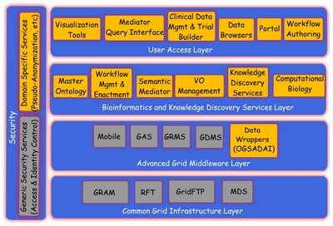
Figure 2-1 The ACGT Layered Architecture
The ACGT platform is designed according to the following technologies and standards:
- The Service Oriented Architecture (Web Services)
- The Grid
- The Semantic Web
These technologies coexist synergistically and complementary to each other in order to support the interoperability and integration requirements of the ACGT end user scenarios and applications. In essence, the Grid provides the computational and data storage infrastructure, the general security framework, the virtual organization abstraction and relevant user management mechanisms etc. The machine to machine communication is performed via XML programmatic interfaces over web transport protocols, which are commonly referred as Web Services interfaces. Finally the Semantic Web adds the knowledge representation mechanisms through the means of OWL ontologies, the implementation neutral query facilities with the SPARQL “universal” query language and the associated query interfaces, etc.

Service Reference Implementation
As part of the initial implementation plan a reference implementation of a service has been started and the process of building and deploying such a service in conformance to the ACGT Grid infrastructure, and security architecture had been documented in the project’s wiki pages (http://decenturl.com/wiki.healthgrid/refimpl). The provision of a new service mostly involves the implementation of the service’s functionality in adherence to the ACGT guidelines but in some cases may require its deployment as well. For the later case of the service deployment the first thing that a service provider should do in order to become part of the ACGT Grid is to get an server certificate signed by the ACGT Certification Authority (CA). This will approve the authenticity of its interactions and a proof of its unique identity. After that the necessary software components should be installed and configured appropriately. These components include the Globus Toolkit and the Apache Tomcat container and when these are installed the new server site is part of the ACGT Grid.
The implementation of the service requires for it to be implemented as a Web Service and its core logic to be wrapped in a way that makes possible the reuse of the existing ACGT infrastructure. The Globus Toolkit incorporates facilities and tools like ‘wsdl2java’ to ease the implementation but to large extent this depends on the specific requirements of the service. For example:
- There may be cases where the service needs to know the identity of the final end-user that calls it
- The data input need not be given directly to the service; instead a reference to the data may be passed and the service should download the ultimate data form the ACGT data grid
- The service needs to further invoke additional services in the name of the user. This implies the support of the delegation of the user’s credentials to the other services.
These requirements and more other are supported by the Grid middleware and the Gridge toolkit. In addition to all of the above the service need to be published in order to be later on discovered and selected among the other services based on its functionality, performance, stability, etc. The need for metadata annotations of services is therefore quite important and the preparation of these service descriptors and their validation by the ACGT quality committees are the final steps in the process of creating a new ACGT service.

Service implementation best practices
Document/Literal services, arrays, call by reference, asynchronous interfaces

The ACGT Workflow Environment

Introduction
The Workflow Management Coalition (WFMC, http://www.wfmc.org/) defines a workflow as "The automation of a business process, in whole or part, during which documents, information or tasks are passed from one participant to another for action, according to a set of procedural rules". In other words a workflow consists of all the steps and the orchestration of a set of activities that should be executed in order to deliver an output or achieve a larger and sophisticated goal. In essence a workflow can be abstracted as a composite service, i.e. a service that is composed by other services that are orchestrated in order to perform some higher level functionality.
The term “ACGT Workflow Environment” collectively describes the end user interfaces and the grid infrastructure for the design, archiving, execution, and management in general of the ACGT scientific workflows. The aim of this environment is to assist the users in their scientific research by supporting the composition of different data access and knowledge extraction and analytical services into complex workflows. This way the users can extend and enrich the functionality of the ACGT system by reusing existing ACGT compliant services and producing “added value” composite services. This reuse and composition of services is in some sense a programming task where the user actually writes a program to realize a scenario or to test a scientific hypothesis.
The major objectives of the ACGT workflow environment are:
- The definition (design) of new scientific workflows based on the user’s experimental scenarios or exploratory data analysis tasks.
- The management of the workflows as reusable functional components. The workflows are functional entities that can be reused either in the same way or with slight modifications (“repurposed”) and therefore they should be persisted and easily located and retrieved.
- The provision and maintenance of the necessary metadata descriptions that will enable not only the discovery of relevant workflows in a custom task but also to support the extraction of knowledge about the way services can be combined and operate in a collaborative manner.
- The execution (“enactment”) of available workflows taking into account knowledge about the ACGT platform and its Grid fabric. In particular the execution of the workflows in the Grid and the availability of services like the Grid Data Management Service (DMS) offer additional degrees of freedom both in terms of performance and in terms of functionality.
- The bookkeeping of the results of the workflows execution and the maintenance of the back links to the initial inputs. The so called “provenance” information should be maintained so that results can be reproduced or better documented as part of the scientific process that the workflow participated in.

Design of the ACGT Workflow Environment
Following a component based methodology we have identified the following software entities for the realization of the ACGT Workflow Environment:
- The Workflow Editor is the end user tool whose major functionality is the definition of new workflows
- The Workflow Engine (“Enactor”) is the network service that is responsible for the enactment of the stored workflows
These two components are able to communicate through a common workflow description language that is able to fully describe the composition of services into the workflow.

Rationale for having two separate software components
We have made the decision that we should separate the two phases of the workflow authoring and the enactment. Well known workflow editors such as the Taverna Workbench or Triana do not make this distinction and they incorporate both functionalities in a single application. There are of course advantages as well as disadvantages to this line of thought. The advantages for having the workflow editor supporting also the enactment is that the user has more control of the workflow execution, it’s easier to use the local resources (e.g. a file in his/her desktop machine), etc. On the other hand the separation of the execution from the authoring phase offers the following advantages:
If we may use a metaphor we could say that having two separate components, one for the authoring and another for the enactment of the workflows, is reminiscent of the way a compiled programming language (usually) works: The user writes and “compiles” the program and after that, in a later step, he/she can execute (“run”) it. On the other hand the approach of having a common environment for authoring and executing the workflows is similar to the “Read Evaluate Print Loop” (REPL, http://en.wikipedia.org/wiki/REPL) interactive environment of some interpreted languages (e.g. Lisp or Scheme). Without delving into religious arguments about which of the two is better, it is generally agreed that the compiled version offers better performance and easier deployment whereas the interpreted environment minimizes the “edit-run-debug” cycle and offers better interactivity because the outputs of each processing step are readily available to the user.
- The workflow can be executed in a remote machine, which hopefully is more powerful, or even in a cluster of machines in the Grid, depending of course on the implementation of the Workflow Enactor. Nevertheless, in every case, the user should not be worried about the specific implementation details of the workflow execution mechanisms and there’s no need to install additional software on his/her workstation.
- There is no burden imposed on the user’s local machine since the majority of computation and data transfer of the intermediate results are taken place in the Grid where the services are run.
- As a consequence of the above, the user is allowed to leave or even shut down his/her machine should the execution of a workflow take too long. The outputs of the workflow can be stored in temporary locations in a user specific area and later on retrieved by the user.
- The workflows by default will be saved outside the user’s premises so it’s easier to enable the sharing and reuse of the workflows. This of course requires the user’s consent and all the security constraints should be satisfied.
- The evolution of the workflow engine and the installation of a new version is easier because the upgrade can be done centrally
There are of course some disadvantages:
- There is an additional step before the workflow is able to be executed: the workflow should be deployed in the Workflow Enactor. This means that the workflow can not be run before it is validated, transformed into the appropriate format, and stored in the enactor’s database. Of course much of this additional step can be done in the background and shunned away by friendly user interfaces.
- The interactivity is severely affected because the workflow is run outside the user’s control. For example additional mechanisms should be implemented in order to provide feedback to the user about the status of the execution or to enable the user to stop the execution at some point. This kind of functionality can of course be implemented and realized by additional programmatic interfaces to the enactor’s core but even in this case the network latency could affect negatively the user’s experience.
The decision taken in ACGT was to uncouple the two phases - the “think” and the “enact” phase - and to provide the tools and the mechanisms that properly handle and serve each one in the best possible way. This decision is also taken based on the project’s technological directions, i.e. the grid and service oriented foundations seem to be more inline to the definition of a more component based architecture.

Workflow Editor
The ACGT Workflow Editor is a graphical tool that allows a user to combine different ACGT services into complex workflows. This tool is accessible through the ACGT Portal and therefore has a web based graphical user interface. It supports the searching and the browsing of the available services and data sources and their composition through some intuitive and user friendly interface. The workflows created can be stored in a user’s specific area and later retrieved and edited so new versions of them can be produced. The publication and sharing of the workflows are also supported so that the user community can exchange information and users benefit from each other’s research. Finally the workflow editor supports the execution of the workflows and the monitoring of their enactment status.

Functional Requirements
The following functional requirements have been identified:
- Present a navigable presentation of the available services and workflows. Faceted classification is a preferred way to support the efficient browsing of a large number of entities and the utilization of the service and data type ontologies will leverage this kind of functionality.
- Support the graphical composition and linking of services based on the descriptions of their inputs and outputs. The Workflow Editor supports the syntactic analysis of services and provides feedback to the user for the compatibility of two services when connected together. The possibility of runtime errors should therefore be largely decreased when the workflow editing environment itself discovers syntactic inconsistencies and notifies the user about them through visual indications.
- Provide for the semantic validation of the workflows assuming that the participating services have been annotated semantically. This kind of functionality will try to eliminate the “logic errors” and support the creation of workflows that model useful and meaningful scenarios.
- Support the persistence and retrieval of workflows. Workflows are stored centrally (in the ACGT Data Grid) and can be designated either as private, which means that only the creator has access to them, or public, which means that all the ACGT users have the rights to view and edit them. The publication facility leverages the reuse or “repurpose” of the workflows by other users to accomplish a similar but slightly different scientific problem, e.g. by changing a parameter’s value or a data input.
- Versioning support is required, especially in the cases where a workflow is made public. The user during the editing of a private workflow will be given the choice to store the altered workflow either as a new version of it or in the old version (overwriting the existing copy). When the edited workflow is a public one then the user is forced to store it under a different name so that the previous public version remains the same and other users could continue using it.
- The workflow editor supports the BPEL workflow description language. This is required in order to deploy the workflow into a BPEL compliant workflow engine for its subsequent execution. Since BPEL lacks the ability to represent visually the workflows graphs, an additional language is needed to describe the visual representation of the workflow. For this language an XML format like SVG could be used or, since this is an internal representation of the workflows, some custom (proprietary) format could be devised.
- Import/Export functionality is needed to permit the interoperation with other workflow editing environments, e.g. Taverna. Especially for the import facility, two are the currently anticipated input formats: BPEL and Taverna’s Scufl. Nevertheless, it is impossible to support the import of all Taverna workflows because of the additional, non Web Service based “processors” that Taverna supports, e.g. “local” Java classes.

External interface requirements
Being a web based application the Workflow Editor is hosted in the ACGT Portal in custom made portlet. This requirement has a number of implications as far as the design of the user interface is concerned (e.g. the same fonts, colors, etc. used in the rest of the portal) but it also has some consequences on the implementation; for example, the workflow editor’s portlet should support “window minimization” and “maximization”. In general, this tool should comply with the requirements and restrictions set by the Portal environment in terms of the presentation and the functionality.
Additionally, the Workflow Editor requires interaction with the following ACGT components:
- The Workflow Engine (Enactor), which is responsible for the execution of the workflows. The Workflow Editor is responsible for the deployment of an abstract workflow as a new concrete workflow which later can be invoked as a service and participate in other workflows. The communication between the workflow editor and the workflow engine depends on the interface offered by the engine and how the “hot” deployment of workflows is implemented.
- The majority of information required for the listing of the available service and the syntactic and semantic validation of workflows comes from the Metadata Repository. In order to support these advanced features the Workflow Editor requires a flexible and transparent interface and query language and therefore the choice is clearly the SPARQL RDF query language used over the corresponding access protocol .
- The Grid Data Management and VO specific Services are used in order to store and maintain the workflow definitions and distinguish between the public and private storage areas.

The architecture of the Workflow Editor
The Workflow Editor has been designed as an application consisting of two components:
- the client side, which runs as a “rich internet application” inside the browser, using familiar and well known web technologies like HTML and Javascript
- the server side, which is located in a central point and is responsible for more computational heavy or the core “business-logic” of the workflow editor.
These two components communicate with each other in a unidirectional, “firewall friendly” way, i.e. the client side makes requests to the server side and not the other way round. An implication of this is that implementation of “server push” scenarios, i.e. cases where the server needs to notify the client for an event of some sort, is difficult although there are a number of solutions. Currently though we don’t have a need for such a functionality.

Technology Background
ACGT Workflow Editor is an internet application. Like all these applications AWE is highly accessible, require no installation, can be upgraded at any time, and offer access to large amounts of data without complex networks. These are the main advantages compared to a native, desktop application. Even though Internet applications usually have poorer usability due to their simpler, less interactive interfaces and slow update times, they are replacing native applications everywhere you look.
A Rich Internet Application [Understanding Ajax] (RIA) is an Internet application that attempts to bridge the usability gap between native applications and normal Internet ones. It contains more code on the browser, which offers higher levels of interactivity and an experience similar to native applications. With RIAs, it's possible to use many technologies, such as Flash, Java, and ActiveX, but the most important one is JavaScript. JavaScript is provided directly by the browser instead of being an add-on like the other technologies. Technologies used for the realization of AWE are: HTML, JavaScript, Ajax, and PHP.

JavaScript
Netscape invented JavaScript [JS and Ajax] as a way to control the browser and add interactivity to Web pages. JavaScript referred to as a "scripting language" and has no connection at all the Java programming language. A JavaScript script is a program that is either contained internally in an HTML page (the original method of scripting) or resides in an external file (the now-preferred method).
There are many things that can be done with JavaScript to make Web pages more interactive and provide site's users with a better, more exciting experience. JavaScript can create an active user interface, giving the users feedback as they navigate to web pages.
But JavaScript is a client-side language; that is, it is designed to do its work on user’s machine, not on the server. Because of this, JavaScript has some limitations built-in, mostly for security reasons:
- JavaScript does not allow the reading or writing of files on client machines. That's a good thing, because nobody wants a Web page to be able to read files off of its hard disk, or be able to write viruses onto the disk, or be able to manipulate the files on the computer. The only exception is that JavaScript can write to the browser's cookie file, and even then there are limitations.
- JavaScript does not allow the writing of files on server machines. There are a number of ways in which this would be handy (such as storing page hit counts or filled-out form data), but JavaScript isn't allowed to do that. Storing and handling data to serer can be done with a CGI written in a language such as Perl or PHP, or a Java program.
- JavaScript cannot close a window that it hasn't opened. This is to avoid a situation where a site takes over user’s browser, closing windows from any other sites.
- JavaScript cannot read information from an opened Web page that came from another server. In other words, a Web page can't read any information

Ajax
Ajax [Ajax1, JS and Ajax] is shorthand for Asynchronous JavaScript and XML, and it is a term that was first coined in early 2005 by Jesse James Garrett, a Web developer and author. Strictly speaking, Ajax is just a small (although particularly popular) part of JavaScript. As commonly used, though, the term no longer refers to a technology by itself (like, say, Java or JavaScript).
In the larger scheme of things, what's generally referred to as Ajax is the combination of these technologies:
- XHTML
- CSS (Cascading Style Sheets)
- The DOM (Document Object Model) accessed using JavaScript
- XML, the format of the data being transferred between the server and the client
- XMLHttpRequest to retrieve data from the server
By working as an extra layer between the user's browser and the web server, Ajax handles server communications in the background, submitting server requests and processing the returned data. The results may then be integrated seamlessly into the page being viewed, without that page needing to be refreshed or a new one loaded.
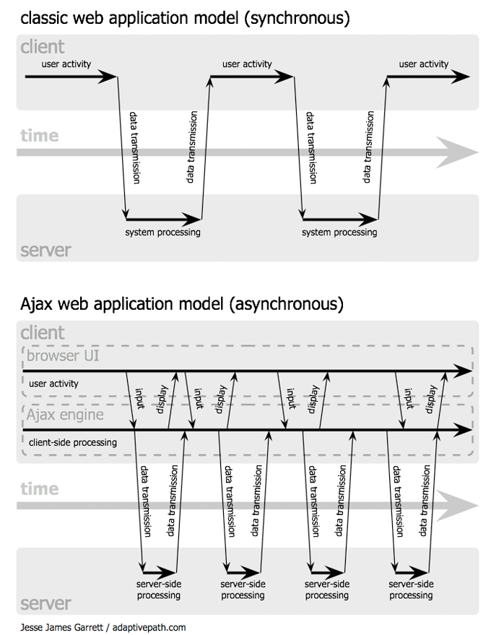
Figure 3-2 The Ajax asynchronous programming model (image courtesy of Jesse James Garrett)
As we can see in Figure 3-2, Ajax builds an extra layer of processing between the web page and the server. This layer, which is often referred to as an Ajax Engine or Ajax Framework, intercepts requests from the user and handles server communications in the background, quietly, unobtrusively, and asynchronously. By this we mean that server requests and responses no longer need to coincide with particular user actions but they may happen at any time convenient to the user and to the correct operation of the application.
In the traditional style of web page, when the user issue a server request via a hyperlink or a form submission, the server accepts that request, carries out any required server-side processing, and subsequently serves to the user a new page with content appropriate to the action you have undertaken.
While this processing takes place, the user interface is effectively frozen. User is made quite aware of this, when the server has completed its task, by the appearance in the browser of the new or revised page.
With asynchronous server requests, however, such communications occur in the background, and the completion of such a request does not necessarily coincide with a screen refresh or a new page being loaded. The browser does not freeze and await the completion by the server of the last request but instead lets the user carry on scrolling, clicking, and typing in the current page.
The benefit to Ajax is that most of the processing for the application is happening within the user's browser, and requests to the server for data are usually short. So with Ajax, you can give users the kind of rich applications that depend on Web-based data, without the performance penalty of older approaches, which required that the server send back entire pages of HTML in response to user actions.

PHP
PHP [PHP] stands for PHP: Hypertext Preprocessor. PHP is a reflective programming language originally designed for producing dynamic web pages. PHP is used mainly in server-side scripting, but can be used from a command line interface or in standalone graphical applications.
PHP is a widely-used general-purpose scripting language that is especially suited for Web development and can be embedded into HTML. PHP generally runs on a web server, taking PHP code as its input and creating Web pages as output.
Five important characteristics make PHP’s practical nature possible:
- Familiarity. Many of the language’s constructs are borrowed from C and Perl, and in many cases PHP code is almost indistinguishable from that found in the typical C or Pascal program.
- Simplicity: PHP engine simply begins executing the code after the first escape sequence (<?) and continues until it passes the closing escape sequence (?>). If the code is syntactically correct, it will be executed exactly as it is displayed.
- Efficiency: PHP 4.0 introduced resource allocation mechanisms and more pronounced support for object-oriented programming, in addition to session management features.
- Security: PHP provides developers and administrators with a flexible and efficient set of security safeguards. These safeguards can be divided into two frames of reference: system level and application level.
Flexibility: PHP is an embedded language, so it is extremely flexible. Although PHP is generally touted as being used in conjunction solely with HTML, it can also be integrated alongside languages like JavaScript, WML, XML, and many others. Additionally, as with most other mainstream languages, wisely planned PHP applications can be easily expanded as needed.
In our case PHP is the technology chosen for the implementation of the server side of the workflow editor. The important thing here is that this choice has no impact on the implementation of the client side: we could have chosen any other server side dynamic web page generating technology like Java Servlets or JSP, or ASP.Net, or even the traditional and currently not so popular CGI scripts. The communication between the client and the server side of the Workflow Editor is based on prearranged wire formats and the two sides are agnostic to each other’s implementation details.

The Workflow Editor in Action
Setting as background the javascript, ajax and php technologies we created the ACGT Workflow Editor (AWE). External, third party, open source libraries that are used in AWE are Ext JS (http://extjs.com/) and draw2d (http://www.openjacob.org/draw2d.html). Figure 3-3 shows the user interface when we invoke AWE.
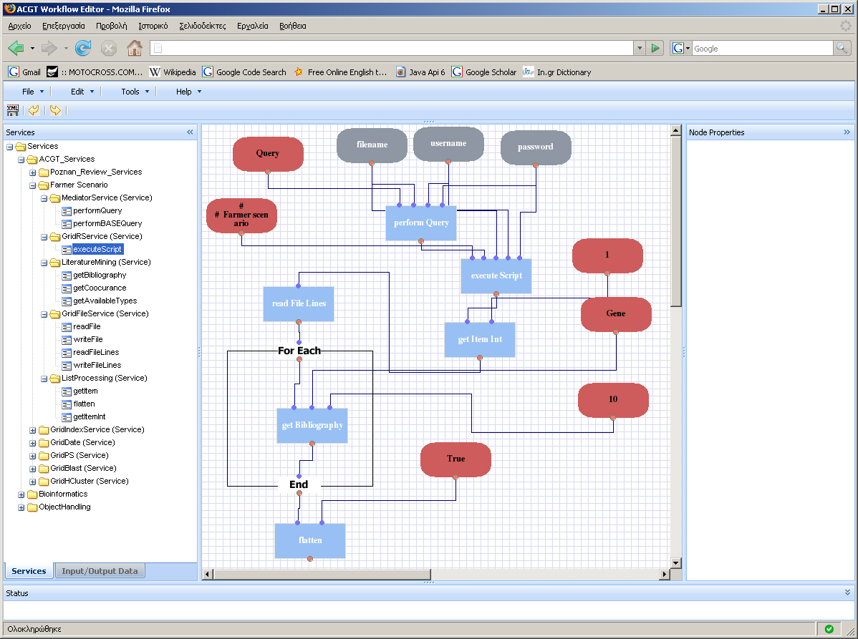
Figure 3-3 A general view of the workflow editor
As we can see the application consists of five frames:
- “North” frame contains a menu bar and menu buttons.
- “East” frame contains all the available services (according to the ACGT web service repository) that the user can use to create a workflow and like input/output variables, constants, loop branches.
- The centric frame is the main frame where the workflow is drawn.
- “West” frame contains information about the selected (if any) items that we have in the workflow.
- The “south” frame contains information about the workflow status (e.g. response from enactor, errors during deploy/run etc).
Interaction with frames is asynchronous, using Ajax technology, in order to gain flexibility and reduce the delay to the end user.
From the menu bar (Figure 3-4) the users have the options to create a new workflow (New button), open an existing workflow from the workflow repository, save the current workflow, and export the workflow to BPEL. Furthermore, the user during the workflow design can undo or redo operations, can deploy the current workflow or “run” the workflow (a workflow must have been deployed before it can be executed). Some of these operations (e.g. Open, Save, Export to Bpel, Deploy, Run) require from the AWE (client) communication with the server-side. PHP scripts are responsible for the client – server communication.
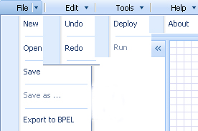
Figure 3-4 Menus in the Workflow Editor
From the east frame the user can select the objects that she/he wants to participate in the workflow. In the bottom of this frame the user can select the view “Services” or “input/output data”. From the view “Services” the user can select all the available web services from the ACGT services repository. The services are hierarchically organized as a tree view (Figure 3-5, left side). A service can be added in the workflow by double clicking on it or using the drag and drop operation to the workflow area (centre frame). Then the service is dynamically generated (using asynchronous call to the service repository) and is visible in the workflow area. The “input/output data” view of the east frame gives the ability to the user to add objects in the workflow compliant with the BPEL standard, such as input/output objects, constants and loop operations.
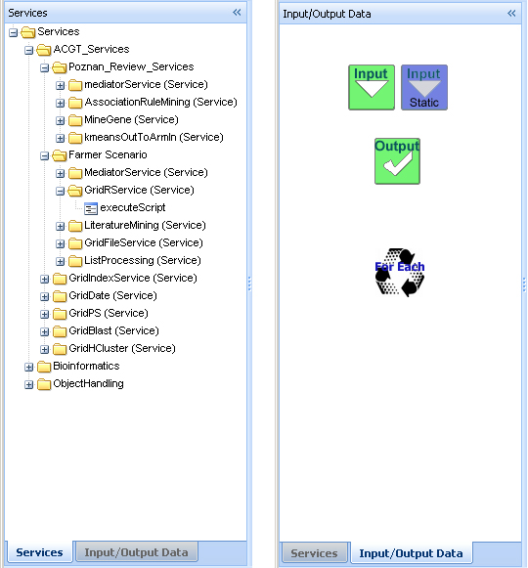
Figure 3-5 Left and right panel
West frame contains information about the selected (if any) items. This information varies depending on the object. If the object is an input then the information that the user get is the name and the data type for the specific input object. Same holds for the output. For the constants the information is the data type and the default value. For the loop object the information that is available to the user is the input/output data types and the name of the loop. For the services the information that the user gets is the service name, the input names – data types, the output names - data types. An example can be shown in Figure 3-6 where information about the GridR service of ACGT is shown.
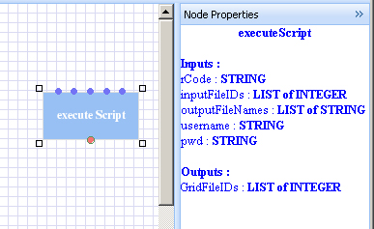
Figure 3-6 Context specific information
In Figure 3-7 the south frame is shown. It contains a status bar with information about the workflow status (e.g. response from enactor, errors during deploy/run etc).
Figure 3-7 Status bar
The central frame contains the workflow area where the user draws its workflow. The user can add as many objects as he/she wants and connect them respectively. The editor using an efficient algorithm prevents the user from connecting objects with different data types. If the user tries to connect objects with conflicting data types then a warning message appears (Figure 3-8).
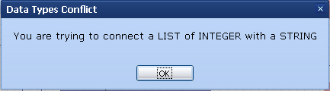
Figure 3-8 Syntactic validation of services connections
Furthermore, the user can change the data type of the constants, the input, the output and the loop input/output objects simply by double clicking on the object. Then a new message box with a list of available data types appears and the user can select the appropriate. An example of this message box can be shown in Figure 3-9.
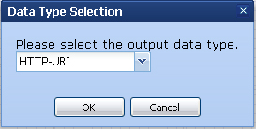
Figure 3-9 Data type annotation
Depending on the needs of the workflow the user can connect as many services as he/she wants, add loops, constants and input/output variables. An example of a workflow concerning the Farmer scenario can be shown in Figure 3-10. At any time the user can save the workflow and continue working on it at a different time. All the workflows are stored in the server side so the user can handle its workflow from any place using only the credentials to access the portal ACGT.
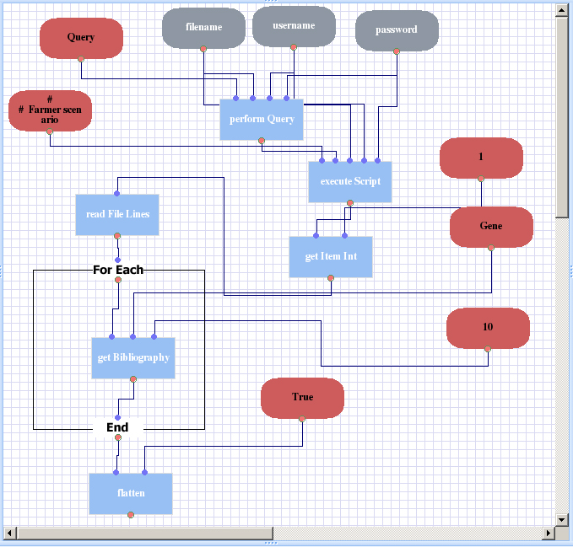
Figure 3-10 A complex workflow implementing the "Farmer scenario"
Move, delete, undo, redo operations are also available.

Performance Requirements
In terms of performance, the development of the Workflow Editor as a Rich Internet application , i.e. an application that is run inside the web browser, requires a great deal of forethought and good analysis and design. The presence of the network usually cannot be hidden due to its inherent latency so a good policy is to try to minimize the interactions (e.g. queries) with the server side or at least to overlap them with some user actions by doing them in the background. Minimization of the communication with the server side implies that as much as possible state is kept on the client, i.e. in the user’s machine. An example of this is that the navigation of the available services should not require re-fetching of the same information if it has been retrieved in the past and can be reused. But also the user should not wait for the whole classification of services to be retrieved from the server and loaded in her browser. So another important policy is the “lazy evaluation”, which means that computations are delayed until their results are actually needed. In the same example, an implementation of this policy will be that the hierarchy of services is loaded one level at a time and additional branches of the tree are retrieved only when the user requests for them, e.g. by clinking in their “root”.
So in conclusion the following design policies should be consider with respect to the performance and the user experience:
- Minimize communication with the server and keep as much as possible business logic in the client
- Perform the network communication interleaved with the user actions, i.e. concurrently in the background
- Cache expensive computations or the results of the interactions with the server side for as much as possible
- Adopt a lazy evaluation of computations and client – server communications to reduce the user perceived delay.

Security
The Workflow Editor as part of the portal is subject to the same access policies and security constraints: The users are authenticated and authorized according to their specific roles and based on the Grid security mechanisms.

Portability
Being web based the Workflow Editor does not require any special installation in the client side, except some modern web browser. Its implementation is based on state of the art technologies that are supported by the majority of the contemporary browsers, like Javascript, (X)HTML, XML, SVG. Nevertheless, since there are always slight incompatibilities, it is important to keep the code portable to at least the following browsers and versions: Internet Explorer 7, Mozilla Firefox 2, and Apple’s Safari 3.

Maintainability
The code is kept as modular as possible to permit its maintenance and evolution. The selection of some high quality libraries and tools for web development will support this modularity and also will keep the code clean by abstracting away the minor vagaries of the web browsers and operating systems.

Software configuration and management: tools used
The code for the Workflow Editor is kept in the ACGT Code Repository as any other ACGT specific software component. The version control system used is Subversion while the Trac system offers the management of the bugs and the issues tracking in a familiar wiki-style environment.

Evaluation and Verification
For the criteria of functionality, reliability, efficiency, and usability the testing and validation of a graphical user interface cannot be automated because it exposes a user interface and not a programmatic interface. Therefore it is evident that the verification and validation of the Workflow Editor for these criteria will be performed by the users. The plan is to follow an iterative process:
- Prototypes of the editor will be released often and made available for the whole ACGT consortium to test and verify. The opinion of some “expert” users, which represent our end user communities, will be largely taken into account in the highest priority.
- The accumulated comments will be subsequently grouped, prioritized, and more formally expressed in the issue and feature tracking system
- The new development efforts will be subsequently guided by these reviews and the general project plan as well.
On the other hand, the maintainability and portability aspects are tested and validated mostly by the developers. In each prototype that represents a stable snapshot of the code a series of supervised tests will be performed with the range of the targeted browsers. Any problems will be also noted using the issue tracking system in order to be resolved in the future versions of the editor.

Workflow Enactor
Each workflow is deployed as a "higher order" composite service and the Workflow Enactor is the Grid enabled component responsible for the invocation, monitoring, and management of running workflows. The standard workflow description language WS-BPEL (http://www.oasis-open.org/committees/tc_home.php?wg_abbrev=wsbpel) has been selected as the workflow description format and being a standard it enables the separation of the workflow editing environment from the workflow enactor and facilitates their communication and integration.
Apache ODE is the workflow enactor chosen for the initial demonstration of the workflow environment. It offers a good level of compliance with the WS-BPEL 2.0 industry standard and it bases its implementation on an efficient model of concurrency (ACTORS)

Metadata
In order to support the composition of the ACGT services the workflow environment should have access to the metadata descriptions of these services. These descriptions play a critical role in the integration in the ACGT ecosystem because they provide useful information about the functional and non functional characteristics of the ACGT components. The metadata make it possible to achieve the discovery, composition, validation, and quality of service verification of the services and tools and therefore enrich the whole platform with advanced functionality and ease and facilitate the user interactions.
In the context of the Workflow Environment there are two metadata related scenarios: the use of existing metadata and the provision of additional metadata related to the workflows. We are further describing each of them in the following paragraphs.

Metadata used by the Workflow Environment
In the current configuration the metadata that are required by the Workflow Editor are used for the following purposes:
- The implementation of the browsing and navigation to the available services
- The syntactic composition of the services
In the first case we need to have information about what are the available processing elements that can be put in a workflow.

Metadata Repository
The tool metadata repository in ACGT provides functionality to publish, discover and maintain metadata about tools (web services and workflows). An initial proposal for metadata was part of Deliverable 6.1 (section 3.1.9) and currently most of this metadata is supported by the tool metadata repository. Examples of metadata for services include operations, parameters (input/output), datatype of parameters, functional category for services and workflows and exportable definitions of services/workflows (WSDL/BPEL).
This metadata is used to provide several necessary functionalities, for example registration, discovery, invocation and documentation of tools. An application programming interface (API) has been developed to provide these functionalities. The API has been implemented as SOAP web services using Axis2. We have used Hibernate to implement persistent java objects that map to database tables. These java objects are used to hold the metadata information.

Open issues
Security! Supporting more control structures, import of taverna workflows..

References

[Ajax1] Phil Ballard. SAMS Teach Yourself Ajax in 10 Minutes ISBN: 978-0-672-32868-8

[JS and Ajax] Tom Negrino JavaScript and Ajax for the Web ISBN: 978-0321430328

[Understanding Ajax] Joshua Eichorn. Understanding AJAX ISBN: 978-0132216357

[PHP] W. Jason Gilmore A Programmer's Introduction to PHP 4.0 ISBN: 978-1893115859

The server certificate also covers the “non-repudiation” property, i.e. so that the service can not deny its involvement in a certain interaction and claim forgery of its identity.
This is the case for the versions available at the time of the writing of this report. At least for Taverna there are plans to move towards to the direction that ACGT is heading in the next major release (2.0) of the software.
For example Google Docs (http://docs.google.com/) is a complete office suite similar in functionality to Microsoft Office that runs exclusively on the browser.
http://www.adaptivepath.com/ideas/essays/archives/000385.php

