
Conceptual specification and a first prototype for an ontology based Clinical Data Management System and for the Trial Builder

Project Number: | FP6-2005-IST-026996
Deliverable id: | D 5.4
Deliverable name: | Conceptual specification and a first prototype for an ontology based Clinical Data Management System and for the Trial Builder
Date: | Februar 26, 2008


COVER AND CONTROL PAGE OF DOCUMENT
Project Acronym: | ACGT
Project Full Name: | Advancing Clinico-Genomic Clinical Trials on Cancer: Open Grid Services for improving Medical Knowledge Discovery
Document id: | D 5.4
Document name: | Conceptual specification and a first prototype for an ontology based Clinical Data Management System and for the Trial Builder
Document type (PU, INT, RE) | INT
Version: | 1.0
Date: | 26/02/2008
Editors:  Organisation:  Address: | Fatima Schera and Gabriele Weiler  Fraunhofer Institute for Biomedical Engineering (IBMT)  Ensheimer Straße 48  66386 St. Ingbert  Germany  fatima.schera@ibmt.fraunhofer.de  gabriele.weiler@ibmt.fraunhofer.de
Document type PU = public, INT = internal, RE = restricted
ABSTRACT:
This deliverable describes the design and initial 3ealization of the Ontology based Trial Management System for ACGT (ObTiMA) that has been developed as part of the ACGT project. This report aims to document the design decisions that were made, to provide a basic understanding of the implementation of ObTiMA, and to illustrate the possibilities and limitations of the system.
The main goal of ObTiMA is to support the design phase of a clinical trial allowing to set up the Patient Data Management System for a trial in a standardized and userfriendly way integrating the ACGT master ontology into the design process. With the Patient Data Management System an end-user (clinician) is able to manage a patient within a clinical trial, to capture data, to report data and to query the database in a standardized way in terms of the ontology. The seamless integration of the ontology into the design process of a trial guarantees that the data collected during the trial has comprehensive metadata, a crucial condition to leverage the data for further research like cross-trial analysis.
The first prototype of ObTiMA is implemented as a stand-alone tool, but later it will be embedded into the ACGT environment.
KEYWORD LIST: clinical data management system; trial builder; trial protocol; case report form; treatment plan; ontology; semantically integration; mediator; crf repository; web services

MODIFICATION CONTROL
Version | Date | Status | Author
0.1 | 15/02/2008 | Draft | Fatima Schera
0.2 | 19/02/2008 | Draft | Gabriele Weiler
0.3 | 26/02/2008 | Draft | Fatima Schera
0.4 | 27/02/2008 | Draft | Gabriele Weiler
0.5 | 28/02/2008 | Draft | Fatima Schera
1.0 | 07/05/2008 | Final | Fatima Schera

List of Contributors
- Stephan Kiefer, IBMT FhG
- Jun Fujima, Hokkaido University
- Cristian Cocos, IFOMIS

List of reviewers

List of Contributors iii
List of reviewers iii
1. Documentation Roadmap and Overview 1
1.1. Purpose and scope of the Deliverable 1
1.2. How the Deliverable is organized 1
1.3. Context 2
1.3.1. ACGT Integration Architecture 2
1.3.2. Requirements for ObTiMA 3
1.4. Objective 4
2. Architecture Background 5
2.1. System Overview 5
2.1.1. Trial Builder 7
CRF Creator (CC) 8
ACGT Master Ontology 9
Ontology Viewer 9
Trial Metadata Designer 9
Trial Outline Builder (TOB) 9
Trial and CRF Repository 10
Vocabularies and dictionaries 10
Registration and authorisation of a trial 10
Trial Setup module 11
2.1.2. Ontology based patient data management system (OPDMS) 11
Management of patients 12
Management of CRFs 12
Trial databases 12
Integration into the ACGT environment using OGSA-DAI services 13
2.1.3. Administration 13
User administration 13
Roles and Rights management 14
2.1.4. Communication and Consultation Modules 14
2.1.5. Data export 14
CDISC ODM 15
Export of anonymized data 15
2.1.6. Reporting of SAE and SUSARs 16
2.2. Use Cases 16
2.2.1. Actors and Goals 16
2.2.2. Mapping Requirements to Architecture 18
2.3. Solution Background 22
2.3.1. Architectural approach of ObTiMA 22
Presentation Layer (or User interface) 22
Controller and Business/Service Layer 22
Data Integration Layer 23
Foundation Services 24
3. Views 26
3.1. Module Views 26
3.1.1. High Level Module View 26
3.2. Runtime Views 27
3.2.1. Template for the runtime views 28
3.2.2. Examples for the runtime views 28
3.3. Data Model View 31
3.3.1. ObTiMA Data Model View 31
3.3.2. Dependencies between some tables on the ER-Diagram 33
3.4. Deployment Views 35
3.4.1. Network Diagram 36
3.4.2. Java EE Deployment Files 37
4. Initial Realization of ObTiMA 39
5. Conclusion 44
5.1. Achievements 44
5.2. Open issues 44
5.2.1. Limitations of the integration of the ACGT MO 44
5.2.2. Limited functionality 45
6. References 47
7. Glossary and acronyms 48
A ObTiMA Use Cases 51
A.1 High-level System Use cases 51
A.2 Use case 1 “Manage user” 54
A.3 Use case 2 “Manage patient” 60
A.4 Use case 3 “Manage roles and rights” 63
A.5 Use case 4 “Manage trial” 68
A.6 Use Cases “Manage CRF” (CRF Builder) 75
B Metadata for Trial 86
B.1 Metadata for an item 93

Figure 1 ACGT information integration architecture 3
Figure 2 ObTiMA system overview 5
Figure 3 ObTiMA - real world business process 6
Figure 4 ObTiMA - high-level view of the major modules 7
Figure 5 Modules of Trial Builder 8
Figure 6 Trial databases 13
Figure 7 ObTiMA use cases 19
Figure 8 ObTiMA: layered architecture 25
Figure 9 High level module view 27
Figure 10 Template for workflows in the runtime views 28
Figure 11 Example: create crf 29
Figure 12 Example: create trial protocol 30
Figure 13 Example: create treatment plan 31
Figure 14 Entity-relationshipmodel for the data model of ObTiMA 32
Figure 15 Relations between tables for the trial specific view and the patient specific view 33
Figure 16 Relations: from template view to instance view 34
Figure 17 ObTiMA: Representation of the trial in the database 35
Figure 18 Network diagram of ObTiMA 36
Figure 19 Deployment view of the components 38
Figure 20 Trial Builder View to create an item from the ontology 40
Figure 21 Trial Builder View after creating a value-item from the class gender 41
Figure 22 Trial Builder View after pressing the button “Subclasses” behind the class Disease 42
Figure 23 Example CRF created with the Trial Builder from the ontology 43
Figure 24 High level system use cases 51
Figure 25 Use case for management of users 54
Figure 26 Use case for management of patients 60
Figure 27 Use case for management of roles and rights 63
Figure 28 Use case for management of ckinical trials 68
Figure 29 Use case for management of CRFs 75

Documentation Roadmap and Overview

Purpose and scope of the Deliverable
This deliverable describes the design and initial realisation of the Ontology based Trial Management System for ACGT (ObTiMA) that has been developed as part of the ACGT project. This report aims to document the design decisions that were made, to provide a basic understanding of the implementation of ObTiMA, and to illustrate the possibilities and limitations of the system.
The main goal of ObTiMA is to support the design phase of a clinical trial allowing to set up the patient management system for a trial in a standardized and userfriendly way integrating the ACGT master ontology into the design process. With the Patient Data Management System an end-user (clinician) is able to manage a patient within a clinical trial, to capture data, to report data and to query the database in a standardized way in terms of the ontology. The seamless integration of the ontology into the design process of a trial guarantees that the data collected during the trial has comprehensive metadata, a crucial condition to leverage the data for further research like cross-trial analysis.
The next section gives more details about the context in which the work was carried out. It is followed by three sections that explain the objective of this deliverable, the intended audience, and the Documentation Roadmap and Overview, which provides the roadmap and document overview of this document and its intended audience.

How the Deliverable is organized
In the Deliverable we describe the design of ObTiMA as well as its integration into the ACGT Grid environment. The deliverable is organized into the following sections:
- Chapter 1: Documentation Roadmap and Overview provides information about this document and its intended audience. It provides the roadmap and document overview.
- Chapter 2: Architecture Background provides information about the software architecture. It describes the background and rationale for the software architecture. It explains the constraints and influences that led to the current architecture, and it describes the major architectural approaches and technologies that have been utilized for the realisation of the application.
- Chapter 3: Views provides an overview of the architecture for ObTiMA. Each view describes a different structure of the system.
- Chapter 4: Prototype describes the prototype of ObTiMA that has been developed so far. Especially the integration of the ontology into ObTiMA is described.
- Chapter 5: concludes by summarising the achievements and discussing outstanding issues.
- Appendix A describes in detail the main use cases for ObTiMA.
- Appendix B documents the metadata for the clinical trials.

Context
Data Management in post-genomic clinical trials is the process of collecting and validating clinical and genomic data with the goal to answer research questions and to preserve it for future scientific investigation. Comprehensive metadata describing the semantics of the data is needed to leverage it for further research like cross-trial analysis. ObTiMA is an application that allows trial leaders to design their trial and especially the required data management system with comprehensive metadata according to their needs, integrating a clinico genomic ontology (ACGT master ontology) into the design process.
The requirements analysis that was performed preceding the implementation of the ObTiMA is described in [1]. The following subsections provide the minimal background information that is needed to understand the subsequent chapters.

ACGT Integration Architecture
One of the main objectives of the ACGT project is the semantic integration of heterogeneous biomedical databases using a mediator. Figure 1 shows the ACGT information architecture as proposed at the outset of the project. To demonstrate the built-in interoperability of the patient data management systems developed as a part of ObTiMA, we integrate the application into ACGT Grid environment in a way that the research data collected in the data management systems can be seamlessly analyzed and mined by researchers using the mediator service depicted on figure 1. The mediator exploits the ACGT Master Ontology on Cancer (ACGT MO), which comprises the knowledge needed to design and carry out specific clinical trials.
To integrate a data source into the mediator traditionally it has to be mapped to the ontology. The mapping process is an error-prone and tedious task that has to be performed by human users. It is necessary for legacy databases. But in order to avoid this process the databases of newly developed data management systems could be set up during creation in an ontology compliant way. In ObTiMA we explore this approach by developing user-friendly tools that enable a leader of a clinical trial to set up a clinical data management system with comprehensive metadata in terms of the ACGT master ontology. This will allow that the data collected in these systems can be seamlessly integrated into the ACGT mediator architecture without further mapping.

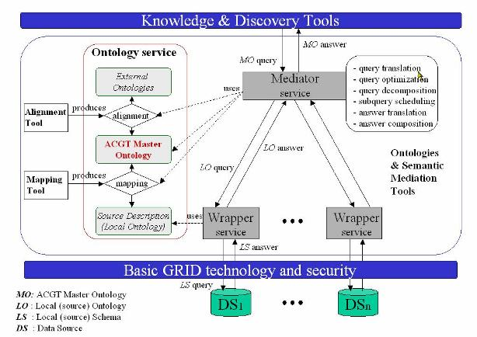
Figure 1 ACGT information integration architecture

Requirements for ObTiMA
ObTiMA should provide a possibility that the newly developed patient management systems could be set up during creation in an ontology compliant way to allow a seamless integration of the data collected in these systems into the ACGT mediator architecture. The developed system should be user-friendly and comfortable.
ObTiMA can be used in different levels:
- create and set up a new clinical trial according to the legal and ethical directives
- data entry via remote data entry (RDE) for managing patients in a clinical trial
- analysis of data in a single trial and across trials
Full functionality of the system is described in the document “User requirements for an ontology based clinical data management system and for the Trial Builder” [1].

Objective
This deliverable describes the design and initial realisation of the Ontology based Trial Management System for ACGT (ObTiMA) that has been developed as part of the ACGT project.
The report aims
- to document the design decisions that were made,
- to provide a basic understanding of the implementation of ObTiMA,
- to illustrate the possibilities and limitations of ObTiMA.

Architecture Background

System Overview
The ObTiMA application has a decoupled architecture that can interoperate with generated software parts. The ObTiMA application is a web application, which comprises the separate parts shown on the figure 2 that cooperate to fulfil the enterprise’s business needs [1]:
ObTiMA
Repository
Trial Outline Builder
Patient Data Management System
CRF Creator
Trial Builder
patient specific view
graphical schema
general view
Figure 2 ObTiMA system overview

After analyzing the user requirements, outlined in the D2.2 [1] we have created a context diagram for the application, shown in the figure 3 below. This figure misses a reference to the type of interaction between each module, but it gives a high level overview of what applications are related.

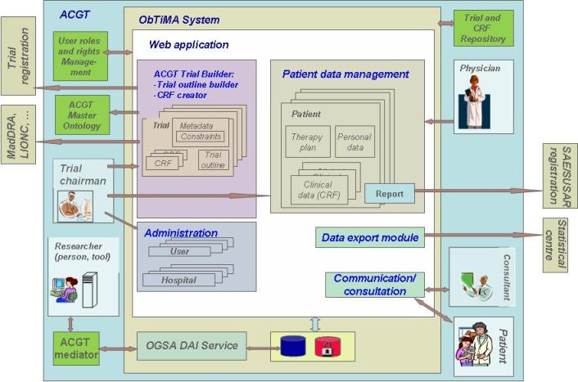
Figure 3 ObTiMA - real world business process

We distinguish three main areas, where the key participants (users, facilities, software components) of the system are located according to their role in the project, shown in figure 3.
- ObTiMA web application area, which includes the ObTiMA web application
- ObTiMA system area, which includes the ObTiMA web application, Data Access services (OGSA-DAI services) and the databases for the trials, created and managed using ObTiMA.
- ACGT area, which includes the ObTiMA system area, ACGT Mediator services, ACGT User roles and rights management, ACGT Master Ontology, Trial and CRF repository, and the ObTiMA end users (Trial Chairman, physician, consultant, researcher, patient etc..)
- Extension area, which includes the ACGT area, different facilities outside of ACGT grid environment (Statistical Centre, SAE/SUSAR Registration Centre, Trial registration centre) and vocabularies (MedDRA, LOINC, ..)
We have transformed the context diagram shown in figure 3 to a simplified high-level view of the major modules of the ObTiMA application and the application's relationship to its key participants that is shown in figure 4.

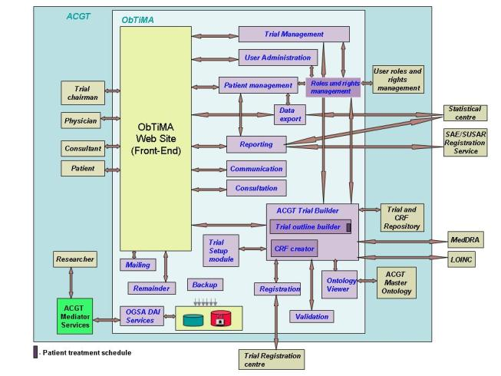
Figure 4 ObTiMA - high-level view of the major modules
In the following the most important modules will be briefly described from the viewpoint of the users of ObTiMA.

Trial Builder
The Trial Builder is a web application that is used to build a new clinical trial. It allows a clinical trial leader to capture data definition and further design specifications for a clinical trial in a standardized way based on a formal ontology. The user will be guided to write the Trial Protocol, to build a graphical schema of the treatment plan and to create all CRFs that are needed for the trial. From these definitions the OPDMS for the trial can then be set up automatically. All legal and ethical requirements will be considered during this process and appropriate solutions provided. The Trial Builder is a component based extendable application.

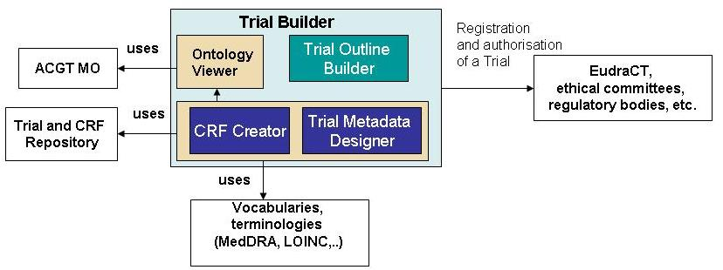
Figure 5 Modules of Trial Builder
Trial Builder provides the possibility to create a clinical trial, including creation and management of ontology based Master Protocol, CRFs and Treatment Plan for a clinical trial as well as validation of the trial design and customizing of trial. ACGT Trial Builder includes the Trial outline builder, the CRF creator, the Trial Setup Module and the Ontology viewer. The ACGT Trial Builder is a core module of Trial Management. The Trial Management includes also the functionality to search for trials by different criterias.
On the figure 5 all main parts of the Trial Builder and other components important for the design of a trial are shown. According to user requirements additional to the main components of ObTiMA some “service” modules are developed within ObTiMA including Ontology Viewer and Trial and CRF Repository. In the next sections the components of the Trial Builder will be described in more detail.

CRF Creator (CC)
With the help of the CRF creator a clinical trial chairman can create all CRFs that are needed for the trial.The main task of this component will be to select the relevant semantic description for the data collected on the CRFs from the shared ACGT master ontology. That will result in an application ontology that is an extract from the ACGT MO. This application ontology defines the metadata for the CRFs as well as for the clinical trial databases. With this approach we want to guarantee that all data stored in the clinical trial database refer to instances of the ACGT MO and that the trial databases can be queried in terms of the ontology.
A clinician aiming to design a trial will naturally want to focus on the user interfaces and trying to integrate and adapt them into the workflow of the specific clinical trial he wants to perform and does not want to be bothered with databases and application ontologies. Therefore the trial leader will built up the application ontology by designing CRFs. The trial leader can define the questions on the CRFs, the order in that the questions will be queried and constraints on the answer possibilities.
In principle for each question the following attributes have to be defined: the question itself, data type of the answer and optionally possible data values, range constraints and a measurement unit. Additionally in order to describe the answer of the question semantically, a description from the ontology has to be chosen. Although an ontology is ‘human understandable’ by providing natural language definitions of entities and relationships it is by definition not based on practical or clinical perceptions of reality. The ACGT master ontology is moreover based on description logics and therefore hard to understand by clinical users. Therefore a tool is required that provides an application specific view on the ontology in a way that a clinician can understand it. For this reason an “Ontology Viewer” has been developed that is described below. The trial leader can chose with the help of the ontology viewer a description for an item from the ontology. As far as possible, all other attributes are determined automatically from this selected path, but can later be changed by the trial leader.

ACGT Master Ontology
The ACGT Master Ontology (MO) has been conceived as ACGT Consortium’s main information repository. It has a modular structure, and has been developed as an extension of Basic Formal Ontology (BFO). The latter is a top-level ontology designed by IFOMIS researchers, that has enjoyed a great degree of success in the biomedical world—witness, among others, its adoption as top-level ontology by one of the largest international concerted efforts targeted at fleshing out a comprehensive ontology of biomedical investigation (OBI). The ACGT MO is presented as an .owl file and is written in OWL-DL.
There are two main sections of the .owl file worth mentioning here: the taxonomy of classes and the taxonomy of relations. The former contains the classes of the ontology (the so-called “universals”) arranged in a taxonomical tree according to the is_a relation—hence, e.g., CanonicalBodySubstance is_a BodySubstance, or Arimidex is_a PharmaceuticalSubstance. The taxonomical tree is supposed to be read in a transitive manner—that is, since PharmaceuticalSubstance is_a ChemicalSubstance, it should follow by modus ponens from the previous sentence that Arimidex is_a ChemicalSubstance also holds true according to the ACGT MO. The upper layer of the tree has been imported from BFO, hence the grand structure of the ontology pays heavy tribute to, among others, BFO’s main Continuant/Occurrent split. This dichotomy is supposed to reflect, roughly, the view according to which reality can be carved either statically, into objectual entities (hormone, hand, tumor, oral cavity), or dynamically, into process-like entities (medication, infection, infarction). Of the greatest interest for the ACGT project is the inclusion of the TNM tumor classification on the Quality branch, the hierarchy of tumor diseases, a taxonomy of relevant carcinomas, a taxonomy of cancer-related drugs, plus many other entries destined to serve the Trail Builder and the CRF generator (many administrative categories, an abundance of terms commonly used in clinical practice etc.). Finally, as mentioned above, by virtue of its inherent modular design, the ACGT ontology is scheduled to import a sizeable section dealing with canonical body parts and substances straight from the NCI Thesaurus.
The relations are required to connect the classes of the is_a tree. In order to capture the complexity of biomedical reality and to express the truths of Medicine and Biology, we have included an abundance of relations besides the mere is_a. Much less structured that the taxonomy of classes, the taxonomy of properties is, nevertheless, liable to further attempts at organizing and structuring. Here are a few examples of structure in the tree of relations: hasBloodPressure is a child of hasPressure which, in turn, is a child of hasMagniture, or hasFunction is a child of implements, or isSisterOf is a child of isSiblingOf which, in turn, is a child of isRelativeOf. An important part of the relations list has been imported from the open-source Relation Ontology (RO): we also find it worth mentioning at this point not only that RO itself is the creation of IFOMIS-based ACGT researchers, but that an enhancement of RO is being actively contemplated by the same researchers during this very time span. As a matter of fact, many aspects in the ACGT MO development have a huge bearing on the kinds of relations to be included in RO, and an active and feverish exchange of ideas between these two efforts has been going on ever since the inception of the ACGT venture, with what can only be regarded as mutual benefits. The ACGT MO can thus be simply regarded as a real world case study in the application of both BFO and RO.

Ontology Viewer
The Ontology Viewer developed within ObTiMA provides an application specific view to the ACGT Master Ontology in order to allow the clinical trial chairman to select an ontology description for an item in an easy way. This description is path from the ontology starting at the class patient since this class is always the focal point of the CRFs.
For this tool in the future it will be developed a clinician’s view (CV) on the problem of CRF design that will be mapped to the ACGT MO. This view is designed by clinicians, is ontology independent and can therefore also be mapped to other ontologies. The CV will give a trial independent basic classification of the content for the CRFs from a clinician’s point of view. The upper categories are Administration, History, Symptoms and Clinical Findings, Diagnostic Procedures, Diagnosis, Treatment, Follow Up and Biobanking. The CV will be trial independent. It is by far not as detailed as the ontology and will provide only the entry point to the ontology for the clinical trial leader. The CV will be integrated into the CRF Builder component in a way that it will guide the trial leader to select appropriate paths to describe the questions on his CRFs from the ontology.

Trial Metadata Designer
Additionally to the CRF Creator component there will be the possibility to describe the metadata of the trial, like e.g. the trial name or defining the participating facilities of the trial etc. Since this is always the same kind of data for each trial the ontology descriptions can be already defined at development time of the Trial Builder and automatically assigned to this data.

Trial Outline Builder (TOB)
The Trial Outline Builder is an independent part of ObTiMA, developed by the University of Hokkaido which includes a graphical schema for the treatment plan template using the Meme Media Technology. By using the Trial Outline Builder a user is able to create Treatment plan templates for the trial in a graphical way.
In the Trial Outline Builder, a clinical trial chairman defines the overall trial outline in the form of a diagram. The construction of this diagram simultaneously creates a user interface for managing the treatment of an individual patient in the trial, and for specifying queries to analyze the treatments and outcomes for all patients.
A trial outline consists of an assembly of medical events such as chemotherapy, radiotherapy, and stratification and randomization steps. Such events are hierarchically structured in a trial outline as a branching tree. Each event is associated with CRFs that hold the corresponding clinical data for each patient treated using that event.
The Trial Outline Builder has two panels. One panel contains graphical exemplars of all medical events that might occur during the conduct of a trial. The trial chairman clicks and drags the exemplar of a desired event type to create an instance of the event, which is then dropped into place within another panel called the Scratchboard. In this way the treatment plan for the whole trial is built up on the Scratchboard. No further actions are required by the chairman to derive from this treatment plan the user interface for managing patients in the trial. Each medical-event component contains references to the corresponding CRFs for such an event, as built using the CRF Creator. When the trial is in progress, clinicians and other users involved in the trial can access the Trial and CRF Repository through the event components, to display or to store data relevant to the event or to a specific patient.

Trial and CRF Repository
The repository is an application that trial chairmen will use for storing trials and CRF templates that are created in ObTiMA for later reuse. The repository consists of a database to store the templates and Web services allowing remote access to the database.
Since in many trials similar or equal data is collected, the CRF Repository is a crucial part of the system is a CRF repository. This is important to share CRFs between similar clinical trials and to develop a set of standardized CRFs. Semantic search based on the ontology will be possible at a later development stage in the CRF repository... The CRFs are stored and can be retrieved in the extended CDISC ODM format [4].
The repository for the Trial Builder consists of two parts:
- a repository for CRFs
- a repository for Trials
The repository itself is structured in a way to easy retrieve and store CRFs.

Vocabularies and dictionaries
During the design phase the medical and scientifical vocabularies and dictionaries will be used. Below are briefly described some of such public sources.
MedDRA or Medical Dictionary for Regulatory Activities is a clinically validated international medical terminology used by regulatory authorities and the regulated biopharmaceutical industry throughout the entire regulatory process, from pre-marketing to post-marketing activities, and for data entry, retrieval, evaluation, and presentation. In addition, it is the adverse event classification dictionary endorsed by the International Conference on Harmonisation of Technical Requirements for Registration of Pharmaceuticals for Human Use (ICH).[5]
Logical Observation Identifiers Names and Codes (LOINC) is a database and universal standard for identifying laboratory observations, developed and currently maintained by the Regenstrief Institute, Inc., an internationally-recognized non-profit medical research organization. LOINC has expanded to include not just medical and laboratory code names, but also: nursing diagnosis, nursing interventions, outcomes classification, and patient care data set. LOINC applies universal code names and identifiers to medical terminology related to the Electronic health record. The purpose is to assist in the electronic exchange and gathering of clinical results (such as laboratory tests, clinical observations, outcomes, management and research). [6]

Registration and authorisation of a trial
Registration and authorization of a Trial on the EudraCT, ethical committees and regulatory bodies will be supported in a later release of ObTiMA. During the design of the trial the end user who wants to run a new trial will select all facilities, where the trial should be registered regarding all legal and ethical requirements for the approval of a clinico-genomic trial. If the facility not yet exists in the database, the user will be guided to create a new profile for the facility by recording of the data of the facility. After successfully validation the new trial will be registered by these facilities by generating of the registration forms with appropriate data of the trial, of the sender and receiver. The user should manually confirm sending of reports. After an acceptance response from all facilities the registration process will be completed. Possible facilities for trial registration are regulatory bodies, EC/IRB, Data Safety monitoring committee (DSMC).

Trial Setup module
The Trial Setup Module will set up the Patient data management system to conduct the trial. The output of the Trial Builder is a platform independent description of the metadata and the CRFs for the clinical trial. This description will be stored in an XML format that is based on the Operational Data Model (ODM) from the Clinical Data Interchange Standards Consortium (CDISC) [4]. The metadata of a clinical trial including a full description of the CRFs of the trial can be stored in the ODM format. We have to extend the format since it does not comprise complete metadata information for a trial. Furthermore, we have defined an extension to this format to include the descriptions from the ACGT master ontology.

Ontology based patient data management system (OPDMS)
An ontology based patient data management system, where the relevant data for individual patients will be collected, will be set up automatically. The trial databases with comprehensive ontological metadata and OGSA-DAI services used for the integration of a clinical data, collected on CRFs, into the semantic mediator architecture of the ACGT grid environment, will be also set up automatically from the definitions made by the trial chairman in the Trial Builder. In the PDMS the clinician will manage the patients. This includes enrolment of patients according to inclusion/exclusion criteria, defined in the design stage of the trial. He can collect personal and clinical data of the patients, which can be later queried in terms of the ACGT Master Ontology. ObTiMA will provide a possibility to create an individual treatment plan for a patient.
OPDMS as part of the ObTiMA web application is the data management system for the trial that will be used by participants as a Remote Data Entry (RDE) system for managing a patient in a clinical trial including data entry and regarding all administrative aspects for patients enrolled in a trial. OPDMS provides the following services:
- Enrolment of patients into a clinical trial
- Management of patients in clinical trial
- Management of patient’s clinical data on CRFs
- Management of clinical trial during runtime of the trial including the functionality to search for trials by different. criterias
- audit trail
- Validation of data entered into the CRFs
- Reporting of CRFs for SAE/SUSAR

Management of patients
Management of patients in ObTiMA includes enrolment of a patient into the running trial if he fulfils the inclusion criteria, defined in the trial, filling in the registration form for the patient, assigning a treatment plan with several CRFs, which should be filled in during the treatment. It is possible to search for a patient by different criteria, view and modification of the clinical data of the patient.

Management of CRFs
Management of CRFs is one of the core parts of the actions regarding the patient. Some restrictions regarding the access to CRFs according to roles and rights of a user, defined in [1], will be implemented in the second release of the application. Only the treating physician is allowed to deal with the personal data of the patient. Only in the case of informed consent the chairman of the trial is allowed to edit the personal data. The same is the case for reference physicians, if informed consent is given and they are in the role of a consultant. All other users can only get access to anonymised data. Protecting data against unauthorised access is done via a secured and password protected connection and via encryption of data in the database.

Trial databases
It has to be noted that the database for the OPDMS will be set up on two physically separated database servers. One server stores the personal data, like name and address of the patients that must not be integrated into the ACGT environment. This database has to be protected according to data protection laws. The other server will host a database with research data. By default the tables that contain the CRF data are set up on the research database server. In the Trial Builder any CRF can be marked to contain personal information. Then the table for this CRF will not be set up in the Research database server but on the protected data base server. The data stored in the research database will be pseudonymized, in order that identification of the data subject will not be possible. Furthermore in this database the trial metadata is stored. Only the data stored in the research database can be queried over the OGSA-DAI services by the mediator. In ACGT there will be two central database servers, where each authorized facility can set up databases for a clinical trial. Furthermore in each facility the databases can be deployed on own servers. This architecture is shown in figure 6.
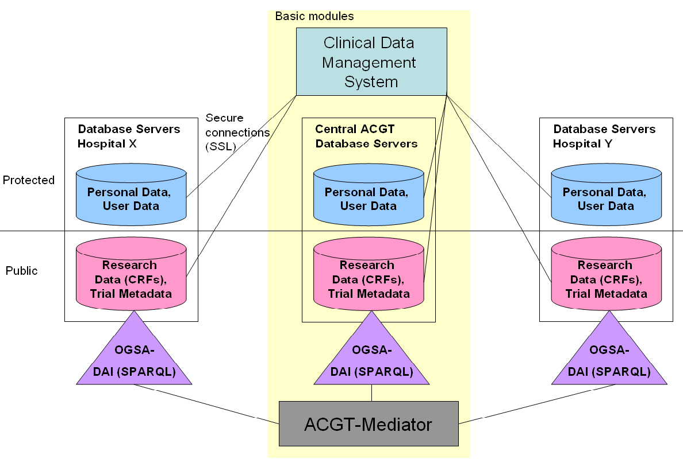
Figure 6 Trial databases

Integration into the ACGT environment using OGSA-DAI services
Parts of the OPDMS will be set up automatically from the output of the Trial Builder in order that the designed trial can be conducted. OGSA-DAI services [see Deliverable 5.2] will be deployed that allow querying the databases in terms of the ontology. As a query language for the services SPARQL [8] is used, an ontology query language that is emerging as the de-facto standard in the Semantic Web. The ACGT mediator will use these OGSA-DAI services to integrate the research data seamlessly with all other data available in the ACGT environment. For this purpose a mapping file containing the ontology mapping is generated automatically that can be accessed from the mediator.
SPARQL [8] is a query language for RDF. RDF is a directed, labelled graph data format intended for representing information on the Web.
Usage and limitations of SPARQL queries with examples for illustration of the basic capabilities of SPARQL, can be shown in [8].
There are various formats in which SPARQL query results can be returned, but for use in Web Services, the SPARQL Query Results XML Format is the most appropriate.

Administration

User administration
The ObTiMA end users are a trial Chairmen, physicians, consultants, researchers, and patients. Before using the ObTiMA software the user has to be registered in the ACGT environment. The credentials for the specific trial of each user will be requested automatically from the ACGT User management module. Because the rights between different trials might be different for a user, he will get different credentials for different trials allowing him to switch between the trials. The credentials give him the access rights for each trial. Within the trial it must be possible for the different users to deal with the data according to their role and rights. (see section “Module: Roles and Rights management”). The personal and contact information for the user will be stored in the database. User information will be accessible only for the trial leader. The chairman of a trial must have the possibility to assign new rights to the user in the trial builder software. The chairman of a trial is the only one and responsible to assign the roles to participants.

Roles and Rights management
Access to ObTiMA is regulated by the roles and rights management of ACGT. Within ObTiMA these general rights for a user of ACGT will be extended in order to provide a secure access of a user to different information items according to his specific rights in the current trial. For each role it has always to be defined for which group of patients these rights are allowed. The following group of patients are defined:
- All patients
- Only patients in the own country
- Only patients in the own hospital
- Only a single patient

Each user can have also detailed rights regarding different CRFs. There is also the possibility to assign super-detailed rights to each item on each CRF to users.

Communication and Consultation Modules
One of the user requirements regarding the functionality of ObTiMA is providing modules, which support communication and consultation issues within a clinico-genomic trial. Communication means communication regarding the research done in a trial, etc. The purpose of the consultation module is support of other kind of communication: regarding a patient enrolled in the trial. It will be a communication between treating physicians or other care givers and can also be a direct communication with a patient enrolled in the trial. For this type of communication an informed consent of the patient will be requested and also the allowance to deal with personal data. Communication and consultation processes will be documented within a trial. The dataset for documenting of the communication and consultation processes and other details see in the section 4.2.1.5.1 in [1]. ObTiMA will provide these modules including the secure access and audit trail of all data entries in one of the last releases of the software. Other services like mailing, remainder and backup will be also implemented in the last release of the ObTiMA that will not be finished during the project duration of ACGT.

Data export
From Release 2 on an extended version of the CDISC ODM format will be supported for data export.

CDISC ODM
Operational Data Model (ODM) from the Clinical Data Interchange Standards Consortium (CDISC) [4] is a vendor neutral, platform independent format for interchange and archive of clinical trials data. The metadata of a clinical trial including a full description of the CRFs of the trial can be stored in the ODM format.
CDISC is an open, non-profit organization that has the mission to develop and support platform-independent data standards that enable information system interoperability to improve medical research. CDISC seeks to achieve its mission through the development of standard data models designed to support the end-to-end data flow of clinical trials.
CDISC has developed a model that specifies a format for interchange and archive of data, the Operational Data Model (ODM) as well as several content models that define standards for datasets for Data submission (SDS), standards for laboratory data (LAB) and standards for analysis datasets (ADaM).
Today sponsors have been implementing individual models (using ODM to export and import data or building their databases on SDS but currently no guidelines exist that describe how to effectively use all of the collective models in combination. So the aims for the future are to harmonise and further improve the models. CDISC wants to achieve final harmonisation of its models until 2010. CDISC cooperates with HL7 and has many sponsors from the pharmaceutical industry. The FDA (US Food and Drug Administration) also supports the standards of CDISC. Therefore the importance of CDISC is permanently increasing. [4].

Export of anonymized data
Another export option which allows the chairman to export data from the Trial in anonymised form will be implemented in the last release of the software. The export will be audited in the audit trail. For the functionality “Data export” the following possibilities are available:
- Export from local to a central database
- Export of pre-defined items during the trial for research and statistics
- Export from a single centre to multi-centre database
The options for the data transfer and the protocol will be defined by the chairman in the Export section. If the chairman selects the button “Export” in the main menu two frames will open. In the first frame “Export details” he can edit the different fields to define the export protocol and content.
The trial chairman has to define:
- Name of Export
- Transfer protocol
- Set of data for export
- Time of time interval of manual/automatic transfer
- Data format

Reporting of SAE and SUSARs
The ObTiMA will use the MedDRA classification system to facilitate automatically generation and transfer of Serious Adverse Events (SAEs) and Suspected Unexpected Serious Adverse Reactions (SUSARs) to regulatory agencies. An adverse event is any undesirable experience associated with the use of a medical product in a patient. The event is SERIOUS and should be reported when the patient outcome is:
- death
- is life-threatening
- requires inpatient hospitalization or prolongation of existing hospitalisation
- results in persistent or significant disability/incapacity
- is a congenial anomaly/birth defect
More details about SAE/SUSARs can be found in [9]
The appropriate criteria for starting this process in a trial will be defined during the trial design.

Use Cases
To capture the functional requirements of the ObTiMA system and to describe interaction between the primary users of the system and the system itself, we have formalized the user requirements in Use Cases. The Use Cases for the first release are described in the following.

Actors and Goals
The following list describes the behaviour of the system on the lowest level of precision and shows the main users of ObTiMA. A detailed description of the functionality of the system can be found in the document “Priority List for ObTiMA”. After each task-level goal the number of the Use Case (UC) described in Appendix 1 “ObTiMA: Use Cases” is given.

Primary Actor | Task-level Goal | Priority
CT Chairman | Create a new facility in the OPDMS (UC 1.1) | 1
CT Chairman | Modify data of a facility (UC 1.2) | 1
CT Chairman | Delete a facility from the OPDMS (UC 1.3) | 1
CT Chairman | Add a new user (UC 1.4) | 1
CT Chairman | Modify data of a user (personal data, roles and rights,..) (UC 1.5) | 1
CT Chairman | Delete a user (UC 1.6) | 1
CT Chairman | Manage a Clinical Trial (UC 4) | 1
CT Chairman | Modify design of a Clinical Trial | 2
(a) CT Chairman  (b) physician | Enrol patient into a Clinical trial (UC 2.1) | 1
(a) CT Chairman  (b) physician | Fill in patient CRF (UC 2.1, UC 2.2) | 1
(a) CT Chairman  (b) physician | Modify data of a patient (UC 2.2) | 1
CT Chairman | Delete a patient (UC 2.3) | 1
CT Chairman | Change status of a CRF (UC 2.1, UC 2.2) | 2
(a) CT Chairman  (b) Reporting module of the OPDMS | Send a Report (UC 2.1, UC 2.2) | 2
CT Chairman | Create a Treatment plan for a patient (UC 2.1, UC 2.2) | ?
CT Chairman | Create a new role for using the ObTiMA (UC 3.1) | 1
CT Chairman | Modify a role for using the ObTiMA (UC 3.2) | 2
CT Chairman | Save a trial or CRF for later reuse (UC 4) | 1
Researcher (person, organisation, tool) | Query a clinical trial database | 1
(a) Consultant  (b) Physician  (c) Patient | Consultation of a clinician or a patient | 3
(a) Physician  (b) Patient | Communication with a clinician | 3
ObTiMA system | Show messages for the user after login | 3
Any user | Change language for the user interface (default – english) | 2 De  3-4 Other
Any user | Get help (online or documentation) for using ObTiMA | 2-3
Any facility with appropriate rights to audit a trial | View Audit trial information | 3
CT Chairman | Manage a repository | 2

Mapping Requirements to Architecture
The following use case diagram shown on the figure 7 depicts the high-level system functional requirements for the ObTiMA application. It shows potential system actors and their actions:
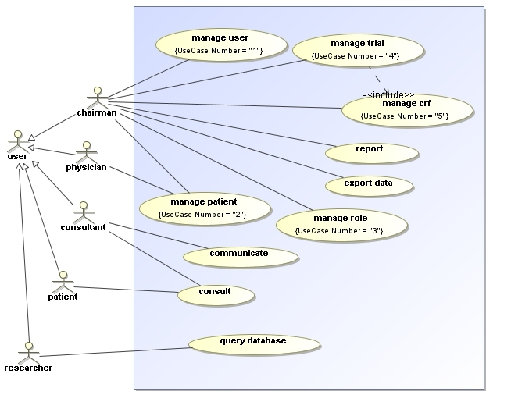
Figure 7 ObTiMA use cases
In the following a very brief description of the use cases for the system is given, detailed Use Cases are given in the Appendix A.

USE CASE BRIEFS
Actor | Goal | Brief
CT Chairman | Involve a new facility in the OPDMS | Chairman creates a profile for a new facility by filling in fields on a shown form with a facility data. The profile will be saved in the protected OPDMS database and will be used for relations to user of the ObTiMA or patients in Clinical Trials.
CT Chairman | Modify data of a facility | Chairman updates a data for a facility on a shown form. The updated profile will be saved in the database.
CT Chairman | Delete a facility from the OPDMS | Chairman deletes a facility from the shown list and writes a reason for this action in a dialog form. The facility will be not deleted In the database - only labelled as “deleted”
CT Chairman | Add a new user | Chairman creates a profile for a new user by filling in fields on a shown form with a user data. The profile will be saved in the protected OPDMS database. This use case is a complex use case, which includes assignation of the user to facilities, definition of the role for the user.
CT Chairman | Modify data of a user | Chairman updates a data for a user (personal data, contact data, role) on a shown form. The updated profile will be saved in the database.
CT Chairman | Delete a user | Chairman deletes a user from the shown list and writes a reason for this action in a dialog form. The user will be not deleted In the database - only labelled as “deleted”
CT Chairman | Set up a new Clinical Trial | Trial chairman can set up the patient management system for the trial.
CT Chairman | Modify design of a Clinical Trial | Trial chairman modifies metadata or CRFs of a trial or deletes a trial.
(a) CT Chairman  (b) physician | Enrol patient into a Clinical trial | A user enrols a new patient into a clinical trial if all inclusions criterion are fulfilled.
(a) CT Chairman  (b) physician | Fill in patient CRF | User fills the assigned to the patient CRFs out and forwards them to the trial chairman for validation.
(a) CT Chairman  (b) physician | Modify data of a patient | User modifies a profile for a patient. The changed profile will be saved.
CT Chairman | Delete a patient | User deletes a profile for a patient from the list of all patients. OPDMS module labels the patient in the database as “deleted”.
CT Chairman | Change status of a CRF | A Trial Chairman validates a completeness and correctness of a CRF and change status of CRF
(a) CT Chairman  (b) Reporting module of the OPDMS | Send a Report | The input data will be checked and a SAE/SUSAR report will be send
CT Chairman | Create a Treatment plan for a patient | According to rules, defined in the Trial metadata, a treatment plan for a patient will be created.
CT Chairman | Create a new role for using the ObTiMA | A chairman defines a new role of a person in a clinical trial and in the ObTiMA system. He assigns to the role a set of rights, which a person is allowed to execute in the system.
CT Chairman | Modify a role for using the ObTiMA | Trial chairman modifies a definition of a role in the system. The changed profile will be saved.
CT Chairman | Save a trial or CRF for later reuse | A trial design and CRF (also part of CRF) will be saved in the repository
Researcher (person, organisation, tool) | Query a clinical trial database | A clinical trial database will be queried by OGSA DAI services of the ACGT by using of the mapping file with semantical descriptions of the data, collected on the items on CRF
(a) Consultant  (b) Physician  (c) Patient | Consultation of a clinician or a patient | A patient or a physician will get a contact channel with another physician, which has a role of a consultant. A system will log the process.
(a) Physician  (b) Patient | Communication with a clinician | A patient will get a contact channel with a physician.
ObTiMA system | Show messages for the user after login | After login into the system, a system will display request for completing or validation of information on CRF or request for enrolment of a patient into the clinical trial.
Any user | Change language for the user interface (default – English) | A user wants to select a preferred language for the system GUI. A system will save this setting for later usage.
Any user | Get help (online or documentation) for using ObTiMA | A user want get help for usage a system. He selects a menu item and the system shows him different possibilities: in-line, guidelines, manual.
Any facility with appropriate rights to audit a trial | View Audit trial information | A user selects a menu item for audit and the system displays him protocols in a structured form, where a information can be ordered by different criteria (user, date, patient, …)
The full specification of the Use Cases is given in the Appendix A “ObTiMA: Use Cases”

Solution Background

Architectural approach of ObTiMA
A common architectural strategy (design pattern), is to layer the architecture of a system into three layers. Therefore, Obtima is designed as a three-layered service application as shown in figure 8. The layers are represented by the rectangles and collaboration between layers by the arrows. The name of a layer is indicated on the top of the rectangle. The three layers are:
- Presentation. The presentation layer provides the application's user interface (UI). This involves the use of Java Server Faces for browser-based interaction.
- Controller and Business/Service. The layer implements the business functionality of the application.
- Data Integration. The data layer provides access to external data storage systems such as databases.
Each layer is structured as described in the following paragraphs.

Presentation Layer (or User interface)
This layer provides user access to the system. The user interface (UI) classes that provide user access to the ObTiMA system is developed using the Java Server Faces (JSFs) Web application framework that simplifies the development of user interfaces for Java EE applications. Unlike other traditional request-driven MVC web frameworks, JSF uses a component based approach. The state of UI components is saved when the client requests a new page and then is restored when the request is returned. JSF uses JavaServer Pages (JSP) for its display technology, but JSF can accommodate other display technologies such as AJAX.
JSF contains all the necessary code for event handling and component organization. Perhaps most important, JSF is part of the Java EE standard. JSF is included in every application server, and it can be easily added to a standalone web container such a Tomcat. [12].
For the development of ObTiMA we use Apache MyFaces [13] implementation, which includes several libraries of JSF components that can be deployed on the core implementation. MyFaces supports several component libraries containing UI widgets for building web-applications with JSF like Tomahawk, Trinidad, and Tobago. In ObTiMA the component library Tomahawk [14] is used. Tomahawk offers an extended version of the standard components, and a number of more advanced additional components.
The presentation layer of the the Trial Outline Builder is implemented on top of a Web-browser-based Meme Media system developed at Hokkaido University. In this system, two-dimensional vector graphics objects combine display and functional behaviour; for the Trial Outline Builder the basic system is augmented with a set of domain-specific graphical components representing medical events.

Controller and Business/Service Layer
For this layer in ObTiMA the application framework Spring [10] is utilized. The Spring Framework is a leading open source Java EE application framework that provides services for all architectural tiers.
Spring uses modern design patterns and technologies (e.g. Inversion of Control, and AOP).
“Inversion of Control” (IoC) design pattern means that individual Java objects do not look for data, but the data is handed to them by the framework. This reduces interdependencies between classes and also reduces their dependence on the framework itself. Informally, inversion of control can be summarized with the so-called Hollywood Principle – “don’t call us, we will call you”. This approach makes Spring-based applications much easier to test, because Java classes can be tested in isolation from the rest of the system (without access to a database, by stubbing or mocking DAOs). [10].
Business/Service Layer represents simple use cases or other business functionality and includes a handling of transactions. Each invocation of a service from this layer means normally one transaction.

Data Integration Layer
The ObTiMA web application must access data that is stored in relational trial databases. Data access components in this layer are responsible for exposing the data stored in these databases to the business layer. Data access components isolate the business layer from the details of the specific data storage solution. This isolation provides the following benefits:
- Minimizes the impact of a change in database provider.
- Minimizes the impact of a change in data representation (for example, a change in database schema).
- Encapsulates all code that manipulates a particular data item in one place. This greatly simplifies testing and maintenance.
This layes in particular the mapping from Java classes to database tables (and from Java data types to SQL data types) is implemented in ObTiMA by using Hibernate. [11]. Hibernate is an object-relational mapping (ORM) library for the Java language, providing a framework for mapping an object-oriented domain model to a traditional relational database. Hibernate solves Object-Relational impedance mismatch problems by replacing direct persistence-related database accesses with high-level object handling functions. Hibernate also provides data query and retrieval facilities. Hibernate generates the SQL calls and relieves the developer from manual result set handling and object conversion, keeping the application portable to all SQL databases, with database portability delivered at very little performance overhead. Hibernate is free as open source software that is distributed under the GNU Lesser General Public License.
In terms of object persistence, it's the DAO interfaces layer that drives data access, implementing queries and other persistence operations. For database access the Spring's DAO layer will be used in conjunction with the ORM tool Hibernate, which is provided by Spring as a built-in support, allowing developers to use a consistent approach to domain objects and exception handling.

Foundation Services
In addition to the three standard layers, Three-Layered Services Application defines a set of foundation services that all layers can use. In ObTiMA we use Security services for maintaining application security. In the section below it is shown how the security services will be realised in the next releases of the software and choosed teqniques for the implementation is described.

Acegi and AOP
For the implementation of the security services in ObTiMA we use Acegi security framework. Acegi Security is an open source project that provides comprehensive authentication and authorisation services for enterprise applications based on the Spring Framework. Acegi Security can authenticate using a variety of pluggable providers, and can authorise both web requests and method invocations. Acegi Security provides an integrated security approach across these various targets, and also offers access control list (ACL) capabilities to enable individual domain object instances to be secured. At an implementation level, Acegi Security is managed through Spring's inversion of control and lifecycle services, and actually enforces security using interception through servlet Filters and Java AOP frameworks. In terms of AOP framework support, Acegi Security currently supports AOP Alliance (which is what the Spring IoC container uses internally) and AspectJ, although additional frameworks can be easily supported.
Since Spring's goal is to be an entire Application Framework, Spring provides a comprehensive framework to integrate AOP. The Spring AOP module integrates aspect-oriented programming functionality directly into the Spring framework, through its configuration management feature. As a result we can easily AOP-enable any object managed by the Spring framework. The Spring AOP module provides transaction management services for objects in any Spring-based application. The Spring AOP module also introduces metadata programming to Spring. Using this we can add annotation to the source code that instructs Spring on where and how to apply aspects.
On the picture below the layered structure of the participating tiers of the software using Spring framework is depicted:
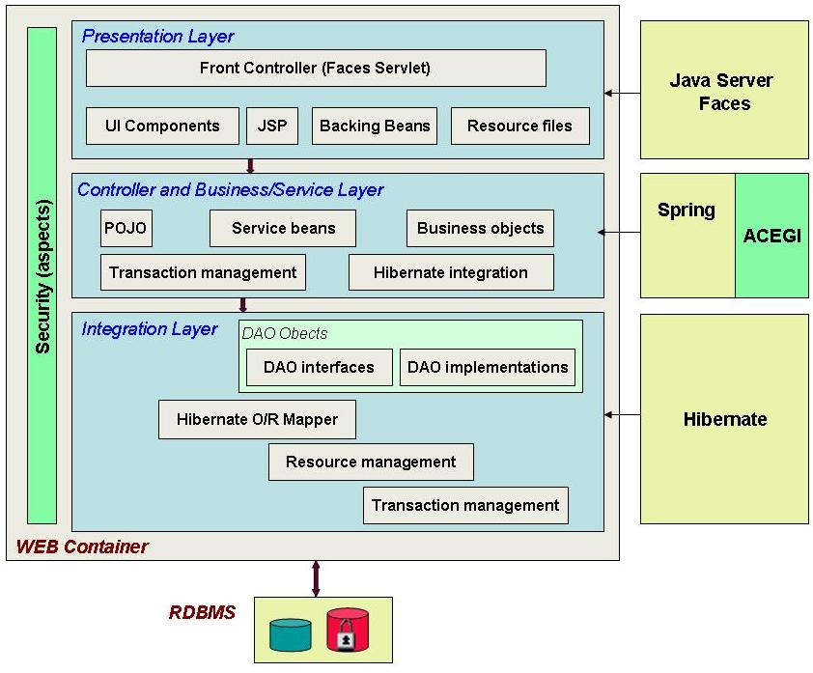
Figure 8 ObTiMA: layered architecture

Views
The views that will be described in this document are:
- Module Views: describe the structure as a set of code units.
- Runtime Views: describe the structure as a set of elements that have runtime presence
- Deployment Views: describe the artifacts organized in the file system and how the system is deployed to hardware.
- Data Model View: describe the structure of the data repository

Module Views
In the following the structure of the system in terms of units of implementation will be shown.
Module view consists of the packages with classes of the developed application, as well as configuration files used from the Spring framework and other resources used in the software.

High Level Module View
Apart from libraries and other resources of the Spring framework as well as resources for the Java Server Faces and Hibernate, ObTiMA web application consists of following two parts:

- Java sources, organized in packages with the package names started by “de.fhg.ibmt.obtima”. Furthermore the developed classes are organized in packages for actions, daos, services, data models, crf repository client, utilities and testing whereas the packages for daos and services consist of two parts: for interfaces and for implementations. Data model classes are annotated according to the EJB3 persistence specification
- Web content including java server faces, images, styles as well as the configuration files for Hibernate and Spring framework.

On the picture below the module view on the package level is shown.
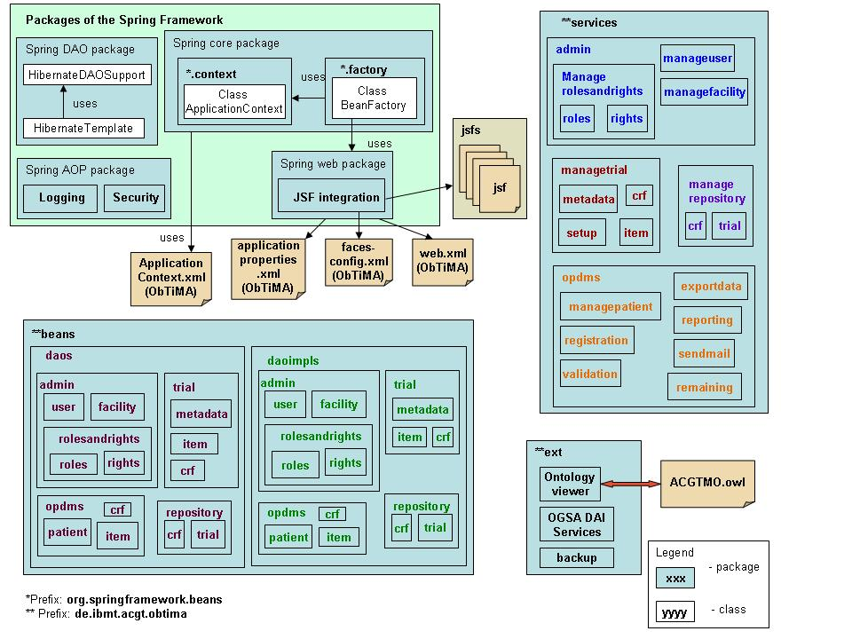

Figure 9 High level module view

Runtime Views
The next picture shows the structure of the system when it’s executed. It explains how software components interact at runtime, what components are replicated, what components access data stores. We have created a template, which can be used for different workflows in the ObTiMA web application.

Template for the runtime views
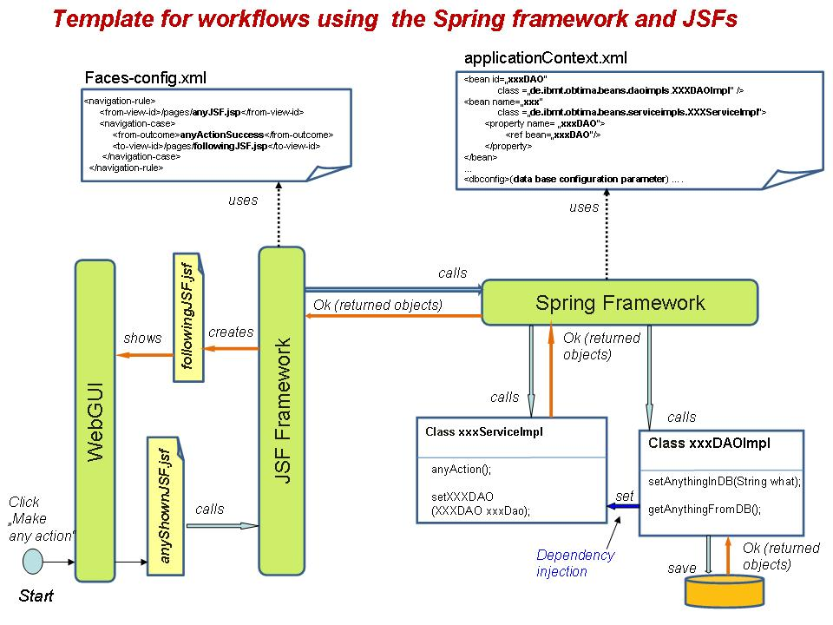
Figure 10 Template for workflows in the runtime views
Below we will show runtime views for some important example processes within the software, in particular for creation of a new trial. Other use cases will be executed in similar workflows.
Since the runtime view for the Use Case 4.1 “Create Trial” consist of the actions for creation of CRFs, master protocol as well as treatment plan for a trial, we present each action in a separate section.

Examples for the runtime views
On the picture below is shown how a CRF will be created and saved in the database (Use case 4.11).

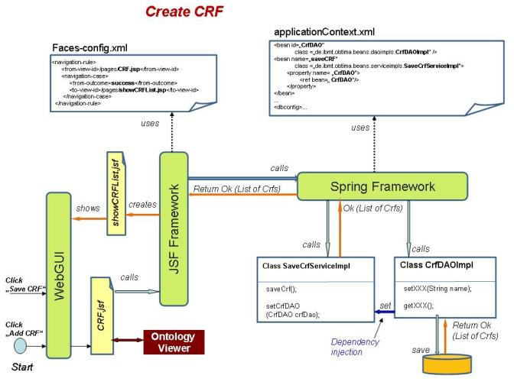
Figure 11 Example: create crf
On the next picture is shown a Use case (informal notation), where the trial protocol (metadata of the trial) will be captured and saved in the database.

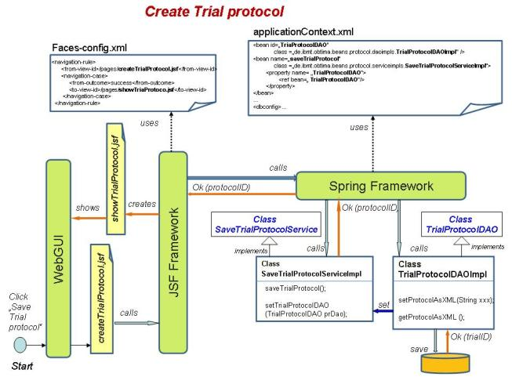
Figure 12 Example: create trial protocol

On the picture below is shown a Use Case where the treatment plan will be created and saved in the database.

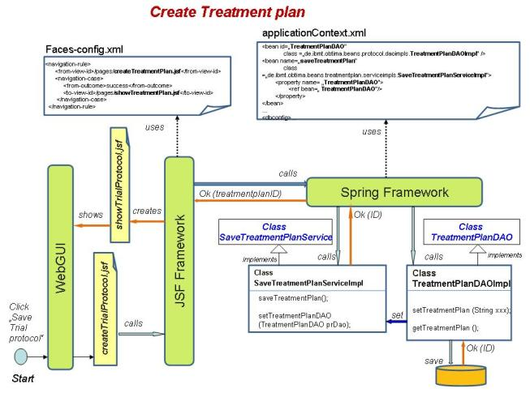
Figure 13 Example: create treatment plan

Data Model View

ObTiMA Data Model View
The data model in the database is generated by the Spring framework using an annotated data model classes in the package de.fhg.ibmt.obtima.dbmodel. On the picture below the entity-relationship diagram of the data model is shown.
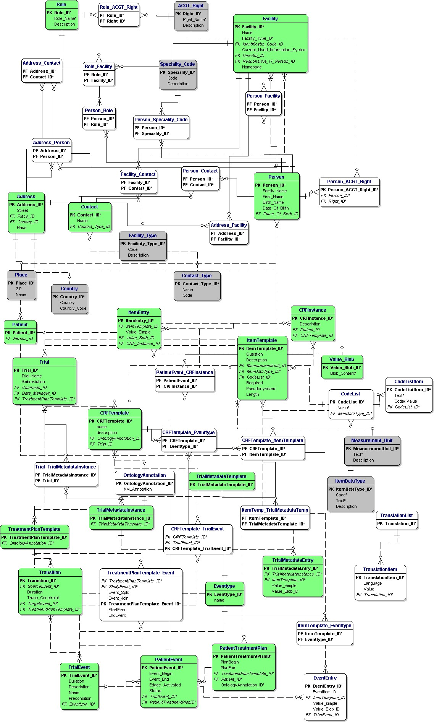
Figure 14 Entity-relationship model for the data model of ObTiMA

Dependencies between some tables on the ER-Diagram
Dependencies between some tables on the ER-Diagram are presented in a simplified form on the next diagrams:
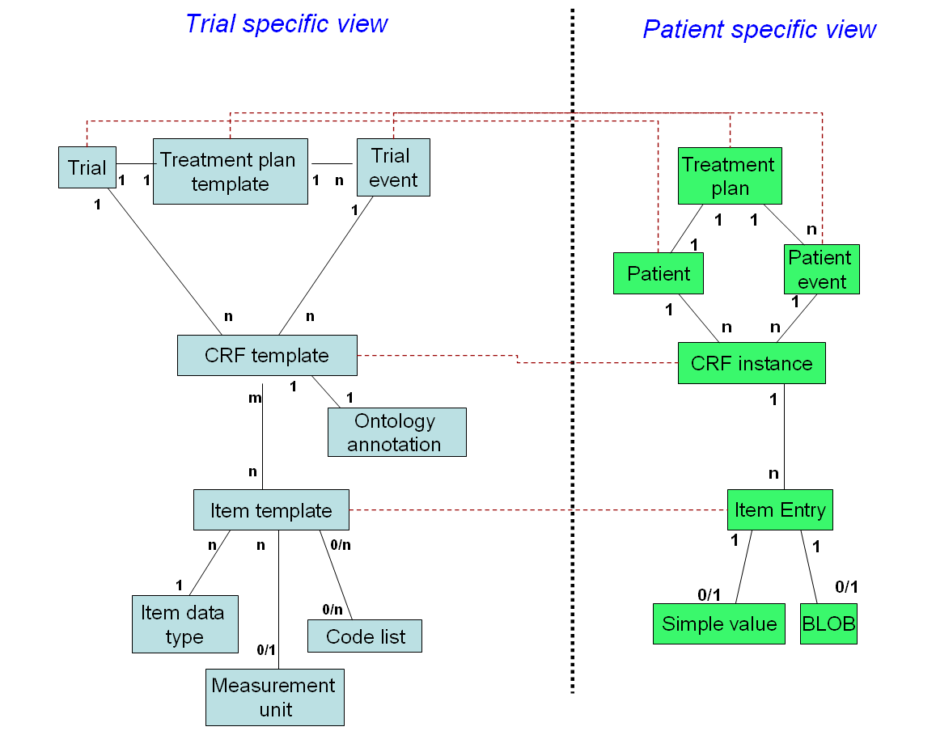

Figure 15 Relations between tables for the trial specific view and the patient specific view

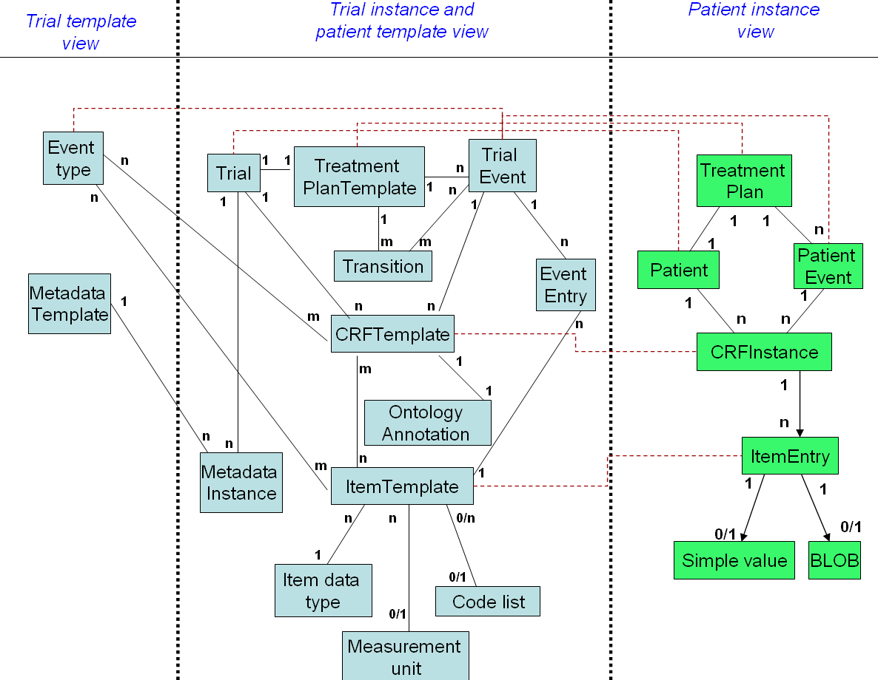

Figure 16 Relations: from template view to instance view

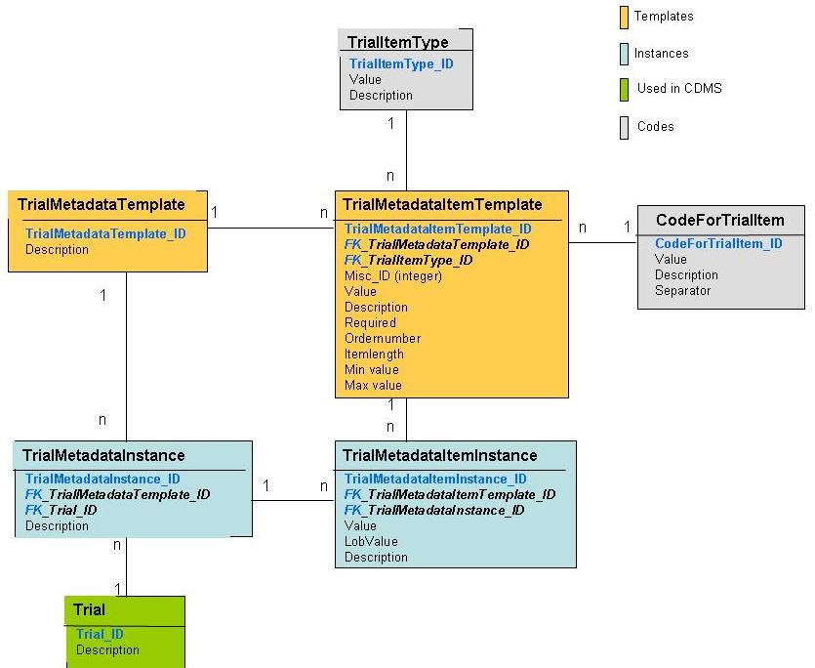
Figure 17 ObTiMA: Representation of the trial in the database

Deployment Views
Deployment Views show at least two distinct but related structures:
- Hardware infrastructure of the production environment
- Structure of directories and files of deployed system
Elements of Deployment Views are processing and communication nodes (e.g., server machine, router) as well as files, directories
Relations of Deployment Views are:
- Interaction mechanisms between two elements (usually: communication channels)
- Containment: a directory/file contains other directories and files

Network Diagram
In this section the structure of the networking components for ObTiMA will be shown.
The main component of ObTiMA, the web application, as well as OGSA DAI web services are installed on the computer, hosted by IBMT, with the IP address 153.96.139.73.
The Trial and CRF repository, the ACGT user roles and rights services as well as ACGT Master Ontology can be installed on different hosts within the ACGT grid environment.
The hosting of Trial databases is shown on the picture 6.
There are two types of usage and accessing the functionalities of ObTiMA shown on the figure 18:
- communication with ObTiMA web application via web browser
- Querying the trial databases via ACGT mediator services using OGSA-DAI services, deployed on the ObTiMA system.
On the figure below all these components are depicted.
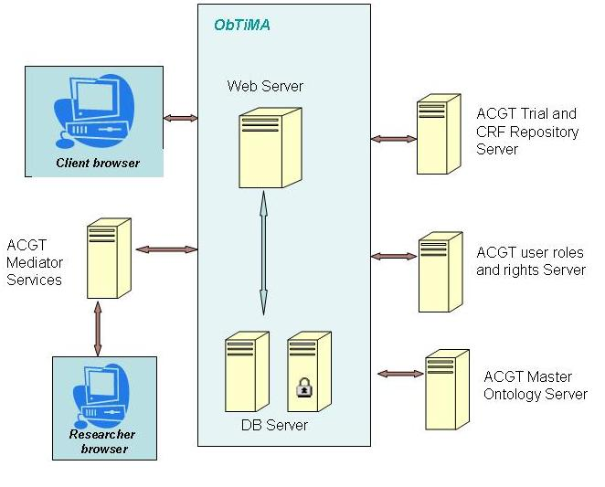
Figure 18 Network diagram of ObTiMA

Java EE Deployment Files
In this section all configuration and deployment resources are described and depicted on the figure 19.
The ObTiMA web application will be deployed as a web archive file inside of the Tomcat web server. On the same host will be installed OGSA-DAI services for accessing the trial databases using the ACGT mediator services.
The mapping file for the ACGT mediator, provided also by IBMT, will be deployed on the mediator side.
ObTiMA will use the owl file, representing the ACGT Master Ontology, which is deployed on a host within the ACGT grid environment. 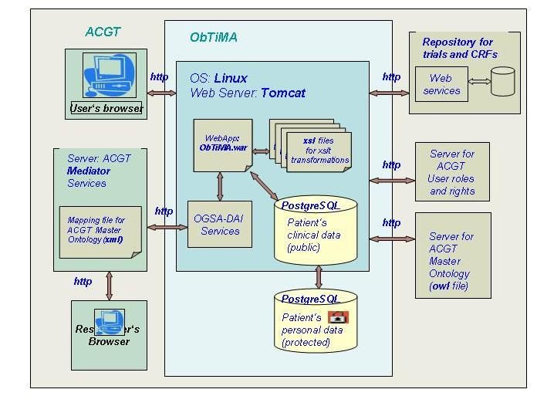
Figure 19 Deployment view of the components

Initial Realization of ObTiMA
A first prototype of ObTiMA is available and can be accessed in the internet. Main components to use ObTiMA in practice are still missing like e.g. a roles and rights management and security features. The prototype focuses on demonstrating the process of ontology based CRF creation. Therefore we will describe how this process can be achieved with the prototype in the following in more detail.
The procedure conducted in the Trial Builder implements the semantics of the ontology in the CRFs in an automatic fashion. The “ontology description” for one item on a CRF is a path from the ontology starting at the class Patient, as this is normally the focal point of CRFs. Starting from the class Patient, for example, the clinician grasps the relevant ACGT-MO classes and relations that connect with Patient, e.g. that the patient can have diseases, a blood pressure, a birth date, etc. In figure 1 the ontology view of the Trial Builder that allows creating an item from the ontology is shown. The currently selected ontology path is depicted on the top that consists at the beginning only of the class Patient. Below that the classes and relations that connect with patient are shown. Here the clinician has the opportunity to either select one of the classes in order to create a question on the CRF, or to explore them further and show their subclasses (by pressing the button “Subclasses” behind the selected class) or relations (button “”Relations”) and assemble more complex questions. Since we do not want to restrict the questions on the CRFs by the structure of the ontology, different possibilities to create questions from the ontology classes are implemented in the Trial Builder.
In the current prototype the user is able to create three types of items with respect to the ontology description:
- “Value-items” are items that query “values” of attributes from the ontology. Examples are birthdate, gender or weight of the patient’s tumor.
- “Exist-items” are items that query if an instance for the selected class exists for the patient. E.g. if the patient has an infectious disease or if the patient has a tumor.
- “Count-Items” are items that query how many instances for a selected class exist for the patient. For example the question how many siblings the patient has.

In the following we will describe how these items can be created with the prototype. For each of this item types a button appears in the user interface behind the classes.
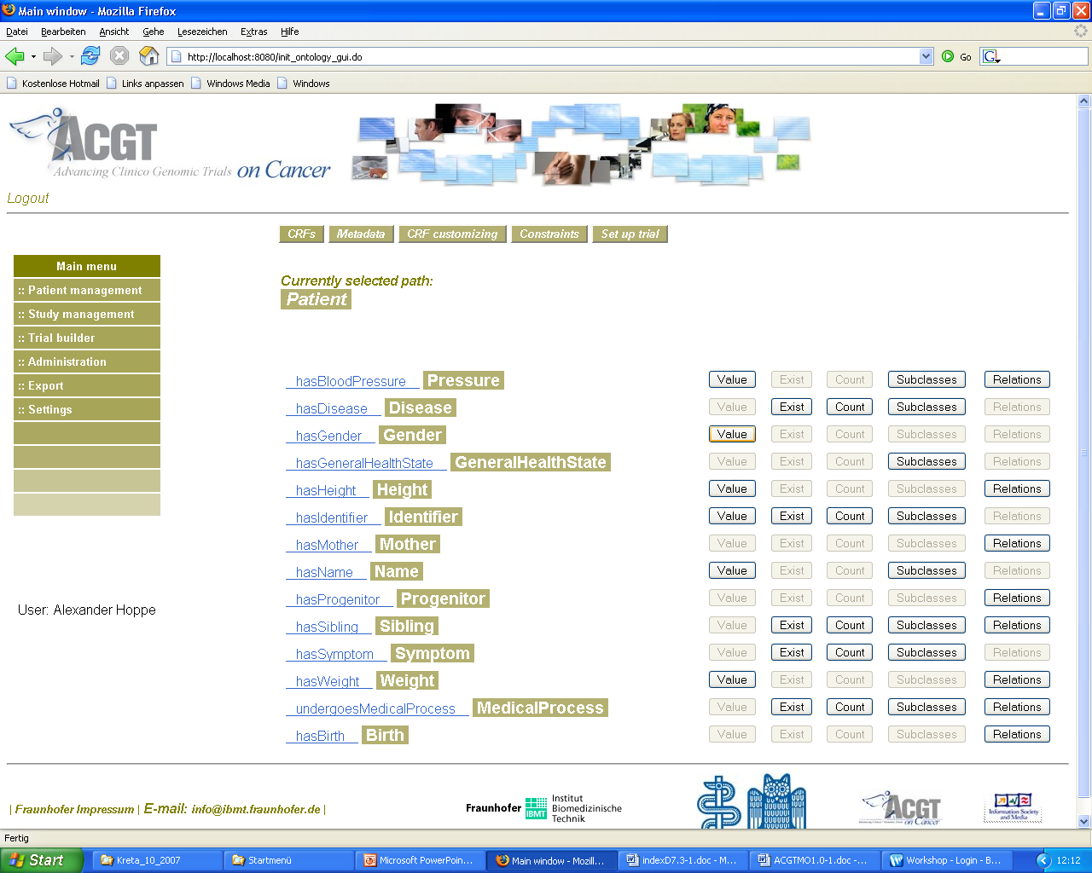
Figure 20 Trial Builder View to create an item from the ontology

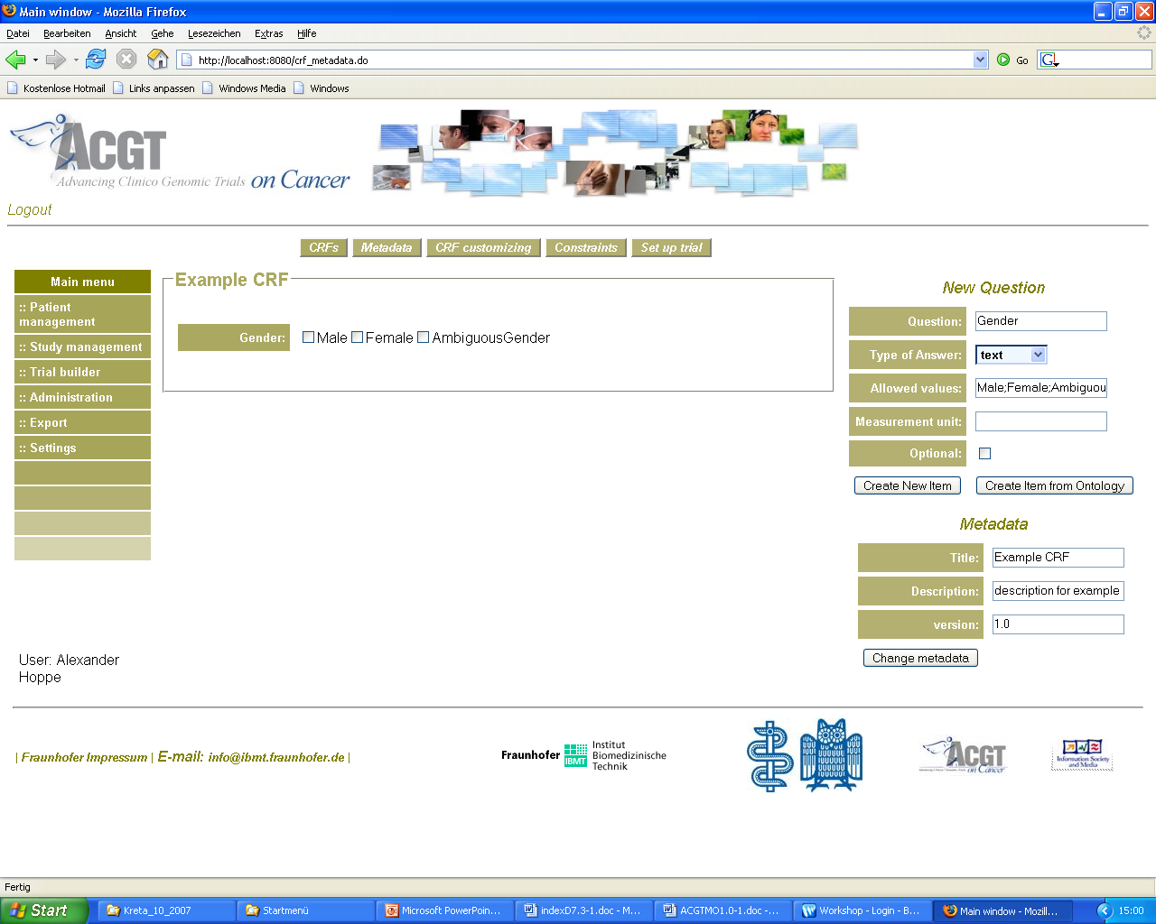

Figure 21 Trial Builder View after creating a value-item from the class gender

An example for a “Value-item” is patient’s gender. The clinical trial chairman can see that there is a relation between the classes “Patient” and “Gender.” In order to create the corresponding question, the clinician chooses the class Gender by pressing the button “Value” behind this class. The attributes required in order to create the possible answers on the CRF can be determined automatically. On the CRF the label of the question appears as the name of the class (Gender). The allowed values are set automatically to Male, Female, and AmbiguousGender since the class Gender is defined as an enumeration in the ontology containing these values. A multiple choice question has hence been automatically created on the CRF (s. figure 2). The attributes that are automatically determined from the chosen ontology path can be changed in each case manually by the clinical trial chairman. When the clinical trial chairman e.g. prefers to have the label “ambiguous gender” instead of “AmbiguousGender” he can change that.

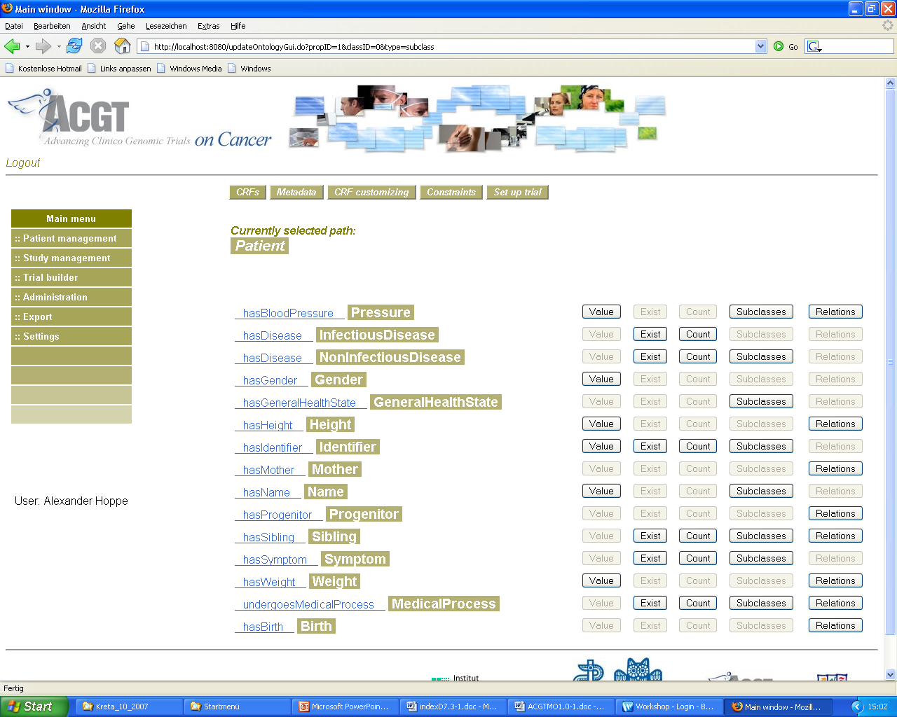
Figure 22 Trial Builder View after pressing the button “Subclasses” behind the class Disease

To create an “exist-item” that queries if the patient has an infectious disease the clinician has to press the button “Subclasses” behind the Class “Disease”. This effects that the subclasses “InfectiousDisease” and “NonInfectiousDisease” are shown in the following view (s. figure 3). The clinician can create the question by pressing the button “Exist” behind the class “InfectiousDisease”. The item is automatically created. The label of the item is assembled from “Has” and the name of the class. This is only a suggestion that is not correct in each case and can be changed by the clinician. The allowed values are automatically set to “yes” and “no” (s. figure 4).

For creating the “count-Item” “Count of siblings” the clinician has to press the button “Count” behind the class Sibling. On the CRF the item is automatically created. The suggestion for the label is assembled of “How many” and the class name plus an “s”. The data type is set to “number” (s. figure 5).

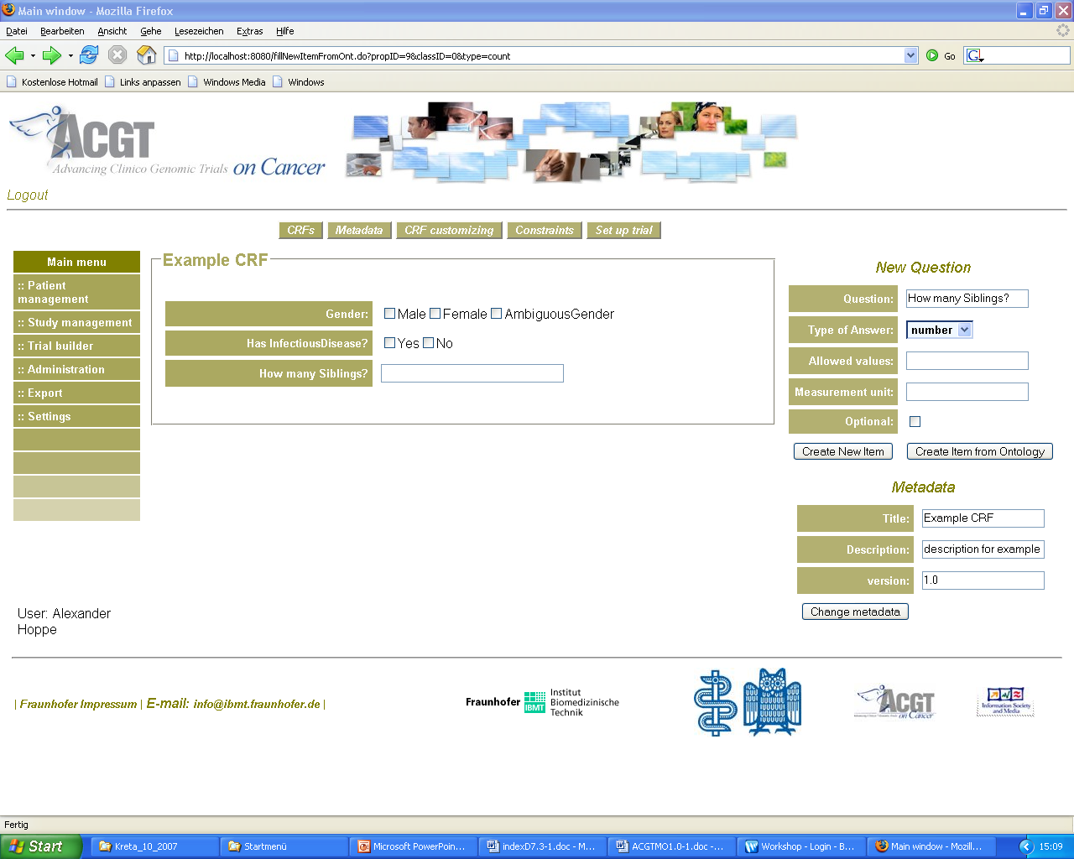

Figure 23 Example CRF created with the Trial Builder from the ontology

The attributes for setting up the appropriate database for storing the data are determined automatically from the selected ontology paths and the changes the trial chairman applies to them, e.g. the question itself, data type of the answer and optionally possible data values, range constraints and measurement units.
The complete ontology annotation is stored in one XML –file for each CRF in the databases for the patient management system. From these files the mapping data for the mediator can be created automatically depending on what information the mediator can “digest” in order to keep the queries feasible.
The ObTiMA web application is accessible under http://obtima.ibmt.fraunhofer.de
Please note, that at the moment only a very limited version is available that will be permanently updated.
Access data can be requested from the editors of the document.

Conclusion
We conclude this deliverable by summarising what has been achieved and by discussing remaining open issues.

Achievements
The described ontology based trial management system leads to direct integration of the data collected in the clinical trial at hand into the semantics of the ontology. Using the ontology will not be time consuming for the clinician, and it will be a useful tool aiding his work in clinical trial management. Through the integration of the ACGT-MO into ObTiMA, data sharing between clinical trials becomes possible in an easy way. This is necessary to leverage the collected data for further research like cross-trial analysis.
In the first release of ObTiMA the following main functions will be implemented:
- Defining the metadata in the master protocol of a trial, saving and modifying it.
- Designing all CRFs for the trial including specification of the items on CRFs with possible values, constraints, and range checks as well as specification of the layout for the CRFs. Items on CRFs can be created by utilizing the ACGT MO.
- Data Access services are deployed that allow querying the databases in terms of the ontology by using the mapping file for the ACGT mediator, which is provided.
- The project partners from Hokkaido University develop the Treatment plan for the trial, which will be integrated into ObTiMA.
- The CRF repository is developed and integrated into ObTiMA system.
- For the Ontology based Patient Data Management System the enrolment of the patients into the trial will be developed as well as the CRF management, which includes adding of CRF to patient, filling in and editing of CRFs.
- The treatment plan of the individual patient is also implemented by Hokkaido University and will be integrated into the Ontology based Patient Data Management System.

Open issues
Since ObTiMA is a very complex project the resources of ACGT will allow only to implement the basic functionalities of the system. In the following we will list current limitations that are subject of further work.

Limitations of the integration of the ACGT MO
The described prototype for the ontology based CRF creation has still some drawbacks and limitations regarding the integration of the ACGT master ontology. Currently it is not possible to create all kind of items for a CRF. Items from more complex descriptions of ontology classes can not be created.
- It can not be indicated that two items refer to the same instance. E.g. when creating an item that queries the length of a tumor and one that queries the weight of a tumor it can not be indicated if the tumor in both items is the same or the items refer to different tumors.
- Between two instances in different items no relations can be applied. E.g. when one creates an item that queries the radiation dose for a patient and one that queries the weight of the tumor it is not possible to indicate that the radiation of the one item is applied to the tumor from the other item.
- At the moment in each step only one item can be created. It would be very useful, if more than one item could be create in one step. E.g. when selecting the class tumor it could be possible to create items for each of the attributes of this tumor.
- The usability of the graphical user interfaces has to be improved in order that they are more understandable by clinicians.
We are currently redesigning the user interfaces addressing these aspects.

Limited functionality

Furthermore the described prototype currently lacks the following basic functionalities:
- functions for the administration including the management of users (and facilities), management of their roles and rights.
- secure access of a ObTiMA user to different sources within a clinical trial according to his roles and rights an the trial
- communication and consultation modules
- reporting of SAE/SUSARs
- usage of the general rights for user given in the ACGT platform
- registration of a clinical trial
- access to the public dictonaries and vocabularies (MedDRA, LOINC..)
- data export module
- usage of the ACGT Metadata Repository

A priority list has been created to indicate the priority of the individual functionalities and to assign them release numbers. According to necessary changes and extensions the priority list will be updated after each release in an iterative process.
In the table below four priority levels correspond to four releases of the software are shown.
Priority levels: 4 (1 – very important, 5 – nice to have) corresponding to 4 versions/ 5 means it is not clear if it can be implemented within the duration of the ACGT project
Release number (equal priority level) | Deadline | Description
1 - Alpha version | 01.02.2008 | Containing the absolutely necessary features for the first prototype; some security features that are necessary to use the system in practice will be missing
2 – Basic version (1.0) | 01.08.2008 | Containing the necessary features to use the system in practice – limited documentation and help functions
3 - Extended version (2.0) | 01.02.2009
4 – Extended version (3.0) | 01.08.2009

References
[1] Prof. Norbert Graf (Editor), Deliverable 2.2: “User requirements for an ontology based clinical data management system and for the Trial Builder”, 15 September 2007
[2] Bass, L.; Clements, P.; and Kazman, R. Software Architecture in Practice, 2nd Edition. Addison-Wesley, 2003
[3] “Designing Enterprise Applications with J2EE” http://java.sun.com/blueprints/guidelines/designing_enterprise_applications_2e/
[4] CDISC: http://www.cdisc.org/
[5] MedDRA: http://en.wikipedia.org/wiki/Meddra and http://www.meddramsso.com/MSSOWeb/index.htm
[6] LOINC: http://en.wikipedia.org/wiki/LOINC and http://www.regenstrief.org/medinformatics/loinc/
[7] OGSA-DAI Web Services: http://www.ogsadai.org.uk/ and http://www.omii.ac.uk/
[8] SPARQL: http://www.w3.org/TR/rdf-sparql-query/
[9] SAE/SUSAR: http://www.fda.gov/medwatch/report/DESK/advevnt.htm
[10] SPRING: http://www.springframework.org/
[11] Hibernate: http://www.hibernate.org/
[12] JSF: http://java.sun.com/javaee/javaserverfaces/
[13] MyFaces: http://myfaces.apache.org/
[14] Tomahawk: http://myfaces.apache.org/tomahawk/index.html

Note please that all URLs given above were valid on 15 Februar 2008

Glossary and acronyms

Term | Definition
OPDMS | Ontology based Patient Data Management System
ObTiMA | Ontology based Trial Management system for ACGT
ACGT | Advanced …
UC | Use Case
CDISC ODM | Clinical Data Interchange Standards Consortium’s Operational Data Model
ACGT MO | ACGT Master ontology
RDE | Remoute Data Entry
SAE/SUSAR | Serious Adverse Event / Suspected Unexpected Serious Adverse Reaction
MedDRA | Medical Dictionary for Regulatory Activities
LOINC | Logical Observation Identifiers Names and Codes
CRF | Case Report Form
CC | CRF Creator
CV | Clinical View
OGSA DAI | Open Grid Services Architecture Database Access and Integration
EC/IRB | Ethic Committee/International Regulatory Bodies
DSMC | Data Safety monitoring committee
XML | Extensible Markup Language
SPARQL | SPARQL Protocol and RDF Query Language
DICOM | Digital Imaging and Communications in Medicine
SDS | Standards for Data submission
LAB | Standards for laboratory data
ADaM | Standards for Analysis datasets
FDA | US Food and Drug Administration
CT | Clinical Trial
UC | Use Case
UI | User Interface
MVC | Modell View Controller
Java EE | Java platform, Enterprise Edition
DAO | Data Access Object
ORM | Object-Relational Mapping
JSF | Java Server Faces
IoC | Inversion of Control
RDF | Resource Description Framework
AOP | Aspect-Oriented Programming
AOSD | Aspect-Oriented Software Development
CRUD | Create, Read, Update and Delete
ICH | International Conference on Harmonisation of Technical Requirements for Registration of Pharmaceuticals for Human Use
EJB3 | The Enterprise Java Beans 3.0 specification
JSP | JavaServer Pages

- ObTiMA Use Cases
  - High-level System Use cases
The following use case diagram depicts the high-level system functional requirements for the ObTiMA application. It shows potential system actors and their actions:
Figure 24 High level system use cases

Each action on this picture is a use case, which has a Summary-level goal – it means that the goal involves multiple user goals on different levels.
Main use cases are included into the table below:
Nr | High level | Use case | Number
1 | Manage user | Create a new facility | 1.1
1 | Manage user | Modify a facility | 1.2
1 | Manage user | Delete a facility | 1.3
1 | Manage user | Add a new user | 1.4
1 | Manage user | Modify a user | 1.5
1 | Manage user | Delete a user | 1.6
2 | Manage patient | Create a new patient | 2.1
2 | Manage patient | Modify a patient data | 2.2
2 | Manage patient | Delete a patient | 2.3
3 | Manage roles and rights | Create a new role | 3.1
3 | Manage roles and rights | Modify a role | 3.2
3 | Manage roles and rights | Delete a role | 3.3
3 | Manage roles and rights | Create a new right | 3.4
3 | Manage roles and rights | Modify a right | 3.5
3 | Manage roles and rights | Delete a right | 3.6
4 | Manage trial | Create Trial | 4.1
4 | Manage trial | Manage Trial | 4.2
4 | Manage trial | Delete Trial | 4.3
4 | Manage trial | Search for Trial | 4.4
4 | Manage trial | Manage Trial Metadata | 4.5
4 | Manage trial | Manage Treatment template | 4.6
4 | Manage trial | Manage Trial CRFs | 4.7
4 | Manage trial | Costumize trial | 4.8
4 | Manage trial | Validate Trial | 4.9
4 | Manage trial | Set up trial | 4.10
4 | Manage trial | Create CRF | 4.11
4 | Manage trial | Create CRF from repository template | 4.12
4 | Manage trial | Manage CRF | 4.13
4 | Manage trial | Delete CRF | 4.14
4 | Manage trial | Manage Metadata for CRF | 4.15
4 | Manage trial | Create ItemGroup | 4.16
4 | Manage trial | Delete ItemGroup | 4.17
4 | Manage trial | Manage ItemGroup | 4.18
4 | Manage trial | Create Item | 4.19
4 | Manage trial | Delete Item | 4.20
4 | Manage trial | Manage Item | 4.21
4 | Manage trial | Manage Metadata for Item | 4.22
4 | Manage trial | Add constraints to item | 4.23
4 | Manage trial | Create item from ontology | 4.24
4 | Manage trial | Manage ontology path for item | 4.25
5 | Manage a repository | ToDo by Thomas Bessler

  - Use case 1 “Manage user”
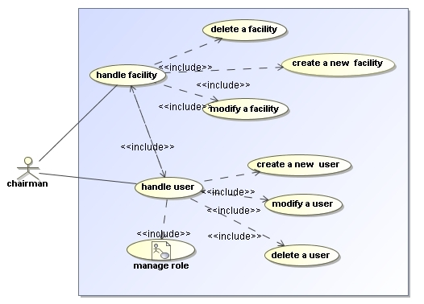
Figure 25 Use case for management of users

Use Case 1.1: | Create a new facility
Primary Actor: | Trial chairman
Summary: | Trial chairman creates a profile for a new facility by filling in fields on a shown form. The profile will be saved.
Scope: | User administration module of the ObTiMA
Stakeholders and interests: | 1. Trial chairman - wants to add a new facility into a list of all facilities in the OPDMS.  2. OPDMS expects a necessary information about the facility
Preconditions: | Trial chairman needs to be logged into the system and to have the appropriate rights.
Success guarantee: | Remote web site accepts data and creates a profile for the facility
Trigger: | Trial Chairman receives a request to involve a new facility
Main success scenario: | - Trial Chairman selects an action to create a facility on the GUI  - OPDMS module displays a web site with a registration form  - Trial Chairman fills in the form and sends the form to save it  - OPDMS module creates a profile for the new facility and displays it
Extensions: | 1.1.3a Trial Chairman aborts process  1.1.3a.1 OPDMS module displays a registration form with empty fields  1.1.4a. A completeness failure: not all required field are filled in  1.1.4a1 OPDMS module shows the user a list of the fields that are to be filled ( continue UC 1.1.3)  1.1.4b A correctness failure: not all ranges of the fields are successfully validated  1.1.4b1 OPDMS module shows the user a list of the failures (continue UC 1.1.3)  1.1.4c. OPDMS module shows a message, that a facility with the similar data is already registered in the system  1.1.4c 1 Trial Chairman continues the creation action (UC 1.1.4)  1.1.4c 2 Trial Chairman aborts the action (UC 1.1.3 a)

Use Case 1.2: | Modify a facility
Primary Actor: | Trial chairman
Summary: | Trial chairman modifies a profile for a facility on a shown form. The changed profile will be saved.
Scope: | User administration module of ObTiMA
Stakeholders and interests: | 1. Trial chairman - wants to change data of a facility in the OPDMS.  2. OPDMS expects required information for the facility
Preconditions: | Trial chairman needs to be logged into the system and to have the appropriate rights.
Success guarantee: | Remote web site accepts changed data and saves a facility profile
Trigger: | Trial Chairman receives a information about a changed data of a facility
Main success scenario: | 1.2.1 Trial Chairman selects an action to modify a facility on the GUI  1.2.2 OPDMS module displays a form with a current facility data  1.2.3 Trial Chairman changes a data on the form sends the form to save it  1.2.4 OPDMS module changes a profile for the facility and displays it
Extensions: | 1.2.3a Trial Chairman manages users, which are assigned to a facility (UC 1.4, UC 1.5, UC 1.6)  1.2.3b Trial Chairman aborts a process  1.2.3b 1 OPDMS module displays a form with the old facility data  1.2.3c Trial Chairman deletes a facility (UC 1.3)  1.2.4a. A completeness failure: not all required field are filled in (UC 1.1.4a)  1.2.4b A correctness failure: not all ranges of the fields are successfully validated (UC 1.1.4b)

Use Case 1.3: | Delete a facility
Primary Actor: | Trial chairman
Summary: | Trial chairman deletes a profile for a facility from the list of all facilities. OPDMS module labels the facility in the database as “deleted”.
Scope: | User administration module of ObTiMA
Stakeholders and interests: | Trial chairman - deletes a facility from the OPDMS.
Preconditions: | Trial chairman needs to be logged into the system and to have the appropriate rights.
Success guarantee: | Remote web site accepts the deleting action
Trigger: | Trial Chairman opts to delete a facility
Main success scenario: | 1.3.1 Trial Chairman selects an action to delete a facility on the GUI  1.3.2 OPDMS module displays a confirmation dialog  1.3.3 Trial Chairman writes a reason for deleting and confirms the action  1.3.4 OPDMS module labels the facility in the database as “deleted”  1.3.4 OPDMS module displays an actualised list of facilities
Extensions: | 1.3.2a OPDMS detected user or patients related to a facility and displays a list of these persons  1.3.2a 1 Trial Chairman manages all displayed persons (UC 1.5, UC 1.6 and UC 2.2, UC 2.3) and continues with UC 1.3.3  1.3.2a 2 Trial Chairman aborts a process  1.3.2a 2.1 OPDMS module displays an unchanged list of facilities  1.3.4a OPDMS module displays a failure of a completeness of the agreement dialog  1.3.4a 1 Trial Chairman completes the agreement dialog (action continues with the UC 1.3.4)  1.3.4a 2 Trial Chairman aborts a process  1.3.4a 2.1 OPDMS module displays an unchanged list of facilities

Use Case 1.4: | Add a new user
Primary Actor: | Trial chairman
Summary: | Trial chairman creates a profile for a new user by filling a shown form. The user profile will be saved.
Scope: | User administration module of the ObTiMA
Stakeholders and interests: | 1. Trial chairman - wants to add a new user into a list of all users of the OPDMS.  2. OPDMS expects a necessary information about the user
Preconditions: | Trial chairman needs to be logged into the system and to have the appropriate rights.
Success guarantee: | Remote web site accepts data and creates a profile for the user in the system
Trigger: | Trial Chairman receives a request to involve a new user
Main success scenario: | 1.4.1 Trial chairman selects an action to create a user on the GUI  1.4.2 OPDMS module displays a web site with a registration form  1.4.3 Trial chairman fills in personal data of the user  1.4.4 Trial chairman assigns a new user to facilities  1.4.5 Trial chairman assigns roles to a new user  1.4.6 Trial chairman assigns patients to a new user  1.4.7 Trial chairman saves the created profile  1.4.8 OPDMS module creates a profile for the new facility and displays the new user in the list of all users in a Clinical Trial
Extensions: | 1.4.3a User aborts a process (similar scenarios for UC 1.4.4, UC 1.4.5, UC 1.4.6)  1.4.3b. A completeness failure: not all required fields are filled in  1.1.4b 1 OPDMS module shows the user a list of the fields that are to be filled (UC 1.4.3)  1.4.3c A correctness failure: not all ranges of the fields are successfully validated  1.4.3c 1. OPDMS module shows the user a list of the failures (UC 1.4.3)  1.4.4a OPDMS module displays a message, that a facility for the user is not known  1.4.4 a 1 Trial chairman creates a new facility (UC 1.1)  1.4.4b OPDMS displays an agreement dialog with a message, that a user with similar data is already assigned to a facility  1.4.4b 1 Trial chairman aborts a process (UC 1.4.3a)  1.4.4b 2 Trial chairman checks the redundancy and agrees the dialog and continue the creation (UC 1.4.5)  1.4.5a Existing roles are not suited for the user  1.4.5a 1 Trial chairman creates a new role (UC 3.1)  1.4.5a 2 Trial chairman modifies an existing role (UC 3.2)  1.4.8a. OPDMS module displays a message about a completeness or a correctness failure (continue with the UC 1.4.3)

Use Case 1.5: | Modify a user
Primary Actor: | Trial chairman
Summary: | Trial chairman modifies a user data on a shown form. The user profile will be changed.
Scope: | User administration module of the ObTiMA
Stakeholders and interests: | 1. Trial chairman - wants to change a user data  2. OPDMS expects a necessary information about the user
Preconditions: | Trial chairman needs to be logged into the system and to have the appropriate rights.
Success guarantee: | Remote web site accepts data and changes the user data in the system
Trigger: | Trial Chairman opts to change a user profile in the system
Main success scenario: | 1.5.1 Trial chairman selects an action to modify a user on the GUI  1.5.2 OPDMS module displays a form with current data of the user  1.5.3 Trial chairman modifies data of the user  1.5.4 Trial chairman saves the changes  1.5.7 OPDMS module changes the user profile and displays it.
Extensions: | 1.5.3a Trial chairman aborts process  1.4.1a.1 OPDMS module displays a user profile with unmodified data  1.5.3b. Trial chairman manages facilities to assign a user (UC 1.1, UC 1.2, UC 1.3)  1.5.3.b 1 Trial chairman continues with the UC 1.5.3  1.5.3b. Trial chairman manages roles to assign a user (UC 3.1 -3.3)  1.5.3.b 1 Trial chairman continues with the UC 1.5.3  1.5.3c OPDMS module shows a correctness or a completeness failure: continue with the UC 1.5.3

Use Case 1.6: | Delete a user
Primary Actor: | Trial chairman
Summary: | Trial chairman deletes a user from the system. The OPDMS module labels the user in the database as “deleted”.
Scope: | User administration module of the ObTiMA
Stakeholders and interests: | 1. Trial chairman - wants to delete a user from the system  2. OPDMS want to save the user data for later retrieve
Preconditions: | Trial chairman needs to be logged into the system and to have the appropriate rights.
Success guarantee: | Remote web site accepts deleting of the user in the system
Trigger: | Trial Chairman opts to delete a user profile from the system
Main success scenario: | 1.6.1 Trial chairman selects an action to delete a user on the GUI  1.6.2 OPDMS module displays an agreement dialog  1.6.3 Trial chairman confirms the deleting action  1.6.4 OPDMS module labels the facility in the database as “deleted” and displays a changed list of a user
Extensions: | 1.6.2a OPDMS module refuses an action and displays patients related to the user  1.6.2a 1 Trial Chairman manages displayed patients (UC 2) and retries deleting of the user again (UC 1.6.1)  1.6.3a Trial chairman aborts process  1.6.3a.1 OPDMS module displays an unchanged list of a user  1.6.4a OPDMS module displays a failure of a completeness of the agreement dialog  1.6.4a 1 Trial Chairman confirms the deleting action ( UC 1.6.3)  1.6.4a 2 Trial Chairman aborts a process  1.6.4a 2.1 OPDMS module displays an unchanged list of the users
  - Use case 2 “Manage patient”
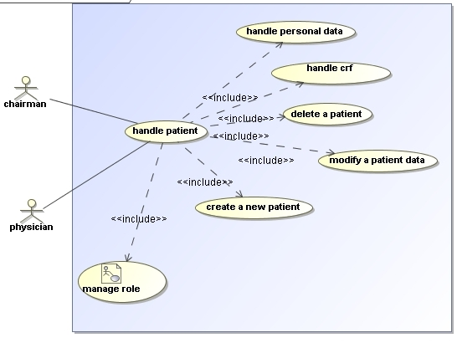
Figure 26 Use case for management of patients

Use Case 2.1: | Create a new patient
Primary Actor: | Trial chairman or a physician (here: user)
Summary: | A user enrols a new patient into a clinical trial if all inclusions criterion are fulfilled. User fills the CRFs assigned to the patient and forwards them to the trial chairman for validation.
Scope: | OPDMS module of the ObTiMA
Stakeholders and interests: | 1. User - wants to add a new patient into the OPDMS of the clinical trial.  2. Trial chairman validates a user data  3. OPDMS expects a necessary information about the patient
Preconditions: | User needs to be logged into the system and to have the right to enrol patient.
Success guarantee: | Remote web site accepts received information and creates a profile for the new patient
Trigger: | User opts to enrol a new patient
Main success scenario: | 2.1.1 User selects an action to enrol a patient on the GUI and fills the displayed registration form  2.1.2 OPDMS module creates a profile for the new user and displays it  2.1.3 User adds CRFs to the patient’s folder and saves them  2.1.4 OPDMS module displays a list of CRFs assigned to the patient  2.1.5 User fills CRF  2.1.6 OPDMS module saves changes  2.1.7 Trial chairman validates CRF and changes status of the CRF  2.1.8 OPDMS module saves changing
Extensions: | 2.1.3a User aborts a process (similar step is possible after UC 2.1.5, 2.1.7)  2.1.4a. OPDMS module shows the completeness or a correctness failure: continue UC 2.1.3 (similar step is possible after 2.1.8)  2.1.4b. OPDMS module shows a message, that a patient with the similar data is already registered in the system  2.1.4b 1 User confirms the enrolment: continue UC 2.1.4  2.1.4b 2 User aborts the action  2.1.4c. OPDMS module refuses an enrolment because a patient doesn’t fulfils an inclusion criteria – aborts the enrolment action  2.1.6a OPDMS checks the input data and sends a SAE/SUSAR report  2.1.7a Content on a CRF is not valide and a trial chairman doesn’t change status of the CRF: continue the UC 2.1.5

Use Case 2.2: | Modify patient’s data
Primary Actor: | Trial chairman or a physician (here: user)
Summary: | User modifies a profile for a patient. The changed profile will be saved.
Scope: | OPDMS module of the ObTiMA
Stakeholders and interests: | 1. User - wants to add a new patient into the OPDMS of the clinical trial.  2. Trial chairman validates a user data  3. OPDMS expects a necessary information about the patient
Preconditions: | User needs to be logged into the system and to have rights to modify a patient’s data.
Success guarantee: | Remote web site has accepts changed information and saves changes
Trigger: | User intends to change a data related to a patient
Main success scenario: | 2.2.1 User selects a patient’s CRF on the GUI and fills it in  2.2.2 OPDMS module saves changes  2.2.3 Trial chairman validates CRF and changes status of the CRF  2.2.4 OPDMS module saves changing
Extensions: | 2.2.1a User deletes a selected CRF  2.2.1a 1 OPDMS module displays an actualized list of the patient’s CRFs  2.2.1b User adds a new CRF to the patient (UC 2.1.5)  2.2.1c User aborts a process  2.2.1c 1 OPDMS module displays an unchanged data of the patient  2.2.1d User deletes a patient (UC 2.3)  2.2.1e. OPDMS module shows the completeness or a correctness failure: continue UC 2.2.1  2.2.2a OPDMS checks the input data and sends a SAE/SUSAR report  2.2.3a A CRF is not valide and a Trial chairman doesn’t change status of the CRF: continue the UC 2.2.1

Use Case 2.3: | Delete a patient
Primary Actor: | Trial chairman or a physician (here: user)
Summary: | User deletes a patient from the list of all patients. OPDMS module labels the patient in the database as “deleted”.
Scope: | OPDMS module of the ObTiMA
Stakeholders and interests: | 1. User - wants to delete a patient from the clinical trial.  2. OPDMS want to save the data for later retrieve
Preconditions: | User needs to be logged into the system and to have the appropriate rights.
Success guarantee: | Remote web site has accepted the deleting action
Trigger: | User want to exclude a patient from clinical trial
Main success scenario: | 2.3.1 User selects an action to delete a patient on the GUI  2.3.2 OPDMS module displays a confirmation dialog  2.3.3 User writes a reason for deleting and confirms the action  2.3.4 OPDMS module labels the patient in the database as “deleted” and displays an actualised list of facilities
Extensions: | 2.3.4a OPDMS module displays a failure of a completeness of the confirmation dialog  2.3.4a 1 User completes the confirmation dialog (action continues with the UC 1.3.4)  2.3.4a 2 User aborts a process  2.3.4.a 2.1 OPDMS module displays an unchanged list of facilities
  - Use case 3 “Manage roles and rights”
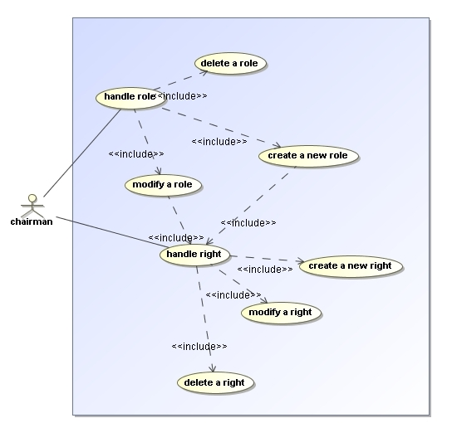

Figure 27 Use case for management of roles and rights

Use Case 3.1: | Create a new role
Primary Actor: | Trial chairman
Summary: | A chairman defines a new role of a person in a clinical trial and in the ObTiMA system. He assigns to the role a set of rights, which a person is allowed to execute in the system.
Scope: | Roles and rights management module of the ObTiMA  Roles and rights management module of the ACGT
Stakeholders and interests: | 1. Trial chairman - wants to create a new role of the person with definite rights in clinical trials and in the ObTiMA system.  2. OPDMS expects that to each created role at least one defined right is assigned.
Preconditions: | Trial chairman needs to be logged into the system and to have the right to enrol patient.
Success guarantee: | Remote web site accepts received information and creates a new role of a person in the system
Trigger: | Current set of defined roles in the system is not suited for a new user. Trial chairman plans to extend the list of roles.
Main success scenario: | 3.1.1 Trial chairman selects an action to create a new role on the GUI and fills the displayed form.  3.1.2 OPDMS module displays a list of existing rights to execute different actions in the system.  3.1.3 Trial chairman assigns a set of rights to the created role and saves changes 3.1.4 OPDMS displays a message about a successfully saving of the new role
Extensions: | 3.1.3a Trial chairman aborts a process  3.1.4a. OPDMS module shows that no right is assigned to the created role and continues with the UC 3.1.2  3.1.4b. OPDMS module shows that a role with a similar set of assigned rights exists in the system and continues with the UC 3.1.2  3.1.4b 1 Trial chairman aborts a process  3.1.4b 2 Trial chairman changes a set of rights for this role (UC 3.1.3)

Use Case 3.2: | Modify a role
Primary Actor: | Trial chairman
Summary: | Trial chairman modifies a definition of a role in the system. The changed profile will be saved.
Scope: | Roles and rights management module of the ObTiMA  Roles and rights management module of the ACGT
Stakeholders and interests: | 1. Trial chairman - wants to change a set of rights assigned to a role.  2. OPDMS expects that to a role at least one defined right is assigned.
Preconditions: | User needs to be logged into the system and to have rights to modify a patient’s data.
Success guarantee: | Remote web site has accepts changed information and saves changes
Trigger: | Trial chairman intends to change a set of rights assigned to a role
Main success scenario: | 3.2.1 User selects a rights to add or remove to/from a definition of a role in the system on the GUI  3.2.2 OPDMS module saves changes
Extensions: | 3.2.1a Trial chairman manages a list of rights (UC 3.1 – 3.3)  3.2.2b OPDMS module refuse a modification and displays a list of participants, which are using this role with the assigned rights  3.2.2b 1 Trial chairman manages displayed list of participants  3.2.2b 2 Trial chairman aborts a process of modification  3.2.2b 2.1 OPDMS module displays an unchanged list of roles  3.2.1c User deletes a role (UC 3.3)  3.2.2a. OPDMS module shows that no right is assigned to the created role and continues with the UC 3.1.2  3.2.2b. OPDMS module shows that a role with a similar set of assigned rights exists in the system  3.2.2b 1 Trial chairman aborts a process of modification  3.2.2b 2 Trial chairman changes a set of rights for this role (UC 3.2.1)

Use Case 3.3: | Delete a role
Primary Actor: | Trial chairman
Summary: | Trial chairman deletes a definition of a role in the system from the list. OPDMS module saves a changed list of roles in the system.
Scope: | Roles and rights management module of the ObTiMA
Stakeholders and interests: | 1. Trial chairman - wants to delete a role from the list.  2. OPDMS expects that a role is not in usage and allows a deleting action.
Preconditions: | Trial chairman needs to be logged into the system and to have the appropriate rights.
Success guarantee: | Remote web site has accepted the deleting action
Trigger: | Trial Chairman opts to delete a role
Main success scenario: | 3.3.1 Trial Chairman selects an action to delete a role on the GUI  3.3.2 OPDMS module displays an actualised list of roles
Extensions: | 3.3.1a Trial chairman modifies a current role (UC 3.2)  3.3.2a OPDMS module refuse a deleting and displays a list of participants, which are using this role  3.3.2a 1 Trial chairman manages displayed list of participants  3.3.2a 2 Trial chairman aborts a process of deleting  3.3.2a 2.1 OPDMS module displays an unchanged list of roles

Use Case 3.4: | Create a new right
Primary Actor: | Trial chairman
Summary: | A chairman defines a new right to execute an action in the system, which can be used by a definition of a role.
Scope: | Roles and rights management module of the ObTiMA
Stakeholders and interests: | 1. Trial chairman - wants to create a new right to execute an action in the system 2. OPDMS expects a correct definition of a right
Preconditions: | Trial chairman needs to be logged into the system and to have the right to enrol patient.
Success guarantee: | Remote web site accepts received information and creates a new right for usage in the system
Trigger: | Current list of defined rights in the system is not suited for a definition of a role. Trial chairman plans to extend the list of rights.
Main success scenario: | 3.4.1 Trial chairman selects an action to create new rights on the GUI and fills the displayed form.  3.4.2 OPDMS displays a message about a successfully saving of the new rights
Extensions: | 3.4.1a OPDMS module shows a message, that a similar right exists in the system  3.4.1a 1 Trial chairman aborts a process  3.4.1a 2 Trial chairman changes a definition of a right (UC 3.4.1)

Use Case 3.5: | Modify a right
Primary Actor: | Trial chairman
Summary: | Trial chairman modifies a definition of a right in the system. The changed definition of a right will be saved.
Scope: | Roles and rights management module of the ObTiMA
Stakeholders and interests: | 1. Trial chairman - wants to change a right  2. OPDMS expects a correct definition of a right
Preconditions: | Trial chairman needs to be logged into the system and to have rights to modify a patient’s data.
Success guarantee: | Remote web site has accepts changed information and saves changes
Trigger: | Trial chairman intends to change a right
Main success scenario: | 3.5.1 Trial chairman selects a right and changes it’s definition on the GUI  3.5.2 OPDMS module saves changes
Extensions: | 3.5.1a Trial chairman creates a new right (UC 3.4)  3.5.1b Trial chairman deletes a right (UC 3.6)  3.5.2a OPDMS module refuse a modification and displays a list of roles, which are using this right  3.5.2a 1 Trial chairman manages displayed list of roles (UC 3.1-3.3)  3.5.2a 2 Trial chairman aborts a process of modification  3.5.2a 2.1 OPDMS module displays an unchanged list of rights  3.5.2b OPDMS module shows that a similar right exists in the system  3.5.2b 1 Trial chairman aborts a process of modification  3.5.2b 2 Trial chairman changes a definition of this right (UC 3.5.1)

Use Case 3.6: | Delete a right
Primary Actor: | Trial chairman
Summary: | Trial chairman deletes a definition of a right to execute an action in the system from the list. OPDMS module saves a changed list of rights.
Scope: | Roles and rights management module of the ObTiMA
Stakeholders and interests: | 1. Trial chairman - wants to delete a right  2. OPDMS expects that a right is not in usage and allows a deleting action
Preconditions: | Trial chairman needs to be logged into the system and to have the appropriate rights.
Success guarantee: | Remote web site has accepted the deleting action
Trigger: | Trial Chairman opts to delete a right
Main success scenario: | 3.6.1 Trial Chairman selects an action to delete a right on the GUI  3.6.2 OPDMS module displays an actualised list of rights
Extensions: | 3.6.1a Trial chairman modifies a current right (UC 3.5)  3.6.2a OPDMS module refuse a deleting and displays a list of roles, which are using this right  3.6.2a 1 Trial chairman manages displayed list of roles (UC 3.1-3.3)  3.6.2a 2 Trial chairman aborts a process of deleting  3.3.2b 2.1 OPDMS module displays an unchanged list of rights
  - Use case 4 “Manage trial”
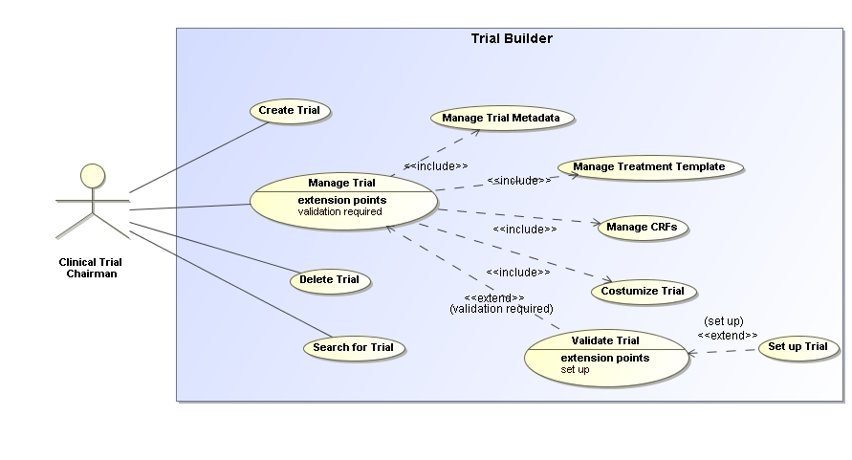
Figure 28 Use case for management of ckinical trials

Use Case 4.1: | Create Trial
Actors: | Trial chairman
Summary: | Trial chairman creates a new trial.
Preconditions: | Trial chairman needs to be logged into the system and to have the appropriate rights.
Main Flow: | 4.1.1 The Trial chairman requests the system to create a new Trial.  4.1.2 The system requests the Trial Name, Abbreviation for the Trial, the Eudra CT number and responsible persons for the Trial, without this information the Trial can not be saved.  4.1.3 The trial chairman enters the required data.  4.1.4 The system stores the trial in the database and shows the interface for describing metadata.
Success guarantee: | System accepts entered data and interface for describing metadata is shown.
Exceptions: | 4.1.4a Trial with same name, abbreviation or EudraCT number already exists in the database. It is not possible to store a trial with the same name or EudraCT number or abbreviation, the trial chairman is requested to change this (continues with the UC 4.1.3).  3a Trial chairman can abort the action.  Nothing happens and interface that was shown before the action is shown.

Use Case 4.2: | Manage Trial
Actors: | Trial chairman
Summary: | Trial chairman manages an already created trial.
Preconditions: | Trial chairman needs to be logged into the system and to have the appropriate rights.  A trial needs to be “selected”.
Main Flow: | - The Trial chairman can chose if he wants to manage the trial metadata, manage the CRFs for the trial, customize the trial or validate the trial  - The system allows the trial chairman to work in the selected category.
Success guarantee: | Interface for the selected category is shown.
Exceptions: | none

Use Case 4.3: | Delete Trial
Actors: | Trial chairman
Summary: | Trial chairman deletes a trial.
Preconditions: | Trial chairman needs to be logged into the system and to have the appropriate rights and a trial has to be selected.
Main Flow: | - The Trial chairman requests the system to delete a Trial.  - The system requests if the trial chairman is sure about that.  - The trial chairman approves.  - The trial with all its metadata and CFRs is deleted physically from the database. The system displays an list with all stored trials.
Success guarantee: | Trial is deleted.
Exceptions: | 3a User does not approve => process is aborted  Interface that was shown before this action is shown.

Use Case 4.4: | Search for Trial
Actors: | Trial chairman
Summary: | Trial chairman searches for a trial.
Preconditions: | Trial chairman needs to be logged into the system and to have the appropriate rights.
Main Flow: | - The Trial chairman requests the system to search for a Trial.  - The system shows a search mask with the following criterias to the trial chairman trial name, trial abbreviation, Eudra CT No., disease, trial chairman and if trial is randomized.  - Trial chairman enters the appropriate data.  - System shows all trials that fit the criteria specified by the trial chairman.  - Trial chairman can select a trial to work with.
Success guarantee: | Trials fitting specified criteria are shown
Exceptions: | 3a Trial chairman can abort the action.  Nothing happens and interface that was shown before the action is shown.  4a No trials are found: Trial chairman is asked by the system to try a new search  Search mask is shown again (continues with UC 4.4.2).

Use Case 4.5: | Manage Trial Metadata
Actors: | Trial chairman
Summary: | Trial chairman manages metadata for an already created trial.
Preconditions: | Trial chairman needs to be logged into the system and to have the appropriate rights.  A trial and the appropriate category “manage metadata” has to be selected. (see use case “4.2. Manage Trial”)
Main Flow: | - The system shows interfaces to enter the metadata for the trial. A list of the metadata is shown in Appendix A.  - The trial chairman can enter, change and delete the metadata. He can then save his changes to the metadata  - System stores metadata in database.
Success guarantee: | Metadata for trial is stored in database.
Exceptions: | 2a Trial chairman can abort the action.  Nothing happens and interface that was shown before the action is shown.  3a Entered metadata does not fit constraints specified for metadata (e.g. range constraints):  System shows appropriate warnings to the trial chairman. Trial chairman gets chance to change metadata. (continues with UC 4.5.2)

Use Case 4.6: | Manage Treatment template
Actors: | Trial chairman
Summary: | Trial chairman manages the treatment template.
Preconditions: | Trial chairman needs to be logged into the system and to have the appropriate rights.  A trial and the appropriate category “manage treatment template” has to be selected. (see use case “4.2. Manage Trial”)
Main Flow: | 1. The system shows a scratch board to create the treatment template for the trial.  2. The user can add events to the scratch board and define the metadata for the events. He can change and delete the events and their metadata. He can then safe the treatment template.  3. System stores treatment template in the database
Success guarantee: | Treatment template is stored in database.
Exceptions: | To be defined!

Use Case 4.7: | Manage Trial CRFs
Actors: | Trial chairman
Summary: | Trial chairman manages CRFs for an already created trial.
Preconditions: | Trial chairman needs to be logged into the system and to have the appropriate rights.  A trial and the appropriate category “manage trial CRFs” has to be selected. (see use case “4.2. Manage Trial”)
Main Flow: | - The system shows a list of all CRFs for the currently selected trial.  - The Trial chairman can chose if he wants to create a new CRF, manage a CRF or delete a CRF. If he wants to delete or manage a CRF he has to select one CRF form the shown list.  - The system allows the trial chairman to work in the selected category.
Success guarantee: | Trial chairman can work in the selected category.
Exceptions: | 1. No CRF selected: System requests the trial chairman to select a CRF (continues with UC 4.7.2).

Use Case 4.8: | Customize trial
Actors: | Trial Chairman
Summary: | Trial chairman can customize the layout of the CRFs that will be shown for the trial in the patient management system.
Preconditions: | Trial chairman needs to be logged into the system and to have the appropriate rights.  A trial and the appropriate category “customize trial” has to be selected. (see use case “4.2. Manage Trial”)
Main Flow: | - The system shows an appropriate user interface to upload a logo for the CRFs and to specify a header and a footer for the CRFs.  - Trial Chairman uploads logo or specifies header or footer. Then he safes the changes.  - System stores changes in the database.
Success guarantee: | Customizing information is stored in the database.
Exceptions: | 2a Trial chairman can abort the action.  Nothing happens and interface that was shown before the action is shown.  3a Logo has not the appropriate attributes (e.g. too big).  System requests to upload an appropriate file for the logo.

Use Case 4.9: | Validate Trial
Actors: | Trial Chairman
Summary: | Trial chairman can validate and set up the trial.
Preconditions: | Trial chairman needs to be logged into the system and to have the appropriate rights.  A trial and the appropriate category “validate trial” has to be selected. (see use case “4.2. Manage Trial”)
Main Flow: | - Trial chairman requests a validation of the trial.  - System checks trial for validation (all required metadata has to be specified, the trial needs at least one CRF, each CRF needs at least one item).  - System shows if trial is valide and in cases the trial is not valide the detected problems.
Success guarantee: | Validation information is shown.
Exceptions: | none

Use Case 4.10: | Set up trial
Actors: | Trial Chairman
Summary: | Trial chairman can set up the patient management system for the trial.
Preconditions: | Trial chairman needs to be logged into the system and to have the appropriate rights.  A trial has to be selected and already validated. (see use case “4.9 Validate Trial”)
Main Flow: | - Trial chairman requests to set up the patient management system for the selected trial.  - System checks trial for validation and if no problems occurred the patient management system for the trial is deployed on the server on that the trial specification is stored.  - System shows appropriate success message.
Success guarantee: | Message is shown that patient data management system has been set up successfully..
Exceptions: | 3a Trial is not valide: Appropriate error message is shown from the system and patient management system can not be set up.

  - Use Cases “Manage CRF” (CRF Builder)
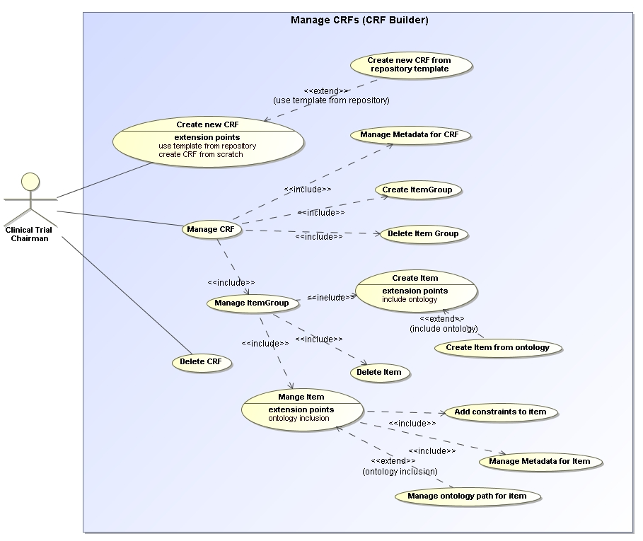

Figure 29 Use case for management of CRFs

Use Case 4.11: | Create CRF
Actors: | Trial Chairman
Summary: | Trial chairman creates a CRF for the trial.
Preconditions: | Trial chairman needs to be logged into the system and to have the appropriate rights.  A trial has to be selected and the appropriate category “create CRF”. (see use case “4.7. Manage trial CRFs”)
Main Flow: | - Trial Chairman requests to create a CRF for the currently selected trial.  - System asks if the CRF should be created from existing CRF template from CRF repository.  - Trial chairman negates. (See use UC 4.12 for approvement)  - System shows interface to enter Name of CRF.  - Trial chairman enters name and approves.  - System creates CRF and shows the empty CRF for further actions.
Success guarantee: | Empty newly created CRF is shown.
Exceptions: | 2a /5a Trial chairman can abort the action.  Nothing happens and interface that was shown before the action is shown.  6a It already exists a CRF with the same name in the currently selected trial  System requests to change the name for the CRF.

Use Case 4.12: | Create CRF from repository template
Actors: | Trial Chairman
Summary: | Trial chairman creates a CRF from a repository template for the trial.
Preconditions: | Trial chairman needs to be logged into the system and to have the appropriate rights.  A trial has to be selected and the appropriate category “create CRF”. (see use case “Manage trial CRFs”)
Main Flow: | - Trial Chairman requests to create a CRF for the currently selected trial.  - System asks if the CRF should be created from existing CRF template from CRF repository.  - Trial chairman agrees.  - System shows interface to select an CRF from the repository.  - Trial chairman selects one and approves.  - System adds CRF to trial and shows CRF for further actions.
Success guarantee: | CRF is shown.
Exceptions: | 2a /5a Trial chairman can abort the action.  Nothing happens and interface that was shown before the action is shown.  6a It already exists a CRF with the same name in the currently selected trial  System requests to change the name for the CRF.

Use Case 4.13: | Manage CRF
Actors: | Trial Chairman
Summary: | Trial chairman manages CRFs.
Preconditions: | Trial chairman needs to be logged in to the system and to have the appropriate rights.  A trial has to be selected and the appropriate category “manage CRF”. (see use case “Manage Trial CRFs”)
Main Flow: | - System shows the currently selected CRF.  - The Trial chairman can chose if he wants to create a new ItemGroup, manage an ItemGroup, delete an ItemGroup or manage the metadata of the CRF. If he wants to delete or manage an ItemGroup he has to select one on the shown CRF.  - The system allows the trial chairman to work in the selected category.
Success guarantee: | Interface for selected category is shown.
Exceptions: | none

Use Case 4.14: | Delete CRF
Actors: | Trial Chairman
Summary: | Trial chairman deletes a CRF for the trial.
Preconditions: | Trial chairman needs to be logged into the system and to have the appropriate rights.  A trial has to be selected and the appropriate category “delete CRF”. (see use case “4.13. Manage CRF”)
Main Flow: | - System queries if the trial chairman is sure that he wants to delete the CRF from the currently selected trial.  - Trial chairman approves.  - System deletes CRF physically from database.
Success guarantee: | Message is shown that CRF is successfully deleted.
Exceptions: | 2a Trial chairman does not approve => process is aborted  Interface that was shown before this action is shown

Use Case 4.15: | Manage Metadata for CRF
Actors: | Trial Chairman
Summary: | Trial chairman manages metadata for already created CRF.
Preconditions: | Trial chairman needs to be logged into the system and to have the appropriate rights.  A trial has to be selected and the appropriate category “manage metadata for CRF”. (see use case “Manage CRF”)
Main Flow: | - System shows interface to enter metadata for the CRF (name of CRF, description of CRF, category of CRF, version)  - Trial Chairman can enter, modify or delete the data. He can then save the canges  3. System stores changes in the database
Success guarantee: | CRF with changed metadata is shown.
Exceptions: | 3a Entered metadata does not fit constraints specified for metadata (e.g. range constraints):  System shows appropriate warnings to the trial chairman. Trial chairman gets chance to change metadata.

Use Case 4.16: | Create ItemGroup
Actors: | Trial Chairman
Summary: | Trial chairman creates ItemGroup on an already created CRF.
Preconditions: | Trial chairman needs to be logged into the system and to have the appropriate rights.  A trial has to be selected and the appropriate category “create ItemGroup”. (see use case “Manage CRF”)
Main Flow: | - System shows interface to enter name and description for the ItemGroup  - Trial chairman enters the requested attributes and approves.  - System shows CRF with newly created ItemGroup
Success guarantee: | CRF with newly created ItemGroup is shown.
Exceptions: | 3a Trial chairman can abort the action.  Nothing happens and interface that was shown before the action is shown.

Use Case 4.17: | Delete ItemGroup
Actors: | Trial Chairman
Summary: | Trial chairman deletes an Item group on a CRF.
Preconditions: | Trial chairman needs to be logged into the system and to have the appropriate rights.  A trial has to be selected and the appropriate category “delete ItemGroup”. (see use case “Manage CRF”)
Main Flow: | - Trial Chairman selects an ItemGroup from the CRF and queries to delete it.  - System asks if he is really sure about that  - Trial chairman approves.  - System deletes ItemGroup physically from the database.
Success guarantee: | CRF without deleted ItemGroup is shown.
Exceptions: | 3a Trial chairman does not approve.  Nothing happens and interface that was shown before the action is shown.

Use Case 4.18: | Manage ItemGroup
Actors: | Trial Chairman
Summary: | Trial chairman manages an ItemGroup on a CRF.
Preconditions: | Trial chairman needs to be logged into the system and to have the appropriate rights.  A trial has to be selected and the appropriate category “manage ItemGroup”. (see use case “Manage CRF”)
Main Flow: | - Trial Chairman selects an ItemGroup on the currently shown CRF.  - The Trial chairman can chose if he wants to create a new Item, manage an Item, or delete an Item. If he wants to delete or manage an Item he has to select one on the shown CRF.  - The system allows the trial chairman to work in the selected category.
Success guarantee: | Interface for the selected category is shown.
Exceptions: | none

Use Case 4.19: | Create Item
Actors: | Trial Chairman
Summary: | Trial chairman creates an Item for a CRF.
Preconditions: | Trial chairman needs to be logged into the system and to have the appropriate rights.  A trial has to be selected and the appropriate category “create Item”. (see use case “Manage ItemGroup”)
Main Flow: | - Trial Chairman requests to create a new item.  - System queries the question for the newly created item.  - Trial chairman enters question and approves.  - System shows CRF with newly created item.
Success guarantee: | Newly created item on CRF is shown.
Exceptions: | 3a Trial chairman can abort the action.  Nothing happens and interface that was shown before the action is shown.

Use Case 4.20: | Delete Item
Actors: | Trial Chairman
Summary: | Trial chairman deletes an item on a CRF.
Preconditions: | Trial chairman needs to be logged into the system and to have the appropriate rights.  A trial has to be selected and the appropriate category “delete Item”. (see use case “Manage ItemGroup”)
Main Flow: | - System asks if trial chairman is sure about deleting the item.  - Trial chairman approves.  - System deletes item physically from database
Success guarantee: | CRF is shown without the deleted item.
Exceptions: | 2a Trial chairman does not approve.  Nothing happens and the interface that was shown before the action is shown again.

Use Case 4.21: | Manage Item
Actors: | Trial Chairman
Summary: | Trial chairman manages an item on a CRF.
Preconditions: | Trial chairman needs to be logged into the system and to have the appropriate rights.  A trial has to be selected and the appropriate category “manage Item”. (see use case “Manage ItemGroup”)
Main Flow: | - Trial Chairman selects an Item on the currently shown CRF.  - The Trial chairman can chose if he wants to manage the metadata for the item, adds constraints to the item or manage the ontology path for the item.
Success guarantee: | Interface for the selected category is shown.
Exceptions: | none

Use Case 4.22: | Manage Metadata for Item
Actors: | Trial Chairman
Summary: | Trial chairman manages metadata for an item.
Preconditions: | Trial chairman needs to be logged into the system and to have the appropriate rights.  A trial has to be selected and the appropriate category “manage metadata for item”. (see use case “Manage Item”)
Main Flow: | - System shows an interface to enter, modify and delete the metadata for the item (see Appendix B for a list what the metadata for an item comprises). Trial chairman saves changes  - System stores changes in database.
Success guarantee: | CRF is shown with modified item.
Exceptions: | 2a Entered metadata does not fit constraints specified for metadata (e.g. range constraints):  System shows appropriate warnings to the trial chairman. Trial chairman gets chance to change metadata.

Use Case 4.23: | Add constraints to item
Actors: | Trial Chairman
Summary: | Trial chairman adds an constraint to an item.
Preconditions: | Trial chairman needs to be logged into the system and to have the appropriate rights.  A trial has to be selected and the appropriate category “manage metadata for item”. (see use case “Manage Item”)
Main Flow: | - System shows interface to enter a constraint for the item  - Trial chairman creates a constraint and approves.  - system stores constraint in the database
Success guarantee: | CRF is shown.
Exceptions: | 3a Trial chairman can abort the action.  Nothing happens and interface that was shown before the action is shown.

Use Case 4.24: | Create item from ontology
Actors: | Trial Chairman
Summary:
Preconditions: | Trial chairman needs to be logged into the system and to have the appropriate rights.  A trial has to be selected and the appropriate category “create Item”. (see use case “Manage ItemGroup”)
Main Flow: | - Trial Chairman requests to create a new item from the ontology.  - System shows an appropriate interface to select an path from the ontology that can describe the item  - Trial chairman selects path from ontology and approves.  - System shows CRF with newly created item.
Success guarantee: | CRF with newly created item is shown.
Exceptions: | 3a Trial chairman can abort the action.  Nothing happens and interface that was shown before the action is shown.

Use Case 4.25: | Manage ontology path for item
Actors: | Trial Chairman
Summary: | Trial chairman changes the ontology description for an item.
Preconditions: | Trial chairman needs to be logged into the system and to have the appropriate rights.  A trial has to be selected and the appropriate category “manage ontology path for item”. (see use case “Manage Item”)
Main Flow: | 1. Trial Chairman requests to see the ontology path for an item.  2. System shows ontology path in an appropriate interface.  3. Trial chairman can change the path and safes it.  4. System stores the new path in the database.
Success guarantee: | CRF is shown.
Exceptions: | 3a Trial chairman can abort the action.  Nothing happens and interface that was shown before the action is shown.

Legend:
- a black-box and a white-box symbols means a system use cases, where a user interacts with a machine

  - the filled building symbol means a business use case, where a user interacts with a company

- - a building symbol means a business use case, where a user interacts with a person or a department in a company

- a bolt symbol means a component use case, where user interacts with a subsystem or component of the system under design.

or - a blue symbols for the user-level goal means the goal of greatest interest, the goal the primary actor has to achieve in a single sitting (2-20 minutes). Two colours of blue mean that one use case occasionally refers to another blue use case.

- a white symbol for the Summary-level goal means that the goal involves multiple user goals on different levels and typically has to be executed over hours, days, weeks, months, or years.

- and symbols for the Subfunction-level goal means low-level or ultra-low-level goals to achieve a user goal.

- Metadata for Trial
Context |  |  |  | Category |  | Type | Format/ Coding/Options |  | Ontology Reference
Trial |  |  |  | Name |  | A254
 |  |  |  | Abbreviation |  | A20 | Abbreviation of the Trial
 |  |  |  | ACGT Number |  | I5
 |  |  |  | Characteristics |  | I2 | -1: not yet known  1: treatment trial  2: preventive trial  3: diagnostic trial  4: screening trial  5: quality of life trial  6: epidemiological trial
 |  |  |  |  |  | I2 | -1: not yet known  1: prospective  2: retrospective
 |  |  |  |  |  | I2 | -1: not yet known  1: randomized  2: non-randomized
 |  |  |  |  |  | I2 | -1: not yet known  1: unicenter  2: multicenter
EudraCT No. |  |  |  | Number |  | A14 | YYYY-NNNNNN-CC
EC/IRB |  | Name |  | Institution ID [2.4.3.2] |  | I5
 |  | Approval |  | Done |  | I2 | -1: not yet known  1: no  2: yes
 |  | Date of approval |  | Date |  | D8 | DDMMYYYY
Regulatory Body |  | Name |  | Institution ID [2.4.3.2] |  | I5
 |  | Approval |  | Done |  | I2 | -1: not yet known  1: no  2: yes
 |  | Date of approval |  | Date |  | D8 | DDMMYYYY
Insurance |  | Name |  | Institution ID [2.4.3.2] |  | I5
 |  | Approval |  | Done |  | I2 | -1: not yet known  1: no  2: yes
 |  | Date of approval |  | Date |  | D8 | DDMMYYYY
 |  | No. |  | Number |  | A50
Funding |  | Name |  | Institution ID [2.4.3.2] |  | I5
 |  | Approval |  | Done |  | I2 | -1: not yet known  1: no  2: yes
 |  | Date of approval |  | Date |  | D8 | DDMMYYYY
 |  | No. |  | Number |  | A50
Sponsor |  |  |  | User ID [2.4.3.3] |  | I5
Chairman / PI |  |  |  | User ID [2.4.3.3] |  | I5
Deputy Chairman |  |  |  | User ID [2.4.3.3] |  | I5
Data Manager |  |  |  | User ID [2.4.3.3] |  | I5
Statistical centre |  |  |  | Institution ID [2.4.3.2] |  | I5
Statistician |  |  |  | User ID [2.4.3.3] |  | I5
Study committee |  |  |  | User ID [2.4.3.3] |  | I5 |  | multiple entries possible
Reference Centres |  |  |  | Institution ID [2.4.3.2] |  | I5 |  | multiple entries possible
 |  |  |  | Contract done |  | I2 | -1: not yet done  1: no  2: yes | multiple entries possible
 |  |  |  | Date of contract |  | D8 | DDMMYYYY | multiple entries possible
DSMC |  |  |  | User ID [2.4.3.3] |  | I5 |  | multiple entries possible
Dates | Start of trial |  |  | Date |  | D8
Dates | patient recruitment |  | Start | Date |  | D8
Dates |  |  | Closure | Date |  | D8
Dates | End of trial |  |  | Date |  | D8
Duration of follow-up |  |  |  | Timeframe |  | I3 | in months
Sample size |  |  |  | Number |  | I4
Statistical analysis |  |  |  | Date |  | D8 | multiple entries possible
 |  |  |  | Number of patients |  | I5
 |  |  |  | Number of events |  | I5
Monitoring of the trial |  |  |  | Done |  | I2 | -1: not yet done  1: no  2: yes
 |  |  |  | If yes: Date |  | D8 | Multiple entries possible
 |  |  |  | Monitor at that date Institution-ID [2.4.3.2] |  | I5 | Multiple entries possible
 |  |  |  | Monitor(s) at that date User-ID [2.4.3.3] |  | I5 | Multiple entries possible
 |  |  |  | Protocol of the visit at that date |  | M | Memo Multiple entries possible
Publication rules |  |  |  | Done |  | I2 | -1: not yet done  1: no  2: yes
 |  |  |  | If yes, Text |  | M | Memo
Amendments |  |  |  | Done |  | I2 | -1: not yet done  1: no  2: yes
 |  |  |  | If yes, please specify | Name of amendment | A50 | multiple entries possible
 |  |  |  | If yes, please specify | Date | D8

Item | Sub-Item | Action
General | Name of the Trial | Give the name and the abbreviation of the Trial
General | Characteristics of the Trial | Answer the following questions with yes or no:  prospective? randomized? multicentre?  Treatment trial? Preventive trial? Diagnostic trial? Screening trial? Quality of life trial? Epidemiological trial?
General | Sponsor | Give the name and address of the sponsor  [Addresses are always: postal address, telephone, fax and email]
General | EudraCT No. | Apply for an EudraCT Number  Information is given at:  http://www3.imperial.ac.uk/clinicalresearchoffice/projectplanning/regulatoryapprovals(excludingethics)/applyforaeudractnumber  To obtain a EudraCT number, follow this process:  - Apply for a security code via the EudraCT website. This will be sent to your email account and will expire after 24 hours.  - Once you have your security code, request a EudraCT number via the EudraCT website by entering the security code along with:  - Your organisation name  - Organisation town/city  - Organisation country  - The sponsor's protocol code number  - Your name  - The email address to which the EudraCT number will be sent  - Member state(s) where the trial is anticipated to be conducted  - The EudraCT number will be sent by email, which you should then save locally.  The EudraCT number has the format: YYYY-NNNNNN-CC  (Y = the year in which the number is issued)  (N = a 6 digit sequential number); (C = a check digit)
General | Chairman | Give the name and address of the chairman (Principal investigator)
General | Deputy Chairman | Give the name and address of the Deputy chairman
General | Study nurse | Give the name and address of the Study nurse
General | Study committee | Give the names and addresses of all members of the study committee
General | Reference centres | Give the names and addresses of all reference centres including the responsible person
General | Data and Safety Monitoring Committee [DSMC] | Give the names and addresses of all members of the Data Monitoring and Safety committee [DSMC]
Basics / Background | Abstract | Template to write the abstract / summary of the trial
Basics / Background | Historical background | Template to write the historical background of this disease
Basics / Background | Results of former trials | Template to write the results of former trials regarding this disease
Basics / Background | State of the art in Molecular Biology | Template to write the State of the art in Molecular Biology of this disease
Basics / Background | Conclusions and open questions | Template to write the conclusions and open questions, including:  - Why are you researching the area?  - What is the previous evidence/gap in knowledge?
Changes | Changes regarding a preceding trial of the same disease | Template to write the changes of a preceding trial, if the new trial is a succeeding one
Aims of the trial | Main objective | Template to write the main objective with reference to the statistical section (primary endpoint(s))
Aims of the trial | Secondary objectives | Template to write the secondary objectives with reference to the statistical section (secondary endpoint(s))
Aims of the trial | Corresponding projects | Template to write the corresponding projects including background, question(s), aims, objectives and purpose
Design | Timeframe | Give the timeframe of the trial, including date of start and end of patients recruitment, duration of the follow-up after the last patient entered the trial
Design | Stratification | Explain all stratifications and define the different risk groups
Design | Randomisation | Explain all randomisations
Patients’ characteristics | Inclusion criteria | Define the inclusion criteria
Patients’ characteristics | Exclusion criteria | Define the exclusion criteria
Patients’ characteristics | Patients’ characteristics | Define Study patient, trial patient, protocol patient
Diagnostics | Initial | Template to write all diagnostic procedures needed for participation
Diagnostics | during the trial | Template to write all diagnostic procedures during the trial and at the end
Diagnostics | Follow-up | Template to write all diagnostic procedures during follow-up including a time schedule
Diagnostics | Relapse | Define how to diagnose a relapse
Treatment | Plan | Direct link to the third section of the TOB
Treatment | Elements | Direct link to the third section of the TOB
Treatment | Drugs | Direct link to the third section of the TOB
Treatment | Modifications | Direct link to the third section of the TOB
Treatment | SUSARs / SAEs | Direct link to the third section of the TOB
Treatment | Supportive therapy | Direct link to the third section of the TOB
Patients safety | Emergencies | Template to list all possible emergencies and how to handle them (Prevention and treatment)
Patients safety | Definitions | Define and describe methods and classification schemas used:  Response criteria, relapse, early death, lost of follow-up and other criteria dealing with patients, the disease or the trial
Statistics | Design | Template to describe primary and secondary objectives, to create a hypothesis and to define alpha and other statistical parameters, to explain the statistical method used, define the collective of patients for analysis including intention to treat analysis and per protocol analysis
Statistics | Sample size | Calculate the sample size to answer the main objective/question and explain the statistical power corresponding to the sample size
Statistics | Timetable | Define the time points for statistical analysis during and after the trial
Statistics | Stopping rule | Define a stopping rule for interruption or withdrawal of enrolling new patients into the trial
Organisation | Financial issues | Template for writing an application for funding  Template for summarizing the funding of the trial
Organisation | (International) cooperation | Template to define data exchange, material exchange, responsibilities, publication rules
Organisation | Registration | Define how centres can participate in the trial
Organisation | Documentation | Template to write how centres have to document within the trial
Organisation | Data management | Define how data are collected, validated, cleaned and how and when reminders for missing data are send to the local hospitals, define CRFs
Organisation | Quality control | Template to write :  How to monitor the trial  How to handle amendments  What are the responsibilities of reference centres  How to deal with treatment or diagnostic violations  Tasks and duties of the Data and Safety Monitoring Committee (DSMC)
Ethics | Declaration of Helsinki | Link to the most recent version
Ethics | Institutional Review board (IRB) or Ethics Committee (IEC) | Template for applying the Ethical approval  Addresses of Ethical Committees
Ethics | Informed consents | Template for writing the informed consents
Ethics | Patients’ information sheets | Template for writing the Patients’ information sheets
Ethics | Data security | Template for writing how data security is handled within the trial
Ethics | Minors | Template for writing how to deal with minors or persons not able to give informed consent
Legal issues | National and international laws | References to relevant laws in the Web
Legal issues | Registration | Template for registration of the trial by the national organisations
Legal issues | Contracts | Templates for writing contracts needed in the trial
Legal issues | GCP Criteria | Link to the Web
Legal issues | Insurance | Template to apply for an insurance for the trial  Information of the given insurance
Analysis | Reports | Template for writing reports
Analysis | Publications | Template for writing publication rules
Analysis | Queries | Define responsibilities and rules for querying the database
Analysis | Trial Builder | Template for defining rules in allowing using the trial builder
Ref. | References | Template for writing references
Appendices | Informed consents | Direct link to the third section of the TOB
Appendices | Patient information sheets | Direct link to the third section of the TOB
Appendices | Treatment Plan | Direct link to the third section of the TOB
Appendices | Ethics Vote | Copy of the ethics vote and the insurance
Appendices | Bio bank | Direct link to the third section of the TOB
Appendices | Participating centres | List of participating centres
Documents | Protocol | This includes all versions of the trial protocol and all amendments
Documents | Official documents | This includes all documents related to ethical, legal or regulatory issues within the trial
Documents | Finance | This includes all documents related to financial issues of the trial
Documents | Contracts | This includes all documents related to contracts with the Sponsor, participating centres, reference institutions, etc
Documents | Consultation | This includes all documents related to consultations regarding the trial. It does not include the consultations related to a specific patient. They will only be found in the database of the specific patient.
Documents | Reports | This includes all reports that have been done during the conduct of the trial and afterwards, including reports to the DSCM and SAE and SUSAR reports
Documents | Papers | This includes all papers related to the trial, that were published

  - Metadata for an item
- Question that will be shown on the CRF
- data type of the answer: e.g. String, Integer,..
- length of the item
- Constraints (optional)
- possible values of answer (optional)
- measurement unit of answer (optional): e.g. kg
- if item is optional (default value: required)
- who has the right to edit, read or delete data (roles and right concept)
- if data should be pseudonymised or anonymised
- if data should be stored in an encrypted way
- It is possible to enter a description of the item that will appear by moving the mouse over this item field later in the patient data management system

